***Project Management Report***

***On***

**Design of Multipurpose Agricultural Robot**

This Project report is submitted in

Partial fulfillments of the requirements for sixth semester term work in

Electronics & Telecommunication Engineering

***Submitted by***

Vaishnavi Sarode

Ayush Kature

Chaitanya Tabhane

Mrunal Dewalkar

Siddhesh Maske

***Guided by***

Prof. Atul Deshmukh



**Electronics &Telecommunication Engineering Department**

**G. H. RAISONI COLLEGE OF ENGINEERING**

**(An Autonomous Institute Affiliated to RTM Nagpur University)**

**Digdoh Hills, Nagpur-440016**

**2021-2022**

**Summer -2022**

# G. H. Raisoni College of Engineering

**(An Autonomous Institute Affiliated to RTM Nagpur University)**

**Digdoh Hills, Nagpur-440016**

Electronics &Telecommunication Engineering Department

**2021-2022**



*Certificate*

This is to certify that the project titled

Design of Multipurpose Agricultural Robot.

is in partial fulfillment of the requirement for sixth semester term work in

Electronics & Telecommunication Engineering

of Rashtrasant Tukadoji Maharaj Nagpur University, Nagpur is a bonafide work carried out & completed under my guidance & supervision during the academic year

**2021-2022**

***Submitted by***

Name of Candidates

Vaishnavi Sarode

Ayush Kature

Chaitanya Tabhane

Mrunal Dewalkar

Siddhesh Maske

Prof. Atul Deshmukh

**Project Guide**

Dr. K. A. Akant Dr. D. P. Choudhary

**Head of the Department In charge, Project Committee**

**ACKNOWLEDGEMENT**

We thank our organization for supporting us during the course of this work. We also thank our guide Prof. Atul Deshmukh for his remarkable guidance and support throughout this project. We also acknowledge our Project In charge Dr. K. A. Akant for moral support throughout the period of this Project. Finally, we like to acknowledge our team efforts in accompanying each other at work.

|  |  |  |  |  |
| --- | --- | --- | --- | --- |
| **Sr.No** | **Name of Candidates** | **Mobile No** | **Email ID** | **Signature** |
| 1 | Vaishnavi Sarode | 9604616474 | sarode_vaishnavi.et@ghrce.raiasoni.net |  |
| 2 | Ayush Kature | 9881247522 | kature_ayush.et@ghrce.raiasoni.net |  |
| 3 | Chaitanya Tabhane | 9325433146 | tabhane_chaitanya.et@ghrce.raiasoni.net |  |
| 4 | Mrunal Dewalkar | 9307276581 | dewalkar_mrunal.et@ghrce.raiasoni.net |  |
| 5 | Siddhesh Maske | 7448152896 | maske_siddesh.et@ghrce.raiasoni.net |  |

**Contents**

**Chapters**

1. Introduction
2. Literature Review
3. Methodology
   1. Tools
   2. Code
   3. Circuit Diagram
4. Application
5. Design and Implementation
6. Result
7. Conclusion
8. References
9. **Introduction**

Indian agriculture has begun in early days by 9000 BCE because of early cultivation of plants, and domestication of crops and animals. Agriculture is the one of the most important careers in India. It serves to be the spine of Indian economy. Farming is India's cornerstone. In our nation, approximately 215.6 million acres of soil is irrigated crop region. The Economic Survey says that there is a need to improve farm mechanization in the nation. Today, India ranks 2d global in farm output. Our record of agriculture includes many examples of using tools, along with the hoe and the plough. Some of the major issues in the Indian agricultural are cost expensive, availability of professional labors, lack of water resources and crop monitoring. To triumph over these issues, the different automation technologies have been utilized in agriculture. The automation within the agriculture would assist farmers to reduce their efforts. In this the robotic is evolved to pay attention in a green way and carry out the operations appropriately. The proposed concept implements the vehicle to carry out the different functions along with ploughing, seed sowing, water sprinkling, soil levelling and slicing the crop. These functions can be integrated into a single robot and then performed. The application consists of gesture/shadow mode to move the robot forward, backward, right, and left along with the buttons with the different operations of a robot such as ploughing, seed sowing, water and pesticide sprinkling, soil levelling and cutting the crop.

1. **Literature Review**

Shreyash Kulkarni AgriBot is a robot designed for agricultural purposes. This Bot can perform basic elementary functions like ploughing, sowing, watering, fertilizing, pesticides and closing the dig. It also provides manual as well as auto control. The main component here is the Arduino that supervises the entire process. Seeding is one of the first steps in farming. During this process seeding is carried out in all the rows of the farming plot. In irrigation process, slowly applies small amount of water to the planted seeds in all the rows of the farming plot. The fertilization process is same as irrigation process, but some crops need fertilizers when the seed germinates, and the plant begins to grow [1]. Sunitha. M has carried out seeding robotics for the irrigation system. Some of the major problems in the Indian agricultural are rising of input costs, accessibility of skilled labours, lack of water resources and crop monitoring. To overcome these problems, the automation technologies with robots were used in agriculture. The automation in the agriculture could help farmers to reduce their efforts [2]. M. Priyadarshini has found on the robot which performs operation like soil, moisture testing, seeding, spraying pesticides, removes compost from the field, which also performs obstacles avoidance operation and metal detection in the path. The robot is controlled using cell phone using DTMF technique. Because of using DTMF technique it overcomes the range or distance problem of using Bluetooth or RF module which having limited working range. Agri Bot integrated system which uses Wi-Fi to communicate between two robots which perform activities like seeding, weeding, spraying of fertilizers and insecticides [3]. Ankit Singh was focused on rover's navigation is performed by remote guiding devices fortified with the positioning system. It uses Arduino Atmega2560 controller and ultrasonic radar sensor for obstacle avoidance. It is controlled using wireless module that can be control by PC/TAB/Mobile. It gives acknowledgement massage of seed tank empty or full to the farmer. The agribot which perform only two operations like digging hole in field that is ploughing in the field and then planting a seed at a regular interval and cover the plough area with soil [4]. N. Firthous Begum, gave the motivation of this research is to decrease harvesting cost and increase the productivity. Conventional harvesting method is highly labour intensive and inefficient in terms of both economy and time. Machine harvesting systems by robot are a partial solution to overcome these issues by removing fruits from the trees efficiently. Thus reduce the harvesting cost to about 35-45% of total production cost. An agribot is designed to reduce harvesting cost [5].

1. **Tools & Methodology**

Multi-Purpose Robotic Systems Within the crop production cycle, most field operations are executed over short periods of time and only once or twice per year. Additionally, those time spans are usually the same for all growers. As a result, buying and sharing a robot is not a feasible option. One of the widely accepted solutions, to reduce the depreciation time of machinery and make it affordable to growers, is to add value to the robotic system mostly by designing it for more than one field operation. This approach has been adopted by universities, research centers and commercial companies. In order to allow the robot to execute more than one task, three main approaches have been identified: designing a robot that can be equipped with different implements, designing a modular robot, or equipping the robot with all the tools from the beginning. It is worth mentioning that all robots are autonomous, however, two of them allow the user to manually control them as well if needed, and two of them are fixed in place with teleoperation systems being used. A list of the most significant reviewed multi-purpose robots. Different design approaches lead to robots that are equipped with a variety of perception and measurement sensors. There are robots equipped only with humidity and temperature sensors, robots that combine more sensors (humidity, temperature sensors and color cameras) and robots that are just equipped with color cameras. Finally, as mentioned before, some of the robots are modular, meaning the sensors that they carry change according to the modules used, while other robots can be fitted with additional sensors according to the growers' needs. Most of the multi-purpose robots presented above do not include specific performance metrics. A smart robotic machine equipped with a computer vision system for weeding and variable-rate irrigation schemes presented up to 90% weeding rate and 75% wet distribution area. Similarly to weed detection, fungal disease detection, combined with treatment operations, presented significant fungicide savings (85%) when automatic detection was used. Furthermore, more than 97.7% of maize seedlings were accurately detected, in order to prepare maize fields for tillage operations

* 1. **Tools**
     1. **Arduino Uno**

Arduino/Genuino Uno is a microcontroller board based on the ATmega328P ([datasheet](http://www.atmel.com/Images/doc8161.pdf)). It has 14 digital input/output pins (of which 6 can be used as PWM outputs), 6 analog inputs, a 16 MHz quartz crystal, a USB connection, a power jack, an ICSP header and a reset button. It contains everything needed to support the microcontroller; simply connect it to a computer with a USB cable or power it with a AC-to-DC adapter or battery to get started. You can tinker with your UNO without worrying too much about doing something wrong, worst-case scenario you can replace the chip for a few dollars and start over again.

* + 1. **Motor**

A motor is a rotary actuator that allows for precise control of angular position. It consists of a motor coupled to a sensor for position feedback. It also requires a servo drive to complete the system. The drive uses the feedback sensor to precisely control the rotary position of the motor.

* + 1. **Servo Motor**

A servo motor is an electromechanical device that produces torque and velocity based on the supplied current and voltage. A servo motor works as part of a closed loop system providing torque and velocity as commanded from a servo controller utilizing a feedback device to close the loop. The feedback device supplies information such as current, velocity, or position to the servo controller, which adjusts the motor action depending on the commanded parameters.

* + 1. **Male to Female Wires**

The difference between each is in the end point of the wire. Male ends have a pin protruding and can plug into things, while female ends do not and are used to plug things into. Male-to-male jumper wires are the most common and what you likely will use most often.

* + 1. **Bluetooth**

This project is a Bluetooth controlled robot. For this, the android mobile user has to install an application on her/his mobile. Then the user needs to turn on the Bluetooth on the mobile. The wireless communication technique used to control the robot is Bluetooth technology. User can use various commands like moving forward, reverse, stop move left, move right. These commands are sent from the Android mobile to the Bluetooth receiver. **Android based robot** has a Bluetooth receiver unit that receives the commands and gives it to the microcontroller circuit to control the motors. The microcontroller then transmits the signal to the motor driver ICs to operate the motors.

* + 1. **Wheels**

Three-wheel drive, also called 4×4 or 4WD, refers to a two-axled vehicle drivetrain capable of providing torque to all of its wheels simultaneously. It may be full-time or on-demand, and is typically linked via a transfer case providing an additional output drive shaft and, in many instances, additional gear ranges.

* + 1. **Motor Driver**

The Motor Driver is a module for motors that allows you to control the working speed and direction of two motors simultaneously. This Motor Driver is designed and developed based on L293D IC. L293D is a 16 Pin Motor Driver IC. This is designed to provide bidirectional drive currents at voltages from 5 V to 36V.

* 1. **Code**

#define IN1 8

#define IN2 9

#define IN3 10

#define IN4 11

#define pumpRelay 12

char data = 0;

//--------------------------------------------------------------------------

void setup(void)

{

Serial.begin(9600);

pinMode(pumpRelay, OUTPUT);

pinMode(IN1, OUTPUT);

pinMode(IN2, OUTPUT);

pinMode(IN3, OUTPUT);

pinMode(IN4, OUTPUT);

digitalWrite(pumpRelay, HIGH);

digitalWrite(IN1, LOW);

digitalWrite(IN2, LOW);

digitalWrite(IN3, LOW);

digitalWrite(IN4, LOW);

}

//----------------------------------------------------------------------------

void loop(void) {

analogWrite(5, 150);

analogWrite(6, 150);

if (Serial.available() > 0) // Send data only when you receive data:

{

data = Serial.read(); //Read the incoming data & store into data

Serial.print(data); //Print Value inside data in Serial monitor

Serial.print("\n");

//=============================== FORWARD CONDITION

if (data == 'X') {

digitalWrite(pumpRelay, LOW);

delay(5);

}

else if (data == 'x') {

digitalWrite(pumpRelay, HIGH);

delay(5);

}

//=============================== FORWARD CONDITION

else if (data == 'F') {

digitalWrite(IN1, HIGH);

digitalWrite(IN2, LOW);

digitalWrite(IN3, HIGH);

digitalWrite(IN4, LOW);

delay(5);

}

//===============================================

else if (data == 'B') {

digitalWrite(IN1, LOW);

digitalWrite(IN2, HIGH);

digitalWrite(IN3, LOW);

digitalWrite(IN4, HIGH);

delay(5);

}

//===============================================

else if (data == 'L') {

digitalWrite(IN1, HIGH);

digitalWrite(IN2, LOW);

digitalWrite(IN3, LOW);

digitalWrite(IN4, HIGH);

delay(5);

}

//===============================================

else if (data == 'R') {

digitalWrite(IN1, LOW);

digitalWrite(IN2, HIGH);

digitalWrite(IN3, HIGH);

digitalWrite(IN4, LOW);

delay(5);

}

//===============================================

else if (data == 'S') {

digitalWrite(IN1, LOW);

digitalWrite(IN2, LOW);

digitalWrite(IN3, LOW);

digitalWrite(IN4, LOW);

delay(5);

}

//===============================================

}

}

* 1. **Circuit diagram**

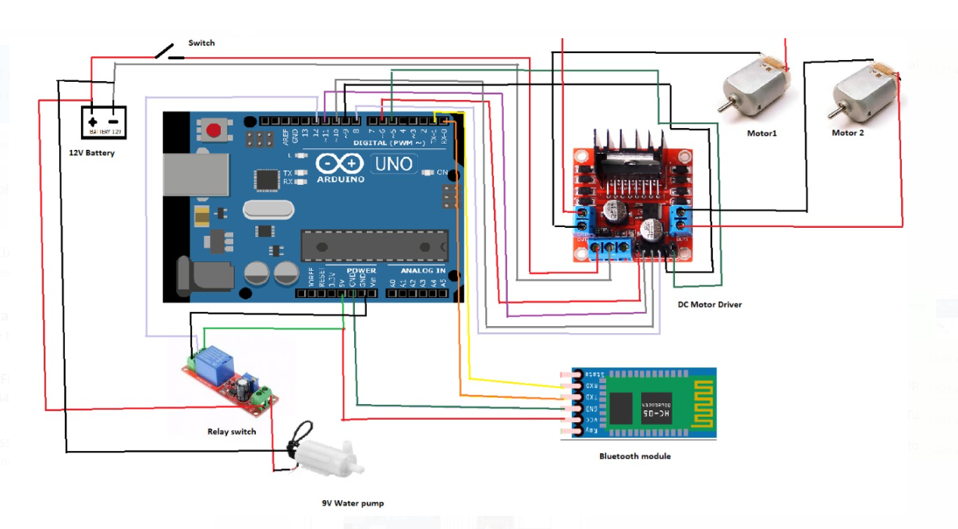

1. **Applications**

* The robots can protect the human workers from the harmful effects of handling the chemicals by the hand
* Another application is it has efficient seed sowing at optimal depth and at optimal distances between crops and their rows, specific for each crop type when they are programmed.
* Robot moves through the field with a water tank that sprays water all over the field which eliminates the usage of large pipe setup and makes the operation easy.
* The robot works based on command given by the controller. Various parameters along the robotic path makes the leveling process easy.
* It makes the crop cutting process faster, efficient and saves time which makes the farmers to think about improvement of the quality of the crop.

1. **Design & Implementation**

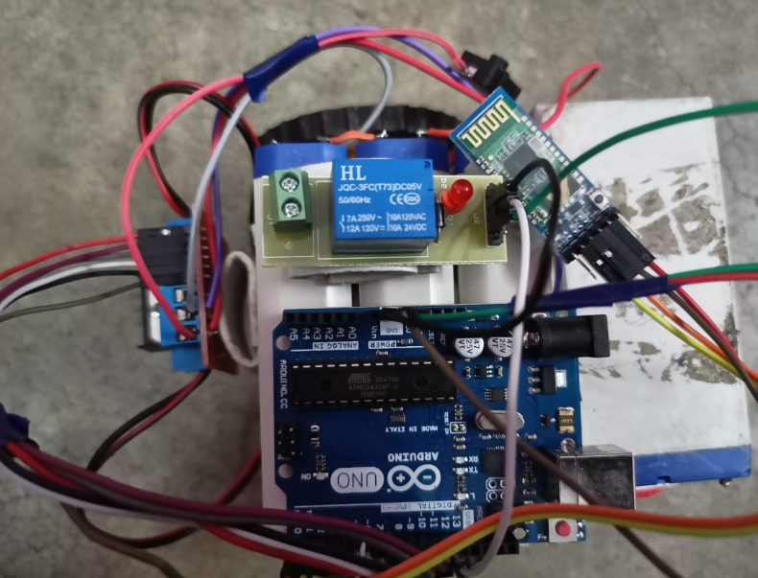

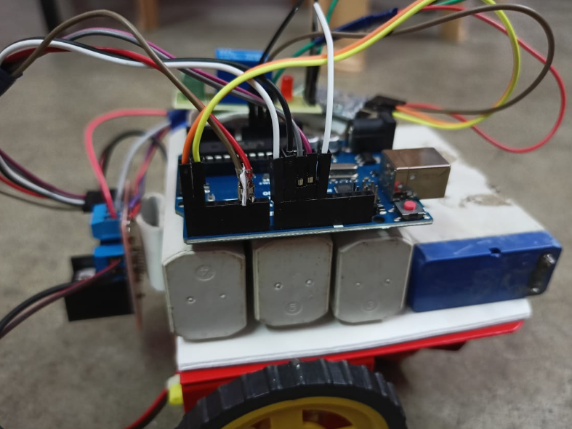

1. **Results**

Overall, throughout all the reviewed robots, the most-studied robot categories were the harvesting and weeding robots, while the least-studied were disease detection and seeding robots. From the studied robots, specific and universal conclusions can be pointed out in order to address the current key issues and potential future challenges. A general overview of an agricultural robot includes part or all of the following components: a navigation system; a vision system; a control system; communication components; the robotic arm with its components; and, of course, a computer, a safety system, a remote assistance/tele-robotics system (to assist the robot when in failure mode), an edge/cloud-AI adaptive learning system and a farmer-friendly brilliant simple interface system.

1. **Conclusion**

Agriculture has been a great source of national income. so, as to modernize the agriculture sector we can make use of machine called agriculture robot that automates the tasks for farmers by minimizing the industry's reliance on physical labor and increasing the efficiency of production. Our Multipurpose autonomous agricultural robot has successfully implemented and tested for various functions like soil levelling, seed sowing, cutting, pesticide and water spraying and digging. It is developed by integrating agricultural robot with Embedded C programming. Using relays for movement of the agricultural robot makes the system easy to move and handle. This also helps from the harmful effect of handling chemicals by the hand. Usage of conventional source of energy has been a prominent means of power supply. Thus, by the usage of the multipurpose robot in the agriculture field makes the productivity higher to the mark with less cost efficiency and also helps in modernizing agriculture sector with a remarkable result

1. **References**

[1] Punam K (Dec, 2019) Survey paper on Agro-bot autonomous robot. International Research Journal of Engineering and Technology (IRJET).

[2] Manu Mitra (March, 2019) Robotic Farmers in Agriculture, Lupine Publications. [3] Kavitha Zole (Feb, 2018) Agriculture Robot. International Research Journal of Engineering and Technology (IRJET).

[4] Ibrahim A (July, 2018) Research and development in agriculture robotics, International Journal of Agriculture and Biological Engineering (IJABE).

[5] Ms. Aditi D. Kokate. Multipurpose Agricultural Robot. International Advanced Research Journal in Science, Engineering and Technology (IARJSET). Vol.4 IOSR Journal of Engineering (IOSRJEN). ISSN (e): 2250-3021

[6] Multipurpose Agribot Shreyash Kulkarni. , ISSN (p): 2278- 8719, Vol.09,Issue 4(April. 2019),||S (III) || PP 32-37.

[7] B S Balaji, Smart Phone Operated Multipurpose Agricultural Robo. International Journal of Engineering Research & Technology (IJERT) ISSN: 2278-0181, Vol. 07.

[8] AhujaJayesh, Bhoite Aakash, Patil Mayur, Tinwala Ensiya, Kumar Sham, “An Innovative Model For Multipurpose Agricultural Use”, International Journal of Advance Engineering and Research Development Volume 4, Issue 3, March -2017. [9] K Durga Sowjanya, R Sindhu, M Parijatham, K Srikanth, P Bhargav, “Multipurpose Autonomous Agricultural Robot”, 978-1-5090-5686- 6/17 ©2017 IEEE, International Conference on Electronics, Communication and Aerospace Technology ICECA 2017.

[10]T. Ramakrishnan & P. S. Sampath (2017). Dry Sliding Wear Characteristics of New Short Agave Angustifolia Marginata (AAM) Fiber-Reinforced Polymer Matrix Composite Material. Journal of Biobased Materials and Bioenergy, 11(5), 391-399. [11] R. Jeyakumar, P.S. Sampath, R. Ramamoorthi &T. Ramakrishnan (2017). Structural, morphological and mechanical behavior of glass fiber reinforced epoxy nanoclay composites. The International Journal of Advanced Manufacturing Technology, 93(1-4), 527-535. [

[12] T. Ramakrishnan & P. S. Sampath, (2017). Experimental investigation of mechanical properties of untreated new Agave Angustifolia Marginatafiber-reinforced epoxy polymer matrix composite material. Journal of Advances in Chemistry, 13(4), 6120-6126.

[13] R. Ramamoorthi, R. Jeyakumar & T. Ramakrishnan (2017). Effect of Nanoparticles on the Improvement of Mechanical Properties of Epoxy Based Fiber – Reinforced Composites - A Review. International Journal for Science and Advance Research in Technology, 3(11), 1251-1256.

[14] T. Ramakrishnan, P. S. Sampath &R. Ramamoorthi (2016). Investigation of Mechanical Properties and Morphological Study of the Alkali Treated Agave Angustifolia MarginataFiber Reinforced Epoxy Polymer Composites. Asian Journal of Research in Social Sciences and Humanities, 6(9), 461-472.