*do the following in view : -  
1) update 2) alter 3) delete*

select * from sales_product_data

1) *update*

update sales_product_data set sumofsales = 100 where product_id = 'OFF-FA-10000304'

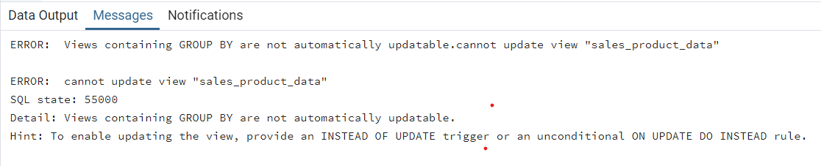

*2)alter*

alter table sales_product_data add column sales2 int default 0 not null

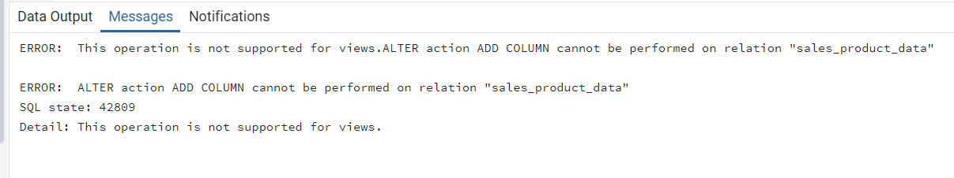

alter table sales_product_data drop column sumofsales

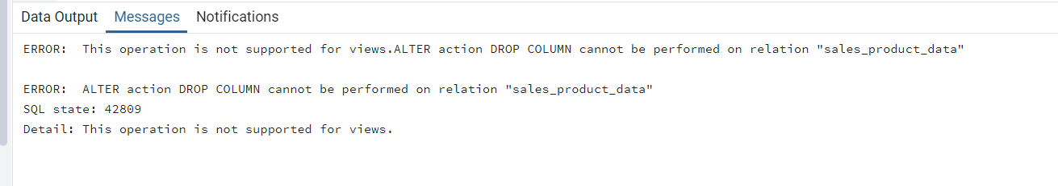

3) delete

delete from sales_product_data where product_id = 'OFF-FA-10000304'

