**1.Import the dataset and do usual exploratory analysis steps like checking the structure & characteristics of the dataset:**

a. Data type of all columns in the "customers" table.

customer_id=String-VARCHAR

customer_unique_id=String-VARCHAR

customer_zip_code_prefix=Integer

Customer_city= String -CHAR(3)

customer_state= String -CHAR (2)

**Insight/Recommendation** : Datatype String with VARCHAR,CHAR is used along with Integer

b. Get the time range between which the orders were placed.

SELECT

concat(x.start_date," ",x.start_time) as First_order,

concat(x.End_date," ",x.end_time) as last_order,

from (

select

min(extract(date from  order_purchase_timestamp)) as start_date,

max(extract(date from  order_purchase_timestamp)) as End_date,

min (extract(time from order_purchase_timestamp)) as start_time,

max (extract(time from order_purchase_timestamp)) as end_time

from `TargetBC.orders`) x

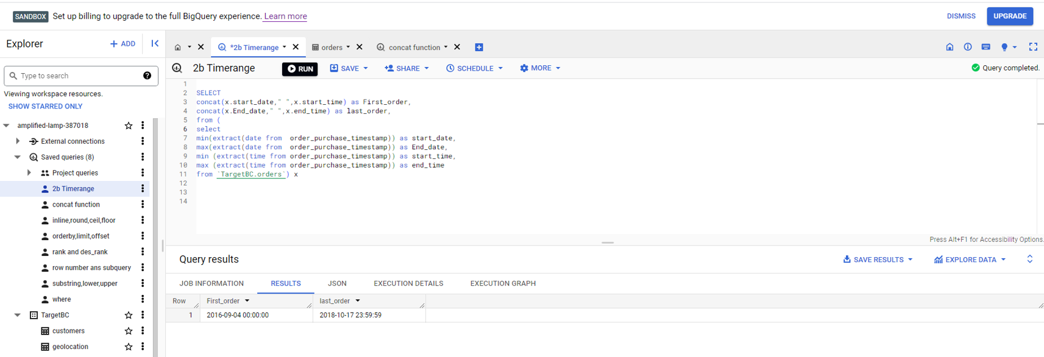

Or

select

min(order_purchase_timestamp) as start_date,

max(order_purchase_timestamp) as End_date

from `TargetBC.orders`;

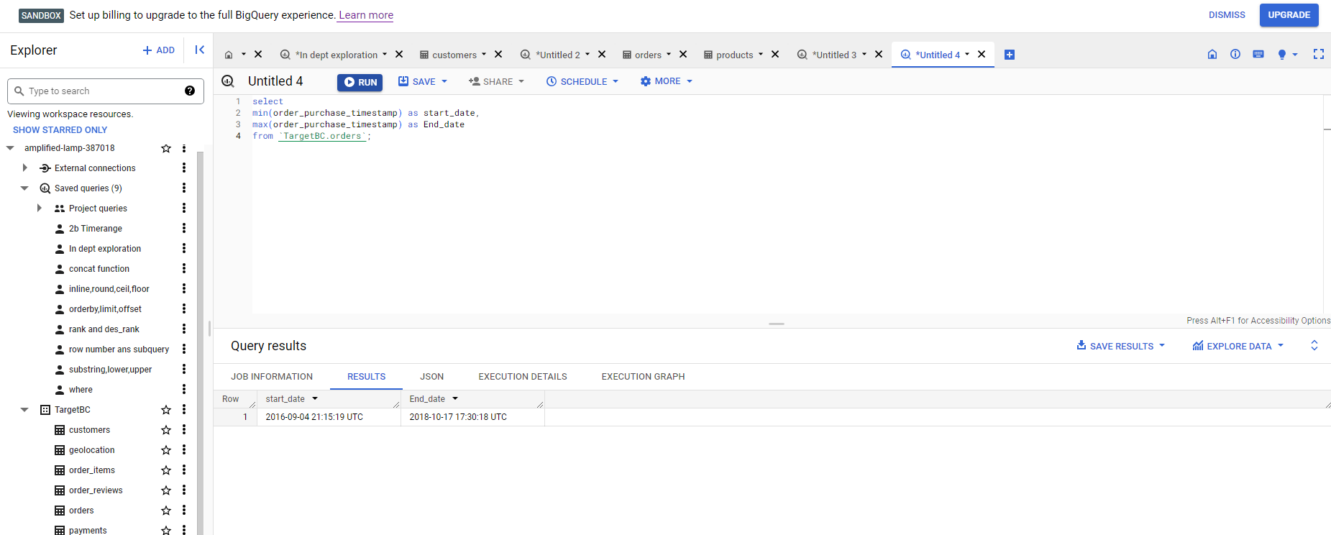

**Insight : Time range for give dataset found to be in between Sept-2016 to Oct-2018**

c. Count the number of Cities and States in our dataset.

SELECT

count(distinct geolocation_city) as Number_of_city,

count(distinct geolocation_state) as Number_of_state

FROM `TargetBC.geolocation`;

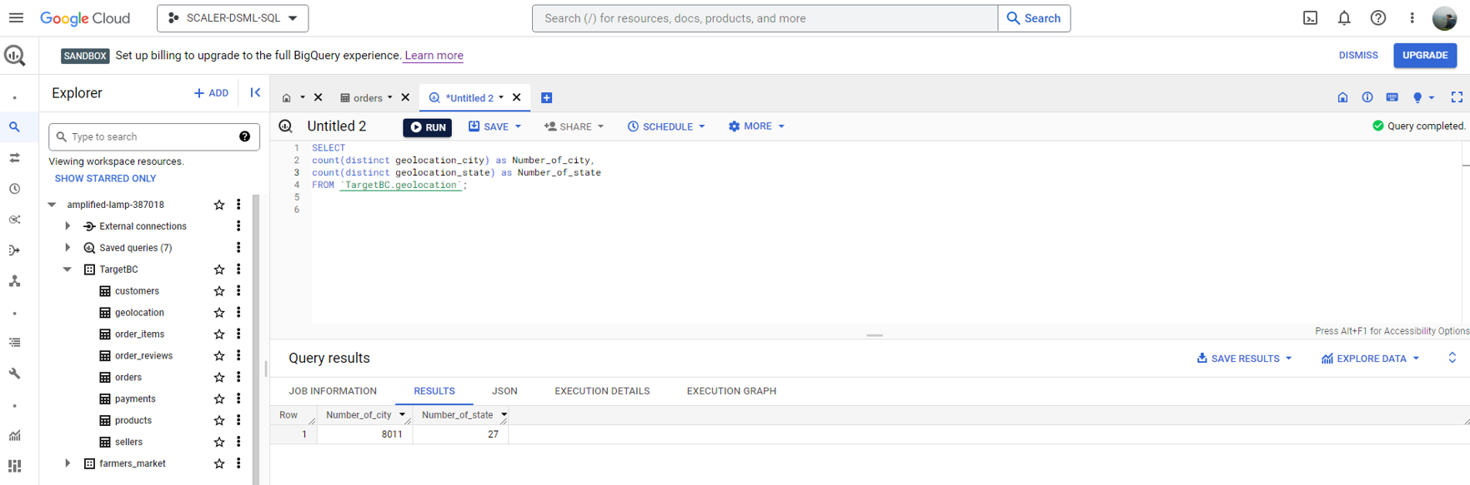

**Insight/Recommendation: Target has spectrum of order from across all state 27 states and 8011 cities covering all region within brazil.**

**2. In-depth Exploration:**

a. Is there a growing trend in the no. of orders placed over the past years?

For Year :

Select count (distinct order_id) as Count_item,

extract(year from shipping_limit_date) as Year_Y,

from`TargetBC.order_items`

 group by 2

 order by 2;

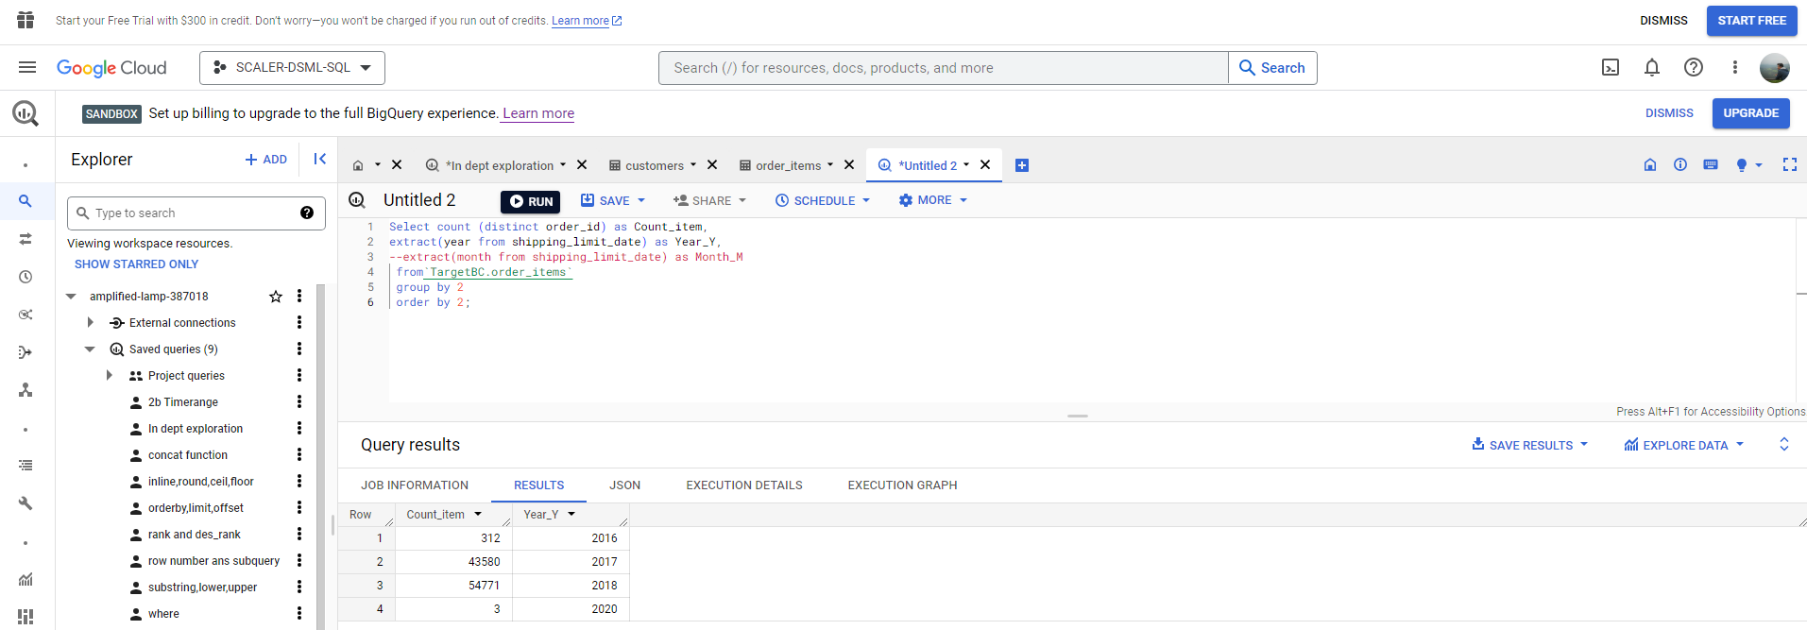

**Insight/Recommendation : In past year 2017,2018 was significant growth but in recent year 2019 onwards it has sharp downfall in number of orders.**

b. Can we see some kind of monthly seasonality in terms of the no. of orders being placed?

Select count (distinct order_id) as Count_item,

extract(year from shipping_limit_date) as Year_Y,

extract(month from shipping_limit_date) as Month_M

 from`TargetBC.order_items`

 group by 2,3

 order by 2,3;

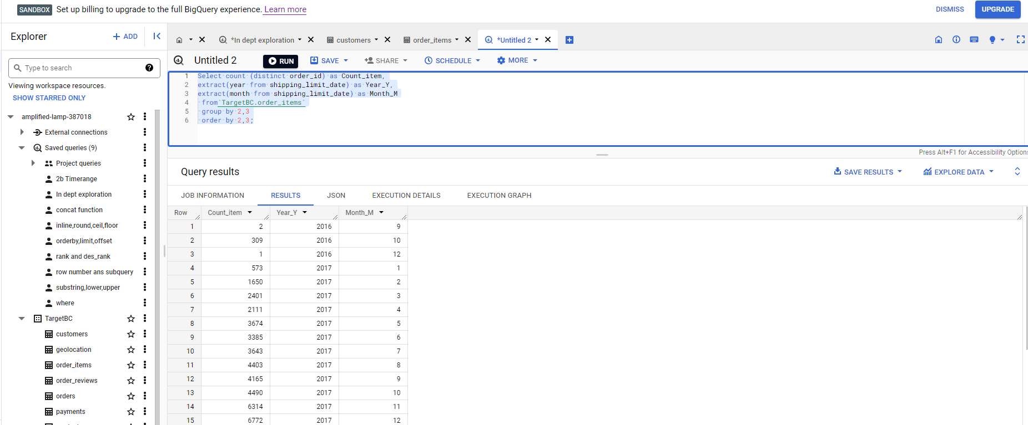

And

select max (Count_item)as Max_order,x.Month_M,

from (

Select count (distinct order_id) as Count_item,

extract(year from shipping_limit_date) as Year_Y,

extract(month from shipping_limit_date) as Month_M,

 from`TargetBC.order_items`

 group by 2,3

 order by 2,3) x

 group by 2;

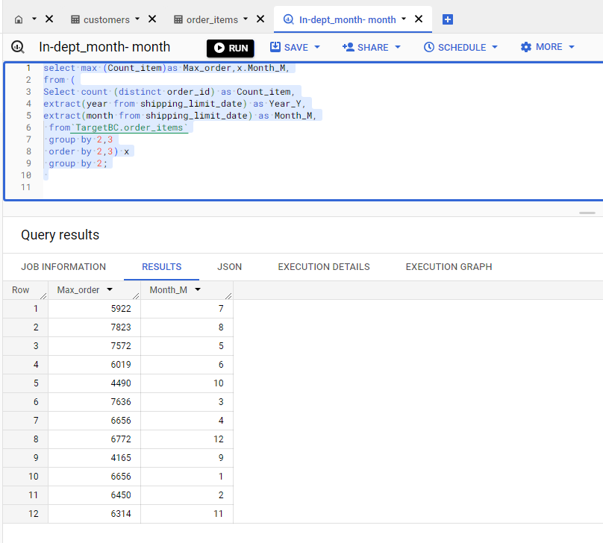

**Insight/Recommendation : Max order trend is shown in month summer start from Dec to March,and then in winter session June to Aug.**

c. During what time of the day, do the Brazilian customers mostly place their orders? (Dawn, Morning, Afternoon or Night)

0-6 hrs : Dawn

7-12 hrs : Mornings

13-18 hrs : Afternoon

19-23 hrs : Night

Select order_purchase_timestamp,

extract(hour from order_purchase_timestamp) Time_hour,

case

when extract(hour from order_purchase_timestamp) between 0 and 6 then "Dawn"

when extract(hour from order_purchase_timestamp) between 7 and 12 then"Morning"

when extract(hour from order_purchase_timestamp) between 13 and 18 then"Afternoon"

else "Night"

end as time_of_the_day,

from `TargetBC.orders`;

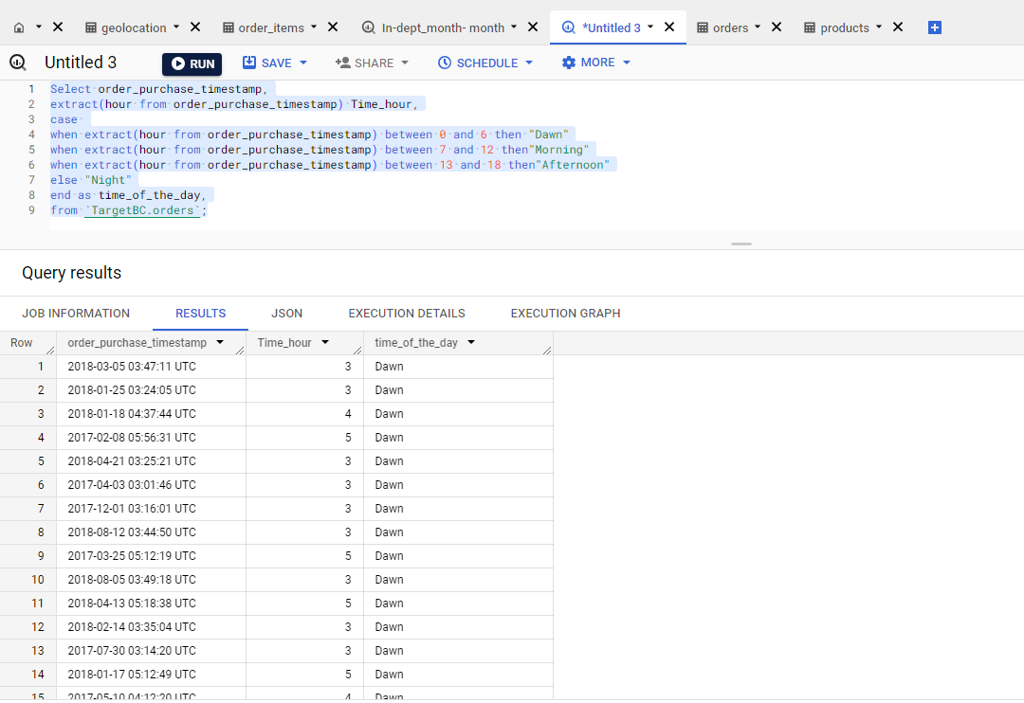

**Insight/Recommendation :** Brazilian customers mostly place their orders in Night.

3. Evolution of E-commerce orders in the Brazil region:

a. Get the month on month no. of orders placed in each state.

select

c.customer_state,

extract(month from o.order_purchase_timestamp) as Month_M,

count(distinct order_id) count_row,

from `TargetBC.orders` as o

join `TargetBC.customers` as c

on o.customer_id=c.customer_id

group by 1,2

order by 1,2;

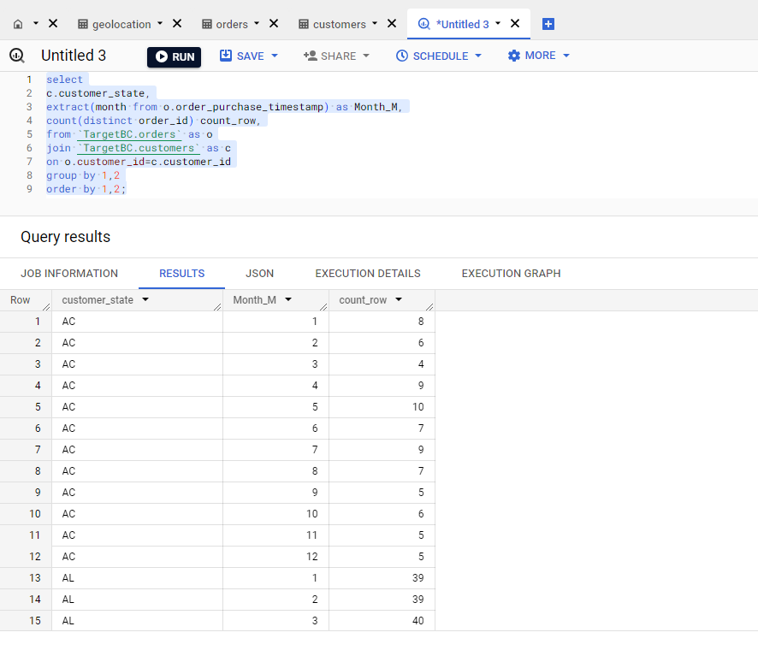

**Insight/Recommendation :** Brazilline state Bahia (BA) got highest number of Month-on Month order compared to all state.

b. How are the customers distributed across all the states?

select customer_state,

count (distinct customer_unique_id) as customers_distributed_state,

from `TargetBC.customers`

group by 1;

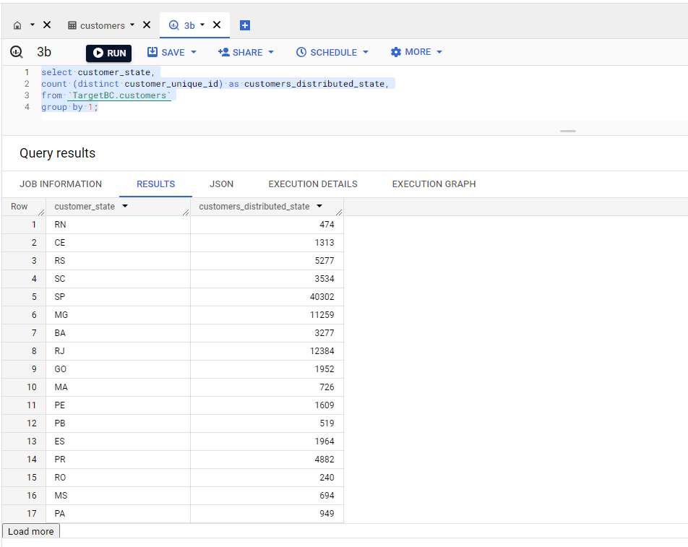

**Insight/Recommendation :** Customer distribution is more in North-east,south,South-east region state.

**4. Impact on Economy: Analyze the money movement by e-commerce by looking at order prices, freight and others.**

a. Get the % increase in the cost of orders from year 2017 to 2018 (include months between Jan to Aug only).

You can use the "payment_value" column in the payments table to get the cost of orders.

select x.Sum_payment,

lag (x.Sum_payment,1) over (partition by x.Year_y order by x.Month_m) as prev_month,

x.Year_y,x.Month_m,

round((((x.Sum_payment- lag (x.Sum_payment,1) over (partition by x.Year_y order by x.Month_m))/lag (x.Sum_payment,1) over (partition by x.Year_y order by x.Month_m))*100),2) as Increase_year,

from (

Select

sum(payment_value) as Sum_payment,

extract(year from shipping_limit_date) as Year_y,

extract(month from shipping_limit_date) as Month_m,

from `TargetBC.payments` as P

join `TargetBC.order_items` O

on p.order_id=O.order_id

where extract(year from shipping_limit_date) between 2017 and 2018 and

extract(month from shipping_limit_date)between 1 and 8

group by Year_y,Month_m

order by Year_y,Month_m) x

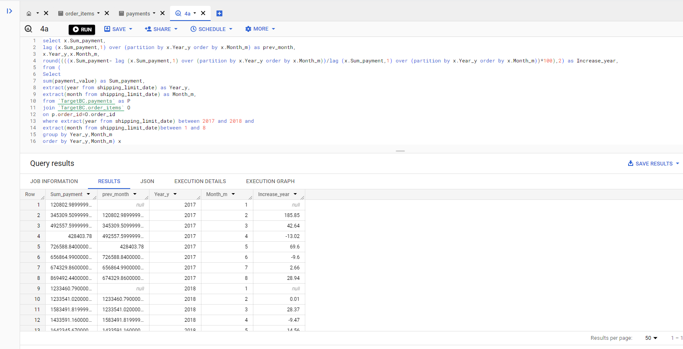

**Insight/Recommendation :**Growth inSales are not consistent (Jan to Aug) for period of 2017 and 2018

b. Calculate the Total & Average value of order price for each state.

select C.customer_state,p.payment_value,

Sum(P.payment_value) over (partition by C.customer_state) as Total_order_price,

round(avg(P.payment_value) over (partition by C.customer_state),2) as Avg_value,

from `TargetBC.payments` as P

join `TargetBC.orders` as O

on P.order_id=O.order_id

join `TargetBC.customers` as C

on O.customer_id=C.customer_id

group by 1,2

order by 1,2;

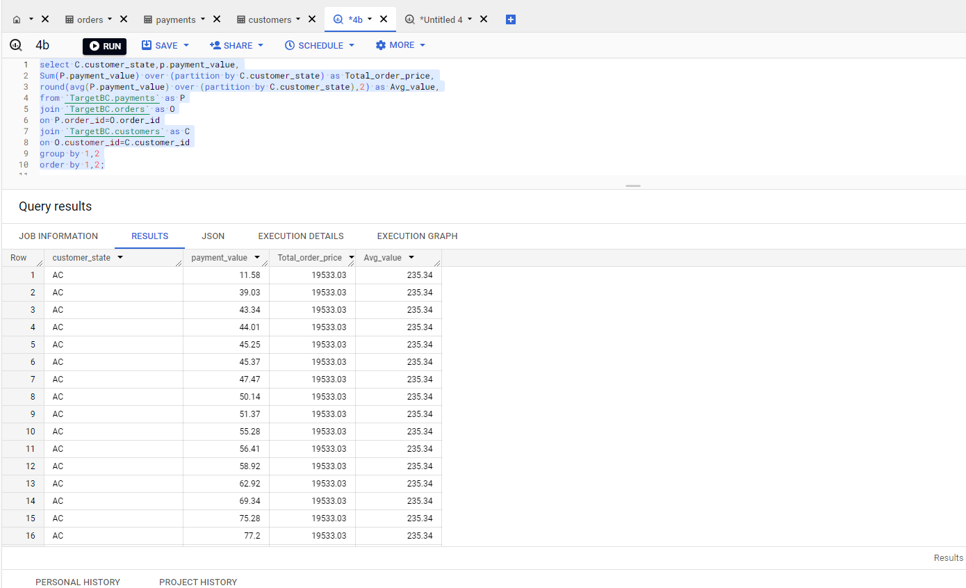

**Insight/Recommendation :**  Average ticket size across all state is more than 200 but need to work to increase Average ticket size.

c. Calculate the Total & Average value of order freight for each state.

select C.customer_state,OI.freight_value,

sum(OI.freight_value) over (partition by C.customer_state) as Total_freight,

avg(OI.freight_value) over (partition by C.customer_state) as Avg_freight,

from `TargetBC.order_items` as OI

join `TargetBC.orders` as O

on OI.order_id=O.order_id

join `TargetBC.customers` as C

on O.customer_id=C.customer_id

group by 1,2

order by 1,2;

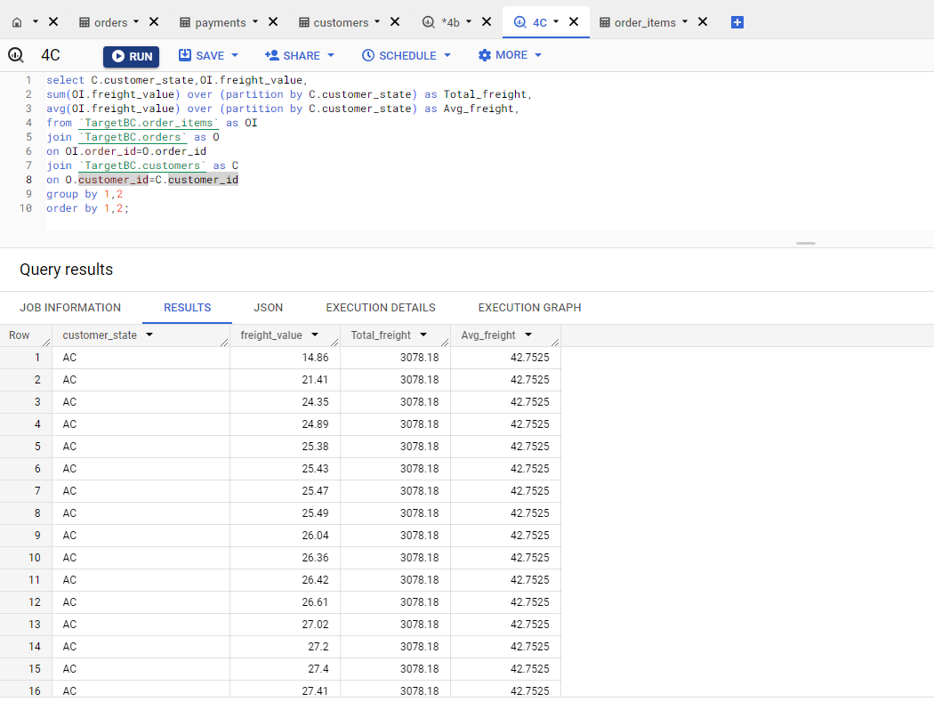

**Insight/Recommendation :** Total and Average freight in North state is quite high~ 40 compared to south region state ~29, Need to setup sub-warehouse to lower down freight costing.

**5. Analysis based on sales, freight and delivery time**.

a. Find the no. of days taken to deliver each order from the order’s purchase date as delivery time.

Also, calculate the difference (in days) between the estimated & actual delivery date of an order.

Do this in a single query.

You can calculate the delivery time and the difference between the estimated & actual delivery date using the given formula:

time_to_deliver = order_delivered_customer_date - order_purchase_timestamp

diff_estimated_delivery = order_estimated_delivery_date - order_delivered_customer_date

Select order_purchase_timestamp,order_approved_at,order_delivered_carrier_date,order_delivered_customer_date,order_estimated_delivery_date,

timestamp_diff(order_delivered_customer_date

,order_purchase_timestamp,day) as time_to_deliver,

timestamp_diff(order_estimated_delivery_date,order_delivered_customer_date,day) as diff_estimated_delivery,

from `TargetBC.orders`;

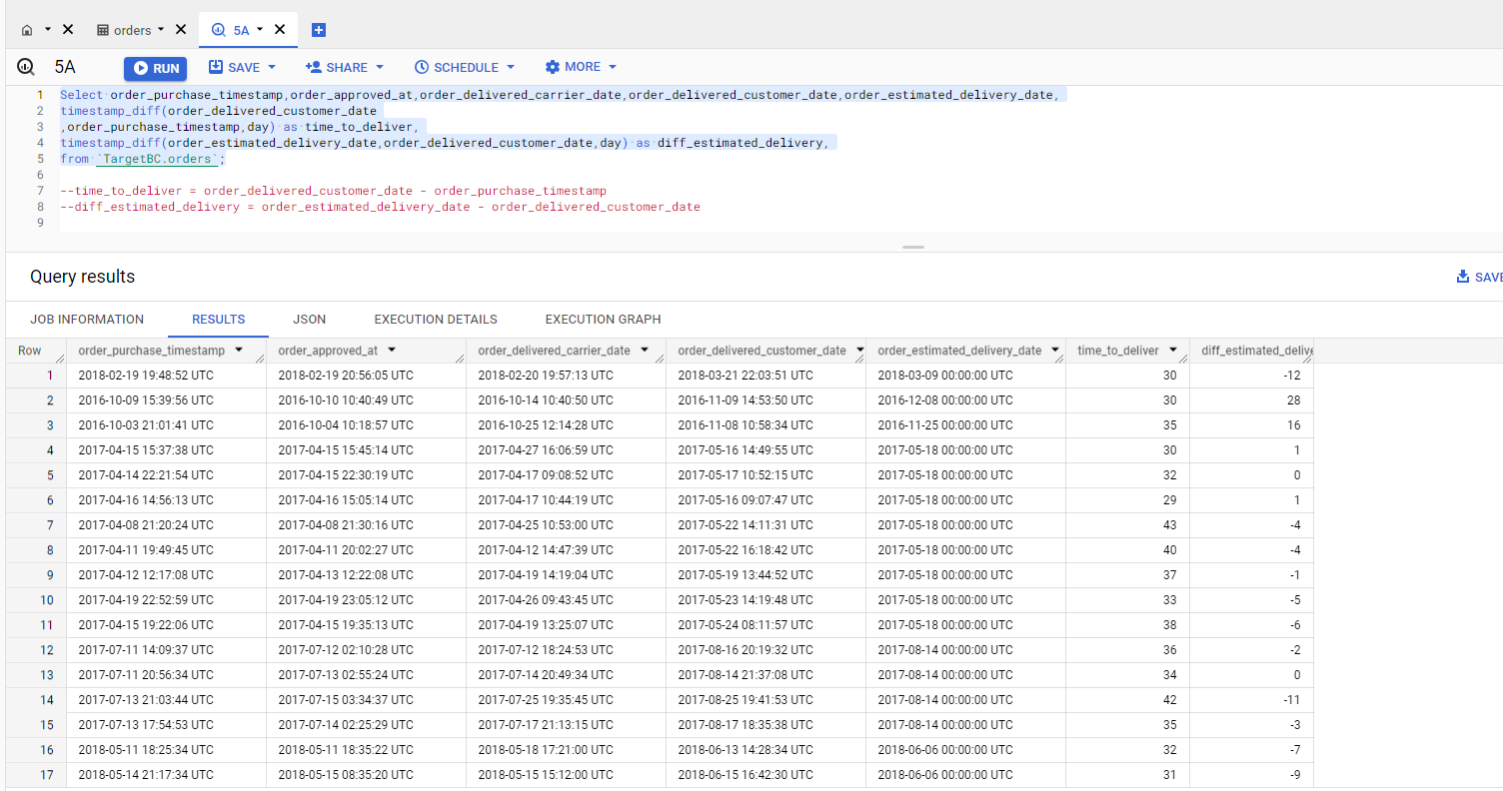

**Insight/Recommendation :**  Time taken to deliver order is almost near to 30 day and every 2nd order is missing estimated delivery date.

b. Find out the top 5 states with the highest & lowest average freight value.

Top 5 Highest states :

select C.customer_state,

round (avg(OI.freight_value),2) as average_freight_value_asc,

from `TargetBC.order_items` as OI

join `TargetBC.orders` as O

on OI.order_id=O.order_id

join `TargetBC.customers` as C

on O.customer_id=C.customer_id

group by 1

order by 1

limit 5;

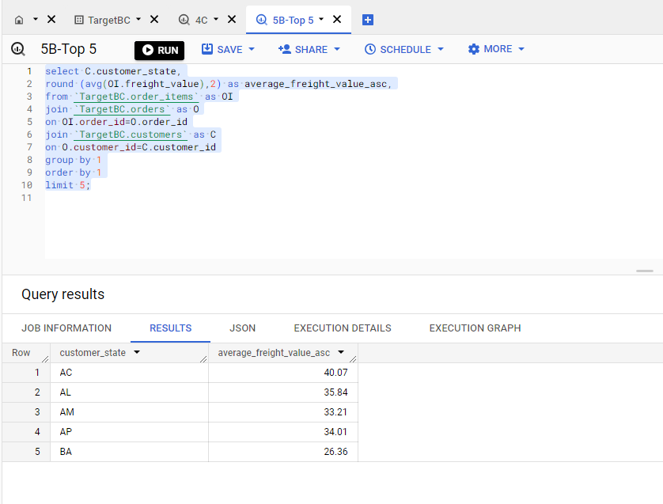

**Insight/Recommendation :** All these 5 state are for North region of brazil where average freight is higher compared to south,south-east region.

Top 5 Lowest states :

select C.customer_state,

round (avg(OI.freight_value),2) as average_freight_value_desc,

from `TargetBC.order_items` as OI

join `TargetBC.orders` as O

on OI.order_id=O.order_id

join `TargetBC.customers` as C

on O.customer_id=C.customer_id

group by 1

order by 1 desc

limit 5;

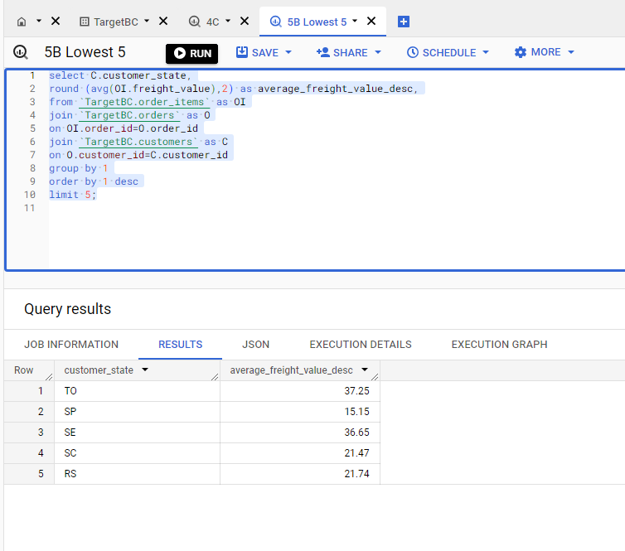

**Insight/Recommendation :** State from South,South-east region has lowest Avg_freight_value

c. Find out the top 5 states with the highest & lowest average delivery time.

Top 5 state Highest average delivery time :

Select C.customer_state,

round (AVG (timestamp_diff(order_delivered_customer_date

,order_purchase_timestamp,day)),2) as Avg_time_to_deliver

from `TargetBC.customers` C

JOIN `TargetBC.orders` O

on C.customer_id=O.customer_id

GROUP BY 1

ORDER BY Avg_time_to_deliver desc

limit 5;

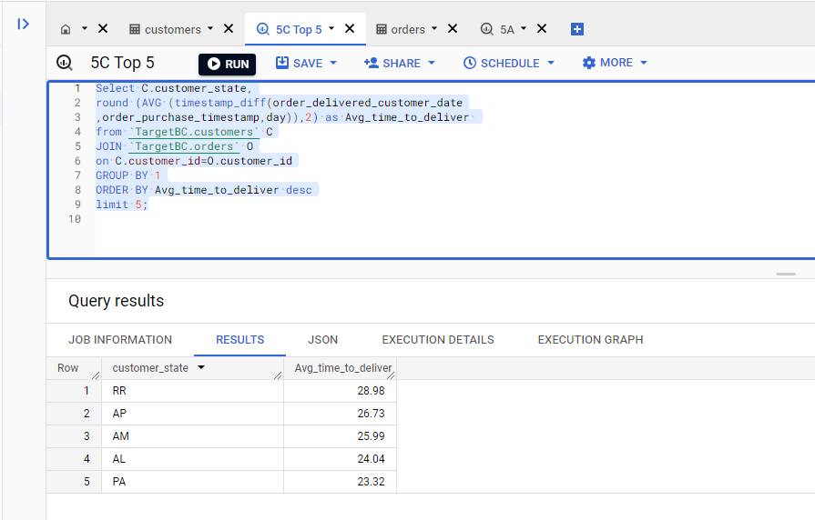

**Insight/Recommendation :** Delivery time for North state is quite high compared to south,southest state.

Top 5 state lowest average delivery time:

Select C.customer_state,

round (AVG (timestamp_diff(order_delivered_customer_date

,order_purchase_timestamp,day)),2) as Avg_time_to_deliver

from `TargetBC.customers` C

JOIN `TargetBC.orders` O

on C.customer_id=O.customer_id

GROUP BY 1

ORDER BY Avg_time_to_deliver

limit 5;

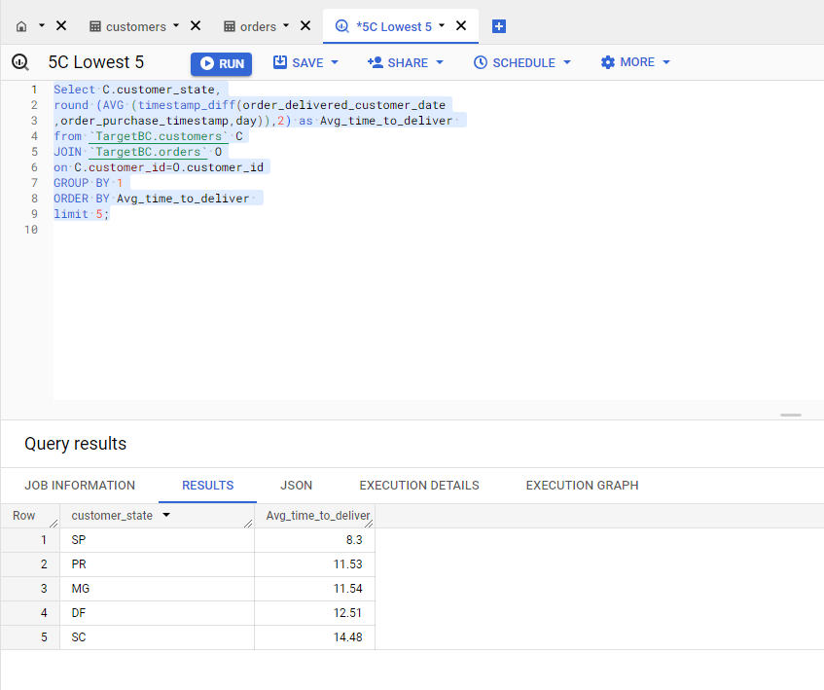

**Insight/Recommendation :** Delivery time for to south,southest state are good compared to north state.

d. Find out the top 5 states where the order delivery is really fast as compared to the estimated date of delivery.

You can use the difference between the averages of actual & estimated delivery date to figure out how

Select C.customer_state,

round (avg(timestamp_diff(O.order_delivered_customer_date

,O.order_estimated_delivery_date

,day)),2) as delivery_difference_day

from `TargetBC.customers` C

JOIN `TargetBC.orders` O

on C.customer_id=O.customer_id

group by 1

order by delivery_difference_day desc

limit 5;

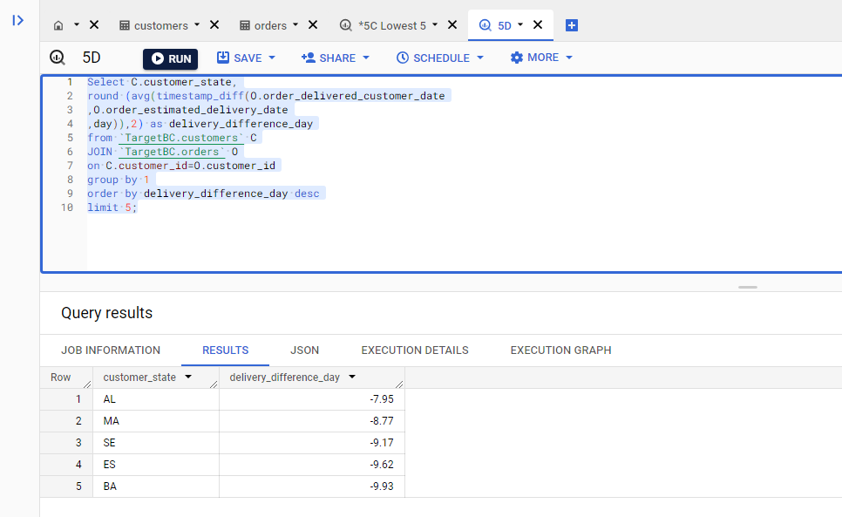

6. **Analysis based on the payments:**

a. Find the month on month no. of orders placed using different payment types.

Select C.customer_state,P.payment_type,O.order_purchase_timestamp,

extract (month from O.order_purchase_timestamp) as Month_,

extract (year from O.order_purchase_timestamp) as year_,

count(P.payment_type) over (partition by P.payment_type order by C.customer_state) as Number_payment_type

from `TargetBC.payments` as P

join `TargetBC.orders` as O

on P.order_id=O.order_id

join `TargetBC.customers` as C

on O.customer_id=C.customer_id

group by 1,2,3

order by Month_,year_;

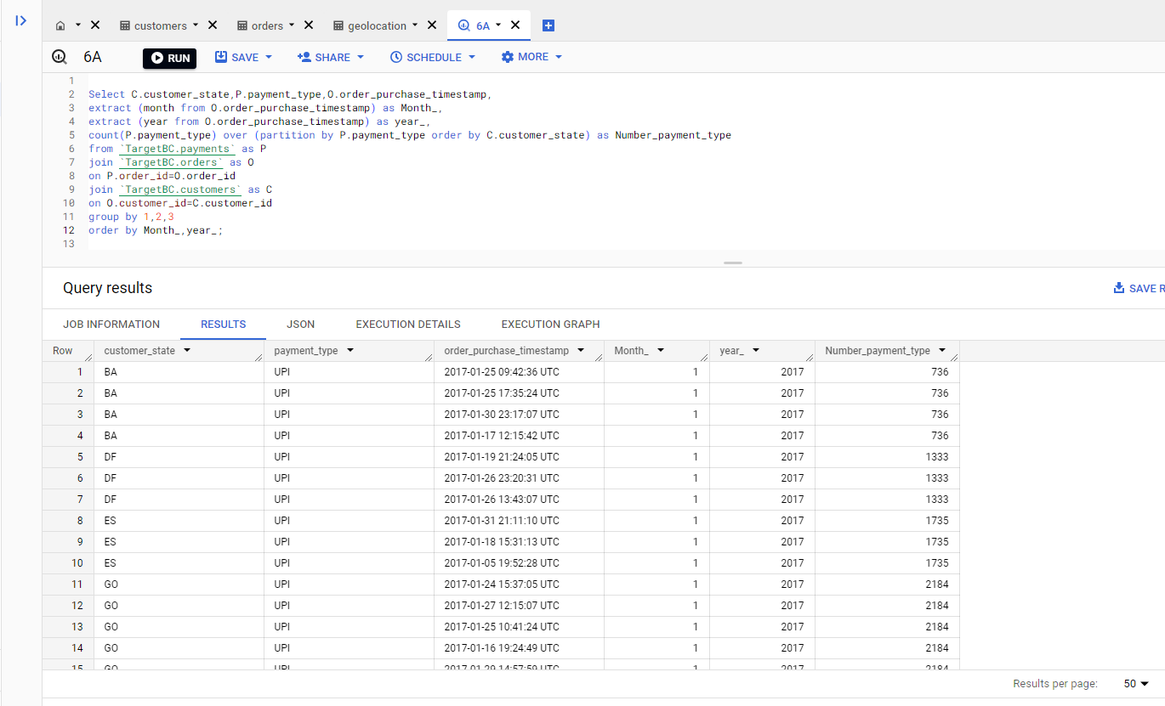

**Insight/Recommendation :** Customer mostly user credit card payment mode compared to debit,UPI this trend is shown across all state.

b. Find the no. of orders placed on the basis of the payment installments that have been paid.

Select payment_type,payment_installments,

count(payment_installments) as No_of_order

from `TargetBC.payments`

where payment_installments> 0

group by 1,2;

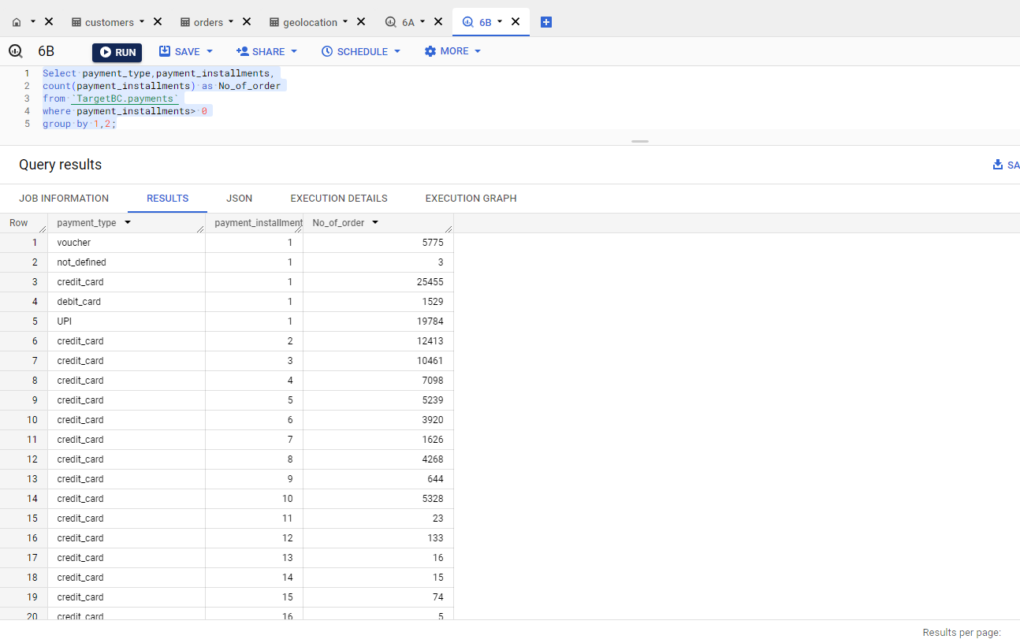

**Insight/Recommendation :** Customer mostly take short period installment form credit cards.