**PRODUCT REVIEWER**

**Instructor:** Dr. Jinsong Ouyang

**CSC 258**

**Distributed Systems**

**Spring 2017**



**Submitted by:**

**Krishna Chaitanya Kaja**

**ABSTRACT:**

Product Reviewer is an android application that is used to search for products with certified reviews over E-Commerce vendors such as Wallmart and Amazon by taking the user input in three different modes such as Text Search, Barcode Scanner and Intelligent Voice Assistant and articulating the data to the users with a sorted top rated user reviews.

**SYSTEM CONFIGURATIONS:**

Android API Level : 25.0.0

MIN SDK Version : 15.0

Gradle Build : 2.3.1

Cloud Services : Wallmart API

Amazon API

API Connections : VOLLEY Libraries

**INTRODUCTION:**

Product Reviewer is the ultimate product guide with over 3 million products reviewed from various E-Commerce vendors such as Amazon, Walmart, and so on. Product Reviewer discover the best products with all the certified user reviews including positive and negative reviews. You can start by searching by a built-in "intelligent assistant" that enables users to search over voice commands on one or more products in a store or by searching for any product using our powerful search engine, product reviewer also provides users a facilities to scan for products . You can also just browse in dozens of categories covering just about anything you can think of buying. Product reviewer show you the best online helpful user reviews and product features along with their detail description.

**FEATURES:**

* 1. Categorizing and sorting reviews according to a specific sorted pattern.
  2. Browsing for reviews for the products according to the keywords given.
  3. Providing a facility for users to search for products using Intelligent voice assistant.
  4. Providing in-detail positive and negative reviews for most of the products.
  5. Providing Questions and Answers asked about the products.
  6. Allowing users to save the products on to their favorites and help them explore or purchase those products in the future.
  7. Providing a facility for users to purchase the browsed products by redirecting the products onto to specific vendors purchase portal to purchase products.

**SCREENSHOTS:**

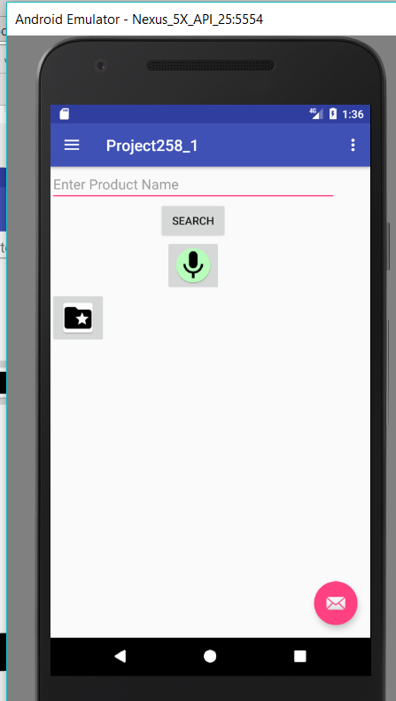

**Fig1: Home Page**

This page has 4 items in all, 3 buttons and one editable text field,

Steps to Search for Products:

1. User can write the product name and click on search button.
2. He will be redirected to an activity where he will list of different products Fig 2.
3. The Voice button will start up a google voice assistant which will predict the spoken product name and use it to fill the text field
4. The last button is to display important saved products to user

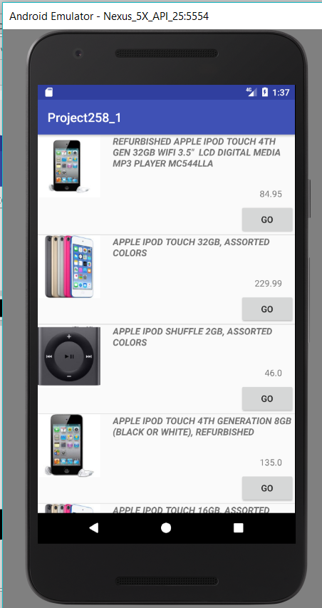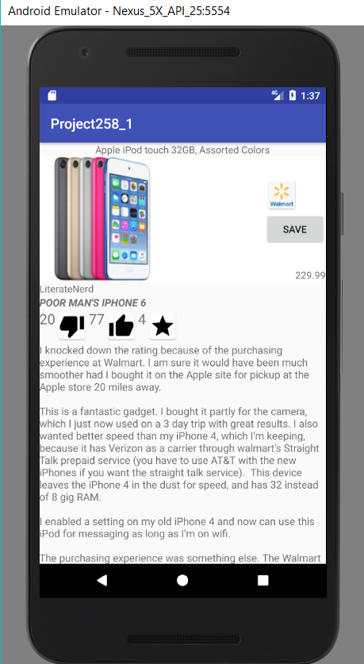

**Fig2: List of various products after successful Fig 3: Details of a certain product**

**search**

In fig 2 after a successful search of a product say iPod, The list of iPod’s available on the vendor’s website is fetched, here Wallmart.

In fig 3, The product is described in details with its detailed reviews along with lager image of the product, the price, the name of the product.

The reviews are composed of the product reviewer name, the title of the review, Number of likes on each review, number of dislikes on each review, number of stars for that review and the actual review content

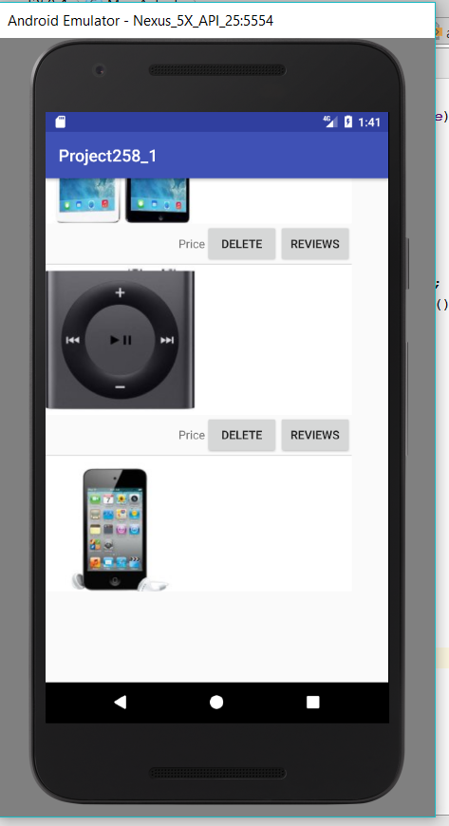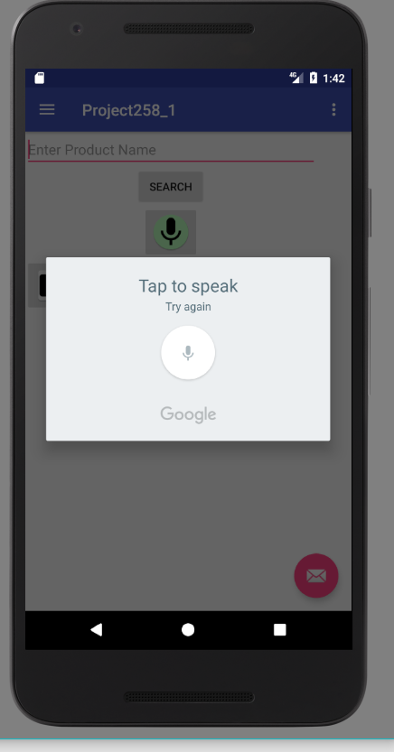

**Fig4: List of saved products Fig5: Voice assistant**

In Fig4 the list of products is shows after the products are saved

It has two buttons

1. To delete the product from the list
2. To open its product information page

In Fig5 after you click on the mic button on the First page of the product, a google’s mic will appear and will be waiting for the user voice to enter. After user speaks product name, the name will appear in the exit text field.

**CHALLENGES:**

The Biggest Challenges we have faced were connecting the API’s to a single page call and articulating the data according to the users precise searching.

Using the Obtained UPC data from the barcode scanner and searching for those products over the E-commerce vendors was a time constraint challenge.

There were instances where in when we tried to pull data from API’s (Wallmart, Amazon) we were able to get the data onto the product page but sorting the products according to the User Certified reviews were not possible due to the product being new onto the E-commerce vendors appropriate reviews and certified reviews were not possible to pull.

Couple of other difficulties are below:

1. We tried to fetch amazon reviews in our application, but amazon stopped providing reviews to public. The just provide a iframe which is just a browser frame in which you can see reviews but you can not fetch or manipulate data in the frame.
2. Similar thing happened with ebay reviews, the stopped their API access to users in jan 2017, they had various functions available on their reviews like search between reviews, sort them by some functions, but ebay stopped its functionality to pubic users.

**CONCLUSION:**

The main functionality of the application is working, i.e., displaying the most valuable review to the user.

**FUTURE EXTENSIONS:**

We could get the barcode running to get the UPC code with their details but establishing a connection to search for products are articulating the products onto the product page will be implemented in the later versions.

1. Connecting this application to other ecommerce websites where reviews are available publicly.
2. Make a user friendly user interface.
3. Add location search for the products.