Computational Tools for Engineers -21CTE408 SJEC-AICTE IDEA Lab

# Static Structural Analysis Of A Bridge

## Alriya D’Souza, Darren Pereira, Chaitanya, Ashal D’Souza

*1Department, University/Institute/Company, City, State, Country Example@ijsrset.com1

2Department, University/Institute/Company, City, State, Country

Example@ijsrset.com2

## ABSTRACT

Pedestrian bridges represent critical components of urban infrastructure, facilitating safe and efficient movement for pedestrians while alleviating traffic congestion. This abstract provides an overview of a rigorous static structural analysis performed on a pedestrian bridge, with a primary focus on evaluating its stability and strength under various static loading conditions. The investigation employs state-of-the-art engineering methodologies, including finite element analysis (FEA), structural modelling, and material characterization, to comprehensively assess the structural performance of the bridge.

**Keywords:** Finite Element Analysis (FEA), Static structural analysis, Urban infrastructure.

## I. INTRODUCTION

Pedestrian bridges play a pivotal role in urban infrastructure, alleviating traffic congestion and fostering safe and sustainable urban environments. These elevated walkways facilitate pedestrian movement over roads, railways, and other obstacles, contributing to reduced pollution and improved mobility. To ensure their long-term safety and usability, a thorough static structural analysis is essential.

Static structural analysis assesses a pedestrian bridge's stability and strength under various static loads, including pedestrian traffic, dead loads, and environmental forces such as wind and temperature effects. This evaluation relies on advanced engineering techniques, including finite element analysis (FEA), structural modelling, and material characterization.

FEA enables engineers to simulate real-world conditions and predict potential stress concentrations, identifying areas prone to deformation or failure. Consequently, this analysis optimizes bridge design, construction, and maintenance, aligning with urban planning goals to create safer and more resilient pedestrian environments.

In the following discussion, we will delve into the components and methodologies involved in static structural analysis, emphasizing its crucial role in enhancing the performance and longevity of pedestrian bridges in urban landscapes.

## II. LITERATURE REVIEW

1. Progressive bridge collapse analysis under floods by coupling simulation in structural and hydraulic fields.
2. Transient Structural health monitoring of The Test Bridges Using Finite Element Method.
3. Structural Analysis And Fatigue Reliability Assessment Of The Paderno Bridge.
4. Flutter Analysis Of Long-Span Bridges Using ANSYS.

## III. Methodology

**Geometry Preparation:**

* Launch ANSYS and access Design Modeler.
* Create a rectangle on the XY plane representing the bridge section.
* Define dimensions of the bridge section.
* Extrude the rectangle to create the 3D bridge model.

**Mesh Generation:**

* Enter the Modelling environment.
* Generate a mesh for the bridge model using the generated geometry.
* Set an element size for the mesh (e.g., 0.01 units).
* Update and refine the mesh as needed for accuracy.

**Boundary Conditions:**

* Navigate to the Static Structural analysis.
* Apply fixed supports to appropriate locations of the bridge model and apply external forces.

**Solution and Analysis:**

* Insert a deformation plot to observe the total deformation of the bridge under the applied loads.
* Begin the solution process to compute the deformation and stress distribution.

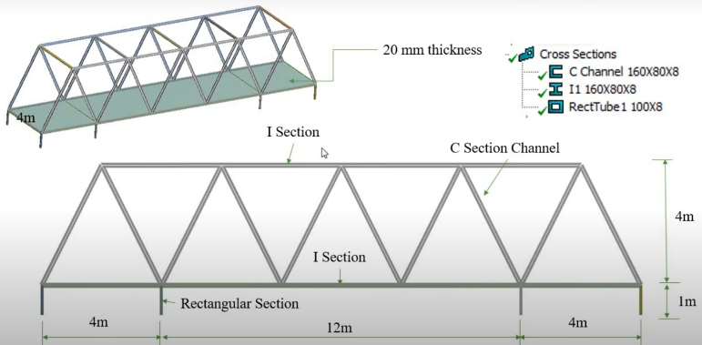

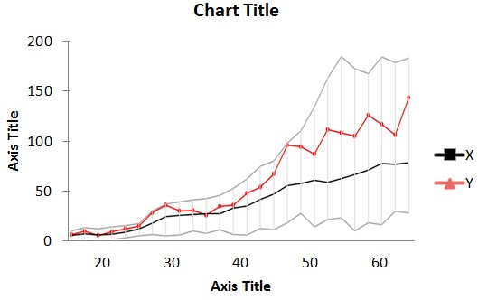

Figure 1: A sample line graph using colours which contrast well both on screen and on a black-and-white hardcopy

## IV. RESULT AND DISCUSSION

The results and inferences drawn from a static structural analysis of a pedestrian bridge are paramount for ensuring the bridge's safety, durability, and performance. Through rigorous analysis, engineers uncover valuable insights into the behaviour of the structure under various loads and environmental conditions. These results include stress and strain distribution, deflection, displacement, safety factors, and load redistribution throughout the bridge. Engineers scrutinize these outcomes to make critical inferences regarding the bridge's structural integrity, safety assurance, load-bearing capacity, and compliance with engineering standards. Furthermore, resonance and vibrations induced by pedestrian traffic or environmental factors are assessed to guarantee user comfort and safety. Based on these inferences, engineers can recommend structural modifications, design optimizations, and maintenance strategies.

## V.CONCLUSION

In conclusion, the static structural analysis of pedestrian bridges is an indispensable step in ensuring the safety and reliability of these essential urban infrastructure components. Through meticulous examination of stress distribution, deflections, safety factors, and load-bearing capacity, this analysis empowers engineers to make informed decisions regarding design improvements, structural optimizations, and necessary maintenance strategies. The inferences drawn from such analyses not only contribute to the longevity and resilience of pedestrian bridges but also play a vital role in enhancing urban connectivity, mitigating traffic congestion, and fostering sustainable urban environments. As cities continue to grow and evolve, the knowledge gained from static structural analyses remains instrumental in the pursuit of safer, more efficient, and more accessible pedestrian pathways, enriching the lives of urban residents and visitors alike.

## VI.REFERENCES

1. A. B. Author, “Title of chapter in the book,” in Title of His Published Book, xth ed. City of Publisher, Country if not
2. First Author and Second Author. 2002. International Journal of Scientific Research in Science, Engineering and Technology. (Nov 2002), ISSN NO:XXXX-XXXX DOI:[10.251XXXXX](http://documentlink/researchpaper.pdf)