Project: Watts Wrong Website | Phase #1

Date: May 13, 2025  
Domain: https://wattswrong.brickmmo.com/

GitHub: <https://github.com/Chaithaha/WattsWrong>

Student: Chaitanya Gehi

# Application Purpose:

The purpose of this would be to tweak, redo and refine the current website, to ensure that there is practical and accurate data.

Personal objectives are to make the website look and function better than what it is at currently. An example is provided below, and is also visible on my github.

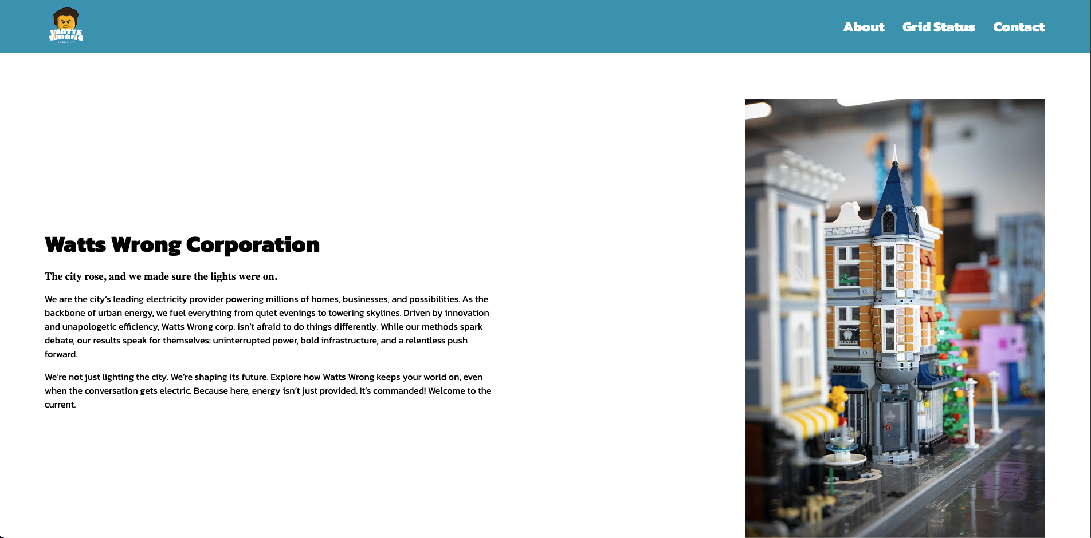

# Front-End:

Front end facing website will include the following features:

* Allows users to read the actual descriptions of the company, who they are and a slight introduction on how they do things differently
* The buttons would be more clickable and accessible to users, redirecting them to the right pages
* Working links to terms and conditions & privacy policy
* Discussing with respected stakeholders to recreate terms and conditions, as well as privacy policy to introduce the element of authenticity

# Back-End:

The back-end features the website could have are a login feature for users where they could check their pending electricity bills.