CONVERSATIONAL IVR MODERNIZATION FRAMEWORK
Use Case: Indian Railway Catering and Tourism Corporation (IRCTC)
1. INTRODUCTION
The project revolves around the idea of modernizing legacy IVR systems based on VoiceXML (VXML) by integrating them with new Conversational AI technologies. The use case selected for implementing the project is the Indian Railway Catering and Tourism Corporation (IRCTC). IRCTC owns one of the most prominent railway ticketing and information systems in the world. The services include ticketing, PNR status, train status, cancellations, refunds, etc.
The legacy IVR systems used by many organizations, such as IRCTC, follow a menu-based architecture. The architecture is based on keypad input in the form of Dual Tone Multi-Frequency (DTMF) tones. The legacy IVR systems have proven to be stable but lack the flexibility of using conversational interfaces. The idea of creating a new framework revolves around the idea of reusing the legacy IVR system assets with new technologies, such as Twilio and Azure Communication Services (ACS).
Task 1: Review of Existing IVR Architecture
Overview of Traditional IVR Systems
A traditional IVR system is an automated response system that is used to communicate with users through telephone interactions. The IVR system interacts with users by sending pre-recorded messages and asking users to press keys on their telephone keypad to respond to the messages. For instance, users can press “1” to know their PNR status, while users can press “2” to know the running status of the train.
In the case of IRCTC, it is assumed that the existing IVR system is developed using Voice XML (VXML), which is a markup language used to create voice applications. The IVR system is used to communicate with users in a structured and predetermined manner. The users are required to communicate with the IVR system by following a predetermined path. The IVR system is effective, but it is not capable of understanding natural language.
VoiceXML (VXML) Architecture and Working
VoiceXML is used to create voice interactions. VoiceXML is based on XML. VoiceXML is used to define the way in which voice interactions can be played out. VoiceXML also defines the way in which conditions, loops, etc., can be implemented. The architecture of a VoiceXML-based IVR system consists of a telephony gateway, VoiceXML interpreter, application server, etc.

When a call is made, the telephony gateway connects the call to the VoiceXML interpreter. The VoiceXML interpreter reads the scripts present in the application server. The scripts contain information on how to interact with the customer, how to validate the response, etc. The server retrieves the information from the databases through the application server. The information required for PNR can be retrieved.
Using navigation tags like <goto> and conditional statements like <if>, VoiceXML facilitates looping mechanisms. Using <field> and <grammar> elements, it also offers structured input handling. <catch> blocks, which deal with no-input or invalid-input situations, are used to handle errors. Because any change in logic necessitates changes to the VXML scripts, this structure lacks flexibility even though it offers control and reliability.
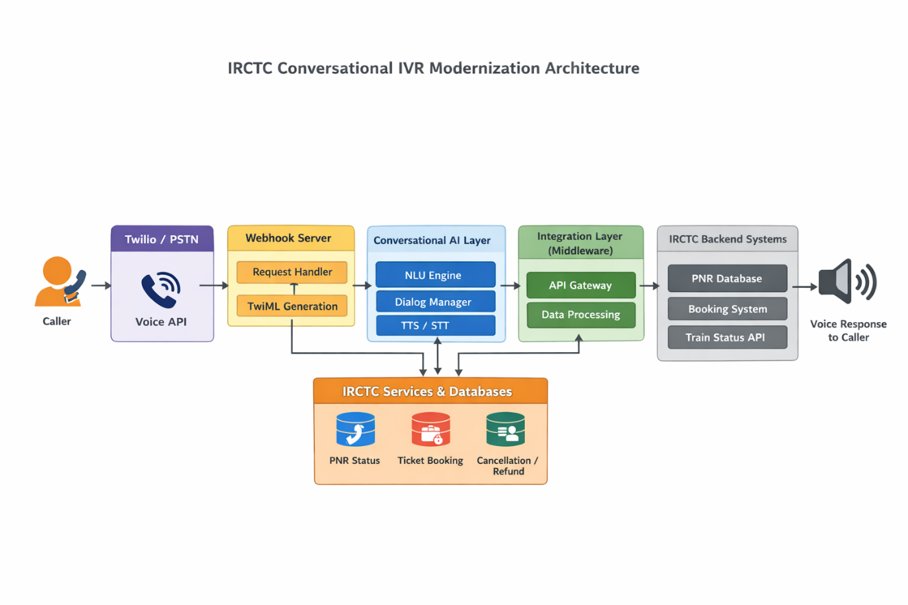

Legacy VXML-Based IVR Architecture
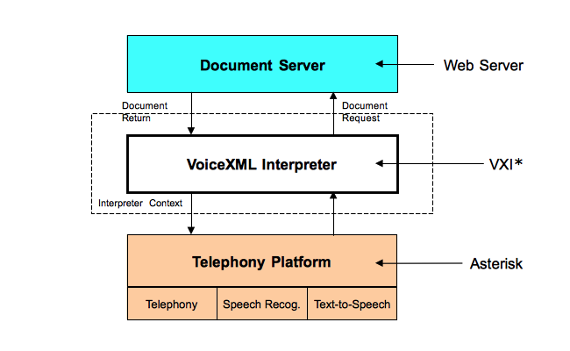
In a VoiceXML-based IVR system implemented for services such as those offered by Indian Railway Catering and Tourism Corporation, there are a number of components that work in tandem with each other in order to effectively handle the telephone call. Once the user dials the official helpline number, the call is routed through the Public Switched Telephone Network (PSTN). The PSTN is essentially the global communication infrastructure used for routing telephone calls. The PSTN routes the call to the telephony infrastructure of the organization.
As the call reaches the telephony infrastructure of the organization, it is received by the telephony gateway. The telephony gateway could be a hardware gateway or a SIP-based digital gateway. The primary responsibility of the telephony gateway is to convert the analog voice signals received through the call to digital data packets. The telephony gateway also enables the establishment of a communication session between the caller and the IVR system.
Upon the establishment of the connection by the telephony gateway, the call is routed to the VoiceXML interpreter. The VoiceXML interpreter acts as the execution engine of the IVR system. The interpreter reads the VoiceXML scripts contained in the application server. The scripts contain the conversation logic, which includes what to say to the end-user, what information to collect from the end-user, branching logic, and looping. The interpreter ensures that the conversation follows a structured path.
The application server has the VoiceXML scripts and the required business logic to process the requests of the users. In case the interpreter has to fetch any data or validate any data, such as the PNR status or the status of the train, it has to communicate with the backend systems through the application server. The backend database contains the required data in a structured format, including the passengers' data, booking data, ticket status, and transaction data. This data is fetched by the application server and sent to the interpreter to be converted to voice and played to the user.
Role of Twilio in IVR Systems
Using APIs, developers can create voice, messaging, and video applications on the cloud-based communication platform Twilio. Twilio functions as a cloud telephony provider in IVR systems, managing incoming and outgoing calls without the need for on-premise telephony equipment.
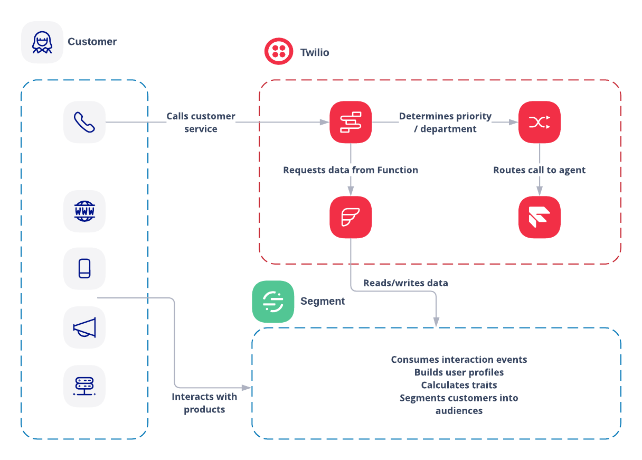
Calls made to an IVR number hosted by Twilio are routed via Twilio's cloud infrastructure. After that, Twilio carries out commands written in TwiML (Twilio Markup Language), an XML-based language that is comparable to VoiceXML. Twilio retrieves dynamic instructions from a webhook server rather than storing static XML files. This enables real-time response generation by backend applications based on user input.
A Twilio-based IVR's architecture usually includes databases, backend APIs, a webhook application server, Twilio cloud services, and the Public Switched Telephone Network (PSTN). Twilio uses HTTP requests to communicate with the application server. After processing the request and communicating with backend systems (like IRCTC booking APIs), the server returns TwiML instructions that dictate the caller's next course of action. In contrast to conventional VXML-only systems, this cloud-native model offers scalability, flexibility, and simpler integration with AI services.

Task 2: Document integration needs for alignment with ACS and BAP platforms

The goal of contemporary IVR integration is to blend conversational AI's intelligence with the dependability of conventional systems. Users of the conventional IRCTC system have to press numbers to navigate menus. A conversational IVR, on the other hand, enables users to communicate organically. For instance, a caller can say, "I want to check my PNR status," rather than pressing "1" to see their PNR status.
Adding a conversational AI layer between the current backend systems and the phone service (like Twilio) is part of the modernization strategy. IRCTC continues to use the same backend APIs. However, the AI engine recognizes user intent, extracts pertinent entities (like the PNR number), and dynamically generates responses in place of strict menu navigation. This hybrid strategy improves user interaction while lowering redevelopment effort.
IRCTC Scalability Considerations

Particularly during periods of high demand for reservations, like Tatkal ticket timings, IRCTC operates on an incredibly large scale. Therefore, a contemporary IVR system needs to be able to effectively manage large concurrent call volumes. Horizontal scaling is supported by cloud-based platforms such as Twilio and Azure Communication Services, which allows resources to automatically grow during periods of high traffic and shrink during periods of low usage.
Moreover, the conversational engine, the API gateway, and the backend services can be deployed individually using a microservices-based architecture. Load balancers can be used to distribute the incoming requests among the servers for the purpose of achieving the required stability in the system. Containerization tools like Docker and Kubernetes can be used for the samepurpose.

Determining Existing Infrastructure and the Integration Plan

Before the implementation process begins, it is important to determine whether IRCTC is already using telephony systems, Twilio, ACS, or any other communication platform. In case the IRCTC is already using the Twilio platform, the modernization of the system would be done by extending the existing TwiML workflows and connecting the AI engine using webhook technology. In case the IRCTC is using the Azure Communication Services platform, the integration would be done by connecting the Azure Bot Service and Azure Speech Service.

In both cases, the main aim would be to avoid the complete change of the infrastructure. Rather, a layered approach would be followed by adding the conversational capabilities to the existing infrastructure.

Proposed Modern Architecture for IRCTC

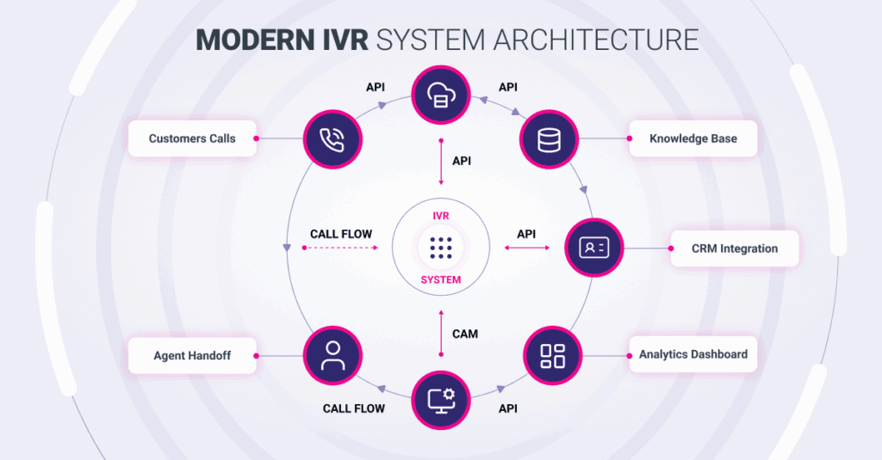
As shown in the architecture diagram below, the architecture is divided into different layers. The topmost layer is the telephony layer. This layer is responsible for handling both incoming and outgoing calls using Twilio or ACS. The next layer is the conversational AI layer. This layer is responsible for speech-to-text conversion and generating responses. The integration layer is the middleware that connects the AI engine to the IRCTC backend services. The business logic layer consists of the IRCTC APIs for bookings, PNR validation, train status, and refund. Lastly, the database layer consists of passenger data, ticketing data, and historical data.

Customized Workflow for IRCTC Use Case
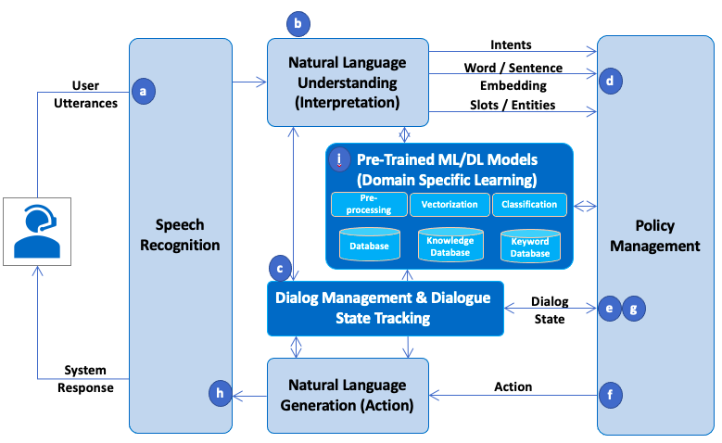
In a contemporary conversational workflow, a user can call the IRCTC helpline number to initiate a call to the conversational system. The call will be received by Twilio, which will then forward it to the conversational engine via a webhook. The AI system will then greet the user and listen to the speech input provided by the user. If the user says, “Check my PNR status,” the AI system will recognize this intent as a PNR status inquiry.

The AI system will then prompt the user to say the 10-digit PNR number. Once the number is received, the middleware will send a request to the IRCTC backend API to fetch the current booking status based on the provided PNR number. The current booking status will be converted to speech and played to the user. The overall experience will be more conversational and user-friendly compared to a menu-driven system.
Task 3: Identify technical challenges, constraints, and compatibility gaps
Custom Development Challenges
One of the major challenges faced in modernization is the conversion of static menu-based logic into dynamic AI-based interactions. In conventional VXML-based systems, the flow is strictly controlled and predefined. However, in conversational systems, the user may respond in any manner. Creating accurate models for intent recognition and achieving high speech recognition accuracy for different languages is a major challenge.
Another major challenge is the implementation of robust error handling mechanisms.
Legacy IVR Technical Challenges in the Current Market
Legacy IVR systems are usually tightly coupled with hardware components such as telephone equipment and static XML code. In order to make changes to legacy IVR systems, modifications have to be done manually. Legacy IVR systems do not have contextual memory, meaning that every action within the IVR flow is independent of the previous action. Legacy IVR systems do not have good analytics, making it hard to track user behavior.
Current market trends in IVR are focused on using AI to automate IVR, supporting multiple channels, and providing analytics. Legacy IVR cannot deliver these features without significant changes.
Real-Time Data Handling and Performance
The IVR system of IRCTC has to handle requests such as PNR validation in real time. If it is delayed, it would affect the user experience. For this purpose, caching tools like Redis can be used to cache the data. Asynchronous processing and event-driven design can be used to improve performance.
Session management is also important to maintain state during a call.
Cloud Limitations and Compatibility Gaps
While platforms like Azure Communication Services and Twilio offer scalability, they also introduce considerations such as usage-based pricing, regional latency, and vendor dependency. Certain advanced AI features may require additional services, increasing complexity and cost.
Compatibility gaps may arise when integrating legacy VXML scripts with modern conversational engines. Careful planning and phased migration are required to ensure smooth interoperability.

Conclusion
Conversational IVR Modernization Framework for Indian Railway Catering and Tourism Corporation outlines a well-structured approach for modernizing conventional VoiceXML-based IVR systems into more intelligent conversational systems. It ensures the modernization process is conducted in a systematic manner by analyzing the conventional architecture and identifying opportunities for integration. Rather than completely replacing the conventional architecture, the approach focuses on reusing the conventional systems and APIs to reduce the development effort required for modernization and maximize the level of technology enhancement.
The integration of conversational AI capabilities with cloud-based communication platforms such as Twilio and Azure Communication Services allows for a paradigm shift from rigid and menu-based interactions to more dynamic and intent-based conversational interactions. The proposed framework improves user experience considerably by allowing users to converse more freely rather than going through cumbersome keypad-based interactions. At the same time, it ensures the reliability and operational stability of existing systems through a phased approach to migration.
This proposed layer-based architecture has the added advantage of scalability, including horizontal expansion, distributed processing, and cloud-based resource management. Additionally, the data handling capabilities of the proposed framework, including efficient API communication and backend integration, ensure that the system can efficiently handle scenarios of high demand, such as during peak booking times. Lastly, the framework has a comprehensive roadmap to bridge the compatibility and technical issues associated with vendor considerations.

