

VASIREDDY VENKATADRI INSTITUTE OF TECHNOLOGY
Approved by AICTE, Permanently Affiliated to JNTU, Kakinada
Accredited by NAAC with ‘A’ Grade - ISO 9001:2008 Certified
Nambur (V), Peda Kakani (M), Guntur Dt. - 522508 April, 2025.

A Project Report
on
Home Rental & PG Finder

submitted for partial fulfillment for the award of the degree of

BACHELOR OF TECHNOLOGY

in

Computer Science and Engineering
by

NEELURI CHAITHANYA - 24BQ5A0516
MULUGU SOMA SEKHARA CHARI - 23BQ1A05E5
POTLA VENKATA VINAY - 24BQ5A05I1
NUNE REVANTH REDDY - 23BQ1A05G2

Under the Guidance of
Dr. N. Lakshmi Prasanna
Professor, CSE



CERTIFICATE

This is to certify that the Project Report titled “Home Rental & PG Finder” is being submitted by, Mr. NEELURI CHAITHANYA, Mr. MULUGU SOMA SEKHARA CHARI, Mr. POTLA VENKATA VINAY, Mr. NUNE REVANTH REDDY, bearing Registered Numbers 24BQ5A0516, 23BQ1A05E5, 24BQ5A05I1, and 23BQ1A05G2 respectively of III B.Tech II semester Computer Science & Engineering is a record Bonafide work carried out by them. The results embodied in this report have not been submitted to any other University for the award of any degree.

Project Guide Head of Department
(Dr. N. Lakshmi Prasanna, Professor) (Dr. V. Ramachandran, Professor)

Submitted for Viva-voce Examination held on

Internal Examiner External Examiner

DECLARATION

We, Mr. NEELURI CHAITHANYA, Mr. MULUGU SOMA SEKHARA CHARI, Mr. POTLA VENKATA VINAY, Mr. NUNE REVANTH REDDY, hereby declare that the Project Report entitled “HOME RENTAL & PG FINDER” done by us under the guidance of Dr. N. Lakshmi Prasanna, Professor at Vasireddy Venkatadri Institute of Technology (A) is submitted in partial fulfillment of the requirements for the award of Bachelor of Technology in Computer Science & Engineering. The results embodied in this report have not been submitted to any other university for the award of any degree.

DATE:

PLACE:

SIGNATURE OF THE CANDIDATE(s)

1.

2.

3.

4.

ACKNOWLEGMENT

We take this opportunity to express my deepest gratitude and appreciation to all those people who made this project work easier with words of encouragement, motivation, discipline, and faith by offering different places to look to expand our ideas and helped us towards the successful completion of this project work.
First and foremost, we express our deep gratitude to Sri. Vasireddy Vidya Sagar, Chairman, Vasireddy Venkatadri Institute of Technology (A) for providing necessary facilities throughout the B Tech program.
We express our sincere thanks to Dr. Y. Mallikarjuna Reddy, Principal, Vasireddy Venkatadri Institute of Technology (A) for his constant support and cooperation throughout the B. Tech program.
We express our sincere gratitude to Dr. V. Ramachandran, Professor & HOD, Computer Science & Engineering, Vasireddy Venkatadri Institute of Technology (A) for his constant encouragement, motivation and faith in offering different places to look to expand our ideas.
We would like to express our sincere gratefulness to our Guide Dr. N. Lakshmi Prasanna, Professor, CSE for his insightful advice, motivating suggestions, invaluable guidance, help and support in the successful completion of this project.
We would like to express our sincere heartfelt thanks to our Project Coordinator Dr. Vidya Sagar Uppuluri, Professor, CSE for his valuable advices, motivating suggestions, moral support, help and coordination among us in successful completion of this project.
We would like to take this opportunity to express our thanks to all the Teaching and Non-Teaching Staff in the Department of Computer Science & Engineering, VVIT for their invaluable help and support.

Names of Students

NEELURI CHAITHANYA - 24BQ5A0516
MULUGU SOMA SEKHARA CHARI - 23BQ1A05E5 POTLA VENKATA VINAY - 24BQ5A05I1
NUNE REVANTH REDDY - 23BQ1A05G2



INSTITUTE VISSION

To impart quality education through exploration and experimentation and generate socially conscious engineers, embedding ethics and values, for the advancement in Science and Technology.

INSTITUTE MISSION

- To educate students with practical approach to dovetail them to industry needs.
- To govern the institution with a proactive and professional management with passionate teaching faculty.
- To provide holistic and integrated education and achieve over all development of students imparting scientific and technical, social and cognitive, managerial and organizational skills.
- To compete with the best and be the most preferred institution of the studious and the scholarly.
- To forge strong relationships and linkage with the industry.



DEPARTMENT VISSION

Providing quality education to enable the generation of socially conscious software engineers who can contribute to the advancement in the field of computer science and engineering.

DEPARTMENT MISSION

- To equip the graduates with the knowledge and skills required to enable them to be industry ready.

- To train socially responsible, disciplined engineers who work with good leadership skills and can contribute for nation building.

- To make our graduates proficient in cutting edge technologies through student centric teaching- learning process and empower them to contribute significantly to the software industry.

- To shape the department into a centre of academic and research excellence.





PEO1 | To provide the graduates with solid foundation in computer science and engineering along with fundamentals of Mathematics and Sciences with a view to impart in them high quality technical skills like modelling, analyzing, designing, programming and implementation with global competence and helps the graduates for life-long learning.
PEO2 | To prepare and motivate graduates with recent technological developments related to core subjects like programming, databases, design of compilers and Network Security aspects and future technologies so as to contribute effectively for Research & Development by participating in professional activities like publishing and seeking copy rights.
PEO3 | To train graduates to choose a decent career option either in high degree of employability / Entrepreneur or, in higher education by empowering students with ethical administrative acumen, ability to handle critical situations and training to excel in competitive examinations.
PEO4 | To train the graduates to have basic interpersonal skills and sense of social responsibility that paves them a way to become good team members and leaders.



The B.Tech CSE program has documented measurable outcomes that are based on the needs of the program’s stakeholders. The program outcomes, which are derived from ABET criteria, were first drafted in the academic year 2009–10 and later revised in 2010–11. The program outcomes that the department presently adopts are as follows:

1 | Engineering knowledge | Apply the knowledge of mathematics, science, engineering fundamentals and an engineering specialization to the solution of complex engineering problems.
2 | Problem analysis | Identify, formulate, review research literature, and analyze complex engineering problems reaching substantiated conclusions using first principles of mathematics, natural science and engineering sciences.
3 | Design/development of solutions | Design solutions for complex engineering problems and design system components or processes that meet the specified needs with appropriate consideration for the public health and safety, and the cultural, societal and environmental considerations.
4 | Conduct investigations of complex problems | Use research based knowledge and research methods including design of experiments, analysis and interpretation of data, and synthesis of the information to provide valid conclusions.
5 | Modern tool usage | Create, select and apply appropriate techniques, resources and modern engineering and IT tools including prediction and modeling to complex engineering activities with an understanding of the limitations.



6 | The Engineer and Society | Apply reasoning informed by the contextual knowledge to assess societal, health, safety, legal and cultural issues and the consequent responsibilities relevant to the professional engineering practice.
7 | Environment and Sustainability | Understand the impact of the professional engineering solutions in the societal and environmental contexts, and demonstrate the knowledge of, and need for sustainable development.
8 | Ethics | Apply ethical principles and commit to professional ethics and responsibilities and norms of the engineering practice.
9 | Individual and Team Work | Function effectively as an individual and as a member or leader in diverse teams, and in multidisciplinary settings.
10 | Communication | Communicate effectively on complex engineering activities with the engineering community and with society at large, such as being able to comprehend and write effective reports and design documentation, make effective presentations, and give and receive clear instructions.
11 | Project Management and Finance | Demonstrate knowledge and understanding of the engineering and management principles and apply these to one’s own work, as a member and leader in a team, to manage projects and in multidisciplinary environments.
12 | Lifelong Learning | Recognize the need for, and have the preparation and ability to engage in independent and lifelong learning in the broadest context of technological change.



 |  | 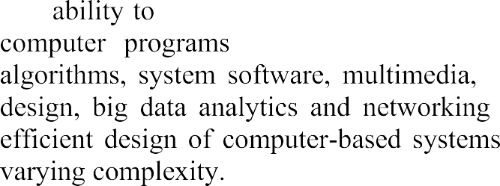
 |  | 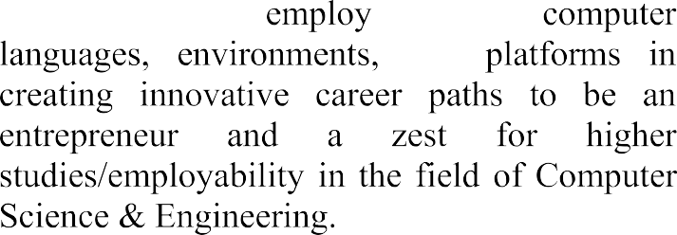







 | PO1 | PO2 | PO3 | PO4 | PO5 | PO6 | PO7 | PO8 | PO9 | PO10 | PO11 | PO12 | PSO1 | PSO2
CO1 | 1 | 2 | 1 |  |  | 2 | 2 | 3 |  | 2 |  |  | 1
CO2 | 2 | 2 | 3 | 2 | 2 |  | 2 | 1 | 2 | 2 | 2 | 1 | 3 | 1
CO3 |  | 1 | 1 | 1 | 3 |  |  |  |  |  |  | 1 | 1
CO4 | 1 |  |  |  |  |  |  |  | 3 | 3 |  |  | 1 | 1
CO5 |  | 1 |  |  |  |  |  | 2 | 3 | 3 | 2 |  | 1 | 2

INDEX

CH No | TITLE | PAGE NO
CHAPTER 1 | INTRODUCTION | 1
 | 1.1 Introduction
CHAPTER 2 | AIM AND SCOPE | 2-3
 | 2.1 Existing System
 | 2.2 Proposed System
CHAPTER 3 | CONCEPT AND METHODS | 4-7
 | 3.1 Problem Description
 | 3.2 Proposed Solution
 | 3.2.1 Database Design
 | 3.2.2 Data Collection
 | 3.2.3 Data Validation and Processing
 | 3.2.4 Data Enrichment
 | 3.2.5 System Architecture
 | 3.2.6 System Evaluation Metrics
CHAPTER 4 | IMPLEMENTATION | 8- 18
 | 4.1 Tools Used
 | 4.2 Code
 | 4.3 Results and Screenshots
CHAPTER 5 | CONCLUSION AND FUTURE SCOPE | 19- 23
 | CONCLUSION
 | FUTURE SCOPE
 | REFERENCES
 | APPENDIX

CHAPTER – 1

INTRODUCTION

1.1 Overview

In the contemporary, fast-paced urban environment, the search for suitable residential accommodation—ranging from independent homes to Paying Guest (PG) facilities—has become a significant challenge for students and working professionals. Despite the proliferation of digital listing platforms, the process of finding a home is often compared to "searching for a needle in a haystack". This difficulty is compounded by a fragmented market where tenants are frequently subjected to endless unorganized listings, fraudulent advertisements, and stagnant communication with property owners.

The Home Rental & PG Finder project is conceived as an intelligent, secure web application designed to bridge the trust and efficiency gap in the rental market. Built using a modern full-stack approach—specifically the MERN stack (MongoDB, Express, React, and Node.js)—the platform serves as a "seamless connection" between property owners and prospective tenants. By integrating advanced system-driven validation, the project aims to redefine the property search experience as one that is simpler, safer, and fundamentally more human-centered.

1.2 Problem Statement

Traditional property listing websites often operate as mere digital bulletin boards, lacking the necessary oversight to ensure data quality. This leads to several systemic failures:

The Trust Deficit: Many platforms do not verify the authenticity of listings, allowing "fake advertisements" to proliferate and waste tenant time.
Stale Data: Properties that have already been occupied often remain listed, leading to "frustrated tenants" and unnecessary inquiries for owners.
Information Overload: Without intelligent filtering or recommendation systems, users are forced to manually sift through thousands of irrelevant properties.
Communication Bottlenecks: Delayed or non-existent responses from property owners create a sense of uncertainty for tenants who need immediate accommodation.

1.3 Rational and Motivation

The motivation behind this project is to transform the rental search from a "frustrating search" into an experience where the website acts as a "helpful assistant" rather than just a list of links. By utilizing Design Thinking and Artificial Intelligence, the system moves beyond passive listings to active, engagement-driven results.

CHAPTER – 2
AIM AND SCOPE

2.1 Aim of the Project

The primary aim of the Home Rental & PG Finder is to establish a trusted, high-engagement marketplace that eliminates the "trust deficit" currently prevalent in the rental industry. The project intends to achieve this by creating an intelligent web ecosystem where every property listing is validated by system administrators and every recommendation is tailored to the specific behavior and preferences of the user.

2.2 Core Objectives

To fulfill the project’s aim, the following technical and functional objectives have been established:
System-Driven Validation: To implement a mandatory document upload and verification process for owners to ensure that only authenticated properties are visible to the public.
Intelligent Discovery: To develop an AI-powered matching algorithm that analyzes user preferences, location data, and past interactions to recommend the most suitable homes automatically.
Dynamic Data Management: To ensure "freshness" by automatically identifying and removing inactive or unresponsive listings after 30 days of inactivity.
Engagement Tracking: To rank owners based on their responsiveness and positive feedback, thereby incentivizing better communication between market participants.
User-Centric Design: To provide a "Mobile-First" responsive interface that allows for easy searching, side-by-side property comparisons, and direct communication.

2.2 PROPOSED SYSTEM

2.1 Functional Scope
The scope of the application covers four critical modules that handle the lifecycle of a rental transaction:
A. Search & Discovery Portal
This module focuses on the tenant's first interaction. It includes a "Smart Search Bar" for filtering by budget, location, and type (Home or PG), alongside "Property Showrooms" that display verified photos. A unique "Comparison Tool" is included to allow tenants to evaluate up to three properties side-by-side.
B. Trust & Identity Management
Acting as the platform's "Gatekeeper," this module facilitates secure owner registration and document submission. It includes an Admin Dashboard where property deeds and IDs are checked before a "Trust Badge" is awarded to the listing.

C. AI Matchmaker (The "Brain")
The AI module continuously learns from user behavior. Its scope includes generating smart recommendations and maintaining the "Freshness Filter," which hides "dead" listings to ensure search results remain reliable.
D. Communication Hub
This module establishes the "Seamless Connection" via an inquiry system that allows tenants to send direct "Interest Requests". It also manages periodic notifications (emails or pop-ups) and engagement tracking for owners.

2.2 Technical Scope
Architecture: The system utilizes a client-server architecture with a React.js frontend for interactivity and a Node.js/Express.js backend for business logic.
Data Management: A MongoDB database is used for flexible storage, while external interfaces like Cloudinary/AWS S3 handle high-resolution image storage.
Security: The scope includes implementing JWT (JSON Web Tokens) for session management and bcrypt for password hashing.

2.3 Future Enhancements (Extended Scope)
The project is designed with modularity to allow for future additions, such as:
Digital Rental Agreements: Automated generation of legal contracts.
In-App Payments: Integrated gateways for security deposits.
Virtual Tours: 360-degree property inspections.
CHAPTER – 3
CONCEPTS AND METHODS

3.1 Problem Description
In today’s rental ecosystem, tenants often face significant challenges in finding reliable and verified accommodation. Existing platforms lack trust mechanisms, leading to issues such as fraudulent listings, misleading property information, and poor communication between tenants and property owners. Additionally, there is no centralized system that ensures document verification, making it difficult for users to rely on the authenticity of listings.
Property owners, on the other hand, face challenges in managing listings, responding to inquiries efficiently, and reaching genuine tenants. The absence of structured communication and engagement tracking further reduces the effectiveness of current systems.
Therefore, there is a need for a secure, efficient, and user-friendly platform that bridges the gap between tenants and property owners while ensuring trust, transparency, and ease of use.
3.2 Proposed Solution
The proposed solution is a Home Rental & PG Finder Web Application developed using the MERN stack (MongoDB, Express.js, React.js, Node.js). The system is designed to function as a trusted marketplace that connects tenants and property owners through a secure and interactive platform.
The application introduces key features such as:
- Verified property listings through document validation
- Advanced search and filtering options
- Direct communication between tenants and owners
- Role-based authentication (Tenant, Owner, Admin)
- Real-time updates and engagement tracking
The system follows a client-server architecture, where the frontend provides an intuitive user interface and the backend handles business logic, authentication, and database operations. The application ensures scalability, security, and performance while maintaining a seamless user experience.
3.2.1 Database Design
The application uses MongoDB as the primary database with Mongoose for schema modeling. The database is designed to handle multiple entities efficiently, ensuring scalability and flexibility.

The key collections include:
- User Collection
Stores details of tenants, owners, and admins, including authentication credentials and preferences.
- Property Collection
Stores property listings with details such as title, description, price, location, amenities, images, and verification status.
- Inquiry Collection
Acts as a communication bridge between tenants and property owners, storing messages and inquiry statuses.
- Verification Document Collection
Stores documents uploaded by property owners for admin verification, ensuring trust and authenticity.
The database design ensures:
- Data consistency
- Efficient querying
- Secure data handling
3.2.2 Data Collection
Data in the system is collected from user inputs through various modules of the application:
- User Registration
Users provide personal details such as name, email, phone number, and role (Tenant/Owner).
- Property Listings
Owners input property details including location, rent, amenities, and images.
- Verification Documents
Owners upload government-approved documents for property validation.
- Tenant Preferences
Tenants provide preferences such as budget range, preferred location, and property type.
All data is collected through validated forms to ensure accuracy and completeness.
3.2.3 Data Validation and Processing
To maintain data integrity and security, the system implements strict validation and processing mechanisms:
- Input validation using frontend and backend checks
- Email format and password strength validation
- File size and format restrictions for image uploads
- Password hashing using bcrypt for secure storage
- JWT-based authentication for session management
These mechanisms ensure that only valid and secure data is stored in the system.
3.2.4 Data Enrichment
The system enhances collected data to improve user experience and system efficiency:.
- Preference Matching
Tenant preferences are used to filter and recommend relevant properties.
- Status Tracking
Properties are categorized as Available or Booked to avoid stale listings.
- Verification Tagging
Verified properties are marked with trust badges to improve reliability.
This enrichment improves search accuracy and decision-making for users.
3.2.5 System Architecture
The application follows a three-tier architecture:
1. Frontend (Presentation Layer)
- Built using React.js and Tailwind CSS
- Provides responsive and interactive UI
- Handles user interactions and API calls
2. Backend (Application Layer)
- Built using Node.js and Express.js
- Handles authentication, business logic, and APIs
- Manages communication between frontend and database
3. Database (Data Layer)
- MongoDB for storing structured and unstructured data
- Mongoose for schema modeling and validation
Additional Integrations:
- Firebase for image storage
- Google Maps API for location services
- JWT for secure authentication
This architecture ensures modularity, scalability, and maintainability.
3.2.6 System Evaluation Metrics
The performance of the system is evaluated based on the following metrics:
1. Performance
- Fast loading time (less than 2 seconds for search results)
- Efficient API response handling
2. Scalability
- Ability to handle multiple users simultaneously
- Efficient database indexing and querying
3. Security
- Encrypted password storage
- Secure authentication using JWT
- Protection against injection attacks
4. Usability
- User-friendly interface
- Mobile-responsive design
- Easy navigation for both tenants and owners
5. Reliability
- Accurate property listings
- Verified data through admin validation
- Consistent system uptime
These metrics ensure that the system meets both functional and non-functional requirements effectively.

CHAPTER – 4
IMPLEMENTATION

4.1 TOOLS USED
4.1 Tools Used
The application is built on the MERN stack, which provides a high-performance, full-stack JavaScript environment.
Core Development Stack
React.js (Frontend Library): Used to build a responsive, next-generation user interface that ensures fast page loading and cross-device compatibility, particularly for mobile users.
Node.js (Runtime Environment): Provides the execution environment for server-side code, allowing the use of JavaScript outside the browser.
Express.js (Backend Framework): A minimal and flexible web application framework for Node.js used to manage API endpoints and business logic.
MongoDB (Database): A NoSQL database used for flexible, scalable storage of user profiles, property listings, and inquiry data.
Supporting Technologies & APIs:
MongoDB Atlas: Used as the cloud-based database-as-a-service to host and manage application data with automated backups.
JSON Web Tokens (JWT): Utilized for secure session management by generating unique, encrypted tokens upon successful user login.
bcrypt: A password-hashing library used to securely encrypt user passwords before they are stored in the database.
Cloudinary / AWS S3: Selected for high-resolution image storage, ensuring property photos are managed efficiently without impacting server performance.
Google Maps API / Mapbox: Integrated to provide location services, allowing tenants to view property positions on interactive maps.

System Logic & Security:
AI Recommendation Service: A logic layer (Python or Node-based) that powers the "AI Matchmaker" by analyzing user behavior to provide personalized recommendations.
Watermarking Logic: A system-driven tool that automatically watermarks uploaded verification documents with "FOR VERIFICATION ONLY" to prevent data misuse.
4.2 CODE STRUCTURE
The AI Resume Analyzer and Job Prediction System is developed using a modular architecture that separates different functionalities into independent components. This modular structure improves system maintainability, scalability, and ease of future enhancements.
Following is the Model Structure for the core entities of the Home Rental & PG Finder:
1. User Model
This model handles authentication and role-based access for Tenants, Owners, and Admins.
User ID: Unique identifier for each account.
Email/Phone: Validated contact information used for login.
Password: Stored as a hashed string using the bcrypt algorithm for security.
Role: An enumeration to distinguish between "Tenant," "Owner," and "Admin" permissions.
Profile Details: Includes name, contact info, and search preferences.
JWT Token: Issued upon successful login to manage secure active sessions.
2. Property Model
This model manages the details of rental listings and their lifecycle status.
Owner Reference: A foreign key linking the property to a specific User ID.
Property Type: Categorized as "PG," "Flat," or "Private Room".
Core Details: Mandatory fields including Title, Rent Price, and detailed Location (City/Area).
Amenities: An object or array containing boolean values for Wi-Fi, AC, Food, Laundry, and Parking.
Images: A list of URLs or paths for high-resolution property photos.
Verification Status: A restricted field (default: 'Pending') that can only be modified by an Admin after reviewing legal documents.
Availability Toggle: A status field to mark a property as "Available" or "Booked" to prevent stale leads.

3. Verification Document Model
This model is used by the "Trust & Identity" module to store sensitive owner documentation.
Property reference: Links the document to the specific property listing.
Document Type: Type of proof provided (e.g., Government ID or Property Deed).
File URL: Secure path to the restricted storage bucket (e.g., AWS S3) where the document is stored.
Watermark Flag: Indicates if the system-driven watermark ("FOR VERIFICATION ONLY") has been applied.
4. Inquiry & Communication Model
This model facilitates the "Seamless Connection" between the two primary user classes.
Tenant ID: Reference to the user expressing interest.
Owner ID: Reference to the property recipient.
Property ID: Links the inquiry to a specific listing.
Message Content: The text of the interest request or direct message.
Timestamp: Used to track owner "Response Rates" for ranking in search results.
5. AI Behavioral Model (Schema-less)
Used by the "AI Matchmaker" to learn from user interactions.
Interaction History: Tracks clicked properties, saved favorites, and search keywords.
Recommendation Score: A dynamic value used to prioritize listings in the "Property Showroom" based on a user’s past behavior.
1. Database Models (Backend - MongoDB/Mongoose)
These models define the structure for users and property listings as described in your system design.

User Model (models/User.js):

JavaScript

const mongoose = require('mongoose');

const UserSchema = new mongoose.Schema({
name: { type: String, required: true },
email: { type: String, required: true, unique: true },
password: { type: String, required: true }, // Hashed using bcrypt [cite: 32]
role: { type: String, enum: ['Tenant', 'Owner', 'Admin'], default: 'Tenant' }, [cite: 115]
phoneNumber: { type: String },
createdAt: { type: Date, default: Date.now }
});

module.exports = mongoose.model('User', UserSchema);

Property Model (models/Property.js)
JavaScript

const mongoose = require('mongoose');

const PropertySchema = new mongoose.Schema({
owner: { type: mongoose.Schema.Types.ObjectId, ref: 'User', required: true }, [cite: 118]
title: { type: String, required: true },
description: { type: String },
rentPrice: { type: Number, required: true }, [cite: 119]
location: {
city: { type: String, required: true },
area: { type: String, required: true },
address: { type: String }
},
propertyType: { type: String, enum: ['Flat', 'PG'], required: true }, [cite: 119]
amenities: [String], // e.g., ['Wi-Fi', 'AC', 'Food'] [cite: 125]
images: [String], // URLs to Cloudinary/S3 [cite: 120, 159]
isVerified: { type: Boolean, default: false }, // Controlled by Admin [cite: 129, 150]
status: { type: String, enum: ['Available', 'Booked'], default: 'Available' }, [cite: 121]
verificationDoc: { type: String } // URL to identity proof [cite: 127]
});

module.exports = mongoose.model('Property', PropertySchema);

2. Backend Controller Logic (Express.js)
This snippet demonstrates the logic for filtering properties, supporting your "Search & Discovery" requirements.

Property Search Controller (controllers/propertyController.js)
JavaScript

exports.searchProperties = async (req, res) => {
try {
const { city, minPrice, maxPrice, type } = req.query;
let query = { isVerified: true }; // Only show verified listings to tenants [cite: 20, 43]

if (city) query["location.city"] = new RegExp(city, 'i'); [cite: 123]
if (type) query.propertyType = type; [cite: 124]
if (minPrice || maxPrice) {
query.rentPrice = {};
if (minPrice) query.rentPrice.$gte = Number(minPrice);
if (maxPrice) query.rentPrice.$lte = Number(maxPrice); [cite: 124]
}

const properties = await Property.find(query).populate('owner', 'name email');
res.status(200).json(properties); [cite: 15]
} catch (err) {
res.status(500).json({ message: "Server Error", error: err.message });
}
};

3. Frontend Component (React.js)
This represents the UI for the "Property Card" seen in your search results.

PropertyCard Component (components/PropertyCard.js)
JavaScript

import React from 'react';

const PropertyCard = ({ property }) => {
return (
<div className="property-card">
<img src={property.images[0]} alt={property.title} className="thumbnail" />
<div className="card-content">
{property.isVerified && <span className="badge">Verified</span>} [cite: 59]
<h3>{property.title}</h3>
<p className="location">{property.location.area}, {property.location.city}</p> [cite: 15]
<p className="price">₹{property.rentPrice}/mo</p> [cite: 15]
<div className="amenities">
{property.amenities.slice(0, 3).map(amt => (
<span key={amt} className="tag">{amt}</span>
))}
</div>
<button className="view-details-btn">View Details</button> [cite: 16]
</div>
</div>
);
};

export default PropertyCard;

4. Middleware: JWT Authentication
This handles secure session management as required by your project specifications.

Auth Middleware (middleware/auth.js)
JavaScript

const jwt = require('jsonwebtoken');

module.exports = function (req, res, next) {
const token = req.header('x-auth-token');
if (!token) return res.status(401).json({ msg: 'No token, authorization denied' });

try {
const decoded = jwt.verify(token, process.env.JWT_SECRET); [cite: 116]
req.user = decoded.user;
next();
} catch (err) {
res.status(401).json({ msg: 'Token is not valid' });
}
};

4.3 RESULTS AND OUTPUT SCREENSHOTS
After implementing the system, the Smart Career Readiness Platform successfully performs the following operations:

1. User Registration and Login
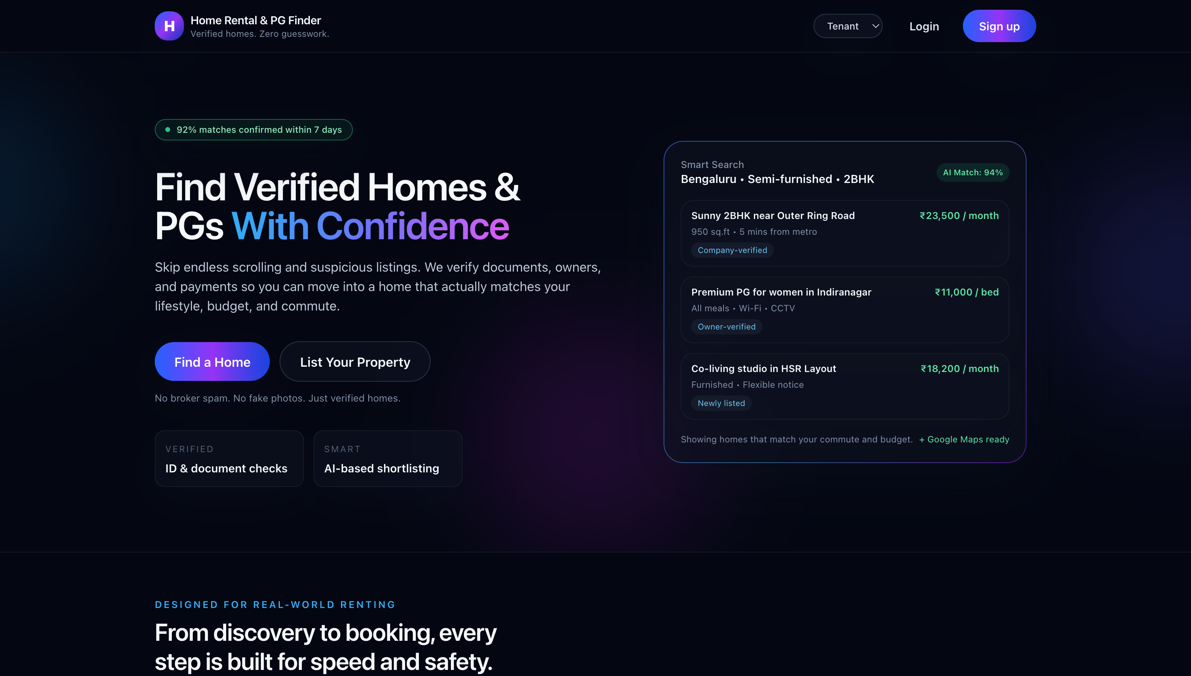
Tenant/Owner can create an account and log in securely to the platform.
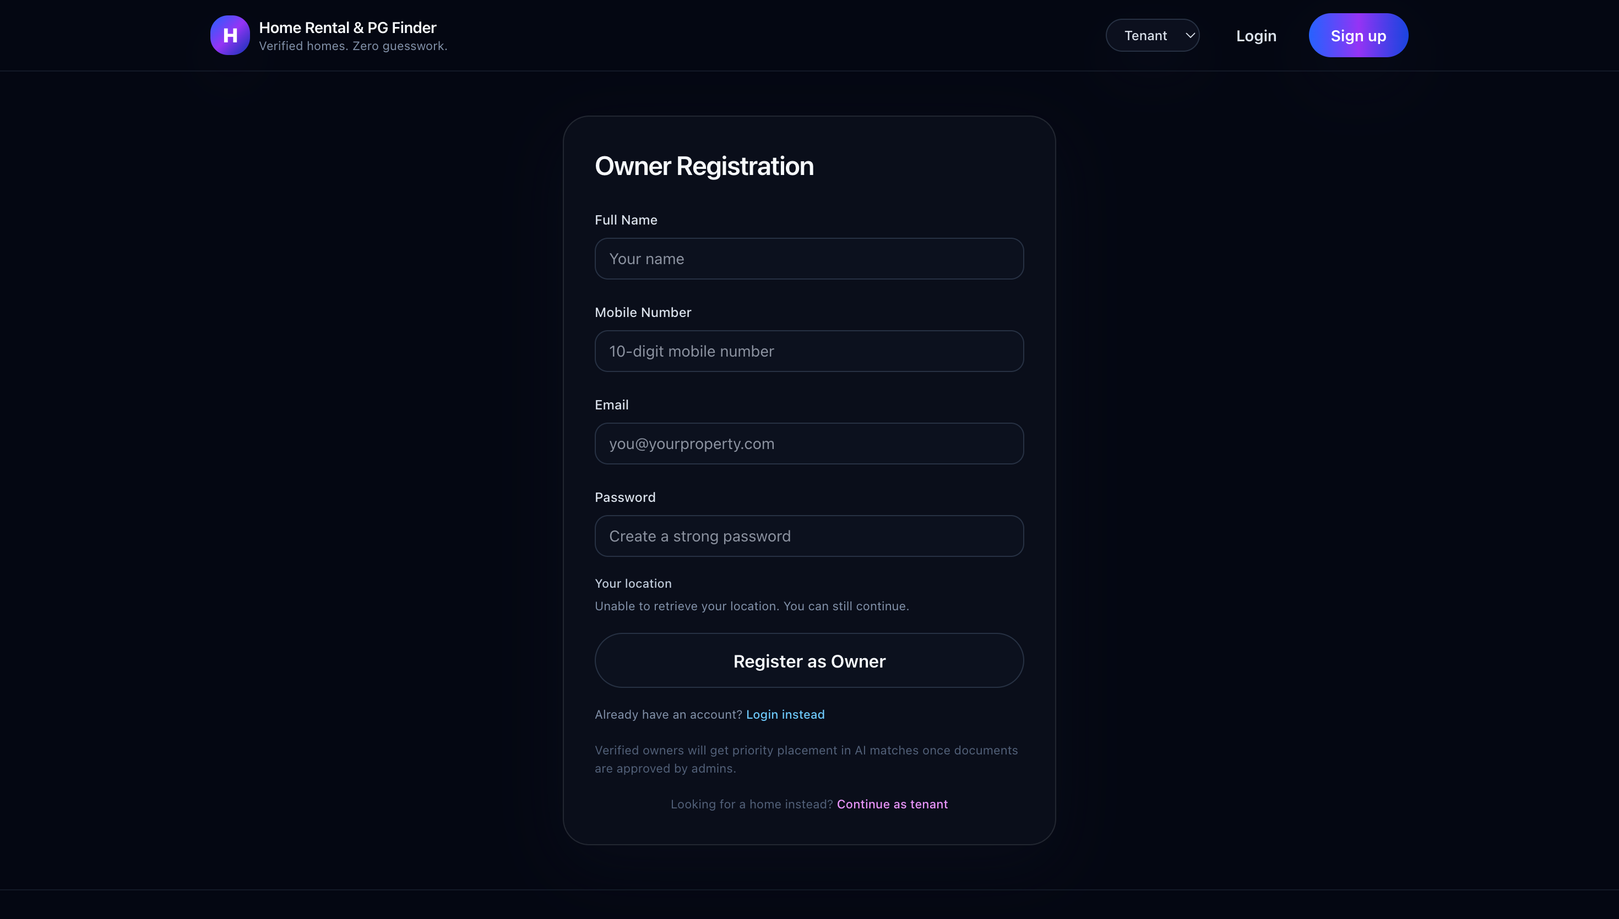
Owner/Tenant Registration window:
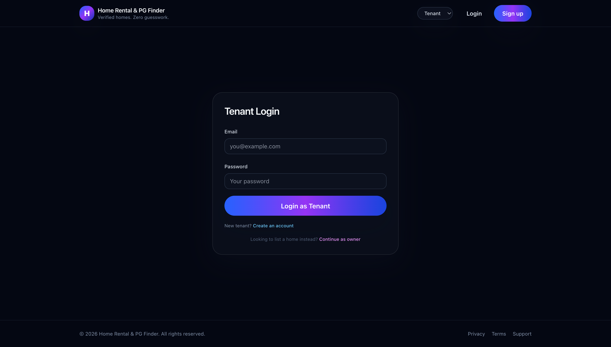
Owner/Tenant login window

2. Profile Creation
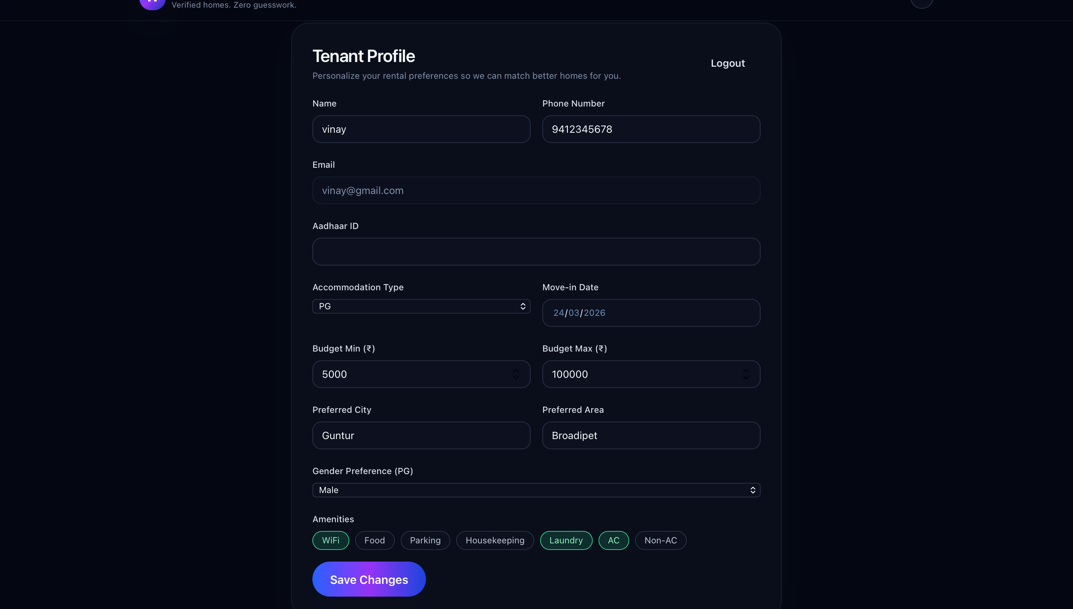
Tenant can enter their details and current interests in their profile.

Dashboard of Tenant: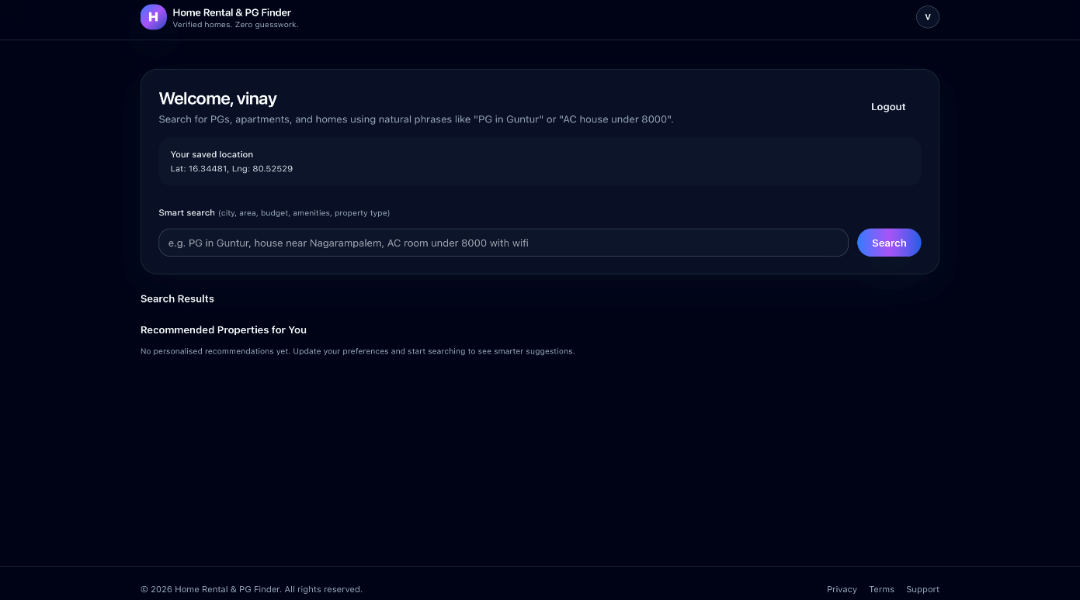

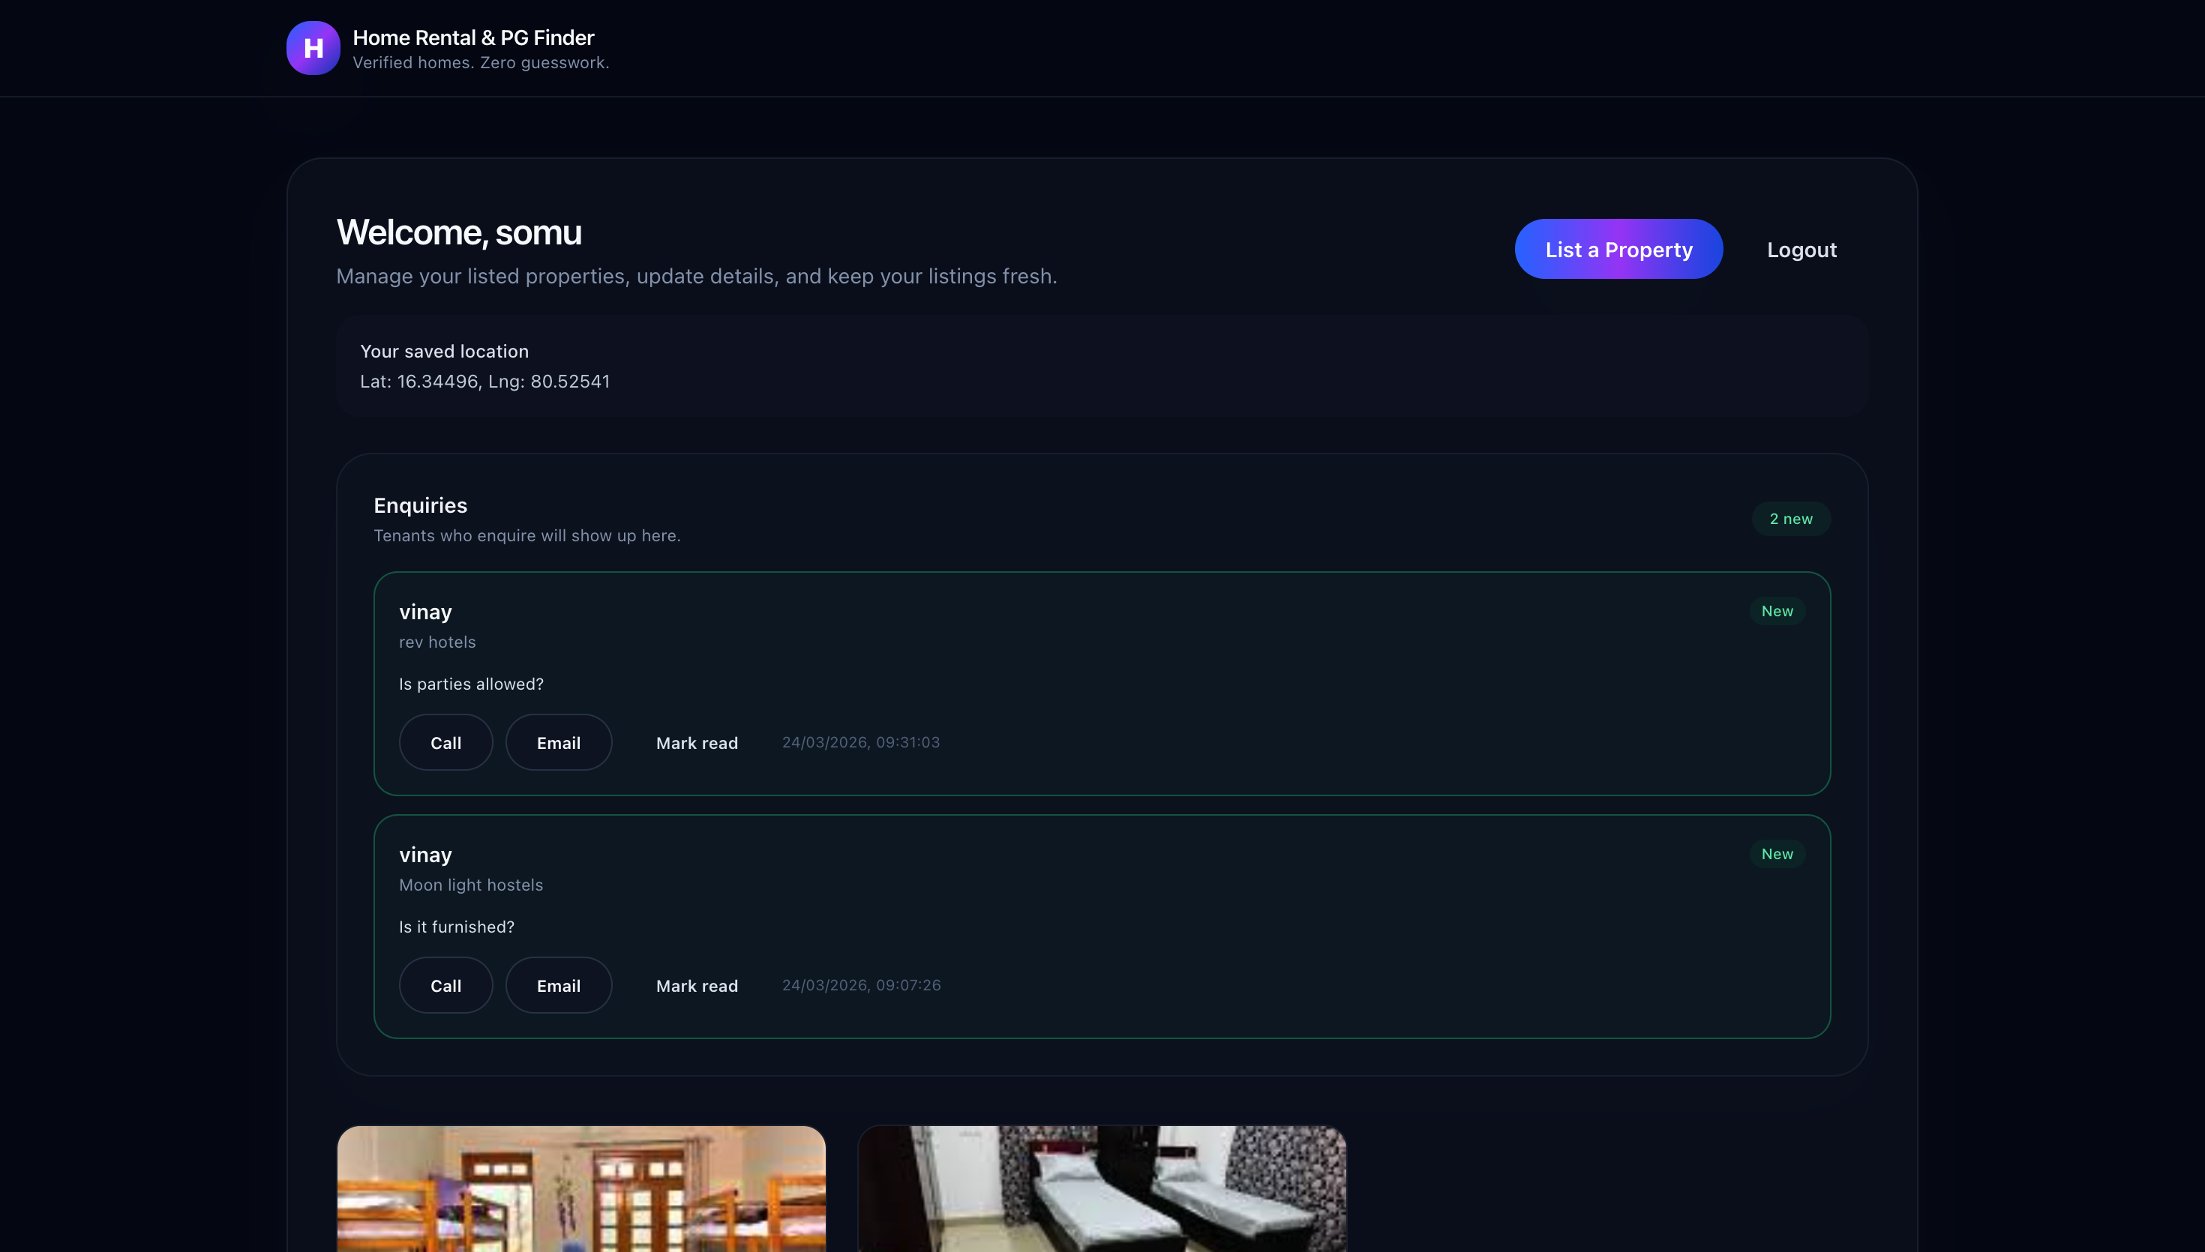
3.Dashboard of Owner:

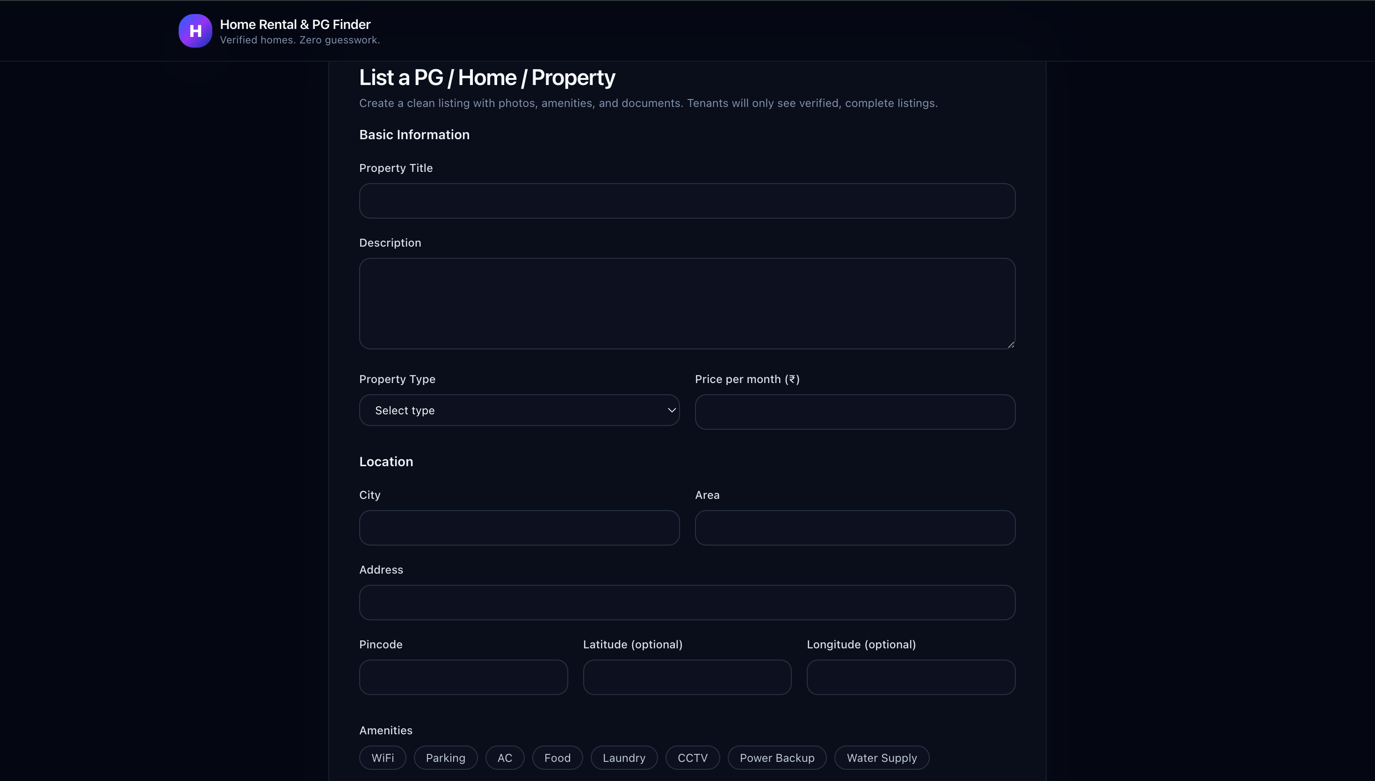
Dashboard of Owner while listing his/her property through valid details:

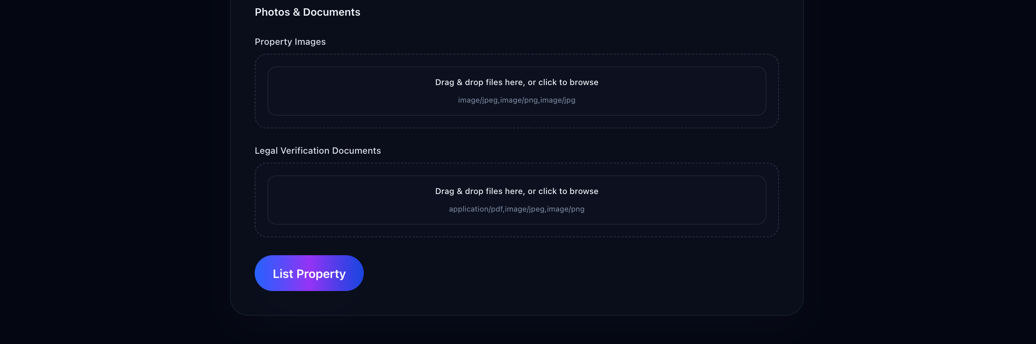
Owner can also update the existing property details:

4.Tenant Dashboard:

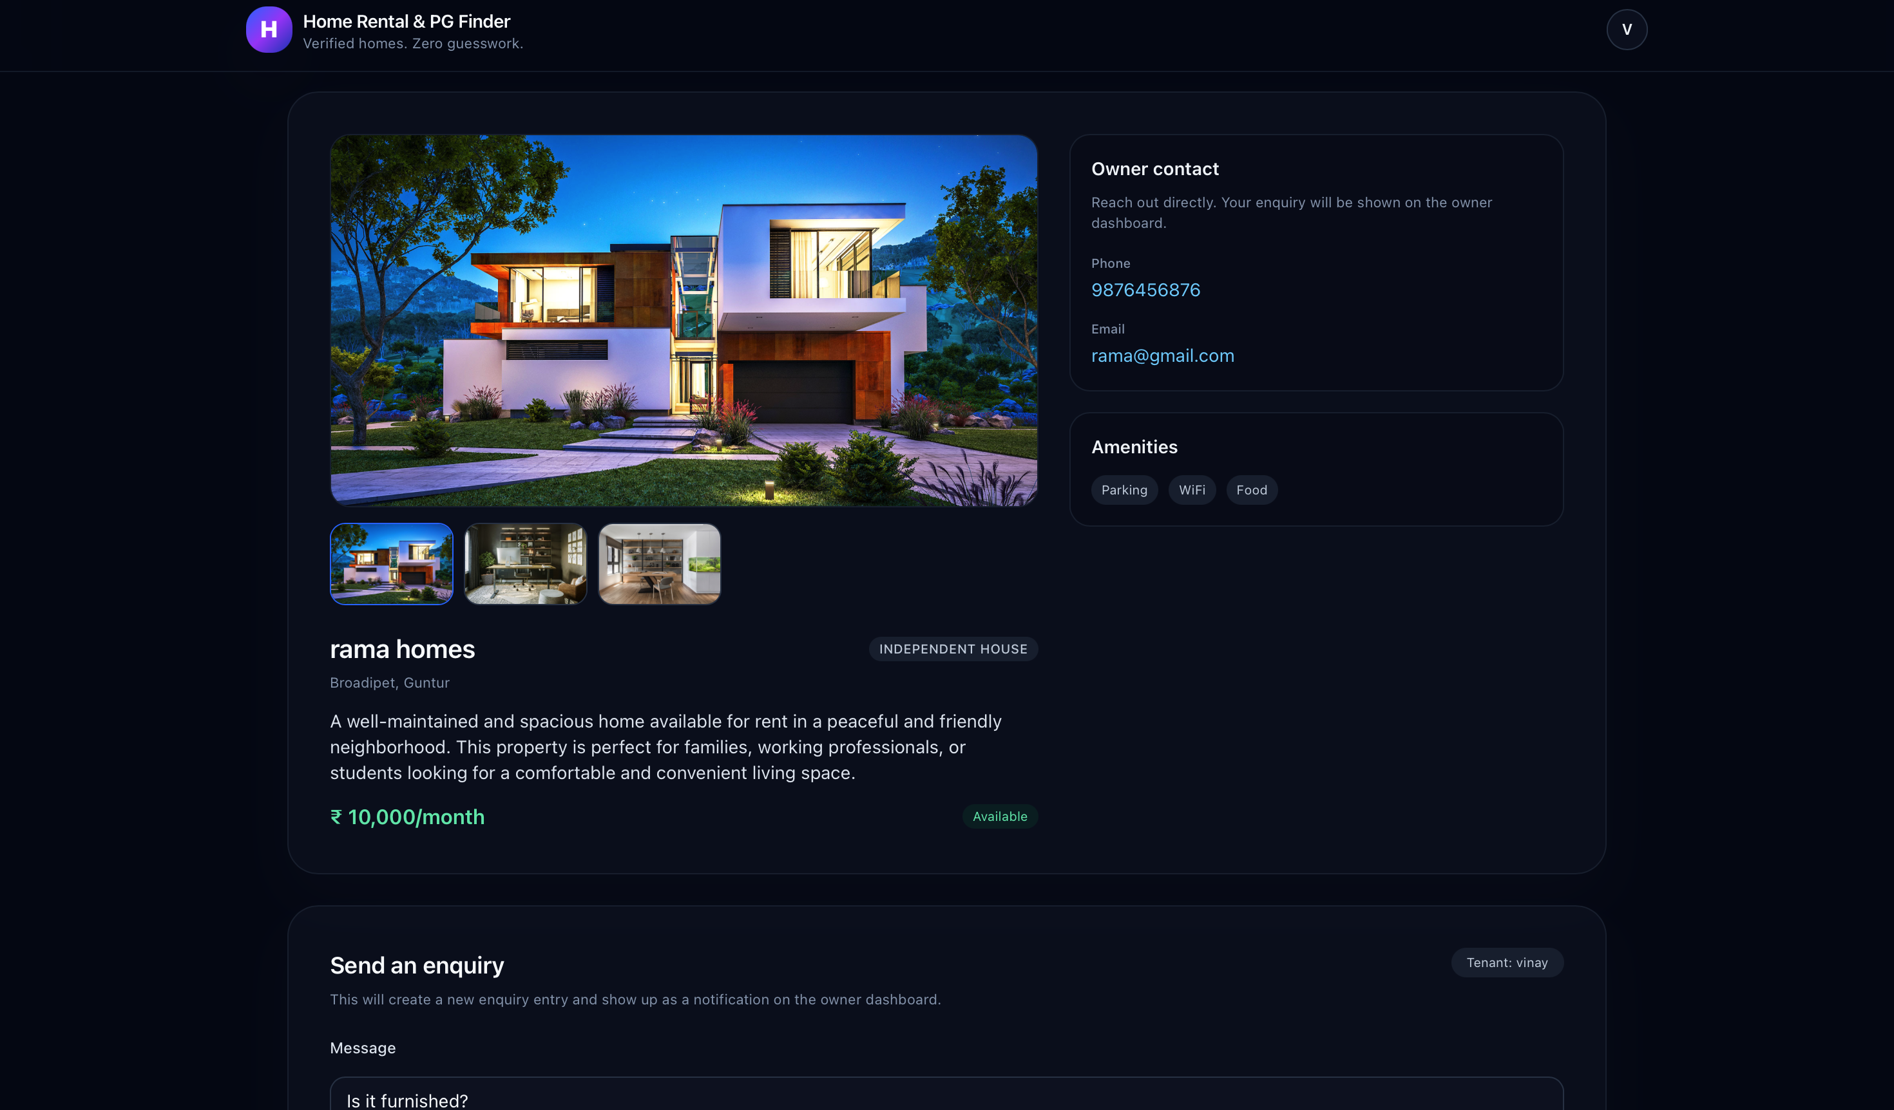
Tenant can check the details of the properties:

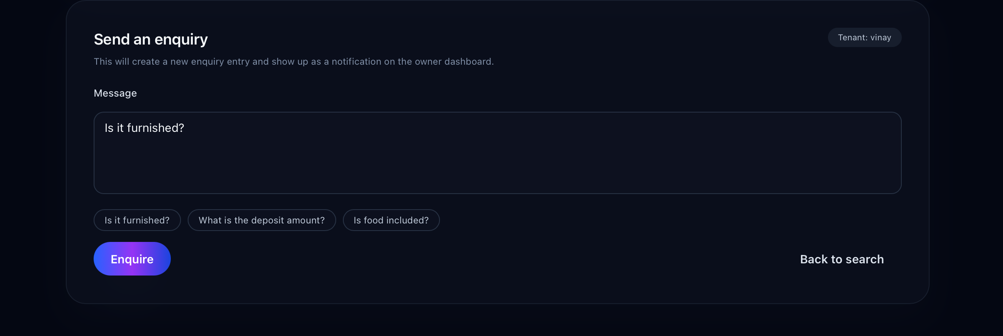
Tenant can enquire about the property through texting to owner :

5.Communication :
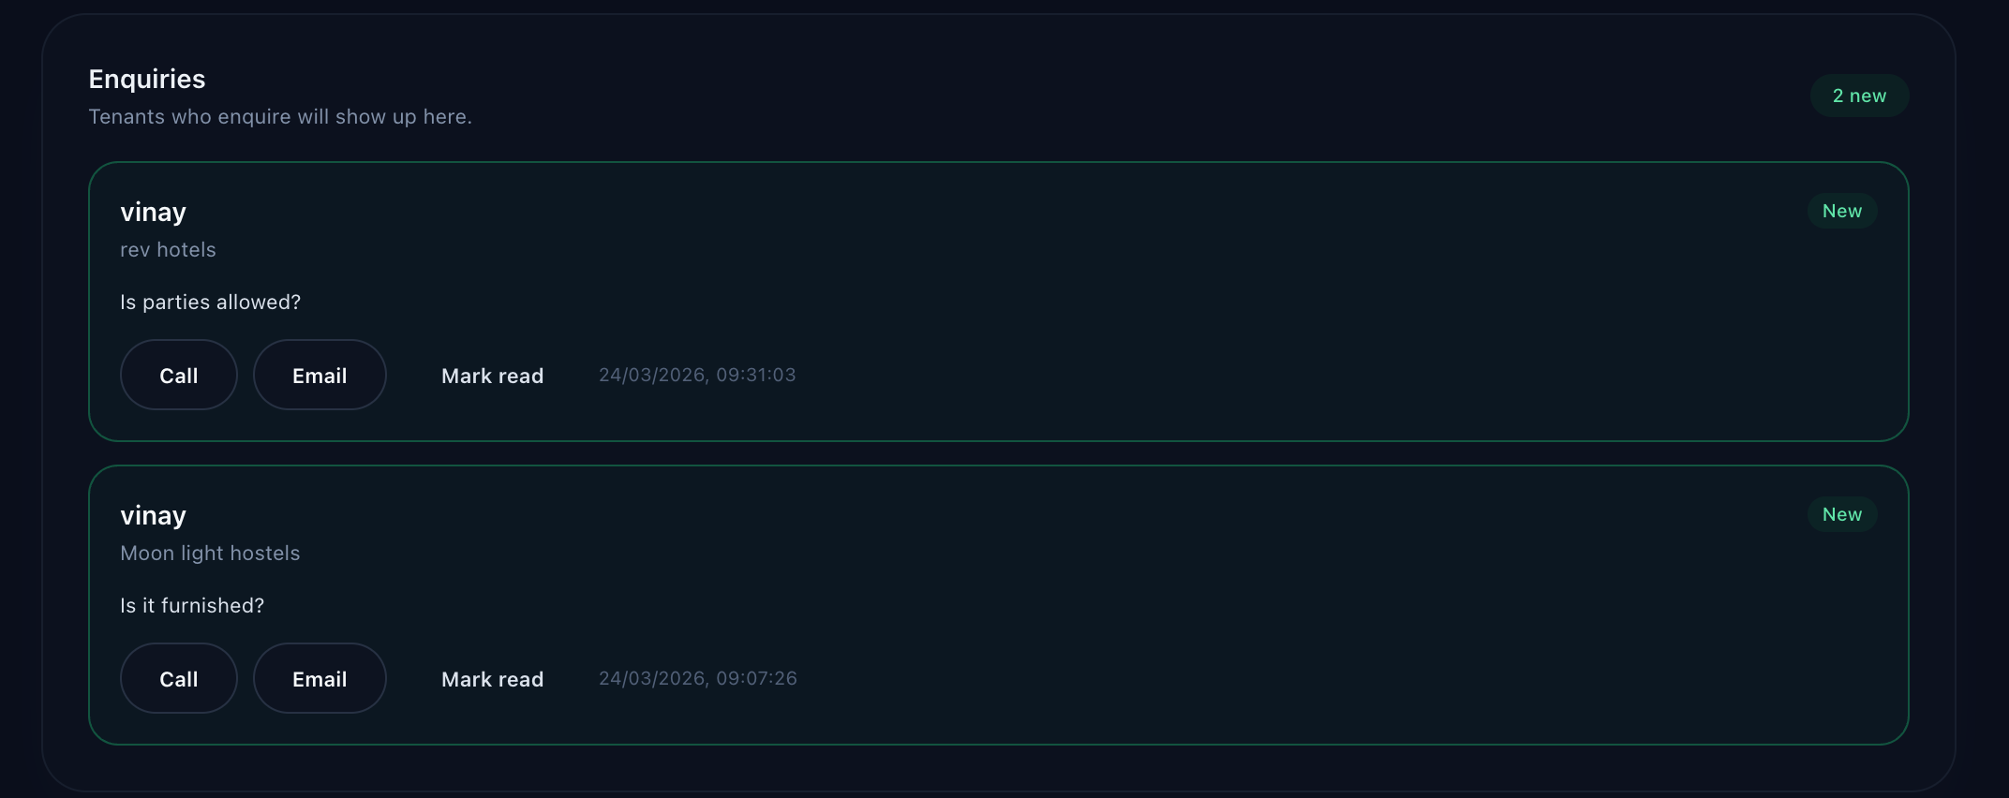
Owner can respond to the enquiry by tenant :

CHAPTER – 5
CONCLUSION AND SCOPE

CONCLUSION:
The Home Rental & PG Finder represents a significant advancement in the digital real estate and shared accommodation market by directly addressing the systemic "trust deficit" that plagues traditional listing platforms. By shifting the paradigm from a passive directory to an active, system-verified marketplace, this project provides a secure and efficient ecosystem for both tenants and property owners.

The successful implementation of the MERN stack (MongoDB, Express, React, and Node.js) has resulted in a high-performance, mobile-first application capable of handling complex functional requirements, from secure JWT-based authentication to real-time communication. The integration of a mandatory Admin-led verification process serves as a critical gatekeeper, ensuring that every listing is backed by legitimate documentation and reducing the prevalence of fraudulent advertisements.

Furthermore, the project’s "intelligent" core—driven by an AI-powered matching algorithm—transforms the user experience by providing personalized, behavioral-based recommendations rather than static search results. Features such as the automated "Freshness Filter" and responsiveness-based owner ranking ensure that the platform remains self-regulating and consistently reliable.

In summary, the Home Rental & PG Finder achieves its primary objective of making the property search process simpler, safer, and more human-centered. It stands as a robust blueprint for future rental platforms, with a scalable architecture ready to incorporate upcoming enhancements like digital rental agreements and virtual 360-degree tours. This project proves that through the strategic application of modern web technologies and rigorous validation logic, the challenges of urban housing discovery can be effectively mitigated.

FUTURE SCOPE
The future scope of the Home Rental & PG Finder focuses on transitioning the platform from a discovery-oriented marketplace into a fully integrated, end-to-end real estate management ecosystem. By leveraging emerging technologies, the platform aims to further automate the rental lifecycle and enhance user immersion.

1. Integrated Financial and Legal Services
- Digital Rental Agreements: The platform will incorporate an automated generator for legal rental contracts, allowing tenants and owners to sign agreements digitally, thereby reducing paperwork and legal overhead.
In-App Payment Gateway: To complete the transaction loop, a secure payment gateway will be integrated to handle token advances, security deposits, and monthly rent payments directly through the application.
2. Advanced Immersive Technologies
- Virtual 360-Degree Tours: To save time for both parties, the system will support virtual property inspections, allowing prospective tenants to explore a home or PG in a 360-degree environment before scheduling a physical visit.
- Augmented Reality (AR) Furniture Placement: Future iterations may include AR tools to help tenants visualize how their own furniture or belongings would fit within a specific room or flat.

3. AI and Data-Driven Enhancements
- Predictive Market Analytics: The AI matchmaker will be expanded to provide owners with pricing suggestions based on real-time market trends and demand in specific geographic areas.
Hyper-Personalized Neighborhood Insights: Beyond property details, the system will integrate third-party APIs to provide tenants with detailed "livability scores," including commute times, local crime rates, and proximity to essential services like hospitals and grocery stores.
4. Community and Reputation Building
- Tenant Reliability Scoring: Similar to the current owner ranking system, a tenant reputation score could be implemented based on payment history and previous landlord feedback to foster mutual trust.
- IoT Smart Home Integration: For premium listings, the platform could integrate with IoT devices to allow owners to manage smart locks or monitor utility usage, providing a "Smart Living" experience for tenants.
REFERENCES:
Technical Stack & Tool References
- React.js: Documentation for building responsive, component-based user interfaces.
Node.js & Express.js: Framework documentation for building scalable server-side applications and RESTful APIs.
MongoDB & MongoDB Atlas: Documentation for NoSQL database management and cloud-based data storage.
JSON Web Tokens (JWT): Standard for secure session management and authentication.
Security Standards: Bcrypt hashing for password encryption and input sanitization techniques for NoSQL injection prevention.
External API & Service References
- Cloudinary / AWS S3: Technical guides for high-resolution image storage and management.
Google Maps API / Mapbox: Documentation for integrating geolocation and interactive map services.
AI Implementation: Research on behavioral learning and recommendation algorithms used for the "AI Matchmaker" logic

sAPPENDIX :

Appendix A: User Manual

A.1 Tenant Operations
- Registration & Login: Users can create an account by providing a valid email and password, which triggers a secure JWT session.
Property Search: Tenants use the global search bar to query by city or landmark and apply filters for budget and property type.
Comparison Tool: Users can select up to three properties to view their amenities (e.g., Wi-Fi, Food, Laundry) in a side-by-side layout.
Inquiry Submission: Tenants send "Interest Requests" directly to owners via a secure form on the property details page.
A.2 Property Owner Operations
- Listing Creation: Owners must fill in mandatory fields, including location, rent, and type, and upload property images.
Verification Upload: Owners are required to upload government-issued documents to receive a "Trust Badge".
Lead Management: Owners track performance through an engagement tracker and mark properties as "Booked" to stop new inquiries.

A.3 Admin Operations
- Validation Dashboard: Admins review uploaded documents against listing details using a split-screen interface.
Approval/Rejection: Admins can "Approve" a listing to make it live or "Reject" it, which notifies the owner of the necessary corrections.
Test Case ID | Feature Under Test | Input/Action | Expected Result
TC-01 | User Authentication | Valid Email and Password | System issues a JWT and redirects to dashboard.
TC-02 | Property Search | City: "Bangalore" | Only properties in Bangalore are displayed.
TC-03 | Verification Logic | Admin clicks "Approve" | Property becomes visible to tenants with a "Verified" badge.
TC-04 | Freshness Filter | 31 days of inactivity | Listing is automatically hidden from search results.
TC-05 | Image Upload | 6MB JPEG File | System rejects upload due to 5MB size limit.

Appendix C: Non-Functional Requirements (NFR)
- Performance: Search results are optimized to load within 2 seconds under 4G network conditions.
Scalability: The backend supports 1,000+ concurrent users without performance degradation.
Security: Passwords are encrypted using the bcrypt algorithm, and sensitive documents are watermarked automatically.
Reliability: The system targets 99.9% uptime with automated daily database backups.

Appendix D: Bibliography & Data Sources
- Technical Stack: React.js, Node.js, Express.js, and MongoDB Atlas documentation.
Infrastructure: Cloudinary/AWS S3 for image hosting and Google Maps/Mapbox for location services.

