Ex.No. 2

Date:3/5/23

**DDL Commands with Constraints – PRIMARY, FOREIGN KEY, UNIQUE, CHECK**

**AIM:**

To add the constraints like primary key, foreign key, unique key and check using DDL commands.

1) Alter the table STUDENT with following structure.

|  |  |  |
| --- | --- | --- |
|  | Column | Constraints |
| # | Name |  |
|  |  | PRIMARY |
| 1 | RegNo | KEY |
| 2 | MobileNo | NOT NULL |

**Query:**



**Output:**

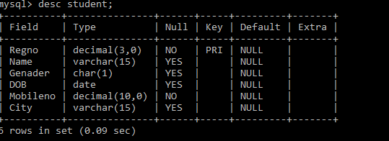

1. Alter the table name FACULTY with following structure. The DeptNo in this table refers the DeptNo in the DEPARTMENT table.

|  |  |  |  |  |  |  |  |  |  |
| --- | --- | --- | --- | --- | --- | --- | --- | --- | --- |
|  |  |  | Column | | Constraints |  |  |  |  |
|  | # |  | Name | |  |  |  |  |  |
|  |  |  | FacNo | | PRIMARY |  |  |  |  |
|  | 1 |  | KEY |  |  |  |  |
|  |  |  |  |  |  |  |  |
|  |  |  | Gender | | CHECK |  |  |  |  |
|  | 2 |  | ‘M’ or ‘F’ |  |  |  |  |
|  |  |  |  |  |  |  |  |

**QUERY:**

**1. **

**2. **

**OUTPUT:**

**1.** 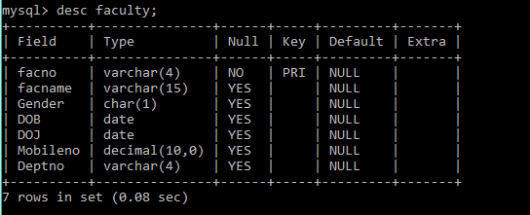

**2. **

|  |  |
| --- | --- |
| 3) | After the FACULTY table is successfully created, test if you can add a constraint |
| FOREIGN KEY to the DeptNo of this table. | |

**QUERY:**



**Since the Deptno is not the primary key of the department table, the column cannot be the foreign key of the faculty table.**

|  |  |  |  |  |  |  |  |
| --- | --- | --- | --- | --- | --- | --- | --- |
| 4) | Alter the table name DEPARTMENT with following structure. | | | | | | |
|  |  |  |  |  | |  |  |
|  |  | Column |  | Constraint | |  |  |
| # |  | Name |  |  |  |  |  |
|  |  | DeptNo |  | PRIMARY | |  |  |
| 1 |  |  | KEY | |  |  |
|  |  |  |  |  |

**QUERY:**



**OUTPUT:**

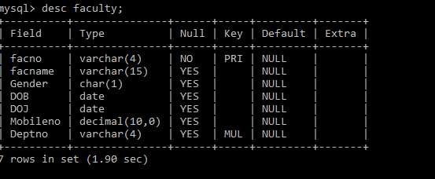

|  |  |  |  |  |  |  |  |  |  |
| --- | --- | --- | --- | --- | --- | --- | --- | --- | --- |
|  | 5) | Alter the table name COURSE with following structure. | | | | | | |  |
|  |  |  |  | |  | | |  |  |
|  |  |  | Column |  | Constraint | | |  |  |
|  | # |  | Name |  |  |  |  |  |  |
|  |  |  | CourseNo |  | PRIMARY | | |  |  |
|  | 1 |  |  | KEY | | |  |  |
|  |  |  |  |  |  |
|  | 2 |  | SemNo |  | 1 to 6 | | |  |  |

**QUERY:**

**1. **

**2.** 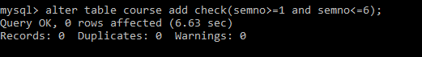

**OUTPUT:**

**1.** 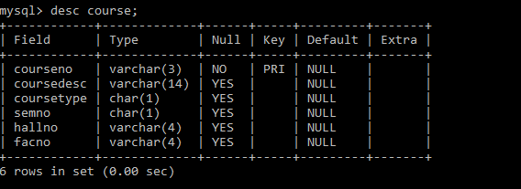

**2. **