SUID : 387781563

**Evolutionary Machine Learning – HW3**

**HW3:**  For the same problem as HW1, use a Particle Swarm Optimization approach, and compare with the previous results (HW1 and HW2).

Link:

https://www.kaggle.com/chaithanya96/bankmarketing

The bank marketing dataset is the csv file with users details used to predict the marketing decision. The decision yes or no is represented with binary numbers 1 and 0. The sample columns included are:

1. 'age',
2. 'job',
3. 'marital',
4. 'education',
5. 'default',
6. 'balance',
7. 'housing',
8. 'loan',
9. 'contact',
10. 'day',
11. 'month',
12. 'duration',
13. 'campaign',
14. 'pdays',
15. 'previous',
16. 'poutcome',
17. 'market?'

The screenshot of the sample dataset is attached below:

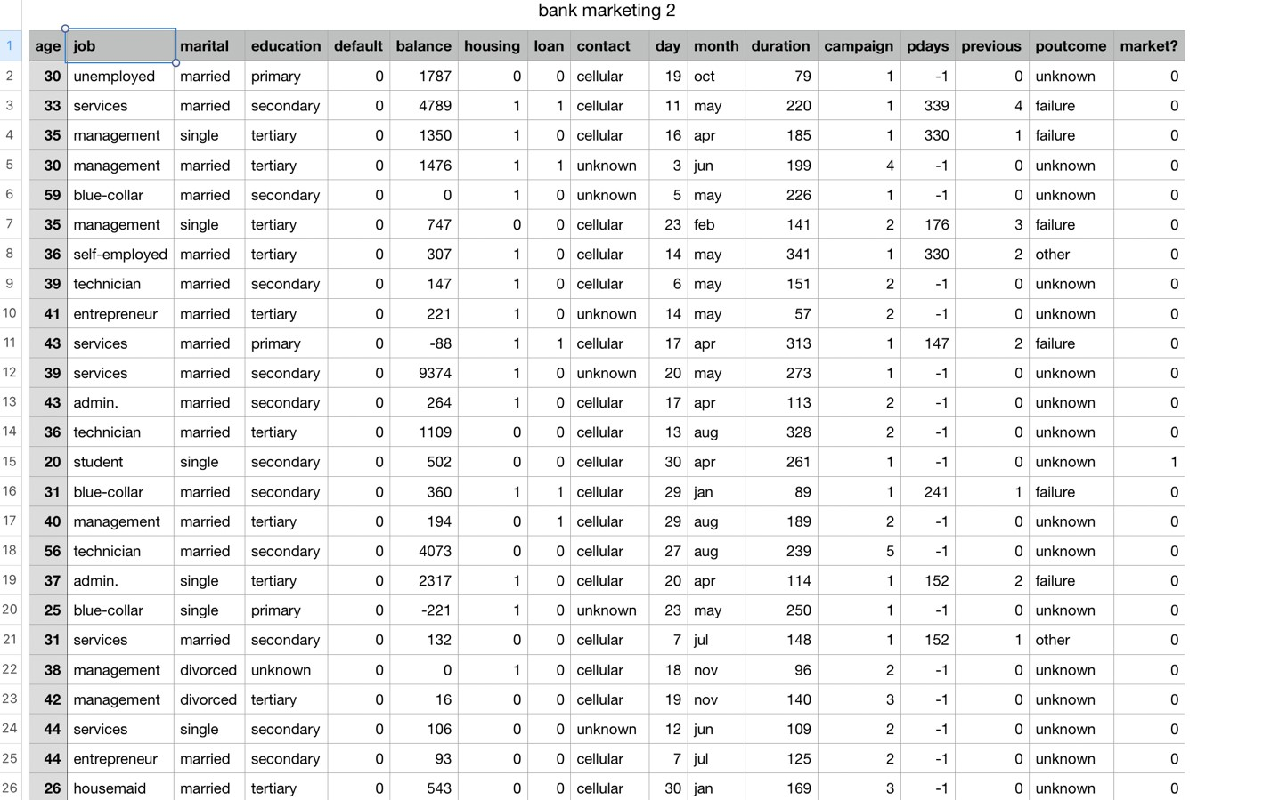

**Code execution steps:**

Particle Swarm Optimization

I have implemented the Particle Swarm Optimization approach to train a shallow feedforward neural network for a 2-class classification task using the pyswarms library available in python. The accuracy is then compared with the accuracy calculated using Genetic Algorithm implementation obtained in HW1 and CMA Evolutionary Strategy obtained in HW2.

The snapshot of the model summary is attached below:

1. Pyswarms python library is installed to implement the Particle swarm optimization approach to train the data.
2. Pandas data frame available in python is used to read the data set.
3. Forward_Propagation function is defined to to carry out the forward propagation of the data.
4. I have initialized the swarms with c1': 0.5, 'c2': 0.3, 'w':0.9 in the program to perform the optimization.
5. In the predict function, I have defined the required Neural network architecture as i

* inputs =10
* class = 2
* hidden layers = 20

1. The weights and biases are rolled back and then the forward propagation is implemented.
2. The prediction accuracy is calculated.

**Conclusion:**

The **Particle Swarm Optimization resulted** in the accuracy of 0.88 i.e. **88**%. **CMA-ES** resulted in 0.715 test accuracy. **Genetic Neural Network** resulted in a test accuracy of 0.89 and the **Sequential Neural Network** resulted in a test accuracy of 0.88.

References

1. <https://en.wikipedia.org/wiki/Particle_swarm_optimization>
2. <http://www.swarmintelligence.org/tutorials.php>
3. <https://www.mathworks.com/help/gads/particle-swarm-optimization-algorithm.html>
4. Discussed with classmates.