Leetcode:
class Solution {
public:
ListNode* middleNode(ListNode* head) {
ListNode* slow = head;
ListNode* fast = head;

while (fast != nullptr && fast->next != nullptr) {
slow = slow->next;
fast = fast->next->next;
}

return slow;
}
};

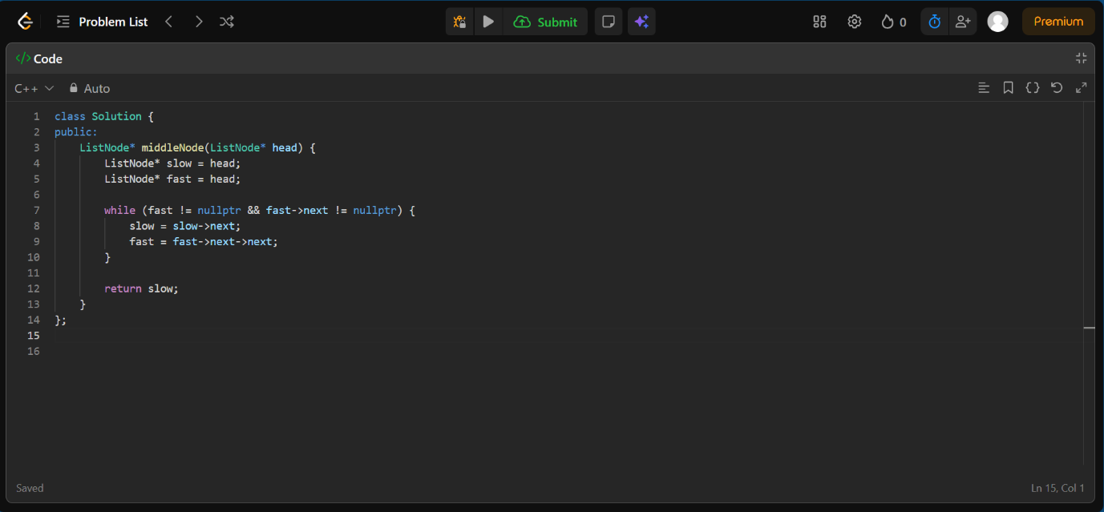
OUTPUT:
