Leetcode:
struct ListNode* removeElements(struct ListNode* head, int val) {
// Create a dummy node pointing to head
struct ListNode* dummy = (struct ListNode*)malloc(sizeof(struct ListNode));
dummy->next = head;

struct ListNode* prev = dummy;
struct ListNode* curr = head;

while (curr != NULL) {
if (curr->val == val) {
// Skip this node
prev->next = curr->next;
free(curr);
curr = prev->next;
} else {
prev = curr;
curr = curr->next;
}
}

struct ListNode* newHead = dummy->next;
free(dummy);
return newHead;
}

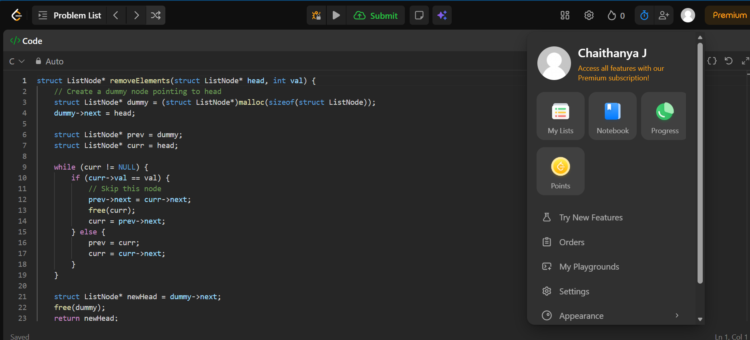
OUTPUT:
