Leetcode:
struct TreeNode* mergeTrees(struct TreeNode* root1, struct TreeNode* root2) {
if (root1 == NULL) return root2; // If first is null, use second
if (root2 == NULL) return root1; // If second is null, use first

// Both nodes exist: sum their values
root1->val += root2->val;

// Recursively merge left and right subtrees
root1->left = mergeTrees(root1->left, root2->left);
root1->right = mergeTrees(root1->right, root2->right);

return root1; // Return the merged tree
}

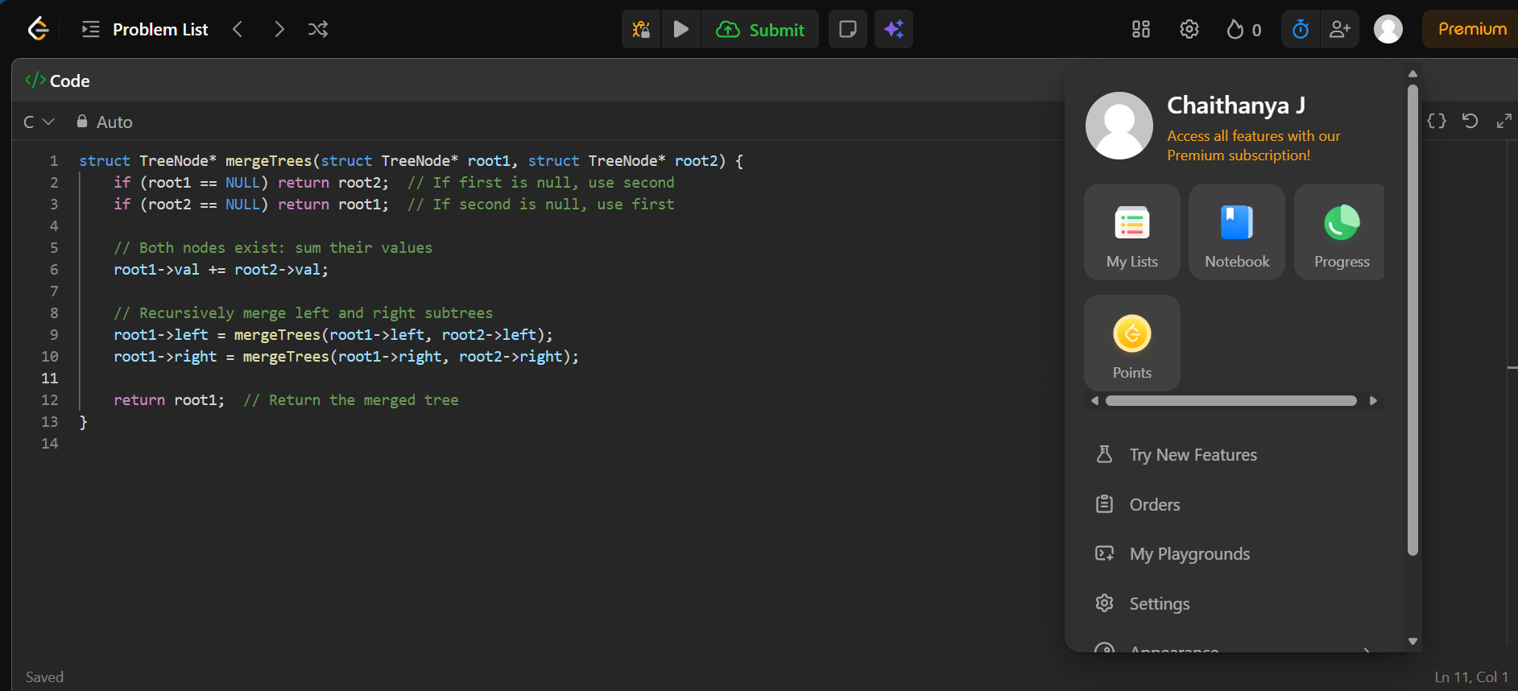

OUTPUT:


