Leetcode:
class Solution {
public:
bool hasCycle(ListNode *head) {
ListNode* slow = head;
ListNode* fast = head;

while (fast != nullptr && fast->next != nullptr) {
slow = slow->next; // move 1 step
fast = fast->next->next; // move 2 steps

if (slow == fast) { // they meet => cycle
return true;
}
}

return false; // fast reached end => no cycle
}
};

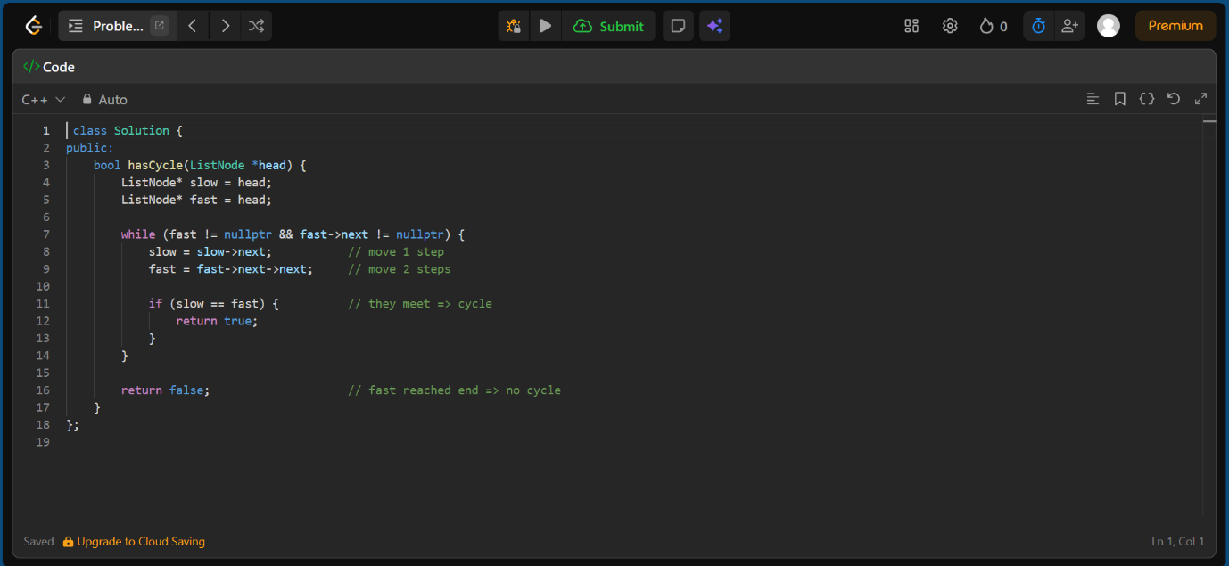

OUTPUT:
