AIHire: Virtual Interview Platform
Project Proposal, Literature Survey and Research Gap Analysis
Branch: CSE & CSIT
Academic Year: 2026–2027
Team No.: 2
Team Members
Roll Number | Student Name
2420030162 | V. Sai Dhanush
2420090077 | D. Krishna Chaitanya
2420090030 | U. Chaitanya Karthik

1. Problem Statement
Traditional recruitment involves considerable manual effort in resume screening, candidate shortlisting, interviews, communication assessment, and coding evaluation. Recruiters may have to process a large number of candidates, making the initial hiring process time-consuming and difficult to standardize.
Existing AI-based solutions often focus on individual tasks such as resume matching, interview assessment, speech analysis, or coding evaluation. There is a need for an integrated system that combines these different assessment stages to provide a comprehensive candidate evaluation.

2. Objectives
The main objective of AIHire is to develop an AI-powered virtual interview and candidate assessment platform that automates the initial stages of recruitment.
Key Objectives
- Analyze candidate resumes and job descriptions.
- Perform resume-job matching and candidate shortlisting.
- Conduct AI-powered, domain-specific voice interviews.
- Convert candidate speech into text using Whisper.
- Evaluate technical responses using BERT and Sentence Transformers.
- Analyze communication and emotion-related speech characteristics.
- Conduct a domain-specific coding assessment.
- Generate an overall candidate score and HR evaluation report.
Proposed Framework
Resume + Job Description → Resume Matching → Shortlisting → AI Voice Interview → Whisper Speech-to-Text → Technical Answer Evaluation → Communication & Emotion Analysis → Coding Assessment → Candidate Score → HR Report
3. Literature Survey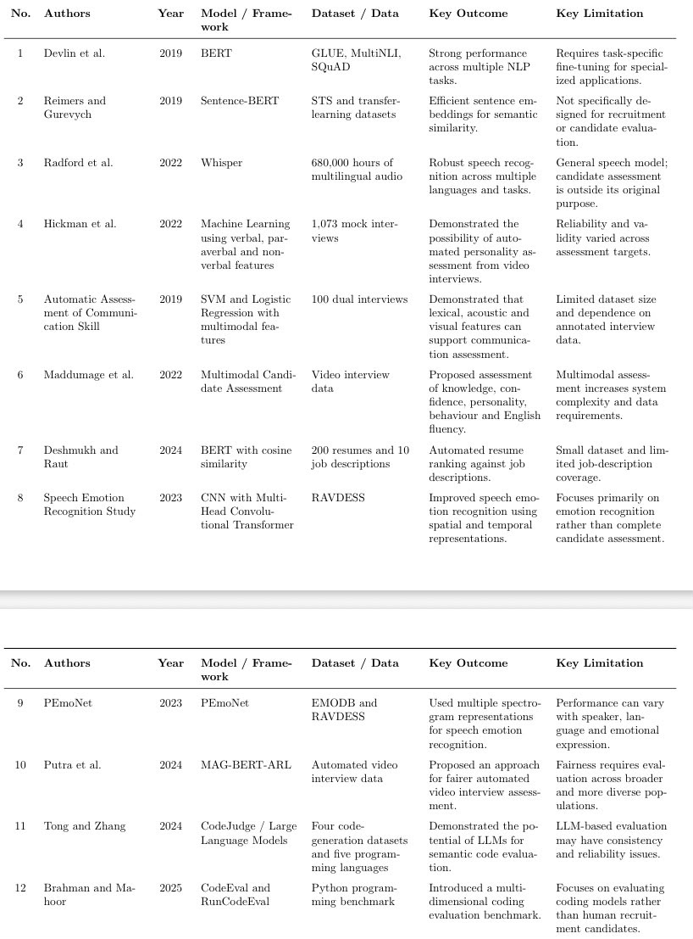

4. Research Gap
Existing studies successfully address individual recruitment tasks such as resume screening, semantic matching, automated interviews, speech recognition, emotion recognition, and coding evaluation. However, these components are generally developed and evaluated separately.
Identified Gaps
- Resume screening does not provide complete candidate assessment.
- Speech recognition mainly focuses on transcription.
- Emotion analysis is often treated as a standalone task.
- Coding assessment is usually conducted separately.
- Automated interviews require further investigation of reliability and fairness.
- Different assessment results are often not integrated into a single candidate profile.
Proposed Research Gap Addressed by AIHire
AIHire aims to address these gaps by integrating:
Resume Matching + AI Voice Interview + Speech-to-Text + Technical Answer Evaluation + Communication/Emotion Analysis + Coding Assessment + Integrated Candidate Scoring
into a single candidate assessment workflow.

5. Innovation & Creativity
AIHire combines multiple AI-based assessment techniques into a single recruitment workflow.
Key Points
- Resume and job-description matching for candidate shortlisting.
- Job-specific AI voice interviews.
- Whisper-based speech-to-text processing.
- BERT and Sentence Transformers for technical answer evaluation.
- Communication and emotion-related speech analysis.
- Integration of coding performance with interview results.
- Consolidated candidate scoring and HR evaluation report.
The creative aspect is the multi-dimensional assessment approach, where technical knowledge, communication, coding ability, speech characteristics, and job suitability are considered together.

6. Novelty
The novelty of AIHire lies in the integration of multiple existing AI technologies into a unified candidate assessment framework.
The project does not claim that technologies such as BERT, Whisper, or Sentence Transformers are individually new. Instead, AIHire combines these technologies with resume-job matching, AI interviewing, communication/emotion analysis, and coding assessment to create a unified recruitment workflow and candidate evaluation report.

7. Feasibility
- Technical Feasibility: Uses established technologies such as Python, NLP, BERT, Sentence Transformers, Whisper, and speech processing.
- Dataset Feasibility: Relevant resume, job-description, speech, emotion, and coding datasets are available.
- Implementation Feasibility: The system can be developed as separate modules and integrated progressively.
- Time Feasibility: The project can be completed through phased development, testing, integration, and documentation.

