AI-DRIVEN AGENTIC SMART EVENT TICKET BOOKING PLATFORM
(EventGenie)

A Mini Project Report Submitted in partial fulfillment of the requirements for the award of the degree of
BACHELOR OF TECHNOLOGY
in
DEPARTMENT OF COMPUTER SCIENCE AND ENGINEERING (CSE) & COMPUTER SCIENCE AND INFORMATION TECHNOLOGY (CSIT)
K L (Deemed to be) University

Submitted by
K. Yaswanth Reddy – 2420090053
U. Chaithanya Karthik – 2420090030
V. Sudhir – 2420030377

Under the Esteemed Guidance of
Dr.Neelima Gogineni

Academic Year 2026–2027


DEPARTMENT OF COMPUTER SCIENCE AND ENGINEERING (CSE) & COMPUTER SCIENCE AND INFORMATION TECHNOLOGY (CSIT)
DECLARATION
We hereby declare that the mini project report entitled “AI-Driven Agentic Smart Event Ticket Booking Platform (EventGenie)” is a record of work carried out by our team in partial fulfillment of the requirements for the award of the Bachelor of Technology degree at K L (Deemed to be) University. The report describes the design and development work undertaken by the team. To the best of our knowledge, the material presented here has not been submitted as a complete report for the award of a degree at another institution.

K. Yaswanth Reddy – 2420090053
U. Chaithanya Karthik – 2420090030
V. Sudhir – 2420030377

DEPARTMENT OF COMPUTER SCIENCE AND ENGINEERING (CSE) & COMPUTER SCIENCE AND INFORMATION TECHNOLOGY (CSIT)

CERTIFICATE
This is to certify that the mini project report entitled “AI-Driven Agentic Smart Event Ticket Booking Platform (EventGenie)” is a bonafide record of project work carried out by U. Chaithanya Karthik - 2420090030, K. Yaswanth Reddy - 2420090053, V. Sudhir - 2420030377 in partial fulfillment of the requirements for the award of the Bachelor of Technology degree in the Department of Computer Science Engineering, K L (Deemed to be) University, during the academic year 2026–2027.

Signature of Course Coordinator | Signature of HOD

ACKNOWLEDGEMENT

The success in this project would not have been possible but for the timely help and guidance rendered by many people. Our wish to express my sincere thanks to all those who has assisted us in one way or the other for the completion of my project.

Our greatest appreciation to my guide Dr.Neelima Gogineni, Department of Computer Science which cannot be expressed in words for his/her tremendous support, encouragement and guidance for this project.

We express our gratitude to Dr. P.Venkateshwar Sir (CSE)/Dr. Kaja Shareef Sir (CSIT), Head of the Department for Computer Science Engineering/ Department for Computer Science and Information Technology for providing us with adequate facilities, ways and means by which we are able to complete this project-based Lab.

We thank all the members of teaching and non-teaching staff members, and also who have assisted me directly or indirectly for successful completion of this project. Finally, I sincerely thank my parents, friends and classmates for their kind help and cooperation during my work.

K. Yaswanth Reddy – 2420090053
U. Chaithanya Karthik – 2420090030
V. Sudhir – 2420030377

TABLE OF CONTENTS
S. No. | Contents | Page No.
1. | Abstract | 06
2. | Introduction | 07
3. | Literature Survey | 08 - 09
4. | Problem Statement and Objectives | 10
5. | Hardware and Software Requirements | 11
6. | Implementation | 12-13
7. | Results and Discussion | 14,15,16,17
8. | Conclusion and Future Scope | 18
9. | References | 19

1. ABSTRACT
EventGenie is a web-based event ticket booking platform designed to help users discover and book tickets for live events in India, including concerts, cultural programmes, music festivals, technology events, comedy shows, and creative exhibitions. The project aims to provide a focused event-discovery experience with a simple interface, event details, ticket selection, user information, and a booking flow. The application is being developed using React and Vite for the frontend and Spring Boot microservices for backend services. The backend is divided into an API Gateway, Eureka service discovery, User Service, Event Service, and Booking Service. Event information is exposed through REST APIs, and the frontend accesses backend endpoints through the API Gateway. A simulated demo-payment workflow is used for academic demonstration; it is not connected to a real payment gateway and must not be treated as a real financial transaction. The planned intelligent component is to recommend events using user preferences and booking history, with the possibility of extending the platform into an agentic assistant that helps users find suitable events and guides them through booking. The current prototype establishes the core web interface and service-based structure. Further work is required to validate all booking scenarios, complete persistent user-history-based recommendations, strengthen security, and deploy the backend for public access.

Team Name: EventGenie

Team Members

K. Yaswanth Reddy – 2420090053
U. Chaithanya Karthik – 2420090030
V. Sudhir – 2420030377

2. INTRODUCTION

2.1 Background
Online event platforms help people discover activities and reserve tickets without visiting physical counters. However, users may need to browse multiple sources to compare event categories, dates, venues, and ticket details. A dedicated event-oriented platform can make this process clearer by presenting event information and booking actions in one place.

2.2 Project Overview
EventGenie is designed specifically for events rather than movies or dining reservations. Target categories include live music concerts, DJ and techno festivals, cultural festivals, classical performances, stand-up comedy, technology conferences, art exhibitions, and other public events. The initial focus is on Indian events, with Hyderabad venues used as examples during development.

2.3 Motivation
The project is motivated by the need for a simple, organized event booking experience and by the opportunity to apply microservices, REST APIs, frontend development, and AI-assisted personalization in a practical application. A modular backend also allows individual services to be developed and tested independently.

2.4 Scope
- Display event cards and details, including venue, date, price, and available seats where supplied by the backend.
- Provide a frontend flow for entering booking details and selecting ticket quantity.
- Separate user, event, and booking responsibilities into backend services.
- Route requests through the API Gateway and register services with Eureka.
- Use a simulated demo-payment result for demonstration only.
- Plan future AI-based event recommendations based on user interests and booking history.

2.5 Organization of the Report
The report presents related platforms, the problem statement and objectives, required hardware and software, implementation structure, prototype results, conclusions, future enhancements, and references.

3. LITERATURE SURVEY
The following platforms were reviewed as examples of event discovery, ticketing, event management, or ticket distribution. They are high-level references for common user journeys and feature categories; EventGenie does not claim to reproduce their proprietary systems.

BookMyShow
Provides event and entertainment discovery with event listings, venue/date information, and ticket purchase flows. Its interface is a useful reference for organizing event cards and guiding users from discovery to checkout. EventGenie narrows its scope to live events and cultural activities.
URL: https://in.bookmyshow.com/

District
Presents experiences and events such as live performances and activities. Its category-based discovery is a reference for browsing events by interest and location. EventGenie uses a similar discovery goal while focusing on its own event-specific requirements.
URL: https://www.district.in/

SkillBox
Focuses on discovering and booking live experiences, music events, and cultural events. It is a relevant comparison for an event-first platform and highlights the importance of event descriptions, artist information, and booking details.
URL: https://skillbox.co/

Paytm
Its ticketing and event-related services illustrate how digital platforms connect discovery and online transaction flows. EventGenie currently uses simulated payment for academic testing and does not process real payments.
URL: https://paytm.com/

Insider
Has been associated with event discovery and ticketing, including concerts, festivals, and experiences. Its event-focused catalog is a reference for event categories, venue details, and booking journeys. Service availability and branding may change over time.
URL: https://insider.in/

BookMyShow Live
Live-event pages highlight concerts, comedy shows, festivals, and other live experiences. This is relevant to EventGenie's focus on concerts, cultural programmes, and comedy rather than movie bookings.
URL: https://in.bookmyshow.com/explore/events

Eventbrite
Supports event publishing, discovery, registration, and ticket management. It is a reference for the broader event lifecycle, although EventGenie's initial prototype is primarily attendee-facing.
URL: https://www.eventbrite.com/

Townscript
Provides event registration and ticketing tools for organizers and participants. It is relevant to event registration workflows and the information required for event listings.
URL: https://www.townscript.com/

Ticketmaster
An established ticketing platform for live entertainment and sports. Its event pages demonstrate how event date, venue, ticket availability, and ticket-selection steps can be organized.
URL: https://www.ticketmaster.com/

4. PROBLEM STATEMENT AND OBJECTIVES

4.1 Problem Statement
Users need a convenient, event-focused platform to discover relevant live events and follow a clear ticket-booking process without navigating disconnected event listings.

4.2 Problem Description
Event details, categories, venue information, and booking steps can be spread across different services. Users may find it difficult to identify suitable events quickly and keep the booking journey organized. EventGenie proposes a unified interface with modular backend services and a foundation for personalized recommendations.

4.3 Objectives
- Develop a responsive web interface for browsing event categories and event cards.
- Provide event details such as name, description, location, date, ticket price, and seat availability where available.
- Create separate Spring Boot services for users, events, and bookings.
- Use Eureka for service discovery and an API Gateway as the common entry point for frontend API requests.
- Implement and test REST endpoints for retrieving event data and managing booking records.
- Demonstrate a simulated payment status flow without connecting to a real payment provider.
- Design a future AI recommendation component that can use user preferences and previous booking activity.
- Keep the codebase modular so authentication, payment integration, notifications, accessibility, and deployment can be added later.

4.4 Expected Novelty
- Event-first scope for concerts, cultural festivals, comedy, technology events, and creative activities.
- Microservice-based structure separating user, event, and booking capabilities.
- Planned AI personalization from user-selected interests and booking history, once implemented and tested.
- Planned conversational assistance to filter events and guide booking, with user confirmation before final actions.

4.5 Sustainable Development Goal (SDG)
Potential alignment includes United Nations SDG 9 (Industry, Innovation and Infrastructure), through development of a modular digital service, and SDG 11 (Sustainable Cities and Communities), through improved discovery of cultural and community events. These are intended areas of contribution; the prototype has not measured social impact.

5. HARDWARE AND SOFTWARE REQUIREMENTS

5.1 Hardware Requirements
- Computer or laptop capable of running Java, Node.js, and a local database.
- Recommended: 8 GB RAM or more, dual-core or better processor, and sufficient disk space for dependencies.
- Internet connection for downloading dependencies, accessing documentation, and optional cloud deployment.

5.2 Software Requirements
- Operating System: Windows 10/11 or compatible.
- Frontend: React, Vite, JavaScript, HTML, and CSS.
- Backend: Java and Spring Boot.
- Service discovery and routing: Spring Cloud Netflix Eureka and Spring Cloud Gateway.
- Build tools: Maven for Java services and npm for frontend.
- Database: MySQL, with MySQL Workbench where configured.
- Development environment: Visual Studio Code.
- API testing: Postman or equivalent REST client.
- Browser: a modern browser such as Google Chrome.

5.3 System Architecture
The application is organized into the following components:
- Frontend (React/Vite, local development port 5173) sends HTTP requests to the API Gateway.
- API Gateway (port 8080) routes requests to the relevant backend service.
- Eureka Server (port 8761) maintains the service registry for discovery.
- User Service (port 8081) handles user-related API responsibilities.
- Event Service (port 8082) provides event REST endpoints and event data.
- Booking Service (port 8083) handles booking records and the simulated demo-payment endpoint.
- MySQL is used where database configuration and persistence are enabled for the relevant service.
Architecture diagram to insert: Frontend → API Gateway → User Service / Event Service / Booking Service. Eureka Server supports service registration and discovery. Show database connections from the services that use configured databases.

6. IMPLEMENTATION

6.1 Frontend
The frontend is built with React and Vite. The main interface is implemented in frontend/src/App.jsx, with styling in frontend/src/App.css. The interface includes navigation, a Hyderabad location label, event search, category browsing, event cards, and a booking popup flow. Event images and labels are mapped for the sample event catalog. The exact displayed events depend on data returned by the backend and the current frontend mappings.
- frontend/src/App.jsx – main React interface, event loading, event display, and booking interactions.
- frontend/src/App.css – layout, typography, cards, responsive styling, and popup appearance.
- Vite development server – serves the frontend locally, typically at `http://localhost:5173`.

6.2 Backend
The backend is divided into Spring Boot projects so each major responsibility is separate. Services are started independently during development and communicate through REST endpoints and service discovery.
- `eureka-server` – service registry, typically available at `http://localhost:8761`.
- `api-gateway` – routes incoming API requests, typically at `http://localhost:8080`.
- `user-service` – user-related service, typically at `http://localhost:8081`.
- `event-service` – event-related service, typically at `http://localhost:8082`; controller endpoints are under `/events`.
- `booking-service` – booking-related service, typically at `http://localhost:8083`; controller endpoints are under `/bookings`.

6.3 Event Service
The Event entity stores event information such as ID, name, description, location, date, start time, end time, available seats, and price. The EventController provides REST operations to retrieve all events, create an event, retrieve an event by ID, update an event, and delete an event. The API Gateway routes `/events/**` requests to the Event Service.

6.4 Booking Service
The Booking entity includes booking ID, user ID, event ID, number of tickets, total amount, payment status, and booking status. The BookingController provides endpoints to list bookings, create a booking, retrieve a booking by ID, and invoke the simulated demo-payment workflow. The exact status behavior should be verified against the final BookingService implementation before submission.

6.5 API Integration
The frontend requests event data through the API Gateway using the `/events` endpoint. During local development, the gateway base URL is `http://localhost:8080`. Eureka allows the gateway to discover registered services by their application names. CORS configuration permits the local Vite origin during development. For public deployment, the frontend API base URL and CORS allowed origins must be updated to the deployed backend and frontend domains.

6.6 Simulated Payment and Limitations
The current payment path is intended for demonstration and testing only. It does not connect to a real payment gateway, charge a card, or confirm a financial transaction. The interface must describe this clearly wherever needed. Parking or transport details shown in the interface are illustrative unless connected to a real allocation or transport service.

6.7 Running the Application
- Start Eureka Server and confirm its dashboard opens at `http://localhost:8761`.
- Start User Service, Event Service, and Booking Service, and verify that they register with Eureka.
- Start API Gateway and confirm `http://localhost:8080/events` returns event JSON.
- Start the frontend using `npm run dev` from the `frontend` directory.
- Open `http://localhost:5173` and test event browsing and the available booking flow.
- Use Postman to test REST endpoints and inspect service logs when an API request fails.

7. RESULTS AND DISCUSSION
The prototype has established a React/Vite frontend and a Spring Boot microservice backend. During local testing, the services were registered with Eureka and the event list was successfully accessible through the API Gateway at `/events`.

Figure 7.1 – EventGenie Home Page

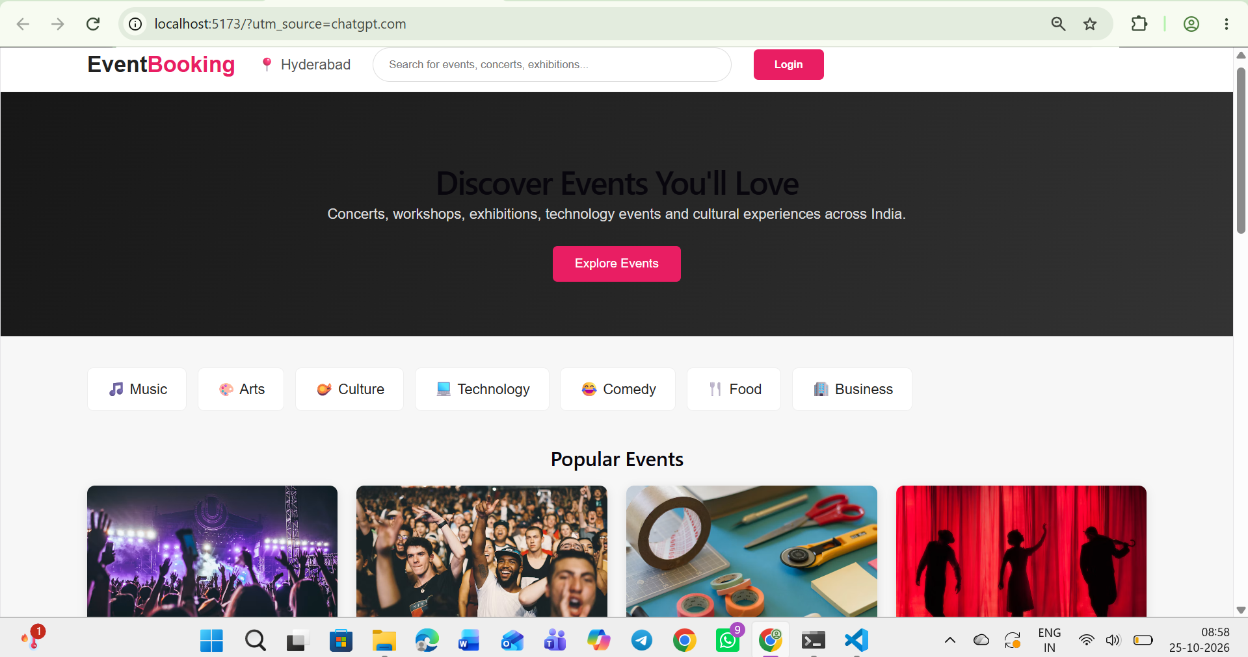

Figure 7.2 – Event Listing / Event Details
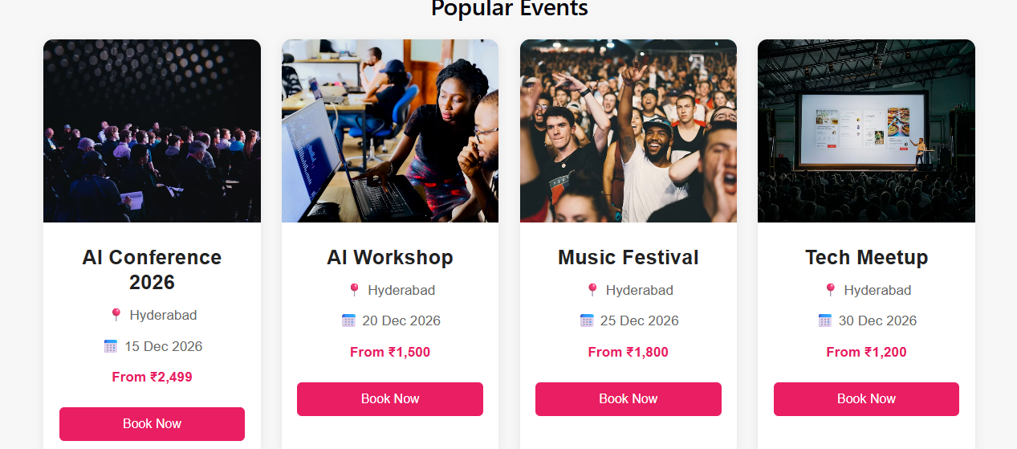

Figure 7.3 – Booking Details Popup
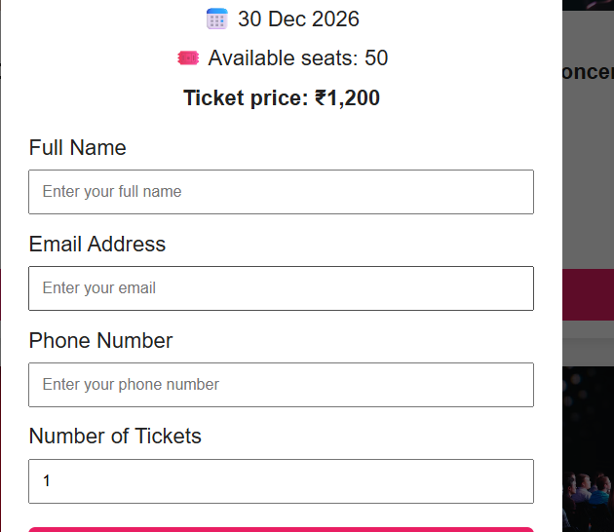

Figure 7.4 – Booking Confirmation

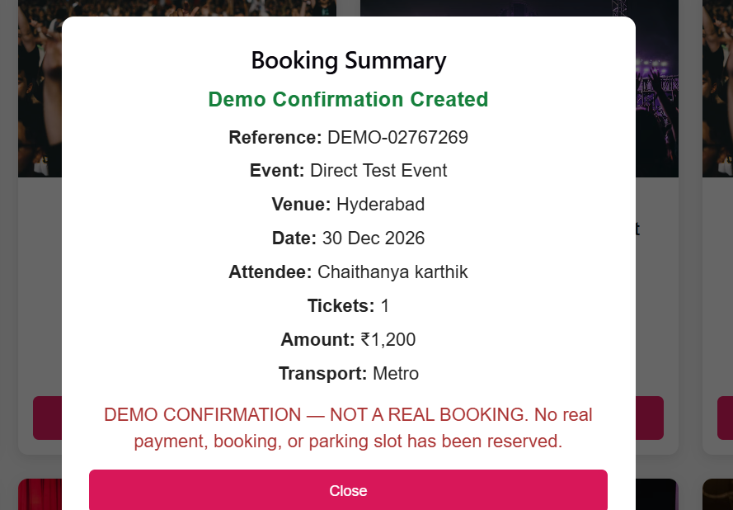

Figure 7.5 – Eureka Dashboard
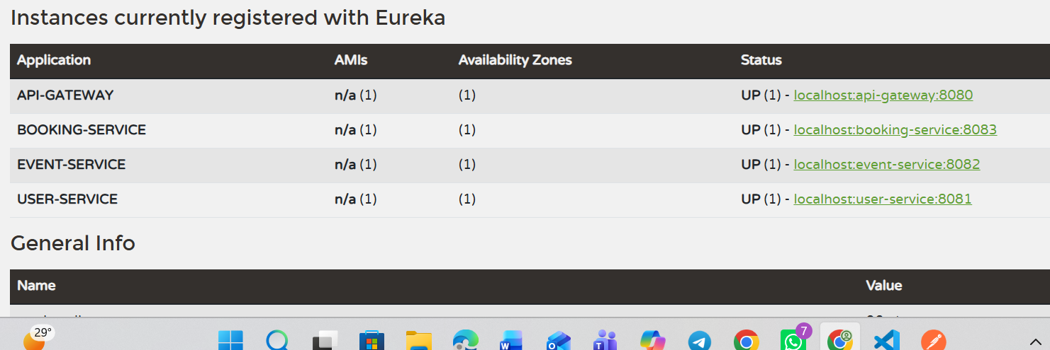

Figure 7.6 – Response
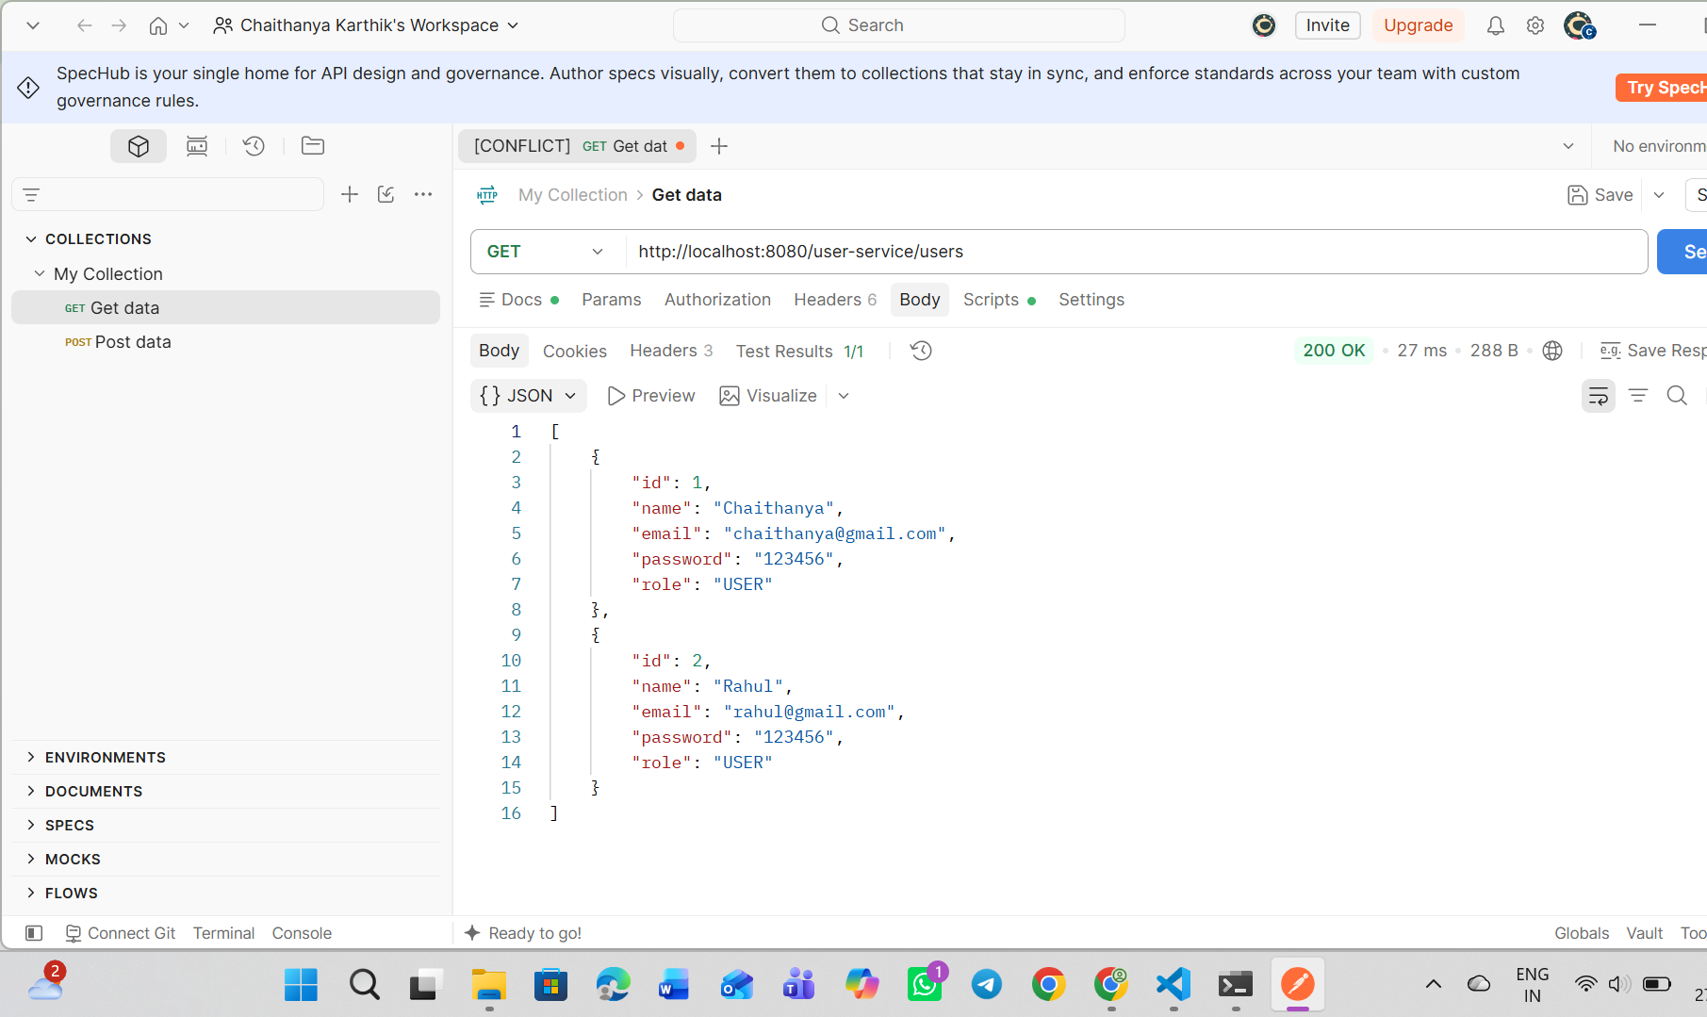

7.1 Discussion
The service-based design separates event, user, and booking responsibilities and makes the application easier to extend than a single monolithic backend. The successful event endpoint test demonstrates that the frontend-facing gateway can reach the Event Service in the local setup. The prototype still requires systematic tests for booking creation, payment-status transitions, data validation, authentication, failure handling, and deployment. AI-based personalization should be presented as planned unless a working implementation and test evidence are added.

8. CONCLUSION AND FUTURE SCOPE

8.1 Conclusion
EventGenie is a prototype for an event-focused ticket booking platform. It combines a React/Vite interface with Spring Boot services, Eureka service discovery, and an API Gateway. The current implementation supports event-data access through a REST API and provides a foundation for user and booking workflows. A simulated demo-payment path is used for academic demonstration rather than real financial processing. The modular architecture supports further development, but the final report should include screenshots and test evidence from the exact version submitted.

8.2 Future Scope

Short-term Enhancements
- Complete end-to-end booking validation, including seat availability, ticket quantity limits, and booking status persistence.
- Add unit, integration, and API tests for all service endpoints.
- Improve form validation, error messages, accessibility, and mobile responsiveness.

Medium-term Enhancements
- Implement secure authentication and authorization with suitable password handling and role-based access.
- Integrate a legitimate payment provider in a test/sandbox environment, with secure callback verification, if approved for the project.
- Add email or SMS booking notifications through a verified provider.
- Implement event recommendations based on user-selected interests and consented booking history.

Long-term Enhancements
- Add a conversational agent to help users find events, compare options, and guide booking while requiring user confirmation before final actions.
- Deploy frontend and backend to cloud hosting, configure production CORS and secrets, and use managed database hosting.
- Add organizer tools, event analytics, multilingual support, and stronger monitoring.
- Evaluate recommendation quality, usability, accessibility, and performance with documented test data.

9. REFERENCES
The following public websites were consulted as high-level references for event discovery, ticketing, event registration, and user-flow ideas. Accessed for documentation preparation on 28 October 2026. URLs are examples of related platforms and do not indicate affiliation.
1. BookMyShow: https://in.bookmyshow.com/
2. District: https://www.district.in/
3. SkillBox: https://skillbox.co/
4. Paytm: https://paytm.com/
5. Insider: https://insider.in/
6. BookMyShow Live: https://in.bookmyshow.com/explore/events
7. Eventbrite: https://www.eventbrite.com/
8. Townscript: https://www.townscript.com/
9. Ticketmaster: https://www.ticketmaster.com/
10. Meetup: https://www.meetup.com/
Additional technical documentation:
- React documentation: https://react.dev/
- Vite documentation: https://vite.dev/guide/
- Spring Boot documentation: https://docs.spring.io/spring-boot/index.html
- Spring Cloud Gateway documentation: https://docs.spring.io/spring-cloud-gateway/reference/
- Spring Cloud Netflix Eureka documentation: https://docs.spring.io/spring-cloud-netflix/reference/
- MySQL documentation: https://dev.mysql.com/doc/

