ASSIGNMENT-3

QUESTION:
Power Query
Objective – Power BI Desktop, Cloud Service and End to End Workflow
Use Case – Import list of the richest people using Query Editor Source – Richest people Analytics – The raw data - your task is to transform it into something more presentable. Report/Dashboard – Richest people • Create a new Power BI report, and load in the data • Some columns have been renamed, while each person's wealth (in billions of dollars) has been extracted 1. Replace the word billion with an empty string. 2. Replace the $ symbol with an empty string. 3. Convert the resulting column to a whole number. • Create a chart just to prove that the billions really are being treated as numbers. Result - Transform data using Query Editor
STEPS:

1. Create a New Power BI Report
- Open Power BI Desktop → File > New.
- Go to Home > Get Data > Excel (or CSV) → Load the file called Richest People.

2. Open Power Query (Query Editor)
- In the Home tab, click Transform Data.
- This opens the Power Query Editor where you can clean your dataset.

3. Clean the Wealth Column
Assume the column is something like Wealth with values like:
$120 billion, $80 billion, etc.
Do the following in Power Query:
- Replace “billion”
  - Select the Wealth column.
  - Go to Transform > Replace Values.
  - Find: billion → Replace with: (leave blank).
  - Now values look like $120, $80, etc.
- Remove the $ sign
  - Again, Transform > Replace Values.
  - Find: $ → Replace with: (leave blank).
  - Now values look like 120, 80, etc.
- Change Column Type
  - Select the Wealth column.
  - In the toolbar → Data Type dropdown → Choose Whole Number.
  - Power Query may ask: “Replace Current Step or Add New Step” → Choose Replace Current.

4. Apply Changes
- Click Close & Apply (top left).
- Now the clean dataset is loaded back into Power BI.

5. Create a Chart to Prove Numbers Work
- In Report View, select a Bar Chart or Column Chart.
- Drag:
  - Person Name → Axis
  - Wealth (cleaned) → Values
- The chart should show bars with numeric lengths → proving the billions are treated as numbers.

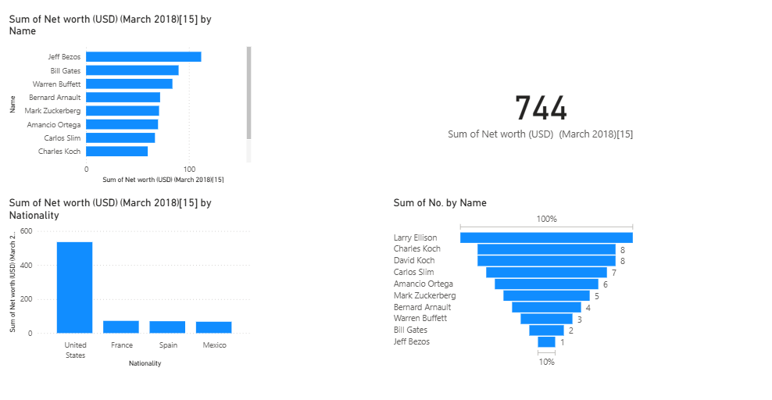
DASHBOARD:

