Plagiarism Detection Model

Chaithra Angadi | Sravya Kaitha
Department of Data Science | Department of Data Science
University of New Haven | University of New Haven
canga1@email.com | skait1@email.com

Abstract
Plagiarism is one of the leading academic misconducts associated with students in learning institutions such as universities. It is also gross misconduct in any form of provision of content by other professionals. People tend to copy content from different sources and provide it as their own work, and sometimes, the concerned people's detection of these plagiarized works might be a problem. This paper, therefore, explores some of the machine learning models that can be used to detect plagiarized content. We evaluate several models, such as decision trees, random forests, and support vector machines (SVM), using a Corpus of Plagiarized Short Answers dataset. These models are then assessed based on the accuracy scores. From the analysis, both Random Forest and Decision Tree models achieved the highest accuracy score of 95% compared to the SVM (90%).

Keywords: Plagiarism, machine learning, SVM, decision tree, random forest

1. Introduction
Plagiarism refers to using someone else's work, ideas, or creations without proper recognition. This activity creates a situation where someone's job is under threat to the authenticity, integrity, and credibility of scholarly endeavors. This problem has become a prevalent issue, and if it is not dealt with in time, it will have huge effects on the academic situation of the whole world as academic works spread all over the world at a very high speed. As a result of the negative impacts that plagiarism will have on the educational sector, a better solution is required to take place as quickly as possible.
This is why the development of a powerful and effective plagiarism detection system is highly recommended to uphold credibility, academic integrity, truthfulness, innovativeness, and intellectual property rights.
The main objective of this research paper is to use a combination of Machine Learning (ML) algorithms and Natural processing Language (NPL) techniques to develop a robust plagiarism detection model to combat the increasing issues of plagiarism in the academic sector.
When the techniques of NLP and ML are compiled together, they can provide a well-structured computational framework that can progressively learn and master the annotated data provided to it. This is because ML models can be trained to identify the difference between the original and plagiarized text, while NPL can be used to identify the flow of the text and whether it is plagiarized or original.
The development of this model will help detect plagiarized work, thus upholding intellectual honesty and academic integrity in the digital world.

2. LITERATURE REVIEW

2.1 Introduction
Plagiarism detection in academic textual content has been a major problem in recent academia, as most of the content that the learners claim to be their own work is actually plagiarized work from other scholars. In traditional times, it was very difficult to detect such academic cheating as plagiarism because there has never been a concrete solution set aside to solve this tragedy in full.
With the increased growth of online information, people are more likely to plagiarize their work than ever before. To solve this problem, an automated solution that will simply run the textual content and flag the plagiarized parts is necessary. This paper mainly describes how this automated system can be developed using both machine learning and natural processing language techniques. Machine Learning and Natural Processing Language techniques are used to solve this problem to ensure that the literature works are of integrity and credibility.

Multiple previous works have been conducted by different authors in relation to plagiarism detection using different techniques.

Babu et al., 2022, explains how using various corpus-based measures of semantic word comparability, the method for evaluating the semantic similitude of texts and a standardized and modified version of the Longest Common Subsequence (LCS) used in the SMV algorithm is a string matching calculation. The text similarity methods that have been in use in recent times have their primary focus on dealing with large datasets or single words. However, in this research, our primary focus is identifying the proximity of two different sentences or brief sections to each other (Babu et al., 2022).
The assessed results of the two different informational indexes will show that the strategy used will outstretch the contending techniques. The author indicated that LCS algorithm is highly effective while using a large dataset.

Kalleberg, 2015, describes how he used decision tree algorithm with the huge and noisy dataset ; this algorithm works well under circumstances where the dataset is imbalanced (Kalleberg, 2015). In a case of a dataset imbalance, oversampling and under-sampling techniques are most effective in putting the dataset in the desired format to ensure that the algorithm works well with the dataset, no matter the structure of which it is provided. In most cases where the dataset is imbalanced, Random trees are easily affected by overfitting . This requires the developer to carefully tune the hyperparameters. The success of the study was based on the balancing the dataset using both oversampling and under-sampling (Kalleberg, 2015).
Lastly, Folty’nek et al., 2019, used SVM algorithm to develop a plagiarism detection model because of its effectiveness in classifying the binary activities performed at detection and pre-processing of the provided text to be analyzed. The commonly used statistical data that the authors used in this case study using this algorithm are the Longest Common Subsequence (LCS), Dice coefficient, Levenshtein distance, and Jaccard coefficient (Folty’nek et al., 2019).

3. research methodology

3.1 Introduction
This project involves building and evaluating machine learning models to identify plagiarized content in a given corpus. The dataset used in this project is a slightly modified version of data created by Paul Clough (Information Studies) and Mark Stevenson (Computer Science) at the University of Sheffield. The project starts with data loading and extraction, data pre-processing, and transformation and ends with model building and evaluation on the train dataset.

3.2 Corpus Dataset
The dataset "A Corpus of Plagiarized Short Answers" was created by Paul Clough from the Information Studies department and Mark Stevenson from the Computer Science department, both at the University of Sheffield. This dataset is often used in academic research to evaluate plagiarism detection systems. It has 100 text files representing different categories of plagiarism, as shown in the figure below.

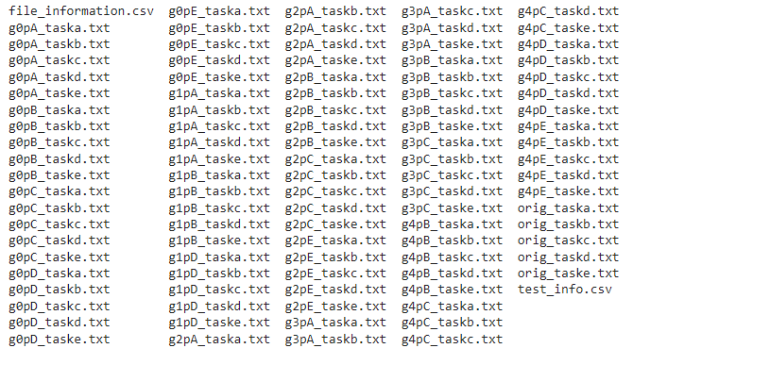

Figure 1: Dataset downloaded files

The dataset was designed to test and develop systems capable of detecting plagiarism, especially in educational settings. It consists of short answer texts collected to form a controlled environment where plagiarism is known and can be quantitatively assessed. The figure below shows the different tasks and plagiarism categories per text file.
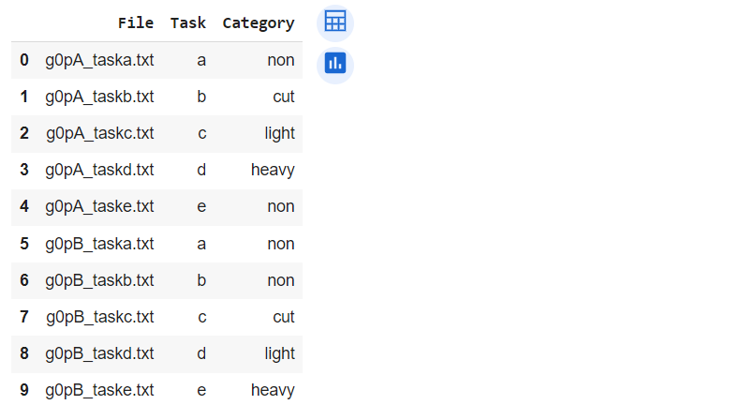
Figure 2: Tasks and categories per text file

3.3 Data Pre-processing
Data pre-processing is one of the most crucial steps in any data analytics project. It ensures that the data used for analysis is accurate. It usually involves many processes that finally result in more robust data for further analysis.

3.3.1 Categorical to Numerical Conversion
The current category values, which are categorical variables, are converted to numerical variables by assigning each category a numerical value. This is done because most machine learning algorithms require numerical values due to the calculations performed with numerical inputs, thereby improving model performance. In our dataset, we converted the "Category" attribute from categorical to numerical by assigning each category a numerical value.
0 - non
1 - heavy
2 - light
3 - cut
-1 orig, this indicates an original file
We also create a "Class" column based on the "Category" column. The resulting data frame is shown in the figure below.

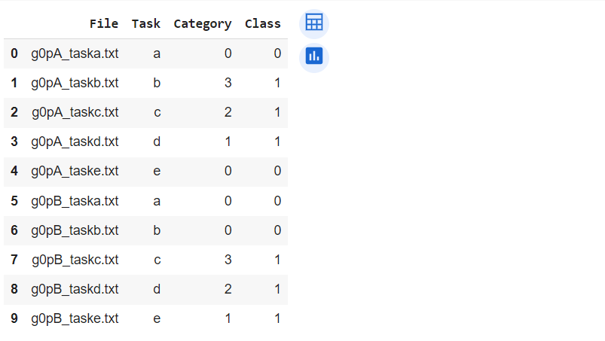
Figure 3: Dataframe after numerical conversion

3.3.2 Text Processing
This process involves transforming the data into forms that machine learning models can utilize for plagiarism detection. We apply various techniques, such as NLP techniques, to help with model performance by reducing the noise in the data.

Tokenization: Tokenization splits text into smaller parts called tokens, typically words or phrases. This step is crucial for structuring raw text for further processing, such as parsing and indexing. Different tokenizers can manage various complexities in text, including punctuation and special characters .

Lemmatization: Lemmatization reduces words to their base or dictionary form by considering their morphological analysis. It ensures that words are reduced to meaningful base forms, considering their parts of speech, which aids in standardizing text inputs for further study.

Stopwords Removal: Stopword removal involves eliminating frequently occurring words that carry little semantic importance, such as "and", "the", and "is". This process helps focus on the significant text elements, improving the efficiency and effectiveness of subsequent data processing and analysis tasks.

3.3.3 Adding Text Column to DataFrame
The text files contain texts that should be added to the DataFrame for further analysis. The resulting DataFrame is shown in the figure below.
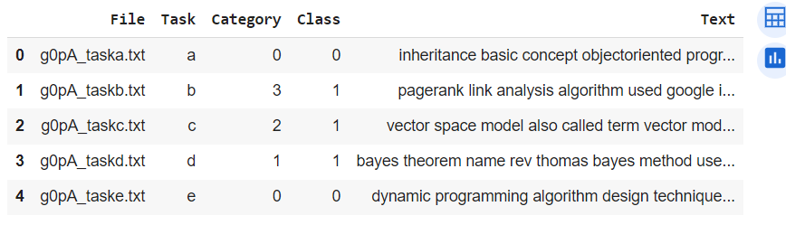
Figure 4: Dataframe with text column

3.3.4 Data Splitting into Train and Test
The dataset is split into train and test sets based on certain conditions by assigning either train or test labels. The two conditions defined are:
- train_test: Rows where the Category value exceeds 0 (indicating plagiarized answers).
- non_plagiarized: Rows where Category is 0 (indicating non-plagiarized or original answers).

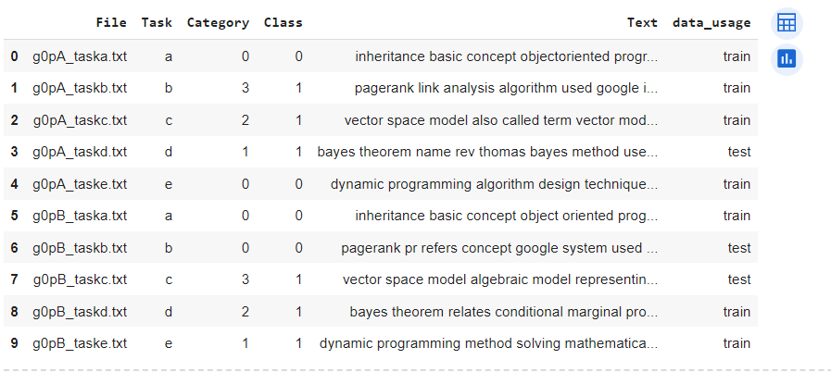
Figure 5: Dataset with train and test values

3.4 Feature Engineering
Feature engineering is a crucial step in building and optimizing machine learning models. It involves selecting, modifying, or creating new features from raw data to increase the predictive power of machine learning algorithms. Practical feature engineering enhances model accuracy by providing algorithms with more insightful data that captures underlying patterns or anomalies. This section defines some similarity features (containment features and Longest Common Subsequence (LCS)) to help us build a robust plagiarism detector model.

3.4.1 Containment Features
Containment is an effective method for detecting overlap in word usage between two documents; it may aid in identifying incidents of cut-and-paste as well as paraphrased levels of plagiarism. Because plagiarism is a pretty tricky task at various levels, it is frequently beneficial to include additional similarity metrics.

3.4.2 Longest Common Subsequence
The Longest Common Subsequence (LCS) is a well-known computer science problem and a key concept in dynamic programming and bioinformatics. It entails identifying the longest subsequence shared by two (or more) sequences that can occur in the same relative order but are not necessarily contiguous. Unlike the most extended common subsequence problem, characters in a subsequence do not have to be in consecutive locations inside the primary sequences.

3.4.3 Features DataFrame Creation
The features dataframe containing all the generated features is then created by defining an ngram range. This dataframe is shown in the figure below.
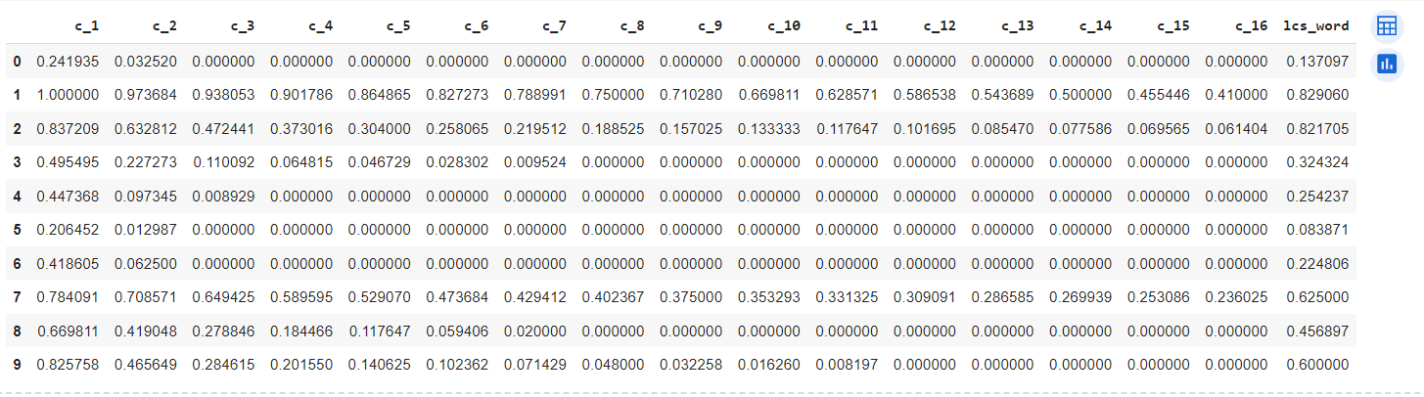
Figure 6: Features dataframe

3.4.4 Features Correlation Matrix
The figure below shows the correlation matrix of the features in the features DataFrame. This correlation matrix helps us choose the right features to include in generating the test and train data.
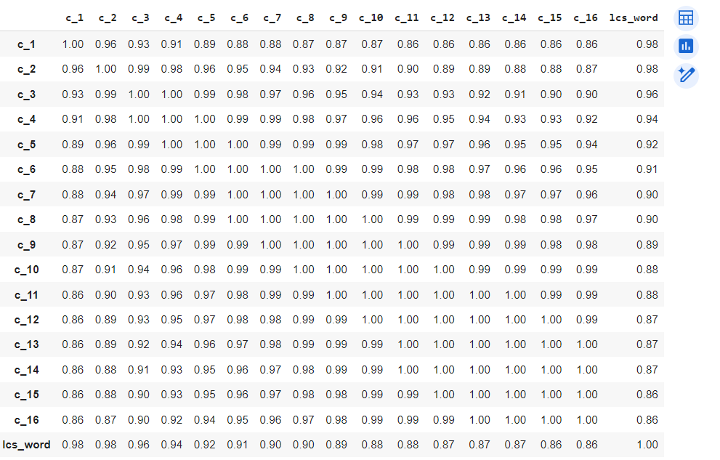
Figure 7: Correlation matrix

4.0 Implementation of Machine Learning Models for Plagiarism Detection
This section describes the various machine learning models used in this project to help with plagiarism detection. These are classification algorithms that classify a text as either plagiarized or not.

4.1 Decision Tree
This was the first model used for plagiarism detection on the dataset. We used the DecisionTreeClassifier to initialize this model using 2 leaf nodes to avoid overfitting and simplify the decision process.

4.2 Support Vector Machine (SVM)

This is another classification model used for plagiarism detection on the dataset. It is initialized using the Support Vector Classifier. This model has a mighty predictive power for classification tasks such as plagiarism detection.

4.3 Random Forest
The last model used for plagiarism detection on the dataset is Random Forest, initialized using the RandomForestClassifier. This model is just an extension of the Decision Tree model, and it constructs a multitude of decision trees at training time and outputs the predicted class.
These three models form a comprehensive toolkit for plagiarism detection in texts. Each model provides different strengths and capabilities for handling the complexities of the text data.

5.0 Evaluation and Results
In this section, each model's results are thoroughly analyzed and evaluated to determine its performance in relation to plagiarism detection.
Various model performance metrics, such as accuracy, precision, recall, and f1-score, were calculated for each model, and a comparison was made to select the best-performing model.

5.1 Results
5.1.1 Decision Tree
This model achieved an accuracy score of 95% with a precision, recall, and f1-score of 100%, 88%, and 93%, respectively.

Accuracy Score: 95.0%
Classification Report:
precision recall f1-score support

0 1.00 0.88 0.93 8
1 0.92 1.00 0.96 12

accuracy 0.95 20
macro avg 0.96 0.94 0.95 20
weighted avg 0.95 0.95 0.95 20

Confusion Matrix:
[[ 7 1]
[ 0 12]]

The Decision Tree model demonstrated strong performance with a 95% accuracy rate. It achieved perfect precision, indicating no false positives, but its 88% recall suggests some actual plagiarism cases were missed. The f1-score of 93% reflects high accuracy and precision in its predictions. However, improvements could be made in detecting all positive cases, as shown in the confusion matrix with few misclassifications.

5.1.2 Support Vector Machine
SVM achieved an accuracy score of 90% with precision, recall, and f1-score of 80%, 100%, and 89%, respectively
Accuracy Score: 90.0%
Classification Report:
precision recall f1-score support

0 0.80 1.00 0.89 8
1 1.00 0.83 0.91 12

accuracy 0.90 20
macro avg 0.90 0.92 0.90 20
weighted avg 0.92 0.90 0.90 20

Confusion Matrix:
[[ 8 0]
[ 2 10]]

The SVM model recorded a 90% accuracy, with excellent recall (100%), indicating it identified all actual plagiarism cases—however, precision at 80% points to some non-plagiarized texts being incorrectly marked as plagiarized. The f1-score of 89% shows a strong performance, especially in identifying true positives, but suggests room for improvement in minimizing false positives, as highlighted by the confusion matrix.

5.1.3 Random Forest
This model achieved an accuracy score of 95% with a precision, recall, and f1-score of 100%, 88%, and 93%, respectively.
Accuracy Score: 95.0%
Classification Report:
precision recall f1-score support

0 1.00 0.88 0.93 8
1 0.92 1.00 0.96 12

accuracy 0.95 20
macro avg 0.96 0.94 0.95 20
weighted avg 0.95 0.95 0.95 20

Confusion Matrix:
[[ 7 1]
[ 0 12]]

Matching the Decision Tree, the Random Forest model also achieved a 95% accuracy. It offered high precision (100%) and a solid f1-score (93%), indicating a robust capability in making accurate and consistent plagiarism detections. The recall of 88% suggests a slight issue in catching every instance of plagiarism. The confusion matrix with minimal false classifications underscores its effectiveness but indicates the potential for subtle improvements in recall.

5.2 Comparative Analysis of the Models
This section introduces a comprehensive analysis of the three models' performance. The table below shows the models and their accuracy scores.

Model | Accuracy
Decision Tree | 95%
SVM | 90%
Random Forest | 95%
Table 1: Model performance comparison table

Decision Trees and Random Forests have the same accuracy score of 95%, while SVM has an accuracy of 90%. Thus, random forests and decision trees are the best models for detecting text plagiarism.

6.0 Conclusion

Plagiarism has been a significant concern due to the rising availability of online resources that people can easily copy without proper recognition. This project majorly focused on building plagiarism detection models that can be used to detect plagiarism in texts. The process started with text pre-processing using data cleaning techniques from NLTK and other standard data cleaning techniques to ensure that the data for training and testing is accurate and appropriate. We built three machine learning models and trained them on the training data, then evaluated them using various metrics such as accuracy, precision, recall, and f1-score. Random Forest and Decision Tree outperformed SVM by achieving an accuracy score of 95% each compared to the 90% achieved by SVM. This means that the two models are better at detecting plagiarism in texts.

References
AL-Jibory, F. K., & Al, E. (2021). Hybrid System for Plagiarism Detection on A Scientific Paper. Turkish Journal of Computer and Mathematics Education (TURCOMAT), 12(13), 5707–5719. https://doi.org/10.17762/turcomat.v12i13.9822
Babu, A., S, A., Udayan, A. P., John, G. M., & B, D. S. (2022). Online Plagiarism Detection and Result Evaluation using Data Mining and NLP. International Journal of Engineering Research & Technology, 10(4). https://doi.org/10.17577/IJERTCONV10IS04031
Chaudhary, A., Kolhe, S., & Kamal, R. (2016). An improved random forest classifier for multi-class classification. Information Processing in Agriculture, 3(4), 215–222. https://doi.org/10.1016/j.inpa.2016.08.002
Chong, M. Y. M. (2013). A study on plagiarism detection and plagiarism direction identification using natural language processing techniques. Wlv.openrepository.com. https://wlv.openrepository.com/handle/2436/298219
El-Rashidy, M. A., Mohamed, R. G., El-Fishawy, N. A., & Shouman, M. A. (2023). An effective text plagiarism detection system based on feature selection and SVM techniques. Multimedia Tools and Applications, 83(1), 2609–2646. https://doi.org/10.1007/s11042-023-15703-4
Foltýnek, T., Meuschke, N., & Gipp, B. (2019). Academic Plagiarism Detection. ACM Computing Surveys, 52(6), 1–42. https://doi.org/10.1145/3345317
Kalleberge, R. (2015, May). Redirect Notice. Www.google.com. https://www.google.com/url?sa=t&source=web&rct=j&opi=89978449&url=https://uia.brage.unit.no/uia-xmlui/bitstream/handle/11250/299460/Rune%2520Borge%2520Kalleberg.pdf%3Fsequence%3D1%26isAllowed%3Dy&ved=2ahUKEwjNk6y45d2FAxUs_7sIHX7zDB0QFnoECCgQAQ&usg=AOvVaw1Q7bWDPjLywzgQ9B3JSgmP

