Q.12.connect to database using PostgreSQL and get the details of participants in test 1 and age > 50.

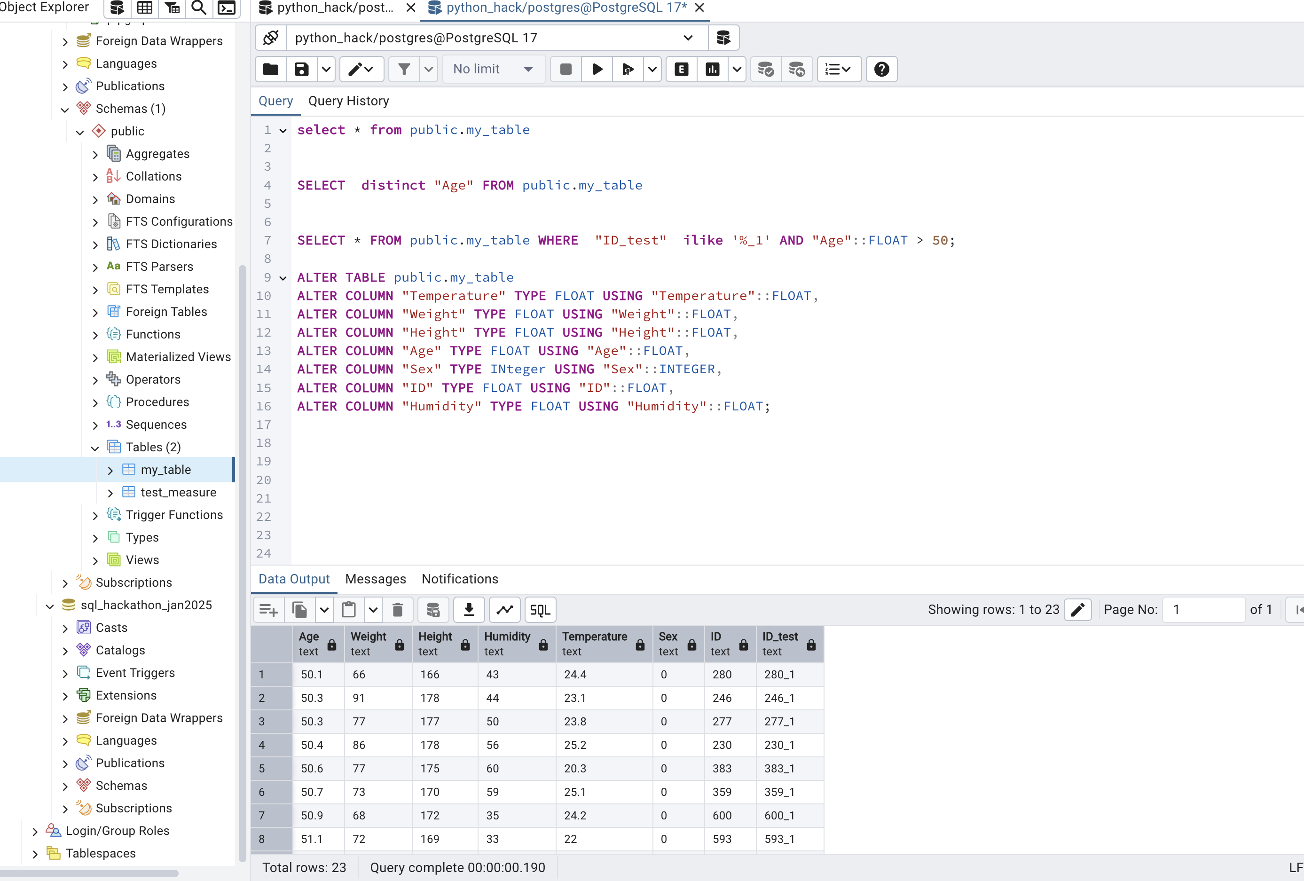

Q.33. Connect to database using PostgreSQL and increase the temperature 2 degrees for participant with maximum humidity and display the result.

