**B.Tech. IOT Project Report**

Submitted in partial fulfillment of the requirements for the

**Smart Dustbin Using Arduino**

**Submitted by**

**BHOOMIKA SHIROL 20191CSE0073**

**CHAITHRA L M 20191CSE0086**

**CLARINA ANNET B A 20191CSE0109**

**SIDDHARTH S CHANDARANA 20191CSE0769**

**RAHUL ANTONY J 20191CSE0770**

**Department of Computer Science and Engineering**

**School of Engineering**

**Under the Guidance of**

**Prof. Dipali Dhakole**

**Assistant Professor**

**Department of Computer Science and Engineering**

**School of Engineering**



**PRESIDENCY UNIVERSITY, BENGALURU**

**202l-22**

**Department of Computer Science & Engineering**

**Bengaluru**



**Certificate**

This is to certify that the project entitled “**Smart Dustbin Using Arduino *”*** has been successfully completed by Ms. Bhoomika Shirol, Ms. Chaithra L M, Ms. Clarina Annet B A, Mr. Siddharth S Chandarana, Mr. Rahul Antony J of sixth semester B.Tech at **Presidency University Bengaluru,** as the Internet Of Things project in complete fulfilment for the award of B.Tech degree course conducted by the Presidency University. The Project Report presented here is the bonafide work of the student.

**Guide:** **Head of the Department:**

Asst Prof. Dipali Dhakole Dr. T K Thivakaran

**Group Members:**

|  |  |
| --- | --- |
| ID | **NAME** |
| 20191CSE0073 | Bhoomika Shirol |
| 20191CSE0086 | Chaithra L M |
| 20191CSE0109 | Clarina Annet B A |
| 20191CSE0769 | Siddharth S Chandarana |
| 20191CSE0770 | Rahul Antony J |

**Acknowledgement**

We as a team are grateful to Dr.T K Thivakaran and Ms. Dipali Dakhole for their constant supervision and guidance. We would also like to express our gratitude to our parents for their encouragement and support.

**ABSTRACT**

In this report, we have presented in detail a low-cost and user-friendly smart dustbin automation system using Arduino UNO, ultrasonic sensors, servomotor, and battery. With an increase in the population, we have an increase in garbage in urban areas. Ordinary trash cans must be opened by pressing your foot against the lever and then emptied. Using IOT and sensor-based circuitry, we propose a smart dustbin that operates automatically to help solve this issue.

This paper describes the hardware and software architecture of the system, future work, and scope. The proposed prototype of the smart dustbin system was implemented and tested on hardware, and it gave us the expected results.

## TABLE OF CONTENTS

*Acknowledgement*

*Abstract*

1. Components Required 06
2. Features of Components Used 07
3. Pinout Diagram 11
4. Manual Connection of the Project 12
5. Code 14

6. ReadMe 16

7. Conclusion 17

**COMPONENTS USED**

1. Arduino Uno
2. Ultrasonic Sensor
3. Servomotor
4. Battery
5. Jumper Wires
6. Bin Frame
7. Cables And Connectors

## FEATURE OF COMPONENTS USED

### **Arduino Board**

Arduino is a prototype platform (open-source) based on an easy-to-use hardware and software. It consists of a circuit board, which can be programed (referred to as a microcontroller) and a ready-made software called Arduino IDE (Integrated Development Environment), which is used to write and upload the computer code to the physical board.

Arduino provides a standard form factor that breaks the functions of the micro-controller into a more accessible package.

## Arduino Pin Out Diagram

## ardu

1. **Ultrasonic Sensor**

An ultrasonic sensor is an electronic device that measures the distance of a target object by emitting ultrasonic sound waves, and converts the reflected sound into an electrical signal.

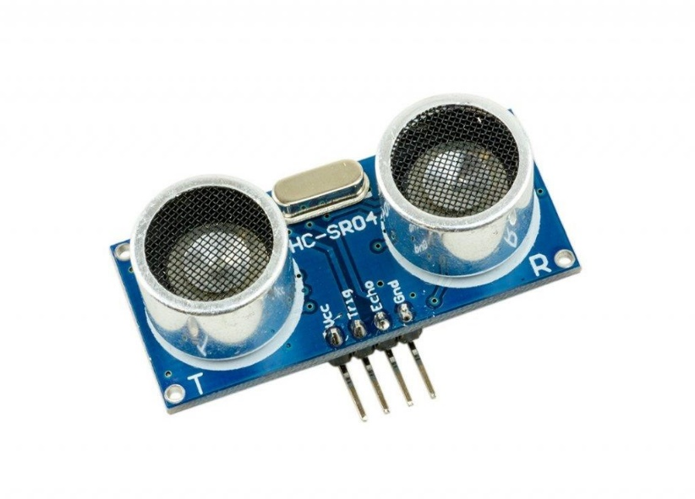

1. **Servomotor**

A servomotor is a rotatory actuator or linear actuator that allows for precise control of angular or linear position, velocity and acceleration. It used to control the speed of the flap of the dust bin.

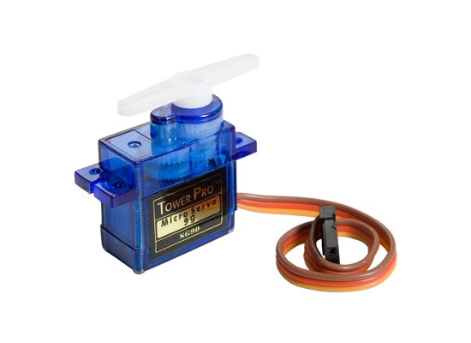

## Jumper Wires

A jump **wire** (also known as **jumper wire**, or **jumper**) is an electrical **wire**, or group of them in a cable, with a connector or pin at each end (or sometimes without them – simply "tinned"), which is normally **used** to interconnect the components of a breadboard or other prototype or test circuit, internally or with other.

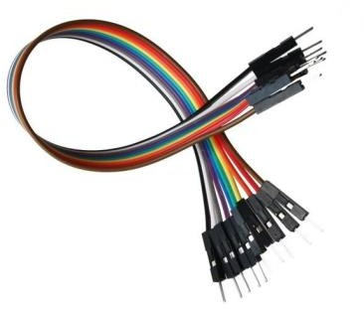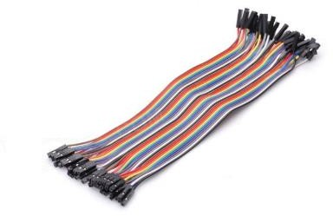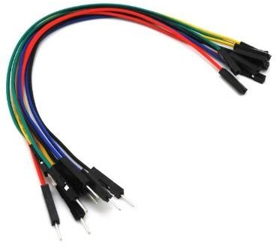

**Male to Male Female to Female Male to Female**

1. **Battery**

 A common nine-volt battery which is usually used in smoke alarms, smoke detectors, walkie-talkies, transistor radios and other small portable devices is used.

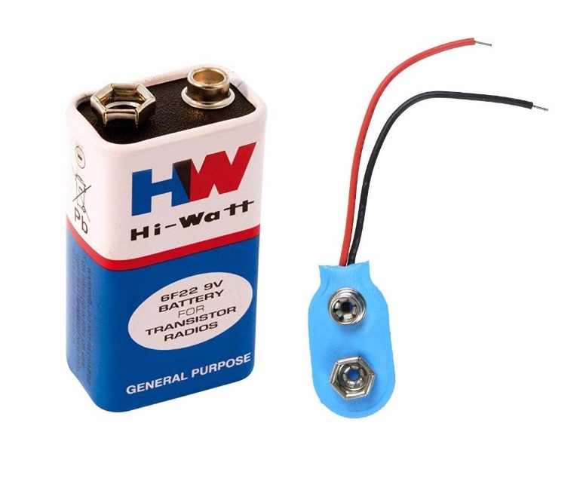

1. **Bin Frame**

 A regular plastic waste bin was used as the bin frame.

And a disposable eco-friendly plate was used as the lid of the bin, this of course  was built as the basic model.

 

1. **USB Cable**

The term USB stands for "Universal Serial Bus". USB cable assemblies are some of the most popular cable types available, used mostly to connect computers to peripheral devices such as cameras, camcorders, printers, scanners, and more.

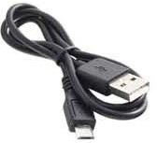

**PINOUT DIAGRAM**

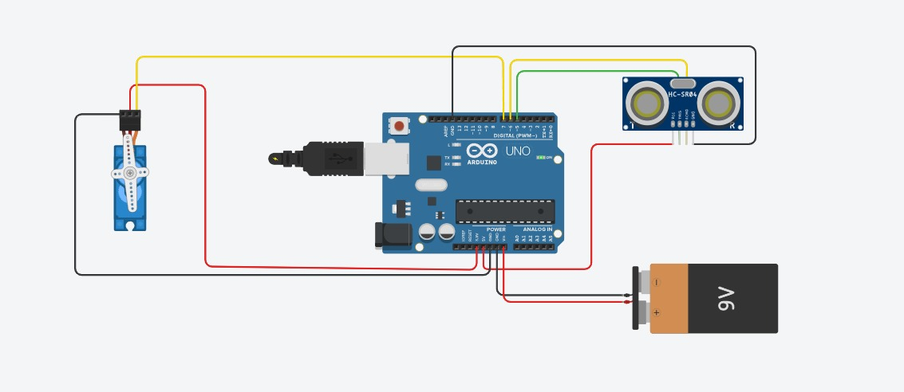

**MANUAL CONNECTION OF PROJECT**

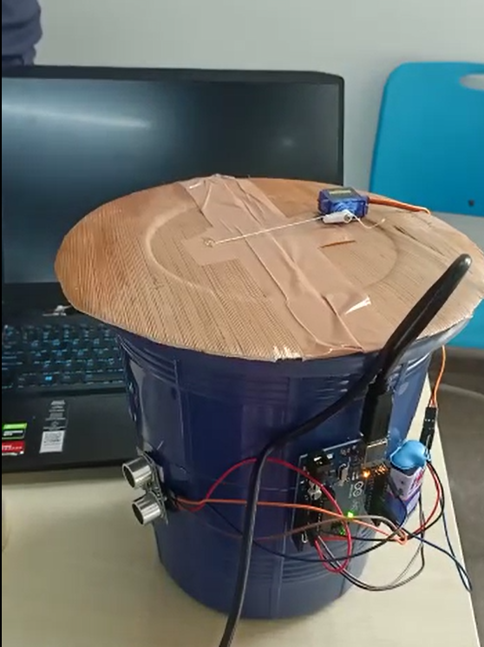

**I**

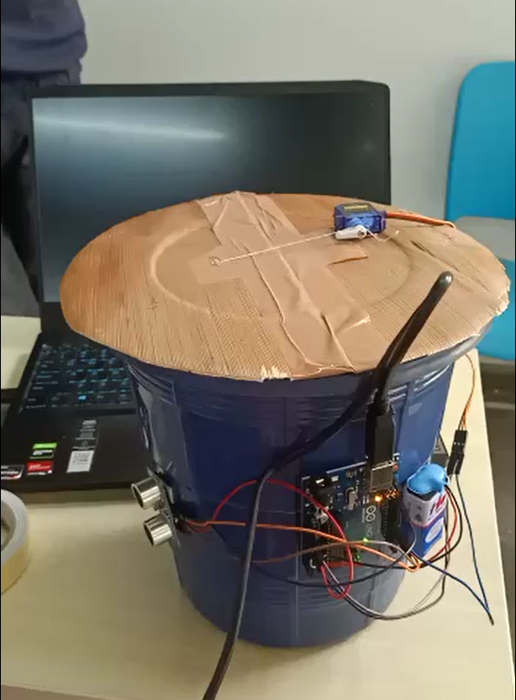

**II**

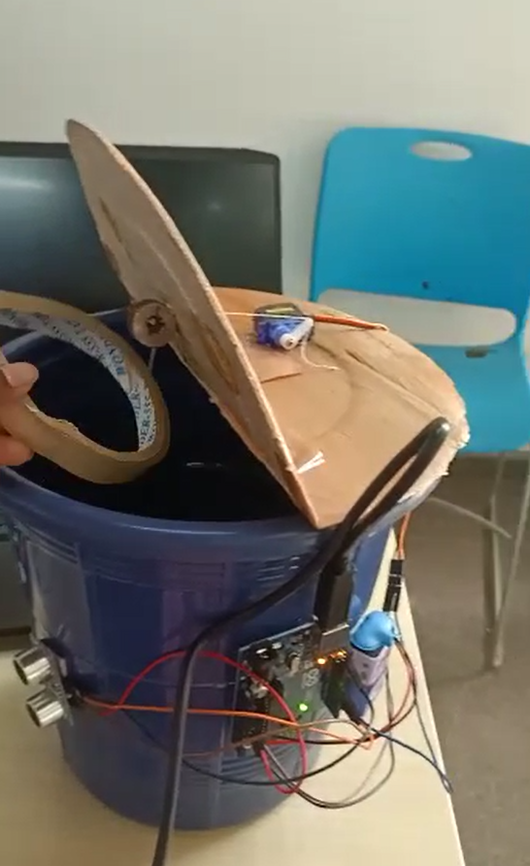

**III**



**IV**

# **CODE**

#include <Servo.h> //servo library

Servo servo;

int trigPin = 5;

int echoPin = 6;

int servoPin = 7;

int led= 10;

long duration, dist, average;

long aver[3]; //array for average

void setup() {

Serial.begin(9600);

servo.attach(servoPin);

pinMode(trigPin, OUTPUT);

pinMode(echoPin, INPUT);

servo.write(0); //close cap on power on

delay(100);

servo.detach();

}

void measure() {

digitalWrite(10,HIGH);

digitalWrite(trigPin, LOW);

delayMicroseconds(5);

digitalWrite(trigPin, HIGH);

delayMicroseconds(15);

digitalWrite(trigPin, LOW);

pinMode(echoPin, INPUT);

duration = pulseIn(echoPin, HIGH);

dist = (duration/2) / 29.1; //obtain distance

}

void loop() {

for (int i=0;i<=2;i++) { //average distance

measure();

aver[i]=dist;

delay(10); //delay between measurements

}

dist=(aver[0]+aver[1]+aver[2])/3;

if ( dist<50 ) {

//Change distance as per your need

servo.attach(servoPin);

delay(1);

servo.write(0);

delay(3000);

servo.write(150);

delay(1000);

servo.detach();

}

Serial.print(dist);

}

**README**

The smart dustbin uses a servo, an Arduino, a trigger and an ultrasonic sensor.

These are all first connected and put on the dustbin in a way where the sensor is kept on the upper half of the dustbin near the mouth and facing towards the user.

The sensor keeps sending an echo signal. As soon as it finds an object within 50 cm, it sends a trigger signal, which is picked up by the Arduino.

The Arduino sends a signal to the servo motor, which is then programmed to rotate backwards. The servo is connected to the front hatch of the dustbin via a string, which helps in lifting and closing the hatch.

Thus, the servo rotates backwards, opening the hatch and waiting for a sleep time of 6 seconds, as where in a real-life application, that would be the time to throw away the trash.

After a sleep time of 6 seconds, the servo motor rotates back, closing the lid of the dustbin. And this continues on to a loop every time the sensor detects and opens and closes the lid of the hatch of our smart dustbin.

# **CONCLUSION**

In this project, we propose a smart dustbin using IOT and sensor-based circuitry. Ordinary trash cans must be opened by pressing your foot against the lever and then emptied. The smart dustbin that we designed does this by itself. This bin can be widely used in offices, homes, and even in public places for garbage management. Thus, we get an automated smart dustbin.