**Architecture and Design**

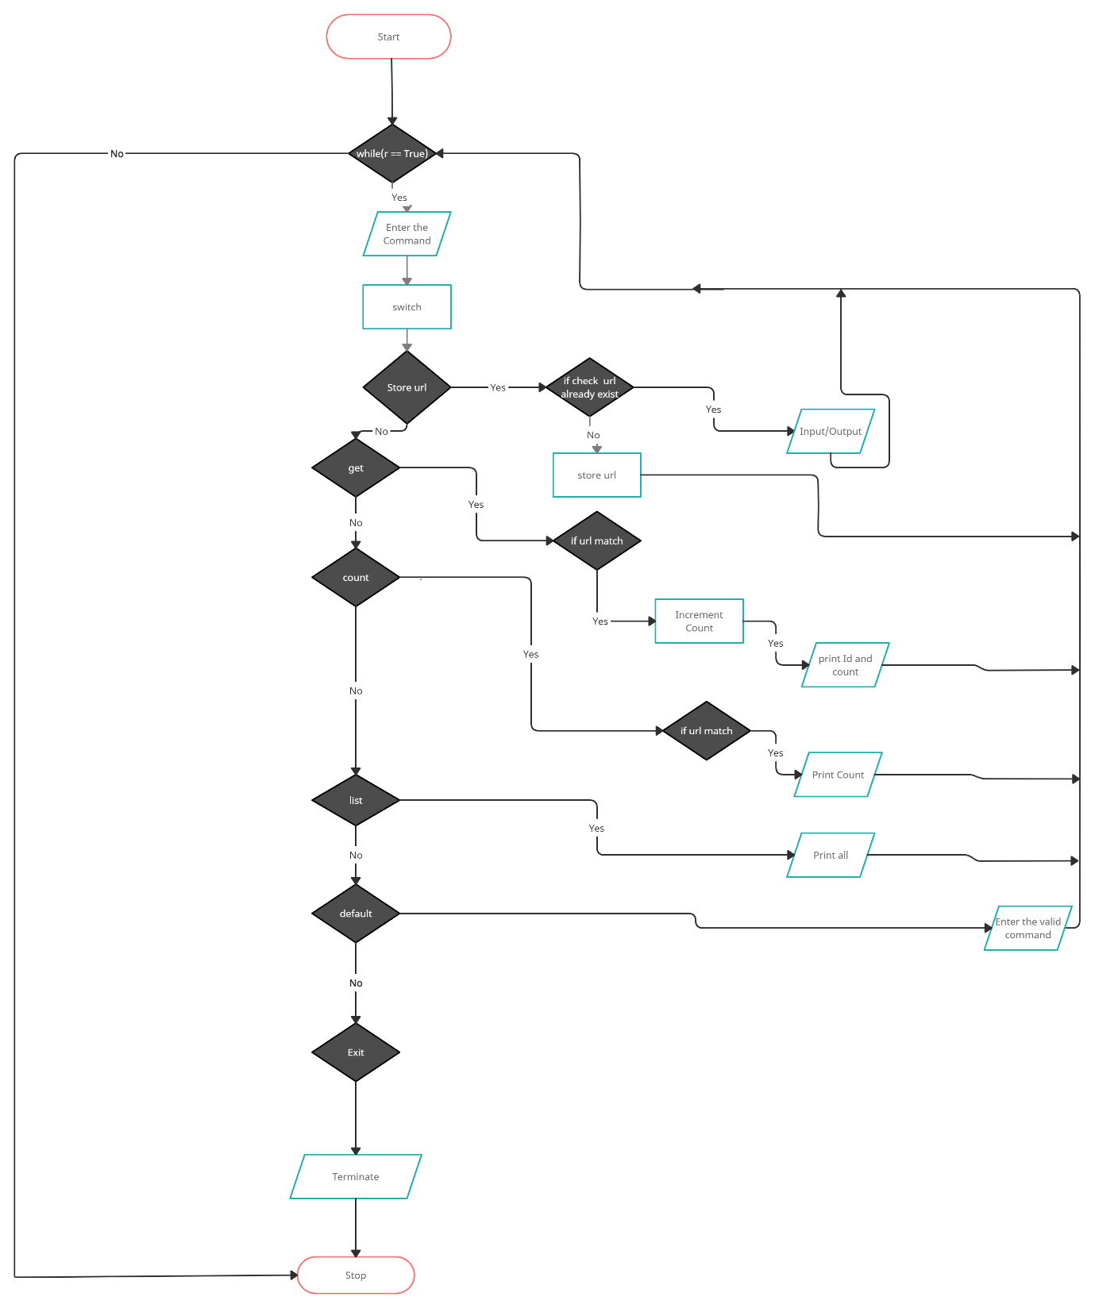

The main class is UrlDataBase. The class Url contains id, urlLink and count. Url[ ] is an array of objects. Initialize the boolean variable r as True, r become false when we exit the program, otherwise enter the command. Then read the command and split using the split() function, It split on the basis of white space. Then convert it into an array and assign it to c and link, both are strings and link is initialized as NULL. There is a chance of exception, if the command is a single word then take the command as string. Then pass the command to switch case . If the command is "get" then print the url id and count.

If the command is "storeurl" then check the url is already exist or not, for that we use a boolean function check(). If it exists then terminate the loop and print already exist, otherwise add the url into array of url. The UUID.randomUUID() function automatically generate a random id for URL. If the command is "list" then it list all the URLs in the array. If the command is "count" then it display the number of times the url become get. If the command is "exit" then terminate the program. As default, if we donot enter a valid command then it displays a message.