|  |  |
| --- | --- |
| **Student Repository** |  |
|  |  |

**Project Detail**

Project Name: Student Repo

Project Version: 1.0

**Project Details:** This project is for the design and developing a backend administrative portal for the Learner’s Academy using Java EE technologies

**Objective**: The Objective of this project is to apply servlet, jsp and JDBC concepts.

**Developer Detail**

Name: Chaithra B

Email: Chaithra.b.Vinay@gmail.com

**Technologies and tools Used:**

* Servlet: to do the business logic and works a controller for the project.
* JSP: to handle the presentation view.
* SQL: to create and manage the database.
* JDBC: to make operations on the database for the project.
* CSS: to format the contents.
* Eclipse: to write and run the code.
* Tomcat: to run and deploy servlet application.

**Flow Chart:**

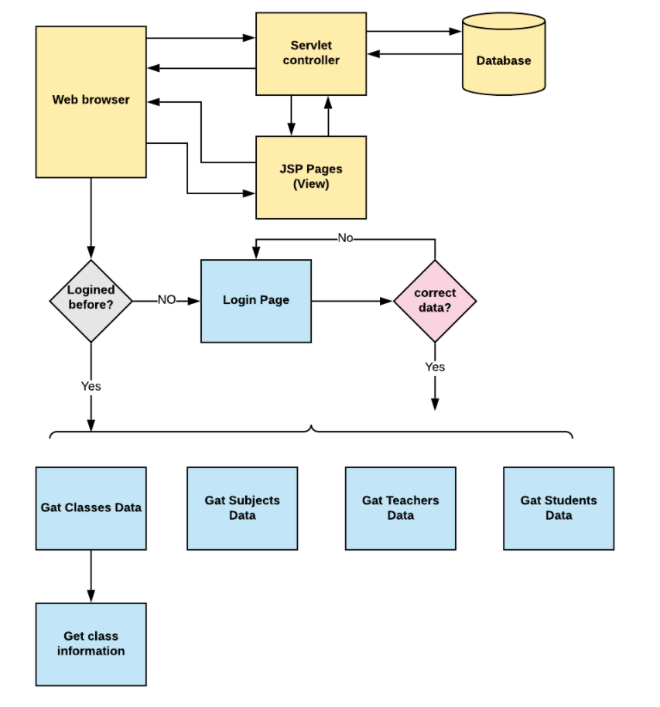

**Sprint Plan:**

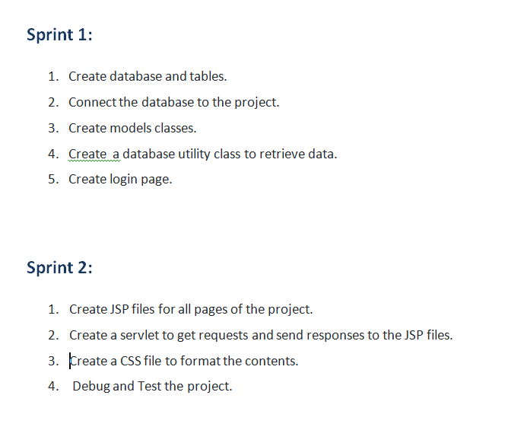

**Concept used in this programme:**

1. Object-Oriented: used to create and model objects for users and their credentials.
2. Databases: used to store and retrieve data.
3. Data Sources: used to define a set of properties required to identify and access the database.
4. Collections: used some collections such arraylist to store collection of data.
5. Exception Handling: used to catch problems that arises in the code especially in I/O blocks.
6. Cookies: to store log-in data on the client browser. Searching and Sorting

**How to run the program:**

1. clone project
2. Import the “database\database.sql” file to your database administration tool.
3. Go to “\src\main\webapp\META-INF\context.xml” file and open it.
4. Edit the database’ properties such as username, password and driverClassName to be suit to your database administration tool.
5. Now run program on a server.
6. To login you must enter admin for both username and password.

**Github Repository** –

<https://github.com/ChaithraBrao/JavaLearningSimpliLearn/tree/main/StudentRepositorySystem>