1.httpd

2. nginx

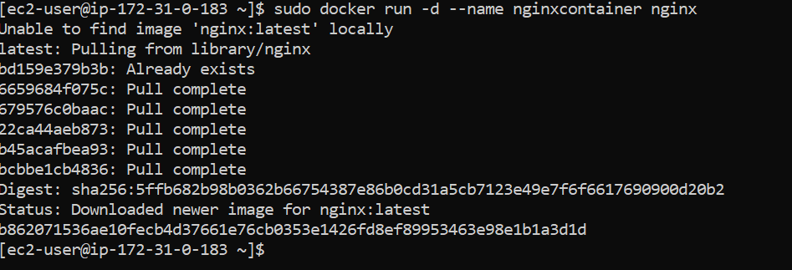

3. mysql

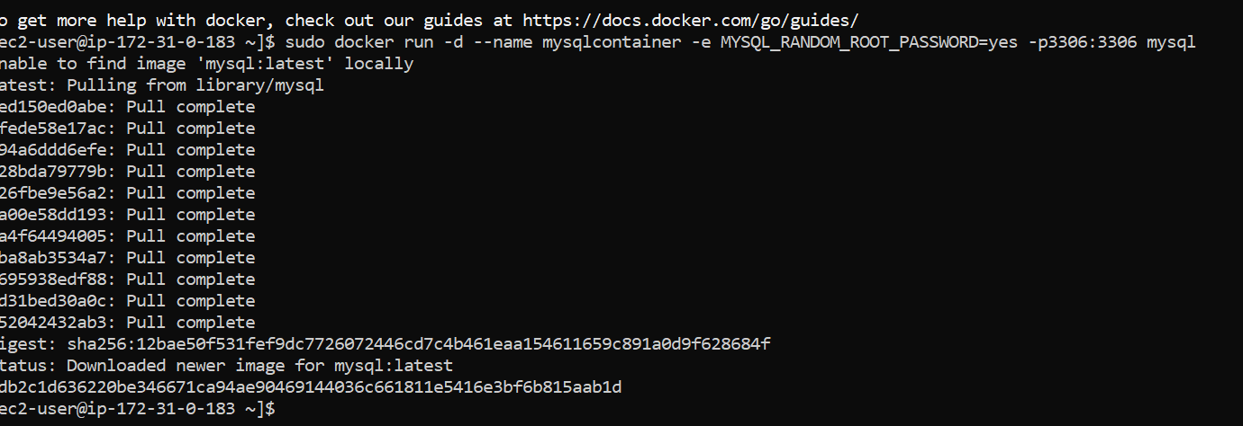

Generated password

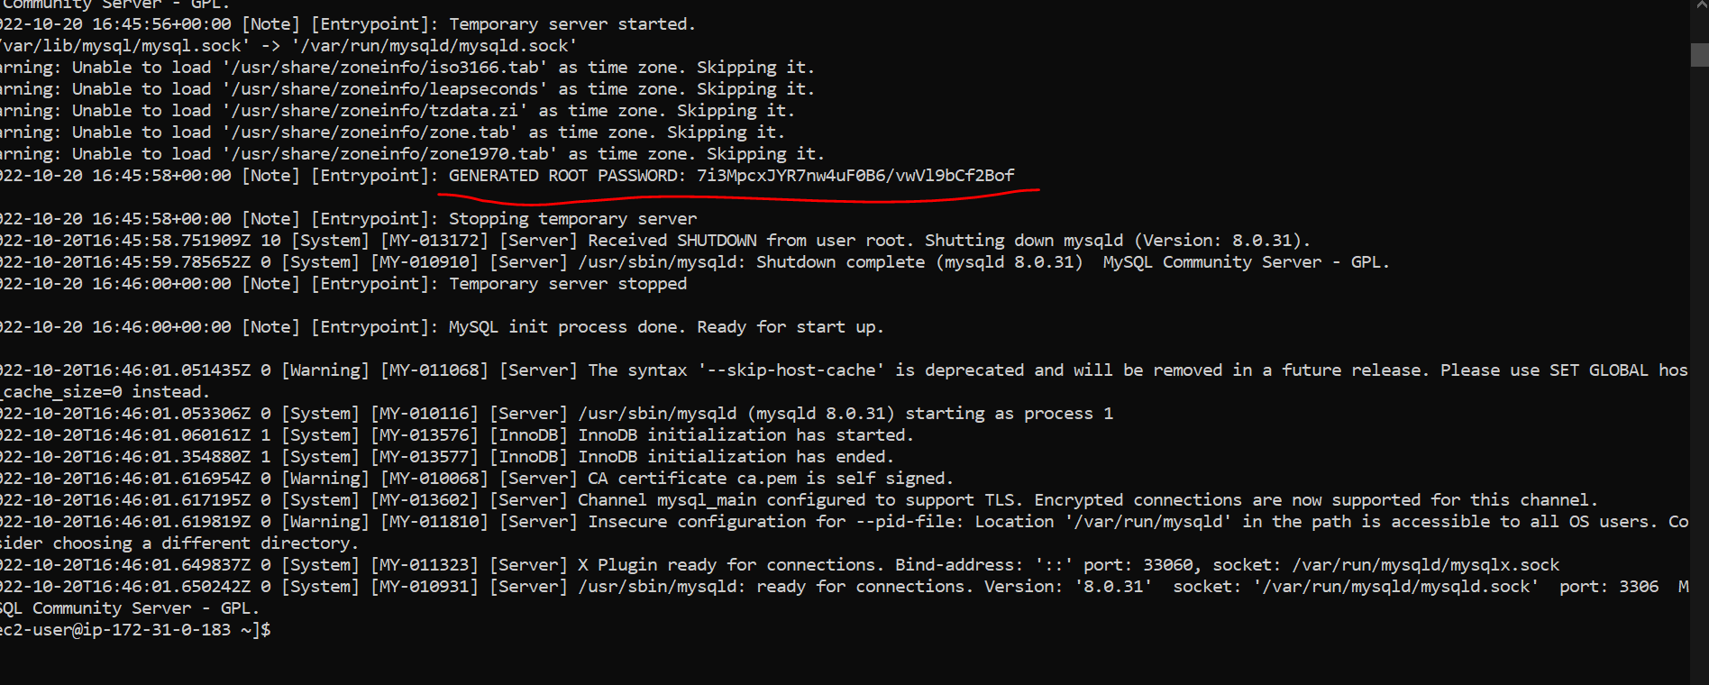

Stop containers



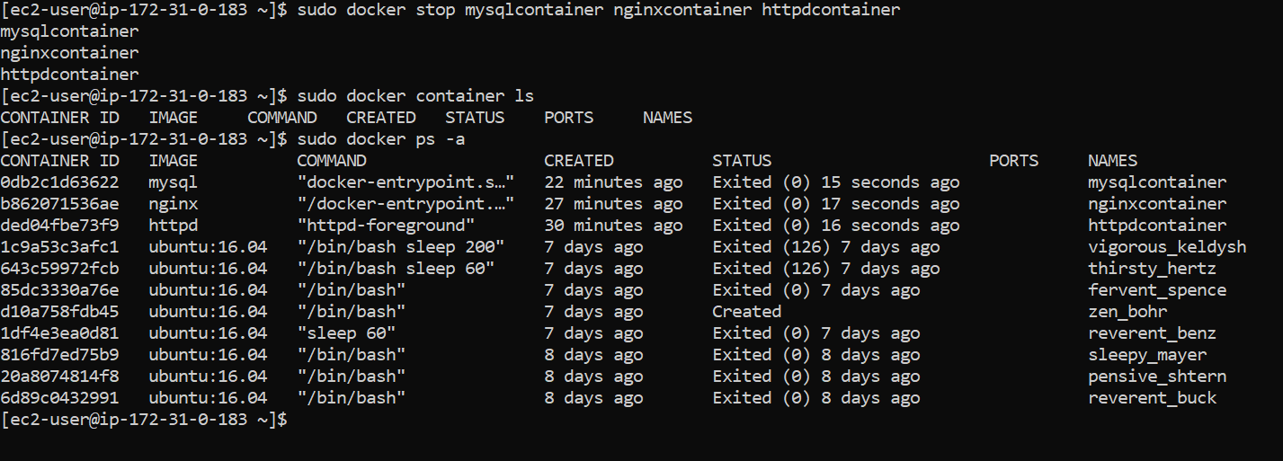

Remove containers

