Ubuntu curl version

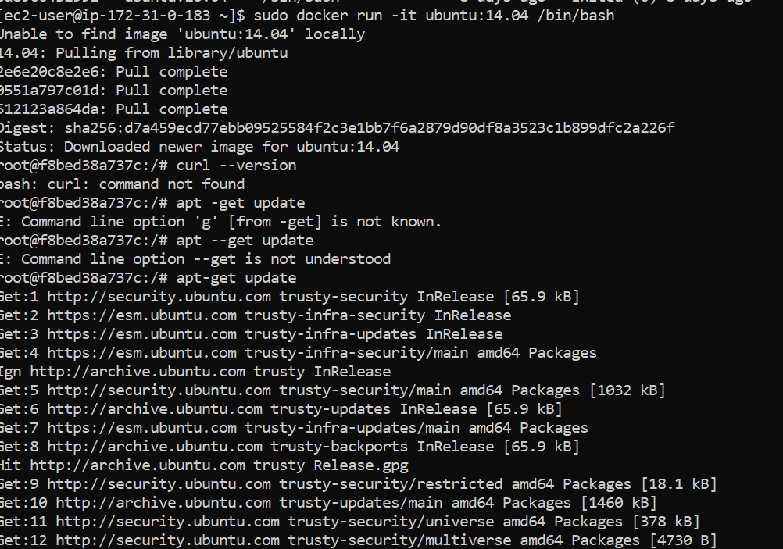

Centos

