7COM1079-0901-2025 - Team Research and Development Project

Final report title: A Comparative Analysis of 24-Hour Download Speeds Between ADSL and FTTC Broadband Connections in the United Kingdom

Group ID:

Dataset number:

Prepared by:

University of Hertfordshire
Hatfield, 2025

Table of Contents
1. Introduction 3
1.1 Problem Statement and Research Motivation 3
1.2 The Dataset 3
1.3 Research Question 3
1.4 Null and Alternative Hypotheses 3
2. Background Research 4
2.1 Research Papers 4
2.2 Why the Research Question Is of Interest 4
3. Visualisation 4
3.1 Appropriate Graphs for the Research Question 4
3.2 Additional Information Relating to Understanding the Data 6
3.3 Useful Information for Data Understanding 6
4. Analysis 7
4.1 Statistical Test Used to Test the Hypotheses 7
4.2 Hypothesis Decision Based on the p-Value 7
5. Evaluation – Group’s Experience at 7COM1079 8
5.1 What Went Well 8
5.2 Points for Improvement 8
5.3 Group’s Time Management 8
5.4 Project’s Overall Judgement 8
5.5 Comment on GitHub Log Output 8
6. Conclusions 9
6.1 Results Explained 9
6.2 Interpretation of the Results 9
6.3 Limitations and Future Work 9
7. Reference List 10
8. Appendix 11
8.1 Appendix A 11

1. Introduction

1.1 Problem Statement and Research Motivation
Quality broadband connectivity is very important in contemporary society as it aids in the productivity of the economy, digital inclusion, and accessibility to necessary online services. Britain has been significantly varied in terms of broadband technologies regarding infrastructure and performance (DeStefano et al.,2023). Asymmetric Digital Subscriber Line (ADSL) uses copper telephone networks, and Fibre to the Cabinet (FTTC) uses fibre optic to enhance the speed of data transmission. Even though service providers boast of headline speeds, the real user experience usually results in diminishing quality of experience because of congestion, quality of infrastructure, and network demand (de Clercq et al.,2023). Measuring practical broadband performance is thus of significance to the consumers, service providers, and policymakers. This paper explores the hypothesis that fibre-based broadband technology achieves very high performance compared to the old copper-based connections based on the actual download speed data.

1.2 The Dataset
The research deploys the data on the UK fixed-line broadband performance released by data.gov.uk and gathered by Ofcom. The database has a total of 5,023 observations and captures performance measurements of the broadband using direct users' rights at their homes. It comprises the type of broadband technology and the real 24-hour average download speeds (Zelalem et al.,2022). This data is dependable, representative on the national level, and fits well when it comes to comparing the actual performance of broadband technologies.

1.3 Research Question
Research Question (RQ)
Do the mean 24-hour download speeds of ADSL and FTTC broadband connections in the UK differ statistically significantly?

1.4 Null and Alternative Hypotheses
In order to answer the research question, formal statistical hypotheses are specified. The null hypothesis (H0) is that the 24-hour download speed mean between the ADSL and FTTC broadband connections does not differ statistically significantly. The alternative hypothesis (H1) is that there is a statistically significant difference in the mean download speeds of the two technologies. With the help of hypothesis testing, the comparison can be checked objectively with the help of the observed data.

2. Background Research

2.1 Research Papers
Past studies have consistently shown that fibre-based broadband technologies are superior to copper-based alternatives. According to Ofcom reports, the fibre connections have higher and more reliable download speeds, especially during peak hours. According to Nwanneka (2022), next-generation access networks are superior in terms of speed and reliability in comparison to the old infrastructure. Briglauer et al., (2022) also reveal that the quality of the broadband has a positive impact on productivity and uptake of digital services. Although these studies affirm the benefits of fibre infrastructure, most of them are based on advertised rates or aggregate rates. The analysis of measured 24-hour data of performance presents a more precise picture of the user experience and reinforces evidence on the existence of differences in technology-based performance.

2.2 Why the Research Question Is of Interest
This research question is pertinent since it deals with actual broadband performance as opposed to theoretical capacity. The internet quality experienced by consumers is the actual download speed and not the claimed speed. This paper gives some practical understanding of the advantages of fibre deployment by comparing ADSL and FTTC based on the measured data (He et al.,2024). The results are also useful to policy makers who are evaluating the success of investment in fibre-based infrastructure in the UK.

3. Visualisation

3.1 Appropriate Graphs for the Research Question
The analysis is supported by two visualisations histogram and a boxplot. The choice of these graphs is to analyse the distribution of download speeds, as well as the distinctions of broadband technologies.
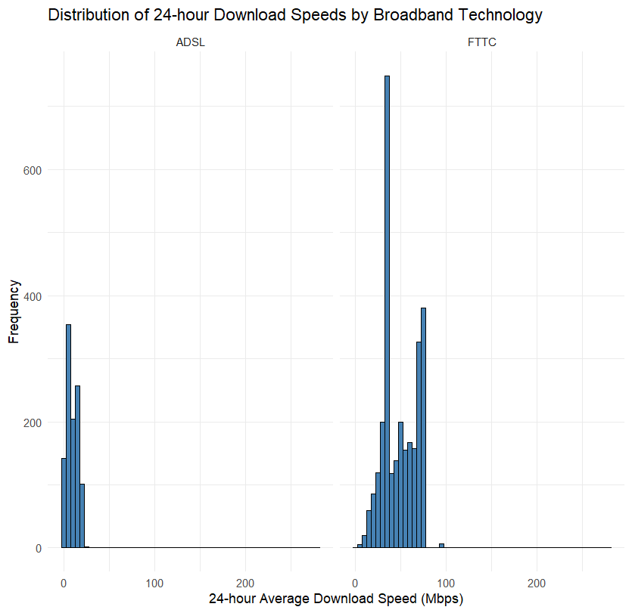

Figure 1: Distribution of 24-Hour Download Speeds by Broadband Technology
(Source: R Studio)
The suitable visualisation of the data is the histogram since it shows the distribution and frequency of the download speeds of each technology. It enables the comparison of the relative distribution of the speeds of ADSL and FTTC connections and shows the variation in the spread and concentration. This renders it appropriate in studying overall performance trends in the precursor of statistical testing.
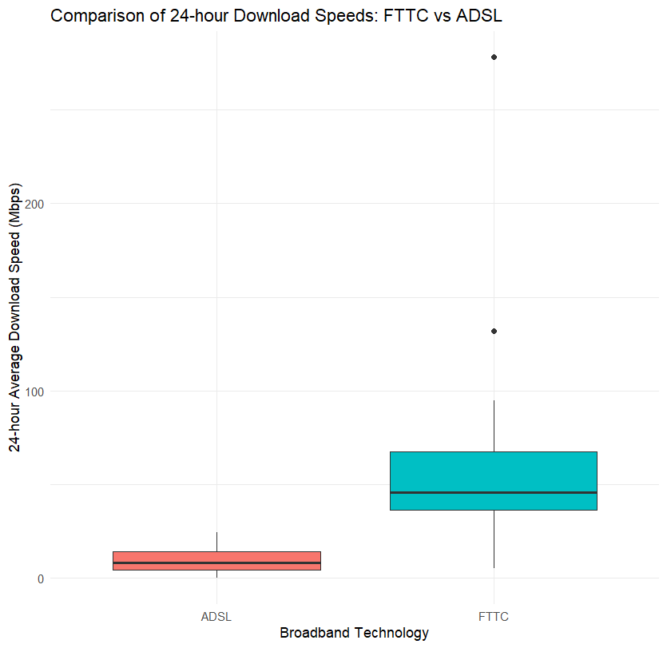

Figure 2: Comparison of 24-Hour Download Speeds – FTTC vs ADSL
(Source: R Studio)
The boxplot is the appropriate choice as it will show the clear comparison of the median value, the variability, and possible outliers of two independent groups. It graphically summarises the variations in central tendency and dispersion, which makes it the best to evaluate whether FTTC is more reliable to use than ADSL.

3.2 Additional Information Relating to Understanding the Data
The histogram indicates that the distribution of ADSL obtains the lowest values, whereas the distribution of FTTC takes a broad and elevated range. This implies that fibre-based connections have more capability to perform and are also more variable.

3.3 Useful Information for Data Understanding
The boxplot shows that there is a distinct difference between ADSL and FTTC distributions. FTTC has a significantly higher median download speed and interquartile range. This graphical data is a strong indication that there is a significant performance difference between the two technologies.

4. Analysis

4.1 Statistical Test Used to Test the Hypotheses
The comparison of 24-hour download speed, 24-hour-mean between ADSL and FTTC connections, is done via an independent sampled Welch two-sample t-test. The reason behind selecting this test is that the groups used are independent and cannot be equated about variances and sample sizes (Savla, 2023). In this case, the Welch t-test is a strong analysis to use to compare the performance in terms of means.

4.2 Hypothesis Decision Based on the p-Value
The Welch t-test suggests that there is a statistically significant difference between the mean 24-hour download speed of ADSL and FTTC connections (t = -102.88, df = 3877.4, p = less than 2.2e-16). Since the p-value is much less than the significance level of 0.05, the null hypothesis is abandoned. In contrast to ADSL connections (9.26 Mbps), FTTc connections have a significantly higher mean download speed (48.83 Mbps). This finding confirms the fact that broadband technology plays an important role in real-world download performance.

Table 1: Descriptive Statistics for Download Speeds
Technology | Sample Size | Mean Speed (Mbps) | Standard Deviation
ADSL | 1,060 | 9.26 | 5.73
FTTC | 2,888 | 48.83 | 18.40

Table 2: Welch t-test Results for Download Speed Comparison

Statistic | Value
Test Type | Welch Two-Sample t-test
t-value | −102.88
Degrees of Freedom | 3877.4
p-value | < 2.2e−16
Mean (ADSL) | 9.26 Mbps
Mean (FTTC) | 48.83 Mbps
Decision | Reject H₀

5. Evaluation – Group’s Experience at 7COM1079

5.1 What Went Well
The team works efficiently during the project, and its responsibilities are well-defined, including frequent communication. The process of data preparation, visualisation, and statistical analysis is completed with the help of R. Group members engage similarly and help each other to overcome technical difficulties.

5.2 Points for Improvement
This would be done through prior planning, especially in the literature review phase. The future projects would be more robust with the help of more time dedicated to academic reading and reference management. Analysis can be further simplified with a better coordination of initial data exploration.

5.3 Group’s Time Management
The team has learnt to manage time by putting internal deadlines and holding frequent meetings. The work is shared equally, and gradual completion is achieved towards submission.

5.4 Project’s Overall Judgement
In general, the project is effective and fulfils the learning outcomes of the module. The team is competent in data analysis, statistical testing, and academic reporting.

5.5 Comment on GitHub Log Output
Major commits are associated with data cleaning, development of visualisation, and ultimate statistical analysis, which directly contribute to cthe ompletion of the project.

6. Conclusions

6.1 Results Explained
The comparison shows that 24-hour average download rates between the ADSL and FTTC connections are statistically significant and different. FTTC has always recorded better mean speeds and variability as an indicator of better network performance.

6.2 Interpretation of the Results
The results prove that the use of fibre-based broadband technology provides significantly higher real-life performance than copper-based ADSL connections. The findings favour further investment in fibre infrastructure to improve digital connectivity and user experience in the UK.

6.3 Limitations and Future Work
The two broadband technologies used in the study do not take into account regional variation and household usage patterns. More technologies, geographic analysis, and multivariate modelling should be added to future research to explain more broadband performance differences.

7. Reference List
Briglauer, W., Cambini, C. and Gugler, K., 2022. The Economic Significance of Modern Broadband Internet Infrastructures and Services. Research Institute for Regulatory Economics, WU Vienna.
de Clercq, M., D'Haese, M. and Buysse, J., 2023. Economic growth and broadband access: The European urban-rural digital divide. Telecommunications Policy, 47(6), p.102579.
DeStefano, T., Kneller, R. and Timmis, J., 2023. The (fuzzy) digital divide: the effect of universal broadband on firm performance. Journal of Economic Geography, 23(1), pp.139-177.
He, W., Wang, X. and Miao, M., 2024. Network infrastructure and corporate environmental performance: Empirical evidence from “Broadband China”. Energy Economics, 131, p.107393.
Nwanneka, M.A.G., 2022. Strategies for Promoting Digital Learning Environment In Adult Education Department In Nigerian Universities. Celebrating the Vision and Resource of Adult Education for Sustainable Development in Nigeria, 130.
Savla, D.N., 2023. Comparing SEM and Its Robustness Adjustments to Student’s and Welch’s T-Test (Master's thesis, San Diego State University).
Zelalem Jembre, Y., Jung, W.Y., Attique, M., Paul, R. and Kim, B., 2022. Mobile broadband performance evaluation: Analysis of national reports. Electronics, 11(3), p.485.

8. Appendix

8.1 Appendix A
# Clear workspace
rm(list = ls())

# Load required libraries
library(readxl)
library(dplyr)
library(ggplot2)

# Read Excel dataset from the given path
data <- read_excel("C:/Users/-17.csv.xlsx")

# View structure (logged in R console)
str(data)

# ----------------------------------------------------------
# Data preparation
# ----------------------------------------------------------

# Select required columns ONLY
data_clean <- data %>%
select(
Technology,
DownloadSpeed = t24hr
)

# Remove missing values
data_clean <- data_clean %>%
filter(!is.na(Technology), !is.na(DownloadSpeed))

# Keep only ADSL and FTTC
data_clean <- data_clean %>%
filter(Technology %in% c("ADSL", "FTTC"))

# Convert Technology to factor
data_clean$Technology <- factor(data_clean$Technology,
levels = c("ADSL", "FTTC"))

# Ensure download speed is numeric
data_clean$DownloadSpeed <- as.numeric(data_clean$DownloadSpeed)

# ----------------------------------------------------------
# Descriptive statistics
# ----------------------------------------------------------

descriptive_stats <- data_clean %>%
group_by(Technology) %>%
summarise(
Sample_Size = n(),
Mean_Download_Speed = mean(DownloadSpeed),
SD_Download_Speed = sd(DownloadSpeed)
)

print(descriptive_stats)

# ----------------------------------------------------------
# Visualisation
# ----------------------------------------------------------

# Histogram (required supplementary graphic)
ggplot(data_clean, aes(x = DownloadSpeed)) +
geom_histogram(binwidth = 5, fill = "steelblue", color = "black") +
facet_wrap(~Technology) +
labs(
title = "Distribution of 24-hour Download Speeds by Broadband Technology",
x = "24-hour Average Download Speed (Mbps)",
y = "Frequency"
) +
theme_minimal()

# Boxplot (main comparison plot)
ggplot(data_clean, aes(x = Technology, y = DownloadSpeed, fill = Technology)) +
geom_boxplot() +
labs(
title = "Comparison of 24-hour Download Speeds: FTTC vs ADSL",
x = "Broadband Technology",
y = "24-hour Average Download Speed (Mbps)"
) +
theme_minimal() +
theme(legend.position = "none")
# ----------------------------------------------------------
# Statistical Analysis – Independent Samples t-test
# ----------------------------------------------------------

t_test_result <- t.test(
DownloadSpeed ~ Technology,
data = data_clean,
alternative = "two.sided",
var.equal = FALSE
)

print(t_test_result)
# ----------------------------------------------------------
# Hypothesis decision based on p-value
# ----------------------------------------------------------

alpha <- 0.05

if (t_test_result$p.value < alpha) {
cat("Decision: Reject the null hypothesis (H0).\n")
cat("There is a statistically significant difference in mean 24-hour\n")
cat("download speeds between FTTC and ADSL broadband connections in the UK.\n")
} else {
cat("Decision: Fail to reject the null hypothesis (H0).\n")
cat("There is no statistically significant difference in mean 24-hour\n")
cat("download speeds between FTTC and ADSL broadband connections in the UK.\n")
}

