**NLP(Natural Language Processing):**

Is the subfield of Computer Science and Artificial Intelligence concerned with interactions between computers and humans(natural) languages. It is used to apply machine learning algorithms to text and speech.

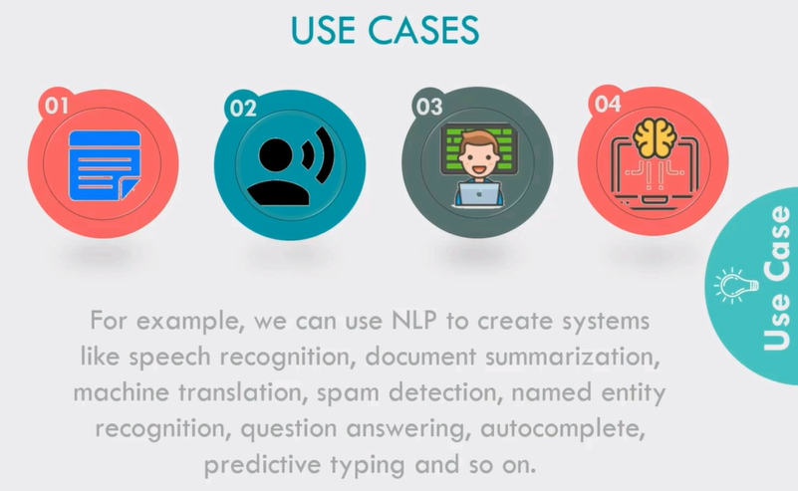

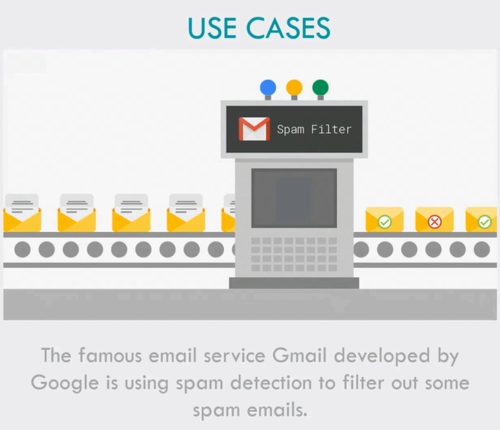

**NLTK( Natural Language Toolkit):**

Is the leading platform for building Python Programs to work with human language data. It provides easy to use interfaces to many corpora and lexical resources. Also it contains a suit of text processing libraries for classification, tokenization, stemming, tagging, parsing and semantic reasoning.

**Basics Steps Of NLP For Text:**

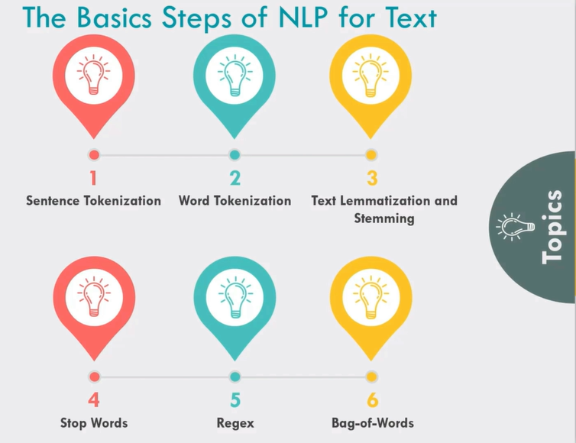

**Imp. Outputs On Regex:**

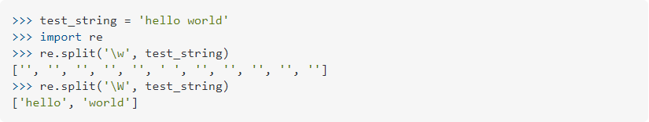

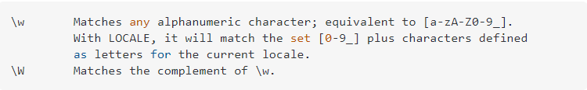

Similarly “\S+” is for the words i.e both uppercase and lowercase letters and “\s+” is for one or more spaces used.

