The first screen : Before the user begins playing

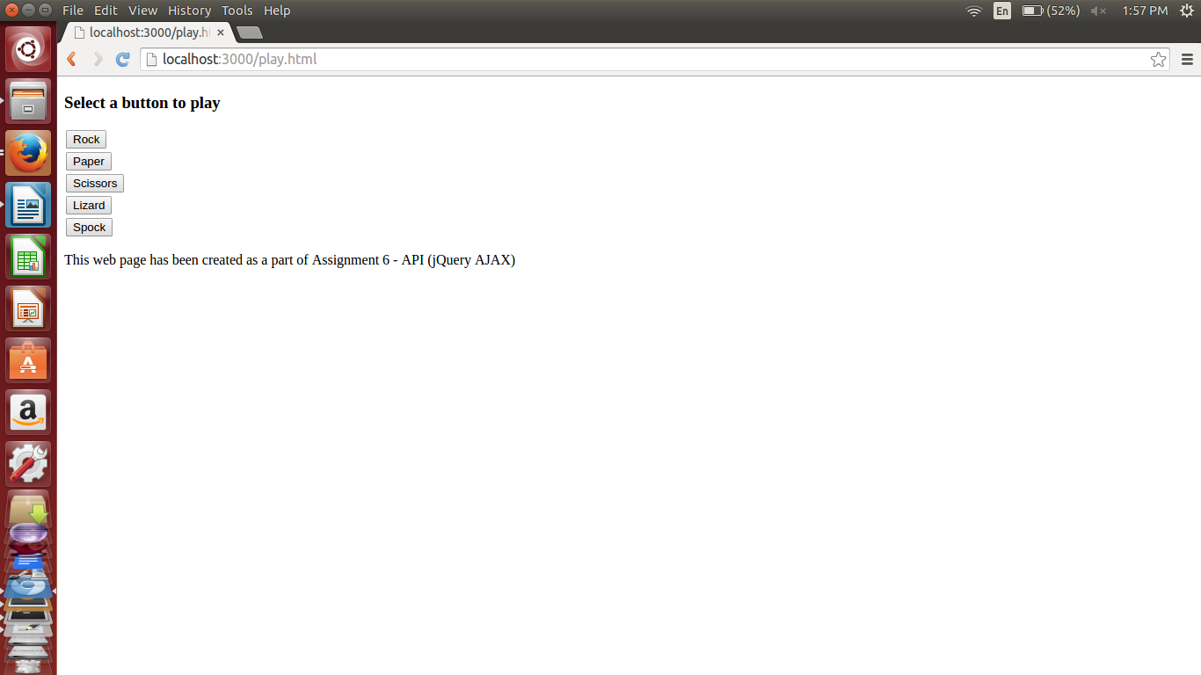

Player clicked on “rock” button – below scr shot showing that user won and the count:
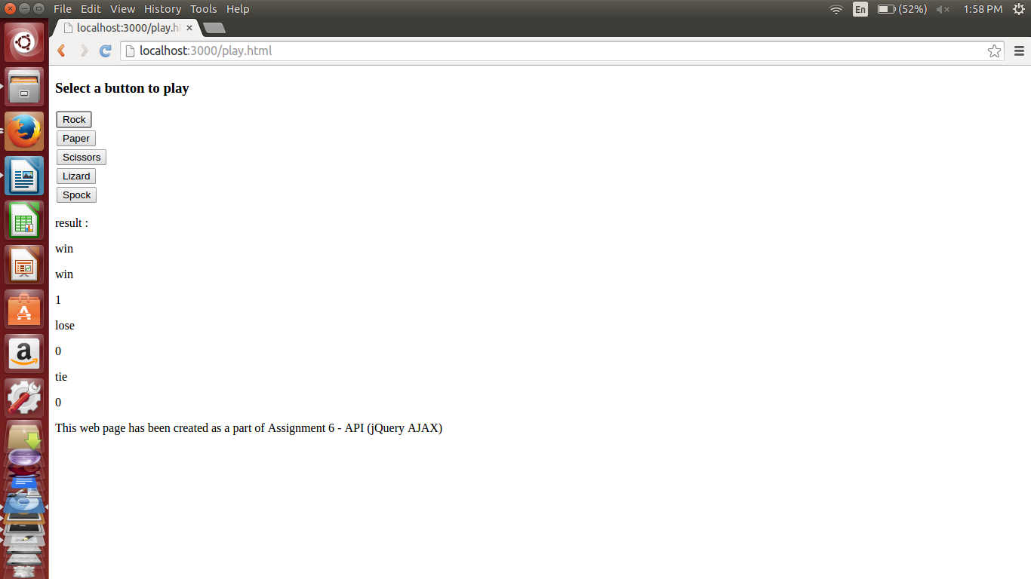

Below scr shot : player played “paper” button , scr shot shows he won again and win count is 2 .
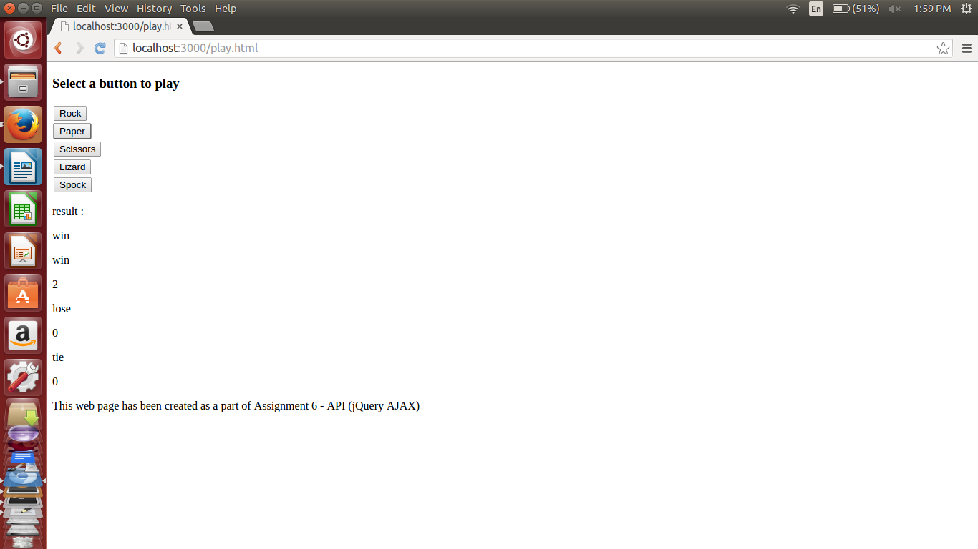
Below Scr shot : user played “scissors” button and won again , so win count = 3:
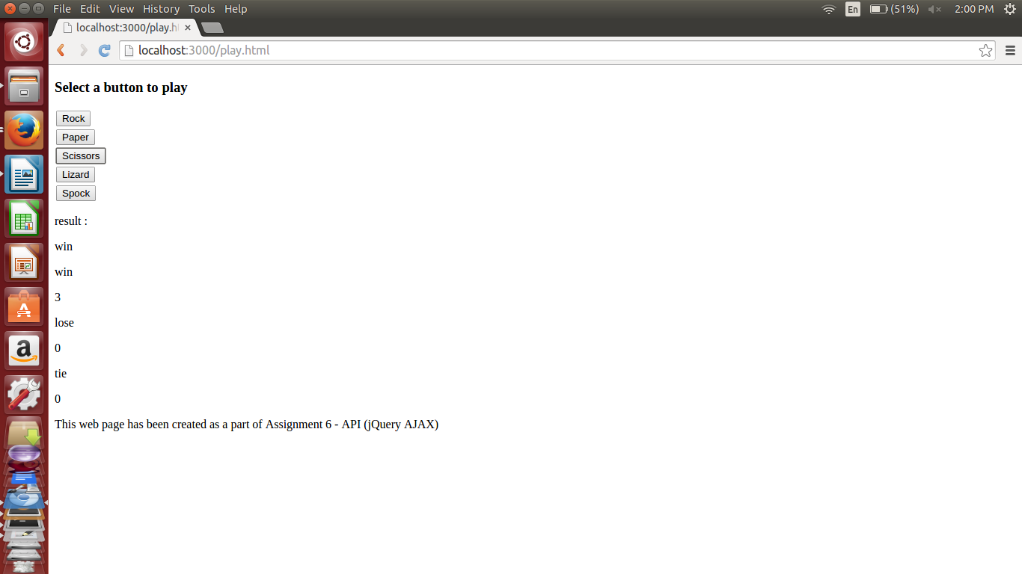

user played “Lizard” button and lost, so lose count is 1.
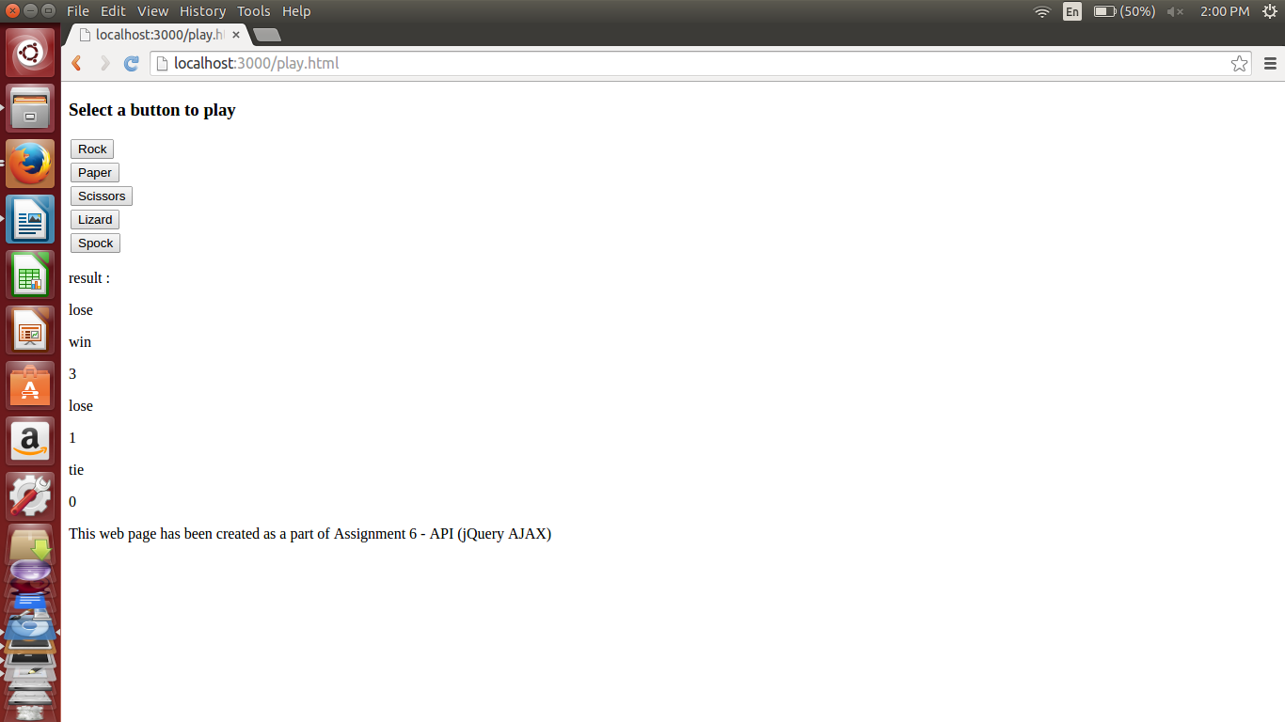
user played “spock” button and won , so win count is 4
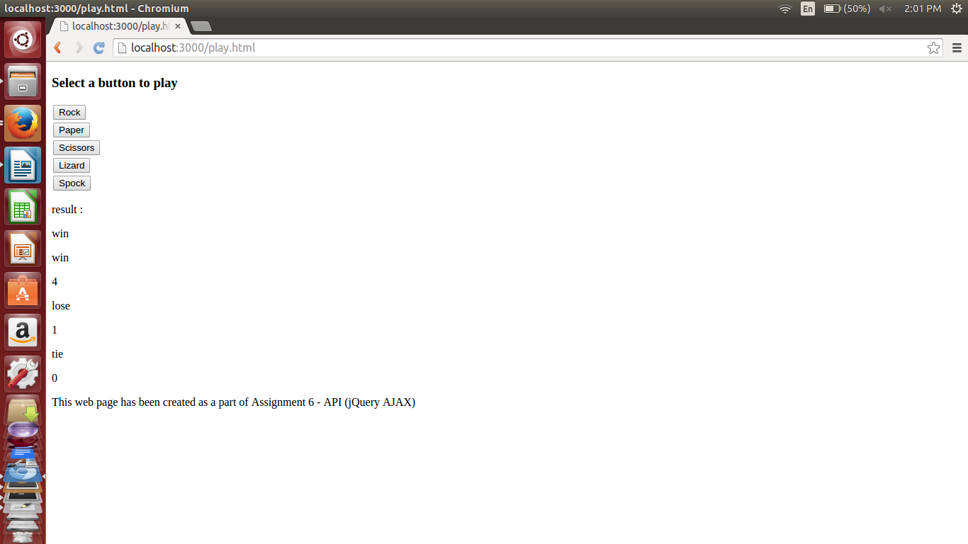

User clicked on “scissors” and got a tie , hence tie = 1
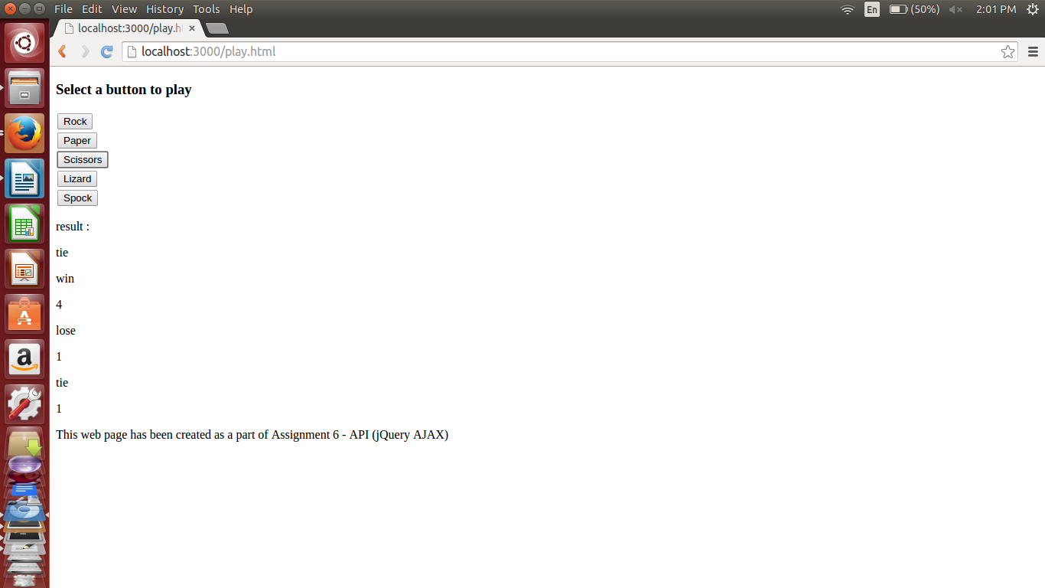
user played by clicking 6 buttons at different times and above are the 6 screen shots showing the game from scratch , in action.

