- Briefly describe your team’s project
Ans :The general purpose of the project is to build a web application for community decision-making where the users can post a question or issue so that the other users can either vote for an option or suggest a different option altogether which can again be voted . In general ,the web page will show a set of questions with set of responses having the vote count.

2. Research and compile a list of APIs that might be useful for your project

Ans :
a) API for Yelp – example below
http://api.yelp.com/v2/search?term=food&location=San+Francisco

b) Facebook API
GET /v2.2/{user-id}/feed or /{page-id}/feed/ or {event-id}/feed or /{group-id}/feed

c) Twitter API – example : to search for tweets by @twitterapi account.
https://api.twitter.com/1.1/search/tweets.json?q=%40twitterapi

d) LinkedIn – example : to request details of a person after providing first name , last name .
https://api.linkedin.com/v1/people/~?format=json

3. For each API, briefly describe how its functionality might be used in your project.
Ans: Yelp : might be useful to pull data from yelp , if the question is about food/restaurant/reviews/ratings in a particular area.
Facebook : example : to post/publish something on facebook wall.
Twitter : APIs could be used to search tweets by a particular twitter ID.
LinkedIN :APIs under this could be used for requesting details of a person after providing certain details in the URL – like first name , last name.
4. Choose one API from your list and create an example web page using jQuery AJAX to call the API and display the returned results
Ans : Yelp API chosen to create web page using Jquery Ajax.
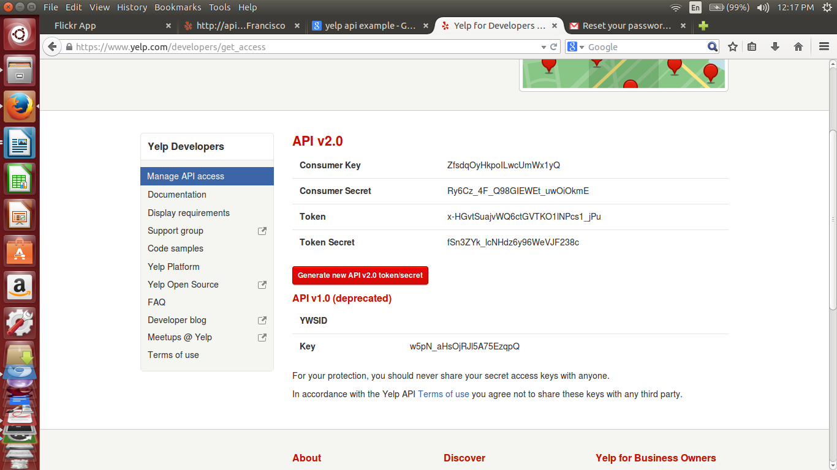
Purpose of the web page : User inputs a city name and clicks on submit button. The resulting web page displays all the restaurants name in that city. Scr shot of the Yelp API authentication token.

5. Describe why you chose that particular API and provide a link to its documentation
A. Primarily , the plan is to use facebook or twitter API , but these require server also. Whereas , the Yelp API works without a server and just with client side JavaScript (jQuery) manipulation. Besides , In this community-based decision making project , food/restaturant is an important aspect to post questions and decide on which restaurant in which city to vote for. - this is the reason for having chosen yelp API. Link for its documentation :
https://www.yelp.com/developers/documentation/v2/search_api
Installation of express from npm.
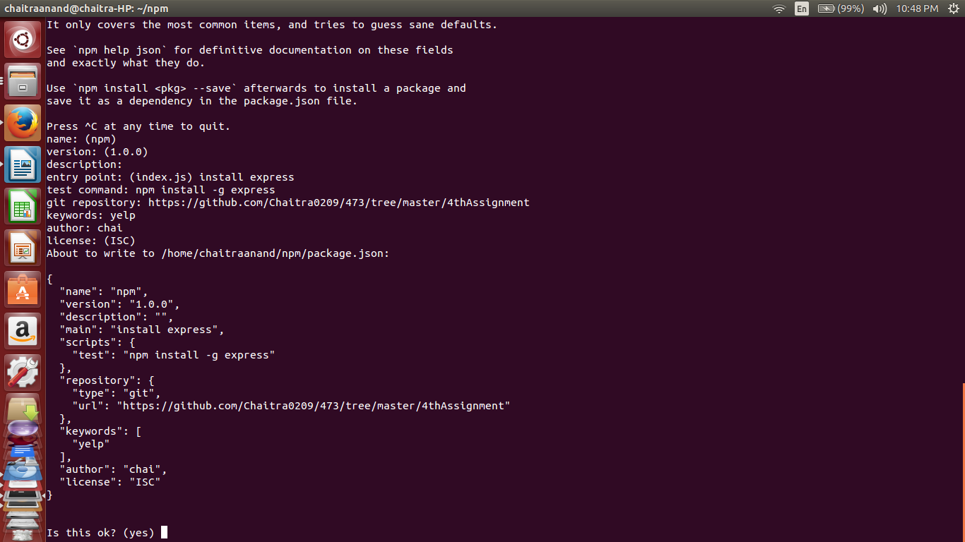

6. Discuss any potential issues that you can foresee with using this API in your project
A. $(document).ready(function(){
//This is to remove the validation message if no restaurant is present

/*$('#term').focus(function(){
var full = $("#list").has("p").length ? true : false;
if(full == false){
$('#list').empty();
}
}); */

var getList = function(){

//Grab the city name and store it in a variable

var ville = $('#term').val();

//Check if the user has entered anything

if(ville == ''){
//If the input field was empty, display a message

$('#list').html("<h2 class='loading'>Please enter something.</h2>");

} else {

/*They must have entered a value, carry on with API call,
first display a loading message to notify the user of activity */

$('#list').html("<h2 class='loading'>The restaurants list is on its way!</h2>");

var url = "http://api.yelp.com/v2/search?ZfsdqOyHkpoILwcUmWx1yQ/x-HGvtSuajvWQ6ctGVTKO1lNPcs1_jPu/"+"term=restaurants&location=Brea&limit=10&format=json&jsoncallback=?";

//after search , it is the consumer key and the token in the url

$.getJSON(url, function (yelpRply) {

/*if (json != "Nothing found."){

//Display the restaurant and a message announcing the result

$('#poster').html('<h2 class="loading">Well, gee whiz! We found you a poster, skip!</h2><img id="thePoster" src=' + json[0].posters[0].image.url + ' />'); */

yelpRply.location.forEach(function (line) {

var $p = $("<p>");
$p.attr("src",line.businesses.mobile_url); /* What to put in this line for displaying the results ? */

$('#list').append($p);
} );

});

};

});

6. Discuss any potential issues that you can foresee with using this API in your project
Ans . → The Yelp API will not work directly if used in a client-side JavaScript code.
→ It works in-sync with yelp server using node.js or express.
→ These in turn require npm for their respective installations , on terminal
→ With different APIs , this procedure may vary.

7. Evaluate your experience creating the example web page and make a recommendation of whether your team should use this API or keep looking for better options.
Ans . The experience of creating the web app was enriching, as it makes use of already existing documentation of API to provide certain information on our web app. However , the APIs seemed to require a server or worked in association with bridging both client and server whereas , the requirement was only for API and client side.
The Yelp API seems a little elaborated and complex , requiring the programmer to change the functions in the code very often. So it is recommended to look for better APIs

8. Describe how the example you wrote might be expanded to use additional functionality provided by the API
Ans. The example web page is for searching 5 restaurants in the city of Fullerton. This can further be expanded to accommodate many more search criteria to help users decide on something related to food , or to vote for a specific option. For example : Which are the Thai restaurants in Fullerton having rating more than or equal to 3.5 ?

