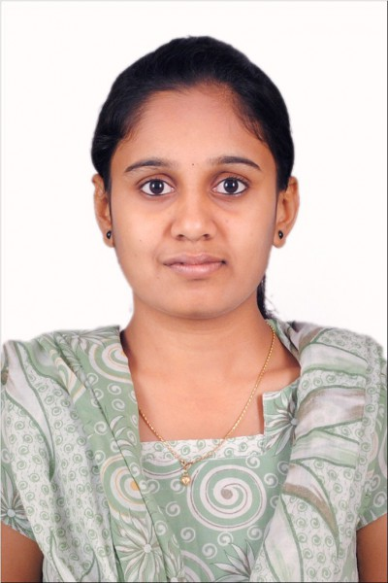

Experience

3.1 years of experience as software test engineer in **­ESIKA INFOTECH PRIVATE LIMITED from** July 2017 till date.

Professional Summary

|  |  |  |  |  |  |  |
| --- | --- | --- | --- | --- | --- | --- |
| * + - Worked on CRM, e-Commerce and Healthcare domains with **Agile Methodology.**     - Experience in analyzing **Functional Requirements**     - Good Exposure and knowledge on **Test Plan**     - Strong knowledge on **Software Development Life Cycle** and **Software Test Life Cycle**     - Extensive experience in writing **Test Cases** using **Test Case Design Techniques**     - Involved in **Test Case Review** process     - Expertise in Manual Testing – **Smoke Testing, Component Testing, Integration Testing, End-to-End Testing, Adhoc Testing, Regression testing.**     - Experience in **Executing Test Cases** and analyzing results.     - Well acquainted with **Reporting** and **Defect Tracking** in **Jira**     - Excellent understanding of Experience in testing **Web** based applications     - Knowledge on **SQL** concepts like Joins, Sub-queries, Co-Related sub queries.     - Good knowledge on **Java OOPS** concepts Exception handling, Strings, Collection.     - Experience of writing scripts using **TestNG framework**.     - Expertise on handling different types of **PopUps**.     - Hands on different types of **Locators**.     - Experience in converting manual test cases to Automation scripts using Selenium in Eclipse**.**     - Experience in working on **Page Object model** with Hybrid Framework**.**     - Well versed in handling elements with Selenium Web Driver     - Involved in writing Xpaths for object identification   Tools Used  **ALM**: Project Management Tool **JIRA**: Defect Tracking Tool  Projects   |  | | --- | | PCM(PULSE CARE MISSION) | | HEALTH CARE | | AGILE | | MANUAL & AUTOMATION | | WEB APPLICATION | |  |

Contact

**Phone:**

+91-9538648120

+91-7337845993

**Email:**

chaitrarajanna25@gmail.com

Languages

English

Kannada

Telugu

**PROJECT 3**

|  |
| --- |
| PROJECT NAME |
| DOMAIN |
| PROCESS |
| TESTING TYPE |
| APPLICATION TYPE |
|  | |

CHAITRA R

SOFTWARE TEST ENGINEER

|  |  |  |  |  |  |  |  |  |  |  |  |  |  |  |  |  |  |  |  |  |  |  |  |  |
| --- | --- | --- | --- | --- | --- | --- | --- | --- | --- | --- | --- | --- | --- | --- | --- | --- | --- | --- | --- | --- | --- | --- | --- | --- |
| TEAM SIZE  DURATION SUMMARY  CONTRIBUTION  **PROJECT 2**   |  |  | | --- | --- | | SHOP-ONS-GO(SOG) |  | | E-COMMERCE |  | | AGILE |  | | MANUAL |  | | WEB_APPLICATION |  | | 4 |  | | 11 MONTHS  SOG is a web based application which belongs to e-commerce domain. It is mainly used to sell the products online and helps the customers to buy the product online easily sitting in their places. |  |  |  | | --- | | PROJECT NAME | | DOMAIN | | PROCESS | | TESTING TYPE | | APPLICATION TYPE  TEAM SIZE  DURATION  SUMMARY  CONTRIBUTION | | |  | | --- | | 5 | | 13 months | | Pulse care mission is a web based application which is mainly used to track the various activities and maintain the records of Hospital.   * Involved in understanding the functional requirements thoroughly and client’s business workflow. * Prepared test scenarios and test cases for functional testing, smoke testing, integration testing, end to end testing, adhoc testing. * Involved in brain storming meeting. * Involved in reviewing Test Cases of Team members |  * Understanding the functional requirements thoroughly and client’s business workflow. * Actively involved in logging defects using Defect tracking tool. | |
| **PROJECT1**  ZIRCON   |  |  | | --- | --- | | MANUFACTURING |  | | AGILE |  | | MANUAL |  | | WEB_APPLICATION |  | |  |  | |  |  | |  |  |  |  | | --- | | PROJECT NAME | | DOMAIN | | PROCESS | | TESTING TYPE  APPLICATION TYPE  6  12 MONTHS   |  |  | | --- | --- | | ZIRCON is a web -based Application which belongs to manufacturing domain where our client was involved in manufacturing of products and running their business worldwide. In order to maintain their business records and tracking the business they are in need of having one software to track their business and also tell us that how the organization works and how the employees inside the organization make use of this software. |  | | * Involved in preparing test scenarios and test cases for Functional testing, Integration testing and Adhoc testing. |  | | * Reviewed the test cases. |  | | * Prepared Traceability matrix |  | | * Involved in preparing test scenarios and test cases for Functional testing, Integration testing and Adhoc testing. |  | |  |  | |  |  |   TEAM SIZE | | DURATION  SUMMARY  CONTRIBUTION | | |
|  | |
|  | |
|  | |

EDUCATION

* Completed **Mtech** from Acharya Institute of Technology Bangalore.
* Completed **B.E** from Nitte Meenakshi Institute of Technology Bangalore.

DECLARATION

I hereby declare that the above mentioned information is correct up to my knowledge and I bear the responsibility for the correctness of the above mentioned particulars.

Signature

**DATE:**

**PLACE:** Bangalore