**QUIZ GAME**

**SYSTEM REQUIREMENTS:**

**-SOFTWARE REQUIREMENTS**

1)This Application is developed in C Programming language.

2)Runs on Windows/Linux

3)Visual Studio Code

4)MingW Compliler for C

**-HARDWARE REQUIREMENTS**

1.Runs on any System with C compiler

**INTRODUCTION:**

A quiz is a form of game or mind sport in which players attempt to answer questions correctly about a certain or variety of subjects. Quizzes can be used as a brief assessment in education and similar fields to measure growth in knowledge, abilities, or skills. Quizzes may be held on a variety of subjects or subject-specific. The format of the quiz can also vary.

# **4 W'S AND 1 H:-**

## Who:

* Users wanting to enhance their knowledge by testing themselves. Also teachers who want to test their students can use it.

## What:

* A simple mcq based quiz for yourself to know what you know and what you don't know about the subject.

## When:

* After you have garnered knowledge about the subject by extensive reading, then comes the quiz to test your learning.

## Where:

* Any person anywhere caan access it to test himself.

## How:

* User can attempt the quiz through any of the online medium.

**SWOT ANALYSIS:**

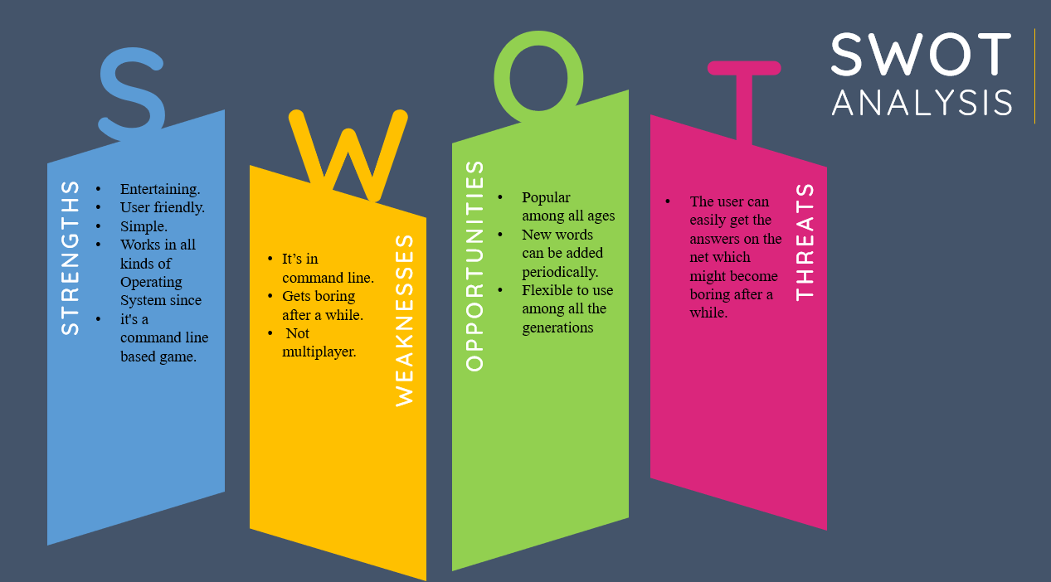

**DETAILED REQUIREMENTS:**

**HIGH LEVEL REQUIREMENTS:**

1. User must register himself to the system.
2. After registering, user have to login to the system.
3. User can attempt the quiz.
4. User can get his score at the end.

**LOW LEVEL REQUIREMENTS:**

1. User has to initially register with the system by choosing a username and password for himself wherein the username will be first checked with the backend if it is available, if available, the user is successfully registered thervise he will have to choose another username.
2. User has to login himself after registering wherein he will enter his login credentials and only after they are successfully validated, he can attempt the quiz.
3. User can choose to read the instructions, attempt the quiz or logout from the system.