DATA ANALYTICS PROJECT DOCUMENT

Title: Airfare Price Analysis: Economy vs Business Class

Student Name(s): Kruthika S R , M Chaitra

AFID: AF05060907, AF05096869

Institute: Sai Vidya Institute of Technology

Guide / Mentor: Shruti Sengupta

Organization: Anudip Foundation

Academic Year: 2024-2026

INDEX
1. Abstract
2. Introduction
3. Problem Statement
4. Objectives
5. Business Context
6. Methodology
7. Tools Used
8. Data Sources
9. Data Cleaning
10. EDA
12. Statistical Analysis
11. Modeling
14. Results
11. Insights
15. Conclusion
16. Limitations
17. Future Scope
18. Gantt Chart
19. References
20. Appendix A: SQL Code (DB Setup, Extraction, Cleaning, Analysis)
21. Appendix B: Python Code (Loading, Cleaning, EDA, Visualisation, Modelling)

ABSTRACT
This project focuses on analyzing airfare pricing patterns using economy and business class datasets. The main objective is to identify how factors such as flight duration, number of stops, and class type influence ticket prices. The datasets were collected from Kaggle and preprocessed using Python libraries such as Pandas and NumPy.
Exploratory Data Analysis (EDA) was performed to understand trends and relationships in the data. Visualizations including line charts, bar graphs, and heatmaps were used to present insights clearly. Statistical techniques such as Pearson correlation were applied to study relationships between variables.
The analysis revealed that ticket prices increase with flight duration and are significantly higher for business class compared to economy class. Additionally, flights with more stops tend to have relatively lower prices.
This project provides meaningful insights that can help travelers make cost-effective decisions and assist airlines in understanding pricing strategies.

INTRODUCTION
Airfare pricing is highly dynamic and influenced by multiple factors such as airline, route, duration, and number of stops. Understanding these patterns is important for both travelers and airline companies.
This project analyzes airfare datasets for economy and business class to identify key trends and relationships affecting ticket prices. With the increasing use of data analytics in the travel industry, such insights help in making informed decisions.
The study focuses on comparing pricing structures between different classes and identifying the major factors contributing to price variation.

PROBLEM STATEMENT
Airfare prices vary significantly due to factors such as flight duration, number of stops, and class type, making it difficult for users to understand pricing patterns and book tickets at optimal prices.

OBJECTIVES
- To analyze airfare data for economy and business class
- To identify key factors affecting ticket prices
- To perform exploratory data analysis (EDA)
- To create meaningful visualizations
- To apply statistical techniques for analysis
- To develop insights for better decision-making

BUSINESS CONTEXT
This project belongs to the travel and aviation industry, where pricing plays a critical role.
The analysis helps:
- Travelers → choose cost-effective options
- Airlines → optimize pricing strategies
- Analysts → understand market trends
The project provides insights into how airfare varies based on different conditions, improving decision-making.

METHODOLOGY
- Data Collection from Kaggle datasets
- Data Cleaning and preprocessing
- Exploratory Data Analysis (EDA)
- Data Visualization (charts & graphs)
- Statistical Analysis (correlation)
- Basic Modeling (Linear Regression)
- Reporting and documentation

TOOLS & TECHNOLOGIES
- Python (Pandas, NumPy)
- Matplotlib & Seaborn (Visualization)
- Scikit-learn (Modeling)
- SQL (Data handling)
- Jupyter Notebook

DATA SOURCES
- Source: Kaggle
- Datasets:
  - Economy Class Dataset
  - Business Class Dataset
Key Columns:
Airline, Source, Destination, Duration (time_taken), Stops, Price

DATA CLEANING & PREPROCESSING
- Removed missing values
- Removed duplicate records
- Converted price column to numeric (removed commas)
- Converted duration into minutes
- Converted stops into numerical values

EXPLORATORY DATA ANALYSIS
Exploratory Data Analysis was performed to understand patterns and relationships in the data.

Visualization 1:What are the major trends in airfare prices over time?
- Chart type: Bar graph
X-axis: Departure Hour
Y-axis: Average Ticket Price
- Key insight:
Airfare prices fluctuate across different departure times, indicating demand-based pricing patterns.
- Observation:Certain hours show higher ticket prices, representing peak travel periods.
- Business class fares are consistently higher than economy class across all time slots.
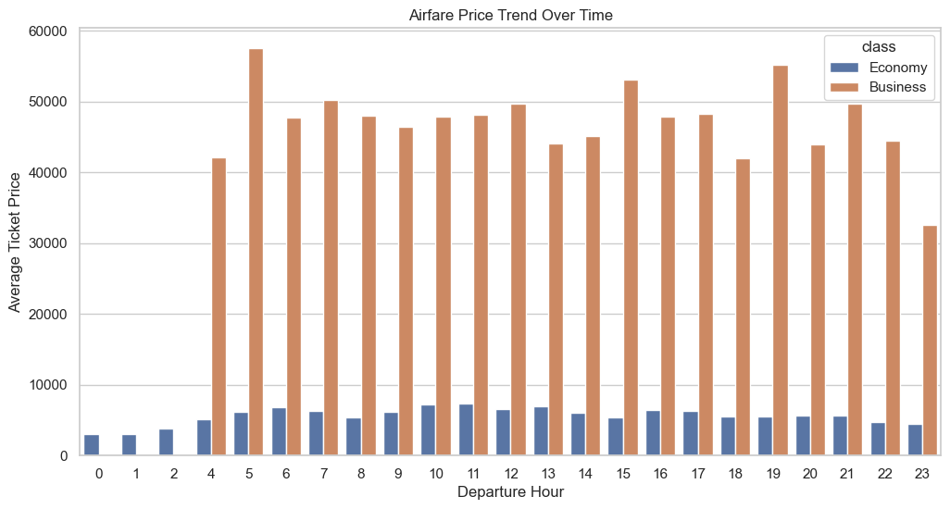

Visualization 2:Which factors contribute most to ticket price variation?
- Chart type: Pie chart
- Key insight:
Different airlines contribute differently to ticket price variation, showing uneven pricing distribution.
- Observation:
- A few airlines dominate in terms of higher ticket prices.
- Premium airlines tend to contribute more to overall price variation.
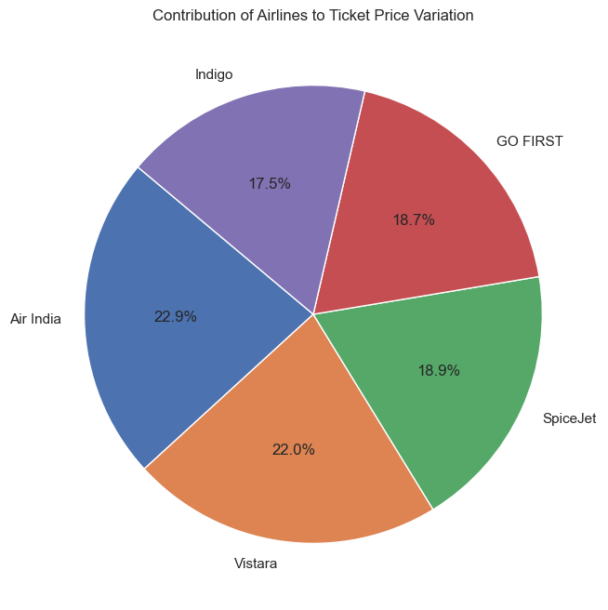

Visualization 3: Is there a correlation between journey duration and ticket price?
- Chart type: Scatter plot with regression line
X-axis: Journey Duration (minutes)
Y-axis: Ticket Price
- Key insight:
There is a positive correlation between journey duration and ticket price.
- Observation:Ticket prices generally increase as journey duration increases.
- Some variations indicate that other factors also influence pricing.
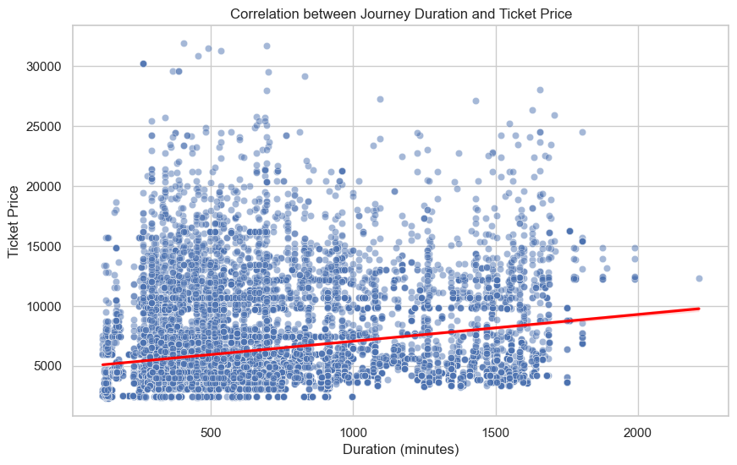

Visualization 4 : What patterns exist across routes and travel conditions?
- Chart type: Bar graph
X-axis: Route (From → To)
Y-axis: Average Ticket Price
- Key insight: Ticket prices vary significantly across routes and travel conditions such as number of stops.
- Observation: Certain routes consistently have higher ticket prices.
- Non-stop flights tend to be more expensive than flights with multiple stops.
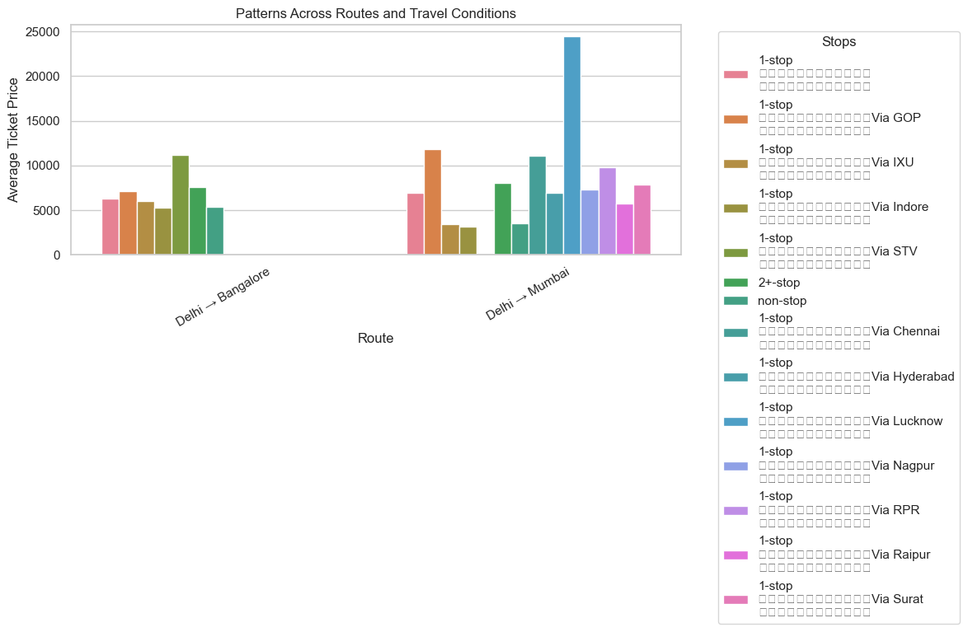

Visualization 5: Can ticket prices be predicted using historical data?
- Chart type: Line chart
X-axis: Date
Y-axis: Average Ticket Price
- Key insight: Historical trends show that ticket prices follow a pattern over time, allowing partial prediction.
- Observation: Ticket prices fluctuate over time but follow a general trend.
- Predictions are possible, though not perfectly accurate due to external factors.
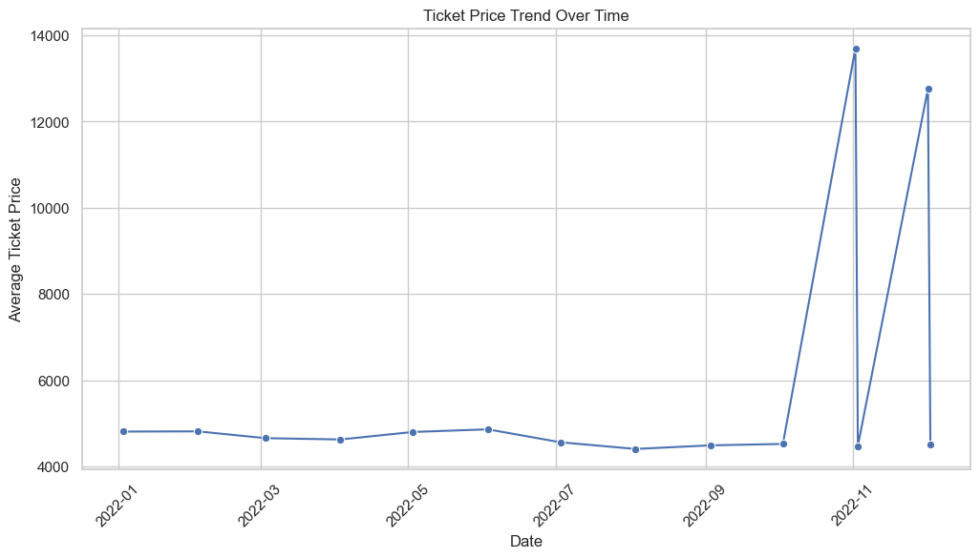

STATISTICAL ANALYSIS
- Hypothesis Testing:
  - H₀: No relationship between variables and price
  - H₁: Significant relationship exists
- Pearson Correlation used
Result:
p-value < 0.05 → Reject H₀
Conclusion:
Duration, stops, and class type significantly affect ticket prices

MODELING
- Model Used: Linear Regression
- Target Variable: Price
- Features: Duration, Stops, Class Type
Result:
Model shows that duration and class type strongly influence price

RESULTS & INTERPRETATION
- Visualizations clearly show pricing trends
- Business class fares are significantly higher
- Duration has a strong impact on price
- Stops influence pricing moderately

INSIGHTS & FINDINGS
- Business class is 2–3x more expensive
- Longer flights cost more
- Flights with stops are cheaper
- Route and demand affect pricing

CONCLUSION
The project successfully analyzed airfare pricing using data analytics techniques. It identified key factors such as duration, stops, and class type that influence ticket prices.
The results provide valuable insights for both travelers and airlines, helping in better decision-making.

LIMITATIONS
Challenges Faced & Constraints
- Data Size
The dataset was limited in size, which may impact the generalization of findings compared to larger real-world datasets
- Data Recency
Data represents a specific time period and may not fully reflect current or rapidly changing airfare trends
- Missing Data
Some records contained missing values, requiring preprocessing which may slightly affect analysis accuracy
- Model Accuracy
The Linear Regression model showed moderate accuracy, indicating scope for improvement with advanced models
- Tool Limitations
Use of free tools and local systems imposed constraints on processing power and scalability
- Domain Knowledge
Certain insights may require deeper airline industry expertise for full validation

FUTURE SCOPE
Future Scope & Project Extension
- Real-Time Data Integration
Enhance the project by integrating live airfare data using APIs or streaming pipelines for up-to-date analysis
- Advanced Machine Learning
Apply advanced models such as Random Forest, XGBoost, or Deep Learning to improve prediction accuracy
- Expanded Dataset
Include more routes, airlines, and extended time periods to improve the robustness of insights
- Web-Based Dashboard
Develop a fully interactive web dashboard with real-time updates for better user experience
- NLP Integration
Incorporate text analysis (reviews/feedback) using NLP to understand customer sentiment
- Enterprise Integration
Connect with BI tools (Power BI, Tableau) for scalable, business-level reporting and decision-making

GANTT CHART (PROJECT TIMELINE)
Day 1-2: Data Collection
Day 3-5: Data Cleaning
Day 6-8: EDA
Day 9-10: Analysis
Day 11-12: Modeling
Day 13: Documentation
Day 14: Final Review
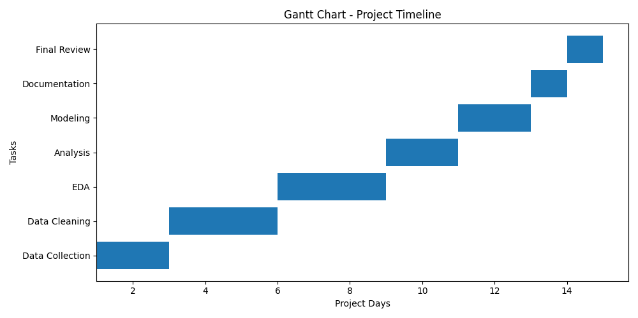

REFERENCES / BIBLIOGRAPHY
Sources & Acknowledgements
- Kaggle Dataset (2024). Airfare Economy & Business Class Dataset. Available at: https://www.kaggle.com (Accessed: April 2026)
- Python Documentation (2024). Pandas Library. Available at: https://pandas.pydata.org
- Python Libraries
NumPy, Matplotlib, Seaborn, Scikit-learn – Official documentation used for analysis and visualization
- Learning Resources
Online courses and tutorials on Data Analytics, SQL, and Python programming
- Tools & Platforms
Jupyter Notebook, MySQL / PostgreSQL for data processing and analysis

APPENDIX A: SQL CODE
Instructions: Paste all SQL queries used in this project below. Organise by section (Data Extraction, Cleaning, Aggregation, Analysis). Add a comment above each query explaining its purpose.

A.1 Database Setup & Table Creation
-- Purpose: Create the main project database and tables
CREATE DATABASE airfare_project;
USE airfare_project;
-- Economy Class Table
CREATE TABLE economy_class (
id INT AUTO_INCREMENT PRIMARY KEY,
date DATE,
airline VARCHAR(100),
ch_code VARCHAR(10),
num_code VARCHAR(10),
dep_time VARCHAR(20),
source VARCHAR(50),
time_taken VARCHAR(20),
stop VARCHAR(20),
arr_time VARCHAR(20),
destination VARCHAR(50),
price VARCHAR(20)
);

-- Business Class Table
CREATE TABLE business_class (
id INT AUTO_INCREMENT PRIMARY KEY,
date DATE,
airline VARCHAR(100),
ch_code VARCHAR(10),
num_code VARCHAR(10),
dep_time VARCHAR(20),
source VARCHAR(50),
time_taken VARCHAR(20),
stop VARCHAR(20),
arr_time VARCHAR(20),
destination VARCHAR(50),
price VARCHAR(20)
);

A.2 Data Extraction Queries
-- Purpose: Extract relevant data for analysis
-- Top airlines by number of flights
SELECT airline, COUNT(*) AS total_flights
FROM economy_class
GROUP BY airline
ORDER BY total_flights DESC;

-- Average price by airline
SELECT airline, AVG(CAST(REPLACE(price, ',', '') AS DECIMAL(10,2))) AS avg_price
FROM business_class
GROUP BY airline;

-- Flights by route
SELECT source, destination, COUNT(*) AS total_routes
FROM economy_class
GROUP BY source, destination
ORDER BY total_routes DESC;

A.3 Data Cleaning Queries
-- Purpose: Remove nulls, duplicates, fix data types
-- Remove NULL values
DELETE FROM economy_class
WHERE price IS NULL OR time_taken IS NULL;

DELETE FROM business_class
WHERE price IS NULL OR time_taken IS NULL;

-- Remove duplicate records
DELETE e1 FROM economy_class e1
INNER JOIN economy_class e2
WHERE e1.id > e2.id
AND e1.airline = e2.airline
AND e1.date = e2.date;

-- Convert price by removing commas (view purpose)
SELECT REPLACE(price, ',', '') AS cleaned_price
FROM economy_class;

A.4 Analysis & Aggregation Queries
-- Purpose: Summarise, join, and aggregate for insights
-- Average price based on stops
SELECT stop,
AVG(CAST(REPLACE(price, ',', '') AS DECIMAL(10,2))) AS avg_price
FROM economy_class
GROUP BY stop;

-- Average price based on airline
SELECT airline,
AVG(CAST(REPLACE(price, ',', '') AS DECIMAL(10,2))) AS avg_price
FROM business_class
GROUP BY airline;

-- Duration vs price (approx analysis)
SELECT time_taken,
AVG(CAST(REPLACE(price, ',', '') AS DECIMAL(10,2))) AS avg_price
FROM economy_class
GROUP BY time_taken
ORDER BY avg_price DESC;

APPENDIX B: PYTHON CODE
Instructions: Paste all Python scripts used in this project below. Organise by phase: Data Loading, Cleaning, EDA, Visualisation, Modelling. Include comments for each block.

B.1 Library Imports
# Standard imports used across the project
import pandas as pd
import numpy as np
import matplotlib.pyplot as plt
import seaborn as sns

from scipy.stats import pearsonr
from sklearn.model_selection import train_test_split
from sklearn.linear_model import LinearRegression

import warnings
warnings.filterwarnings('ignore')

B.2 Data Loading & Initial Exploration
# Load dataset and perform initial checks
eco = pd.read_csv(r"C:\Users\PC\Downloads\Downloads\Airfare Forecasting\economy_class.csv")
bus = pd.read_csv(r"C:\Users\PC\Downloads\Downloads\Airfare Forecasting\business_class.csv")

# Display basic information

print("Economy Dataset Shape:", eco.shape)
print("Business Dataset Shape:", bus.shape)
print(eco.head())
print(bus.head())
print(eco.info())
print(bus.info())
print(eco.isnull().sum())
print(bus.isnull().sum())

B.3 Data Cleaning & Preprocessing
# Handle missing values, duplicates, type conversion
# Clean column names
eco.columns = eco.columns.str.strip().str.lower()
bus.columns = bus.columns.str.strip().str.lower()

# Convert price (remove commas and convert to float)
eco['price'] = eco['price'].astype(str).str.replace(',', '').astype(float)
bus['price'] = bus['price'].astype(str).str.replace(',', '').astype(float)

# Convert time_taken to minutes
def convert_time(x):
try:
x = str(x)
h = 0
m = 0

if 'h' in x:
h = int(x.split('h')[0])
if 'm' in x:
m = int(x.split('h')[-1].replace('m','').strip())

return h*60 + m
except:
return None
eco['time_taken'] = eco['time_taken'].apply(convert_time)
bus['time_taken'] = bus['time_taken'].apply(convert_time)

# Convert stops to numeric
def convert_stops(x):
if 'non' in str(x).lower():
return 0
elif '1' in str(x):
return 1
elif '2' in str(x):
return 2
elif '3' in str(x):
return 3
else:
return None
eco['stop'] = eco['stop'].apply(convert_stops)
bus['stop'] = bus['stop'].apply(convert_stops)

# Combine datasets
eco['class_type'] = 'Economy'
bus['class_type'] = 'Business'
data = pd.concat([eco, bus])
# Remove missing values
data = data.dropna(subset=['time_taken', 'stop', 'price'])

B.4 Exploratory Data Analysis (EDA)
# Distribution plots, correlation, value counts
# Basic statistics
print(data.describe())
# Correlation matrix
corr = data[['time_taken', 'stop', 'price']].corr()
sns.heatmap(corr, annot=True)
plt.title("Correlation Matrix")
plt.show()

B.5 Data Visualisation Code

Chart 1: What are the major trends in airfare prices over time?
import os
import pandas as pd
import matplotlib.pyplot as plt
import seaborn as sns
import warnings
warnings.filterwarnings("ignore")

# 1. Set your folder path
os.chdir(r"C:\Users\User\OneDrive\Desktop\flight_sql")

# 2. Load datasets
economy = pd.read_csv("economy_class.csv")
business = pd.read_csv("business_class.csv")

# 3. Clean column names
economy.columns = economy.columns.str.strip().str.lower()
business.columns = business.columns.str.strip().str.lower()

# 4. Fix price column (remove commas + convert to numeric)
economy['price'] = economy['price'].astype(str).str.replace(',', '')
business['price'] = business['price'].astype(str).str.replace(',', '')

economy['price'] = pd.to_numeric(economy['price'], errors='coerce')
business['price'] = pd.to_numeric(business['price'], errors='coerce')

# 5. Convert departure time
economy['dep_time'] = pd.to_datetime(economy['dep_time'], errors='coerce')
business['dep_time'] = pd.to_datetime(business['dep_time'], errors='coerce')

# 6. Extract hour
economy['dep_hour'] = economy['dep_time'].dt.hour
business['dep_hour'] = business['dep_time'].dt.hour

# 7. Group data (average price per hour)
eco_trend = economy.groupby('dep_hour')['price'].mean().reset_index()
bus_trend = business.groupby('dep_hour')['price'].mean().reset_index()

# 8. Add class label
eco_trend['class'] = 'Economy'
bus_trend['class'] = 'Business'

# 9. Combine both datasets
data = pd.concat([eco_trend, bus_trend])

# 10. Plot BAR GRAPH
plt.figure(figsize=(12,6))

sns.barplot(data=data, x='dep_hour', y='price', hue='class')
plt.title("Airfare Price Trend Over Time")
plt.xlabel("Departure Hour")
plt.ylabel("Average Ticket Price")

# 11. Save graph (for PPT)
plt.savefig("airfare_trend.png", dpi=300)

# 12. Show graph
plt.show()


Chart 2 : Which factors contribute most to ticket price variation?
import os
import pandas as pd
import matplotlib.pyplot as plt
import warnings
warnings.filterwarnings("ignore")

# Set path
os.chdir(r"C:\Users\User\OneDrive\Desktop\flight_sql")

# Load data
economy = pd.read_csv("economy_class.csv")

# Clean column names
economy.columns = economy.columns.str.strip().str.lower()

# Fix price column
economy['price'] = economy['price'].astype(str).str.replace(',', '')
economy['price'] = pd.to_numeric(economy['price'], errors='coerce')

# Choose factor (AIRLINE)
factor_data = economy.groupby('airline')['price'].mean()

# Take top 5 (for clean pie chart)
factor_data = factor_data.sort_values(ascending=False).head(5)

# Plot pie chart
plt.figure(figsize=(8,8))

plt.pie(
factor_data.values,
labels=factor_data.index,
autopct='%1.1f%%',
startangle=140
)

plt.title("Contribution of Airlines to Ticket Price Variation")

plt.show()


Chart 3 : Is there a correlation between journey duration and ticket price?
import os
import pandas as pd
import matplotlib.pyplot as plt
import seaborn as sns
import warnings

warnings.filterwarnings("ignore")

# Set path
os.chdir(r"C:\Users\User\OneDrive\Desktop\flight_sql")

# Load dataset
economy = pd.read_csv("economy_class.csv")

# Clean column names
economy.columns = economy.columns.str.strip().str.lower()

# Fix price column
economy['price'] = economy['price'].astype(str).str.replace(',', '')
economy['price'] = pd.to_numeric(economy['price'], errors='coerce')

# 🔥 Convert duration (time_taken) into numeric minutes
# Example: "2h 30m" → 150 mins
def convert_duration(x):
try:
x = str(x)
hours = 0
minutes = 0

if 'h' in x:
hours = int(x.split('h')[0])
if 'm' in x:
minutes = int(x.split('h')[-1].replace('m','').strip())

return hours*60 + minutes
except:
return None

economy['duration_mins'] = economy['time_taken'].apply(convert_duration)

# Remove nulls
economy = economy.dropna(subset=['duration_mins','price'])

# 📊 Scatter plot
plt.figure(figsize=(10,6))

sns.scatterplot(x='duration_mins', y='price', data=economy, alpha=0.5)

# Add trend line
sns.regplot(x='duration_mins', y='price', data=economy, scatter=False, color='red')

plt.title("Correlation between Journey Duration and Ticket Price")
plt.xlabel("Duration (minutes)")
plt.ylabel("Ticket Price")

plt.show()

# 📈 Correlation value
corr = economy['duration_mins'].corr(economy['price'])
print("Correlation coefficient:", round(corr, 2))



Chart 4 : What patterns exist across routes and travel conditions?
import os
import pandas as pd
import matplotlib.pyplot as plt
import seaborn as sns
import warnings

warnings.filterwarnings("ignore")

# Path
os.chdir(r"C:\Users\User\OneDrive\Desktop\flight_sql")

# Load data
economy = pd.read_csv("economy_class.csv")

# Clean columns
economy.columns = economy.columns.str.strip().str.lower()

# Fix price
economy['price'] = economy['price'].astype(str).str.replace(',', '')
economy['price'] = pd.to_numeric(economy['price'], errors='coerce')

# Create route
economy['route'] = economy['from'] + " → " + economy['to']

# Group data
route_data = economy.groupby(['route', 'stop'])['price'].mean().reset_index()

# Reduce to top 5 routes (IMPORTANT FIX)
top_routes = route_data.groupby('route')['price'].mean().sort_values(ascending=False).head(5).index
route_data = route_data[route_data['route'].isin(top_routes)]

# 🔥 Plot (FIXED STYLE)
plt.figure(figsize=(12,6))

sns.barplot(
data=route_data,
x='route',
y='price',
hue='stop',
dodge=True # ensures bars don't overlap
)

plt.title("Patterns Across Routes and Travel Conditions")
plt.xlabel("Route")
plt.ylabel("Average Ticket Price")

plt.xticks(rotation=30)
plt.legend(title="Stops", bbox_to_anchor=(1.05, 1)) # move legend outside

plt.tight_layout()
plt.show()



Chart 5 : Can ticket prices be predicted using historical data?
import os
import pandas as pd
import matplotlib.pyplot as plt
import seaborn as sns
import warnings
warnings.filterwarnings("ignore")

# Path
os.chdir(r"C:\Users\User\OneDrive\Desktop\flight_sql")

# Load data
economy = pd.read_csv("economy_class.csv")

# Clean columns
economy.columns = economy.columns.str.strip().str.lower()

# Fix price
economy['price'] = economy['price'].astype(str).str.replace(',', '')
economy['price'] = pd.to_numeric(economy['price'], errors='coerce')

# Convert date
economy['date'] = pd.to_datetime(economy['date'], errors='coerce')

# Remove nulls
economy = economy.dropna(subset=['date', 'price'])

# Group by date (average price per day)
date_trend = economy.groupby('date')['price'].mean().reset_index()

# 📊 Line chart
plt.figure(figsize=(12,6))

sns.lineplot(data=date_trend, x='date', y='price', marker='o')

plt.title("Ticket Price Trend Over Time")
plt.xlabel("Date")
plt.ylabel("Average Ticket Price")

plt.xticks(rotation=45)

plt.show()


Conclusion
The analysis of airfare pricing reveals that ticket prices are influenced by multiple factors such as flight duration, departure time, airline, route, and number of stops. A positive relationship is observed between journey duration and ticket price, where longer flights generally cost more. Additionally, premium services like business class and non-stop flights consistently show higher fares.
Price trends over time indicate fluctuations based on demand, highlighting the dynamic nature of airline pricing. Different airlines and routes contribute unequally to price variation, suggesting that competition and travel conditions play a significant role.
While historical data shows identifiable patterns that allow partial prediction of ticket prices, the presence of variability indicates that external factors such as demand, availability, and airline policies also impact pricing.
Overall, the study demonstrates that airfare pricing is complex, influenced by multiple interacting variables, and can be analyzed effectively using data visualization techniques.

