SECTION 0

SECTION 1

SECTION 2

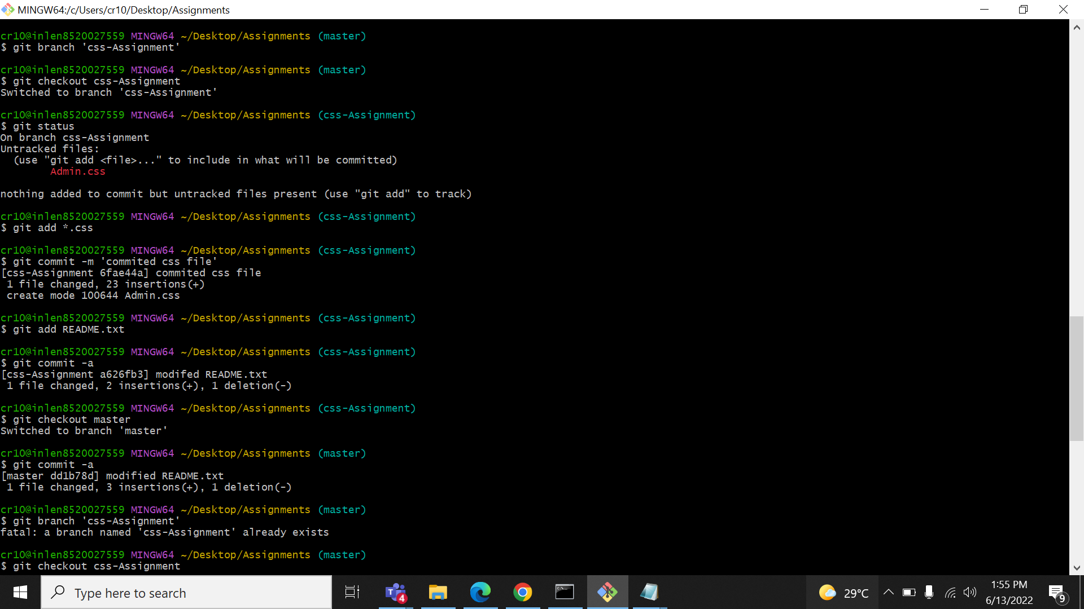

SECTION 3

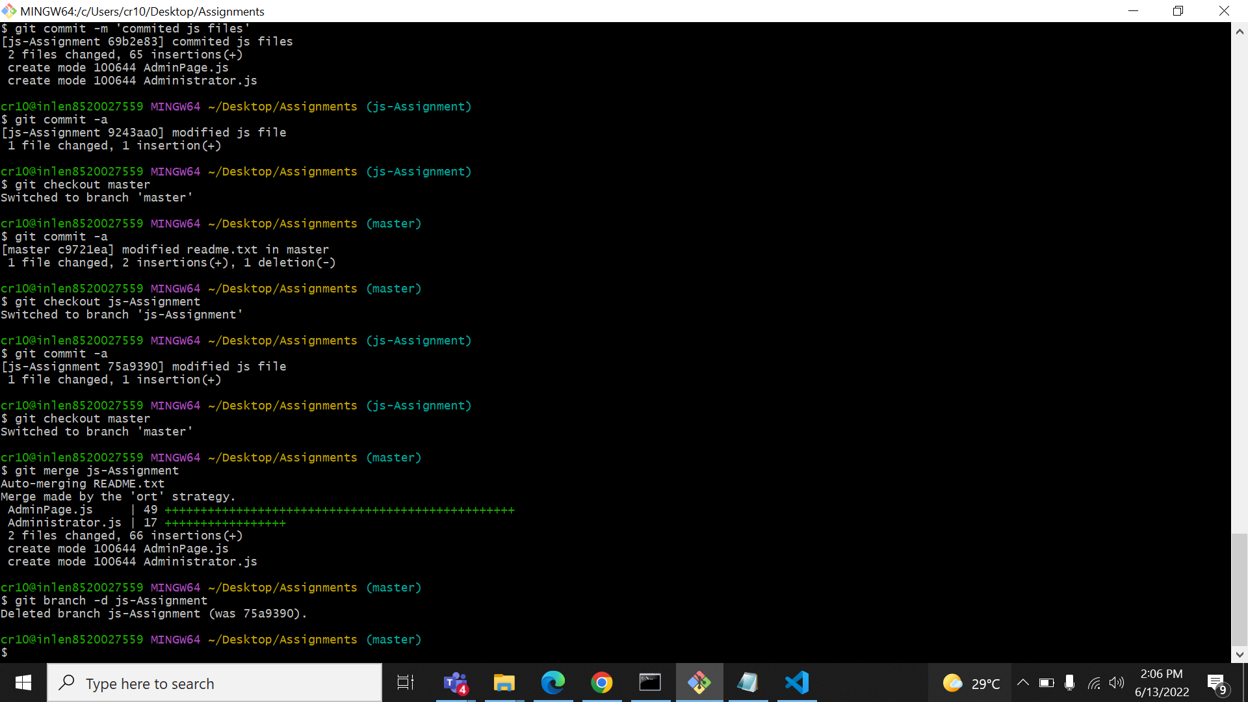

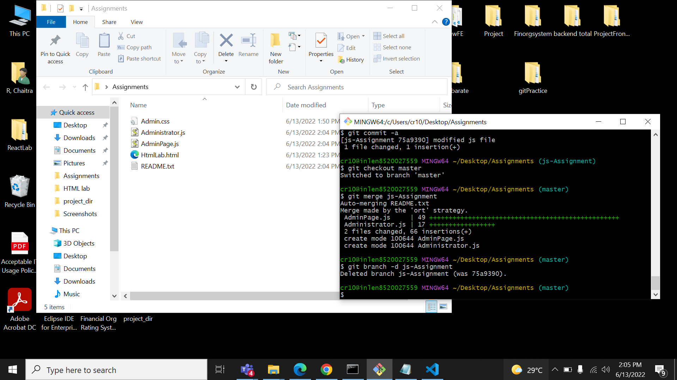

SECTION 4

SECTION 5

