1. Explain Automation Life cycle

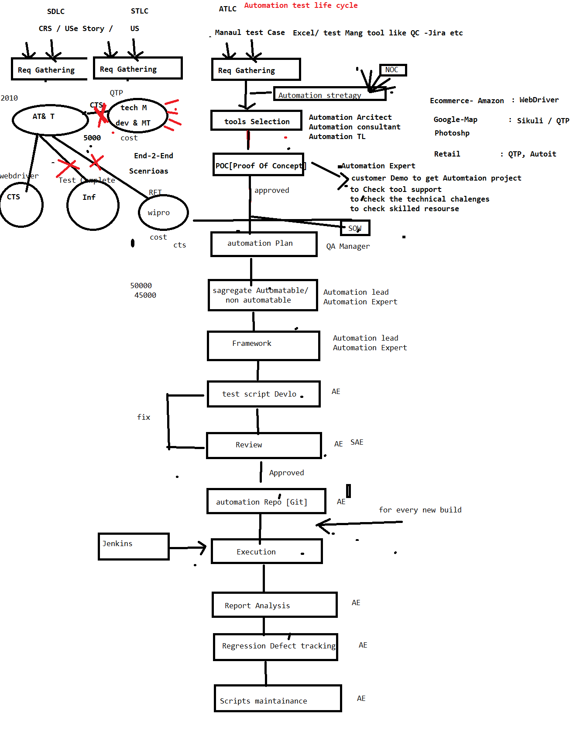

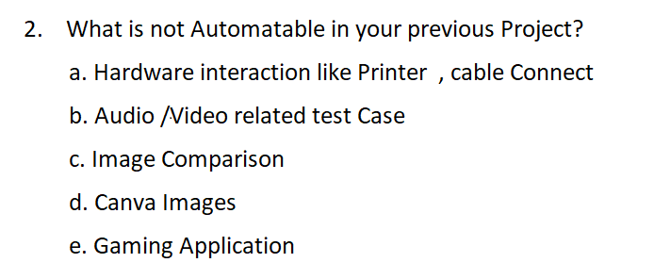

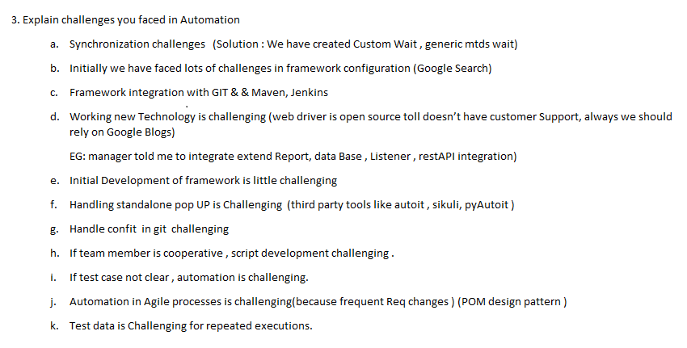

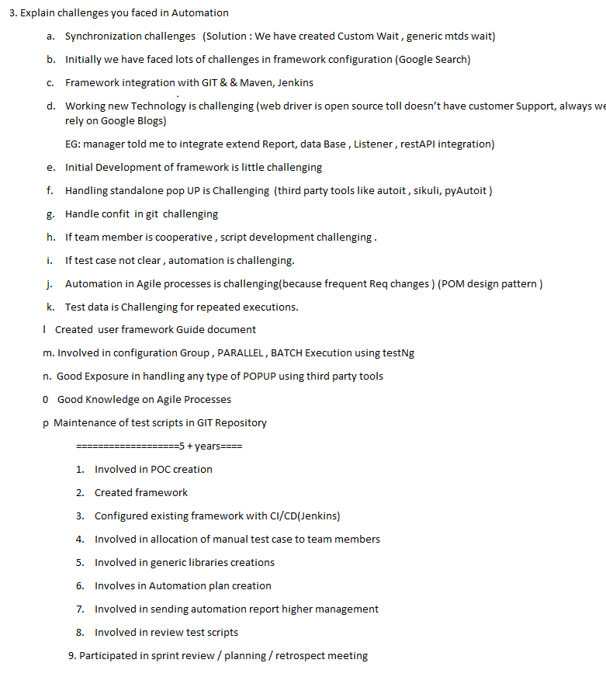

========================================================

1. Explain few complicated scenarios which you automated in your previous Project & explain the Challenged
2. Explain one critical bug which you got via automation
3. What is daily Activity

When Ever I reach Office to Check Email

Email => WRT 🡺 Review

Email => WRT 🡺 test Script Allocation

Email => WRT 🡺 Meeting

Email => WRT 🡺 JIRA (retest the defect)

Email=> WRT 🡺 JENKINS 🡺 verify the report

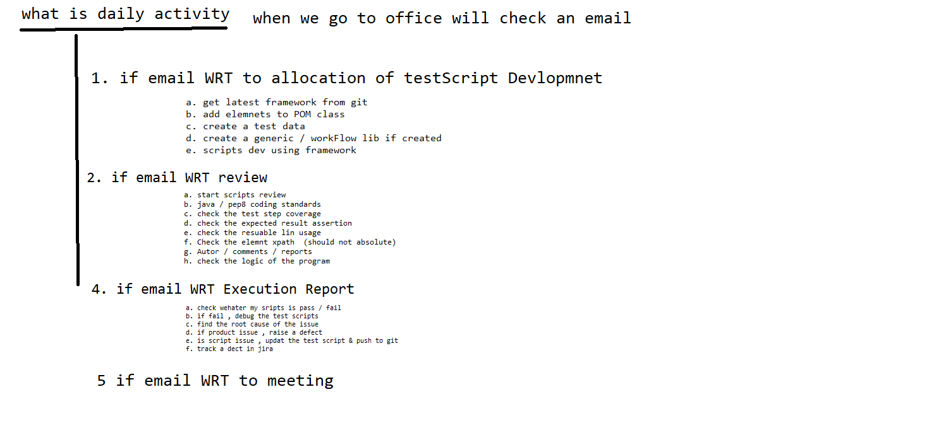

What is duration of the Project?

What is sprint duration in your previous project

**How many build you get in one sprint?**

How many test case you had in your previous project?

Which processes you fallowed

How many test case used to get for automation in every sprint / release

How many test case you automated /day/month/year/ in entire project

What is your team size

I will give 100 test case , what is your estimation ?

How long automation batch execution take place ?

How may defect you found via automation in your previous project ?

Percentage of manual & automation in your previous project ?

