BAGALKOT UNIVERSITY, JAMAKHANDI 587301


Internship Report on
" Training and Development of Employees in Shree Prabhulingeshwar Sugars and Chemicals Limited "
Submitted in partial fulfillment of academic session in under-graduation degree course of

Bachelor of Commerce

Submitted by:
Sachin Biradar (U26YN23C0129)
Under the Guidance of
Internal Guide:
Prof. S. S. Hiremath
Dept. of Commerce

BLDEA’s COMMERCE BHS ARTS AND TGP SCIENCE COLLEGE, JAMAKHANDI-587301

2025 – 2026

DECLARATION
I, Sachin Biradar, hereby declare that the Internship Report titled “Training and Development of Employees in Shree Prabhulingeshwar Sugars and Chemicals Limited.” is a genuine and bonafide work carried out by me during my internship at Shree Prabhulingeshwar Sugars and Chemicals Limited.
I further declare that this report is submitted in partial fulfillment of the requirements for the award of the degree of Bachelor of Commerce (B.Com). The information presented in this report is true to the best of my knowledge and belief. This work has not been submitted to any other university or institution for the award of any degree or diploma.
Place: Sachin Biradar
Date: U26YN23C0129

ACKNOWLEDGEMENT
I would like to express my sincere gratitude to Shree Prabhulingeshwar Sugars and Chemicals Limited for providing me with the opportunity to complete my internship and prepare this project report on Training and Development of Employees in Shree Prabhulingeshwar Sugars and Chemicals Limited.”
I extend my heartfelt thanks to the management and the HR Department of the organization for their continuous support, valuable guidance, and encouragement throughout the internship period. Their practical insights and cooperation helped me gain a better understanding of HR practices in a real organizational environment.
I am also thankful to my college principal and faculty members for their guidance and motivation in successfully completing this project. Their academic support and suggestions were extremely helpful in shaping this report.
Finally, I would like to thank my parents and friends for their constant encouragement and moral support throughout the preparation of this report.

INDEX

SI No. | Title | Page No
1. | INTRODUCTION  - Introduction to the Study  - Objectives of Study  - Scope of Study  - Limitations of study  - Source of Data | 6-9
2. | ORGANISATION PROFILE  - History  - Overview of the company  - Details of the directors  - About the owner  - Organization structure  - Facilities / infrastructure  - Objectives  - Future plans  - SWOC analysis | 10-19
3. | CONCEPTUAL FRAMEWORK  - Conceptual framework  - Methods and technique of Data analysis | 20-23
4. | DATA ANALYSIS AND INTERPRETATION | 24-32
5. | FINDINGS  SUGGESTIONS  CONCLUSION  BIBILOGRAPHY | 33-38

CHAPTER-1

INTRODUCTION

Introduction of the study

The skills or knowledge required to do a particular job is developed in the human being with the help of training only. The trained employee is an asset to the organization and the employer. The training is valuable to employee because it increases his efficiency & he gets greater opportunity for advancement through promotion. The development includes the improvement in the technical knowledge and skills, ability to solve problems etc.

Management is the development of people and not the directional of the things. Management & personnel, administration are one and the same thing from the very beginning, labour had been important factor of production. Even today technical development could not under mine the place of labour is the active factor of production which only use the other factors in the best possible manner, otherwise no production is possible.

The perfect knowledge & skill which can be acquired through the best source and that is training. When the most suitable person is selected in the organization through the application of the scientific selection process after that the next important function of the personnel management is to arrange for their training. Every organization must have a systematic training programme.

Objectives of the Study
The report studies the different departments of Shree Prabhulingeshwar Sugars and Chemicals Limited and the functioning of each department.

Hence the objective of this study is: -

- To see the impact of Training & Development in the organization

- To know how the training & development programme by improve efficiently of the employees.

- To identify the training and development needs given to Employees.

- To identify the methods of training and effectiveness of training.

- To know whether Training has been provided at right point of time

Scope of the study

The study of TRAINING AND DEVELOPMENT was conducted at The Shree Prabhulingeshwar Sugars and Chemicals Limited. Source of information collected will be the information provided by the HR department as well as the
survey and the observation made there on .

Scope of the study is restricted to employees of Shree Prabhulingeshwar Sugars and Chemicals Limited.
Limitations of the Study
- The information is based only on the sample selected for the study and not on the entire population.
- Some employees were unwilling to reveal their opinions on certain issues.
- Top managers did not share confidential data due to management policies.
- The researcher could not contact and collect data from employees working in night shifts.
- The in-plant training period of 60 days was too short to conduct a detailed study.
- Since the sample size is only 100, it may not truly represent the entire population.
- The accuracy of the research results is limited to the accuracy of the responses provided by the employees, which cannot be fully guaranteed.

Source of the Data

Primary Data
The primary data collected through survey method on employees & interview schedules, personal observations made by researcher & well structured questionnaire method.
The questionnaire is based on various aspects of training & development of the employees.

Secondary Data
Secondary data consists of readily available information on various authentic digital labs, journals, magazines, books, and company databases. Data was also collected wherever necessary from annual reports and other office records of the study of training & development of Shree Prabhulingeshwar Sugars and Chemicals Limited.

CHAPTER – 02

ORGANISATION PROFILE

Shri Prabhulingeshwar Sugars and Chemicals LTD.
Siddapur

Shri Prabhulingeshwar Sugars and Chemicals LTD is an integrated company with the primary objective of manufacturing sugar and allied products. It is founded by Shri. Jagadeesh. S. Gudagunti. The company was incorporated on 25 May 1995, in Siddapur village which falls under the territory of Bagalkot district and Jamkhandi taluk.
It was started with the plant capacity of 2500TCD and 17.5MW cogeneration plant in 1999. It is remarkable that the company has tremendously increased its plant capacity to 8500TCD and 38.5MW cogeneration plant.
In the present day the plant is famed as fast growing industrial group and has won the notable awards for its excellent performance. The company has diversified its fields from sugar manufacturing to power and ethanol production.

Overview of the company:
CIN | U85110ka1995plc017861
COMPANY NAME | Shri Prabhulingeshwar Sugars and Chemicals Limited
STATUS | Active
ROC | Bangalore
REGISTRATION NUMBER | 17861
CHAIRMAN AND MD | Shri. Jagadeesh. S. Gudagunti
INITIAL INVESTMENT | 186 crores.
AREA OF PLANT | 200 crores
NATURE | Company limited by shares (Non govt)
CLASS OF COMPANY | Public
DATE OF INCORPORATION | 25 may 1995
AUTHORISED CAPITAL | ₹60,00,00,000
PAID UP CAPITAL | ₹46,61,85,952
LISTING STATUS | Unlisted
TELEPHONE NO | 08353-2382200, 238004
FAX NO. | 08353-231864, 238166
EMAIL ID | prabhusugar.cs@gmail.com
WEBSITE | https://www.prabhusugars.com

Details of the Directors :

Shri. Jagadeesh S. Gudagunti | Chairman and managing director
Shri. Veerupakshayya J. Gudagunti | Executive director
Shri. Dharmalingayya S. Gudagunti | Director
Shri. Rajendrakumar S. Gudagunti | Director
Shri. Nagappa G. Sanadi | Director
Shri. Deval A. Desai | Director
Shri. Suresh P. Hiremath | Independent director
Shri. Sudheer S. Gudagunti | Director
Shri. Satish S. Gudagunti | Director
Smt. Ishwari A. Gudagunti | Director

About the owner

Shri Jagadeesh S. Gudagunti
Former president, south Indian sugar mills Association

The chairman, shri Jagadeesh Gudagunti is a technocrat, industrialist and consultant for sugar machinery manufacturing. He has an experience of more than 40 years as an Industrialist and consultant for sugar industries, distilleries and material handling equipment’s. He is a licensed sugar machinery manufacturer registered with NSCSF, NCDC, commissioner of sugar (MH & AP), TASCO, Gujarat and Karnataka governments. As a project consultant he has visited KENYA ,NIZERIA , VIETNAM , CHINA , GERMANY , PHILLIPINES , MALAYSIA and other countries , for rehabilitation and modernization of sugar , paper and distillery plants.
He has received many awards and certificates of merit for having excellent manufacturing works especially for sugar products through his concerns namely M/s Extrat Engineering works pvt. Ltd. Dharwad and M/s J. S. Gudagunti and associates. He has received certificates of merit for excellence in productivity, quality, innovation and management. He is awarded “ UDYOG RATNA ” by Institute of economic studies and “ VANUYA RATHNA ” award from Karnataka chamber of commerce , Hubbli and also been awarded “ INTERNATIONAL GOLD STAR MILLENIUM AWARD ” for excellence in promoting global integration.

Organisation structure :

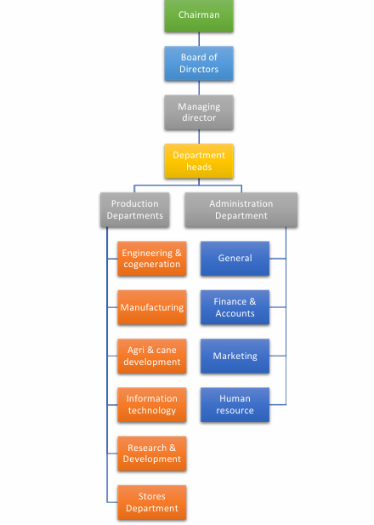

Facilities:
Conference hall :

The conference hall of the company is built with all modern equipment’s including comfortable chairs, air cooling and big display screen. The hall is maintained well and is used by the company for holding director’s meeting.


Parking facility :
The company has provided parking facility to the employees for parking their two wheelers inside the factory premises.



Administration department :
The administration department of the company is established in the sideway of factory entrance that is at a little distant from the working plant in between the nature.


Modern machineries and equipment’s :
The plant is working at full potential using modern and updated technology and is undertaking research and development activities regularly to grab the opportunities of technological advancements.

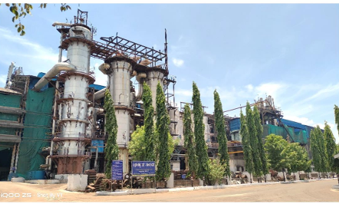

Proper safety measures :
The company has given the equal importance to the safety of workers. For this purpose the instruction for unusual cases are displayed on instruction panels at relevant locations and also the emergency assemble points for the workers during emergency are clearly located using such info panels.

Quarters for workers :
The company has also provided the quarter facilities for the employees and workers of the plant with free and continuous electricity supply and also provided all other essential facilities in the quarters.



Green care :


The plant is surrounded with green plants and trees in the most of the areas that makes the plant fascinating and also provides the good environment to the workers with the fresh breathe.


Objectives of SPSCL, Siddapur:

- To utilize maximum man power and product capacity and utilities of raw materials to produce sugar and development of the irrigation project .
- To manufacture sugar and it’s bye products out of sugar cane grown and supplied by the society and to sell to sum to best .
- To acquire lands either by way of sale, leases are otherwise for cultivation of sugar cane and other crop and for reaction of building, machinery etc.
- To give good product rate to the farmer who supply sugar cane to their factory.
- To provide large scale employment.

Future Plans of SPSCL:

- Planning for the further automation
- Expansion of co-generation of power
- Improving the infrastructural facility and contribution of more quarters
- Processing of refinery sugar i.e., Exportable quality
- Listing the shares of company in the stock exchange

SWOC Analysis :

Strengths
- High quality products.
- Located at the area with good infrastructure.
- Technologically well-versed.
- Good source of raw material.
- Own power generation capacity.
- Production efficiency.

Weaknesses
- More competitors.
- Less number of skilled employees.
- Lack of employee commitments.

Opportunities
- All the projects will provide reasonable profit to the company.
- Expansion of project to the bi products.

Challenges
- Government intervention
- Strong competition with Godavari sugars and Nandi sugars.

CHAPTER-3
CONCEPTUAL FRAMEWORK

Training
Efforts were initiated by the organization to foster learning among its members and that tends to be narrowly focused and oriented towards short-term performance.

Development
Efforts that are oriented towards broadening of individual skills for handling future responsibilities.

Definition of Training
“It is a learning process that involves the acquisition of knowledge, sharpening of skills, concepts and rules or changing of attitudes and behaviours to enhance the performance of employees.”

Key Points
- Training is an activity which leads to improved skills and behaviours.
- It’s not what you want in life, but it’s knowing how to reach it.
- It’s not where you want to go, but it’s knowing how to get there.
- It’s not how high you want to rise, but it’s knowing how to take off.
- It may not be quite the outcome you were aiming for, but it will be an outcome.
- It’s not what you dream of doing, but it’s having the knowledge to do it.
- It’s not the goal you set, but it’s what you need to achieve it.
- It’s not a set of goals, but it’s more like vision.

Training Methods

A) On-the-Job Methods

1) On-the-Job Training
An employee is placed in a new job and is told how it is to be performed. It aims at developing skills and habits consistent with the existing practices of an organization and by orienting him to his immediate problems. A variety of training aids and techniques are used such as procedure charts, lecture manuals, sample problems, demonstrations, oral and written explanations, etc.

2) Vestibule Training or Training-Centre Training

It involves classroom training imparted with the help of equipment and machines identical to those in use at the place of work. It is often used to train clerks, bank tellers, inspectors, machine operators, typists, etc.

3) Simulation
It is an extension of vestibule training. The trainee works in closely duplicated real job conditions.

4) Demonstration and Examples
Here the trainer describes and demonstrates how to do a certain work. He performs the activity himself, giving a step-by-step explanation of why, how, and what of what he is doing.

5) Apprenticeship
A major part of training time is spent on on-the-job productive work. Each apprentice is given a programme of assignments according to a predetermined schedule, which provides efficient training in trade skills. This method is appropriate for training in crafts, trades and technical areas.

B) Off-the-Job or Classroom Methods
The location of this training may be a company classroom, an outside place owned by the organization, an educational institution or association which is not part of the company.
These methods are:

1) Lectures
These are formally organized talks by an instructor on specific topics. This method is useful when philosophy, concepts, attitudes, theories and problem-solving have to be discussed.

2) The Conference Method
Under this method, a conference is held according to an organized plan. Mutual problems are discussed and participants pool their ideas and experience in attempting to arrive at better methods of dealing with these problems.

3) Seminar or Team Discussion
The group learns through discussion of a paper on a selected subject. The paper is written by one or more trainees. The material to be analyzed is distributed in advance in the form of required reading.

Case Discussion
Under this method, a real or hypothetical business problem or situation demanding solution is presented to the group members. They are trained to identify the problems present, suggest various alternatives for tackling them, analyze each of these, find out their comparative suitability and decide for themselves the best solution.

Role-Playing
This method is also called role-reversal, socio-drama or psycho-drama. Here trainees act out a given role as they would in a stage play. Two or more trainees are assigned roles in a given situation, which is explained to the group.

Programmed Instruction
This involves two essential elements:
- A step-by-step series of knowledge, each building upon what has gone before.
2.A mechanism for presenting the series and checking the trainee’s knowledge.

CHAPTER -4
DATA ANALYSIS AND INTERPRETATION

4.1 Training Method in SPSC Ltd

Training Method | No. of Respondents | % of Respondents
On-the-job Training | 30 | 60%
Off-the-job Training | 10 | 20%
Both | 10 | 20%
Total | 50 | 100%
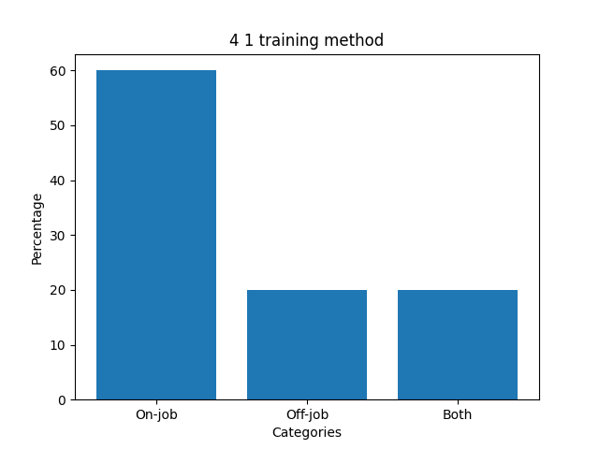
Analysis:The above data indicates that 60% of employees feel that on-the-job training is more effective. While 20% feel that off-the-job training is more effective and another 20% prefer both.
Interpretation:Most employees (60%) prefer on-the-job training, indicating it is considered more practical and effective. A smaller portion (20%) prefer off-the-job training, while another 20% value both methods equally.

4.2 At What Extent It Helped Better Job

Job Offer | No. of Job | % of Job
To large extent | 30 | 60%
To little extent | 5 | 10%
To some extent | 15 | 30%
Total | 50 | 100%
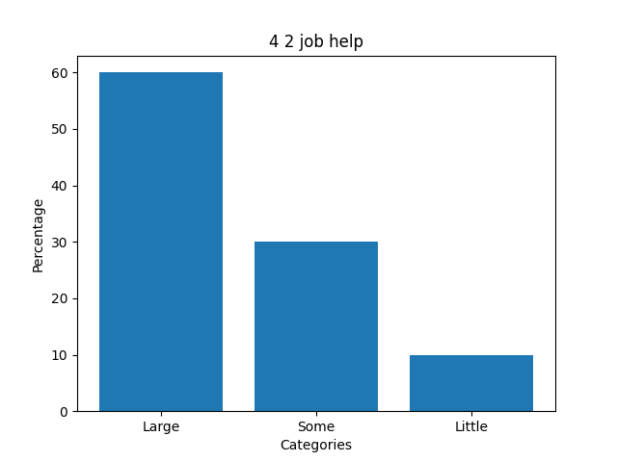

Analysis:The above data indicates that 60% of employees agree to a large extent that training helped them do a better job, 30% to some extent, and 10% to a little extent.
Interpretation: The majority (60%) feel training helped them to a large extent in performing their job better. Around 30% experienced moderate improvement, while only 10% saw minimal benefit.

4.3 Rating of Training Program

Method of Rating | No. of Rating | % of Rating
Excellent | 20 | 40%
Good | 15 | 30%
Average | 15 | 30%
Total | 50 | 100%

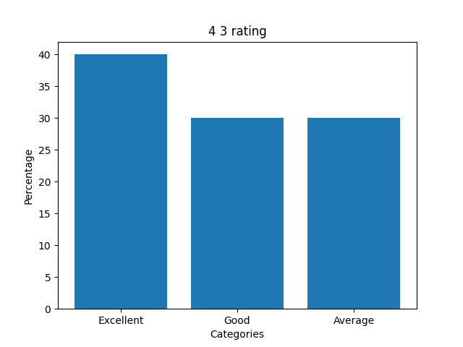

Analysis:40% of respondents feel the training program was excellent, 30% feel it was good, and 30% feel it was average.
Interpretation: A significant 40% rated the training as excellent, while 30% rated it good and another 30% average. This shows an overall positive perception of the training program.

4.4 Training Objective Discussed

Details | No. of Opinion | % of Opinion
Agree | 25 | 50%
Disagree | 20 | 40%
Not at all agree | 5 | 10%
Total | 50 | 100%
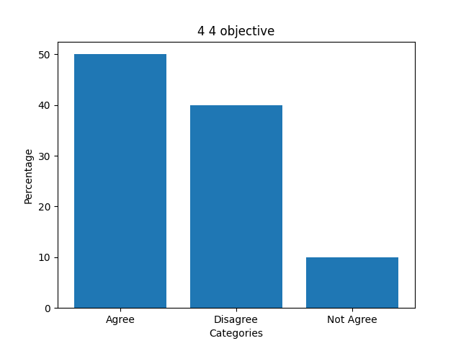

Analysis :50% of respondents agree that training objectives were discussed at the beginning, 40% disagree, and 10% do not agree at all.

Interpretation: Half of the respondents (50%) agree that training objectives were clearly discussed at the beginning. However, 40% disagree, indicating a need for better communication of objectives

4.5 Relevance of Training Content

Details | No. of Opinion | % of Opinion
Strongly Agree | 30 | 60%
Agree | 10 | 20%
Disagree | 10 | 20%
Total | 50 | 100%

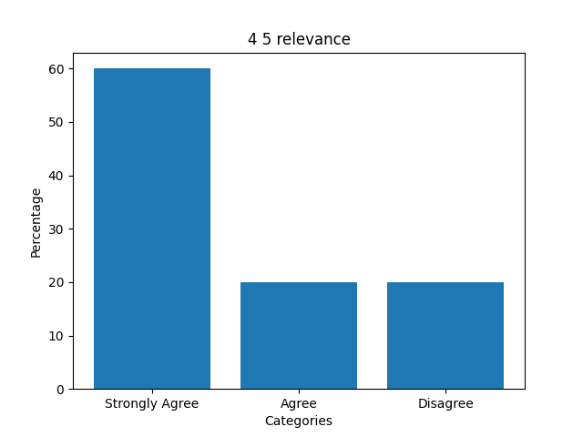

Analysis:60% strongly agree that training content is relevant to the job, 20% agree, and 20% disagree.

Interpretation: Most respondents (60%) strongly agree that the training content is relevant to their job. However, 20% disagree, suggesting some gaps in content alignment.

4.6 Training Meets Needs

Details | No. of Opinion | % of Opinion
Organizational Needs | 35 | 70%
Occupational Needs | 10 | 20%
Individual Needs | 5 | 10%
Total | 50 | 100%

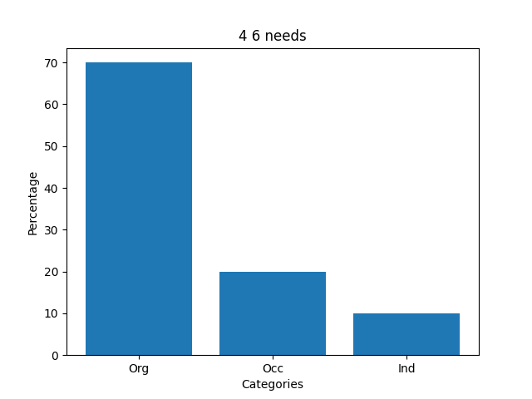

Analysis:70% of respondents say organizational needs are met, 20% say occupational needs are met, and 10% say individual needs are met.

Interpretation: A large majority (70%) believe that organizational needs are met through training. Fewer respondents feel that occupational (20%) and individual needs (10%) are adequately addressed.

4.7 Training Material Availability

Details | No. of Opinion | % of Opinion
Highly Equipped | 33 | 67%
Moderately Equipped | 12 | 22%
Not Equipped | 5 | 11%
Total | 50 | 100%

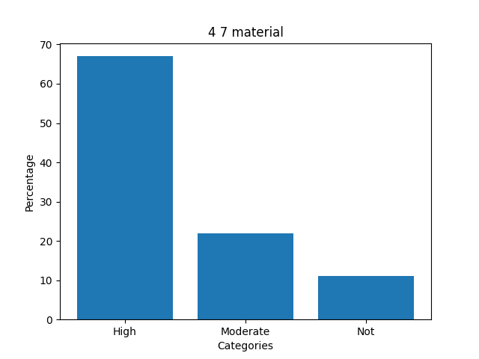

Analysis :67% feel training materials are well equipped, 22% feel moderately equipped, and 11% feel not well equipped.

Interpretation: Most employees (67%) feel that training materials are well equipped and sufficient. However, 33% believe improvements are needed in the availability or quality of materials.

4.8 Compulsory Training

Details | No. of Opinion | % of Opinion
Highly Recommended | 25 | 50%
Required to some extent | 20 | 40%
Not required | 5 | 10%
Total | 50 | 100%

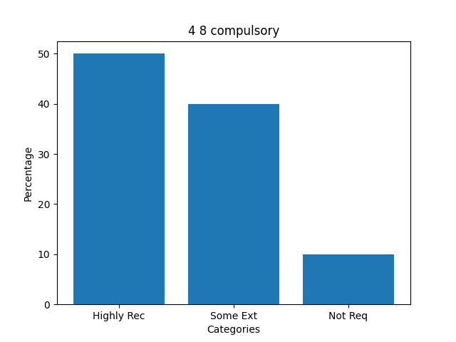

Analysis:50% feel training should be compulsory, 40% feel it is required to some extent, and 10% feel it is not required.

Interpretation: Half of the respondents (50%) strongly recommend making training compulsory. While 40% support it to some extent, only a small percentage (10%) feel it is unnecessary.

CHAPTER -5
FINDINGS, SUGGESTIONS ,
CONCLUSION,
BIBILOGRAPHY

FINDINGS
Training is the basic requirement for every employee when they join any organization to get adjusted with the work and improve skills and techniques related to the assigned job. It is the responsibility of the company to provide training.
- Majority of employees are satisfied with the training they receive.
- Training courses are relevant to employees’ needs.
- Employees are getting training at the right time.
- There is a system to approach higher authorities when training is needed.
- Training helps build interpersonal relationships between superiors and subordinates.
- The company arranges various training programs (on-the-job and off-the-job).
- Lectures, conferences, workshops, seminars, and group discussions are used as training methods.
- 50% of employees say training & development programs are satisfactory.
- 60% of employees say previous training programs are good.
- 48% say training is a good platform to acquire knowledge.
- 40% strongly agree training helps their career.
- 55% strongly agree they gained experience after training.
- 50% agree they receive regular training on required topics.
- 85% agree there is an increase in development activities.
- 40% agree training programs are very helpful.

SUGGESTIONS

- The management should identify the training needs and they should prepare & design training program.
- The program schedule and the training policy should be displayed on the notice board.
- For designing training program trade union should be consulted.
- At the end of each training program opinion about the training programs should be taken from the participants.
- The trained employees should be given some sort of incentives.
- As far as possible training program should be arranged outside the factory campus.
- Training should be provided based on the job profile and the knowledge gap identifying by conducting training need analysis.
- The training program should be designed not only for increasing their knowledge & skills but also to make them more creative for the development of the organization.

The training programs can be made more effective by organizing those programs, which would be beneficial in workplace and applicable in day to day work life.

CONCLUSION
In this study, it has been analyzed that many employees feel that the training program in the organization is inadequate.The training program not only helps employees become aware of their job but also helps them become more creative and proactive, leading to organizational development.
Training programs also help employees develop interpersonal and intrapersonal skills. Training should be provided to every employee by identifying needs scientifically and should always be proactive. Finally, the project helped in understanding the practical aspects of the corporate world.
The project was completed with real-time learning experience

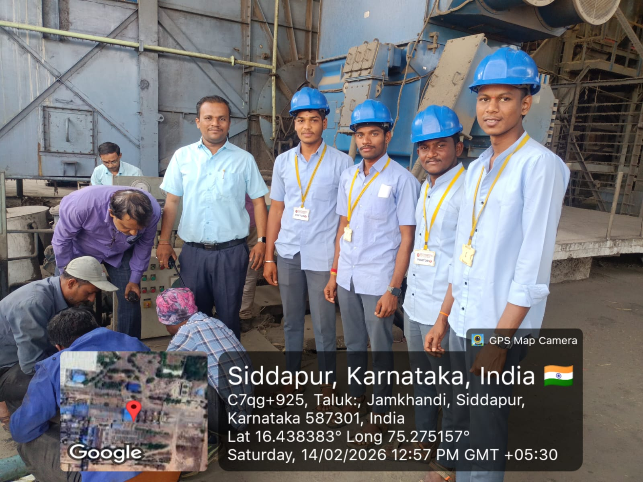

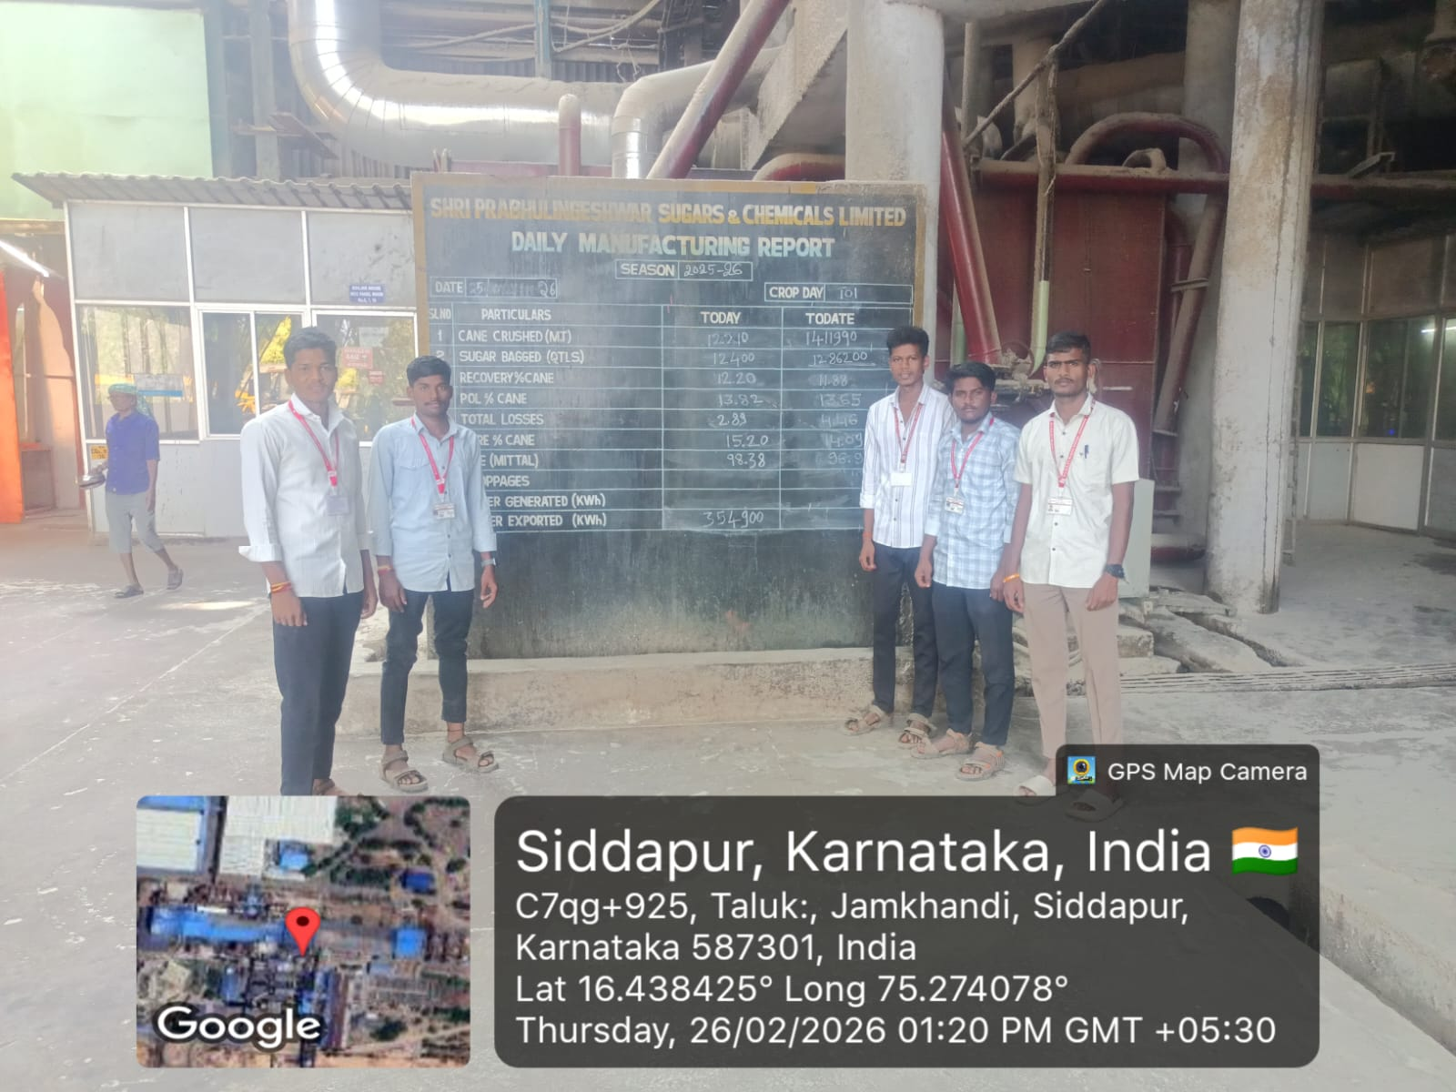

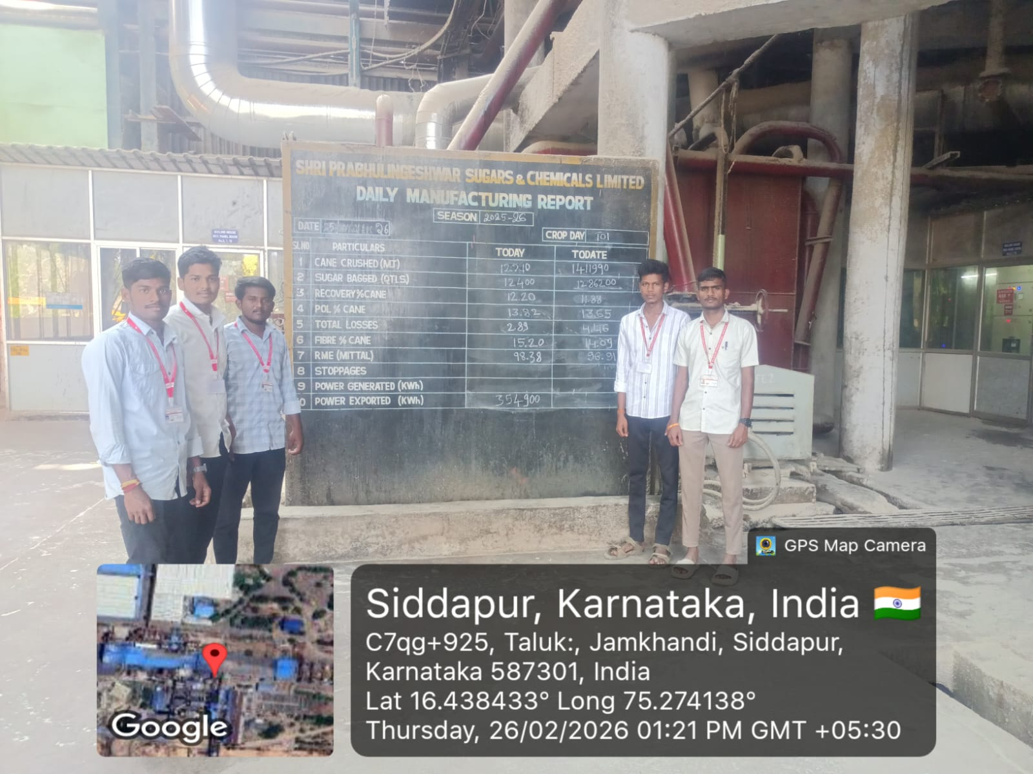

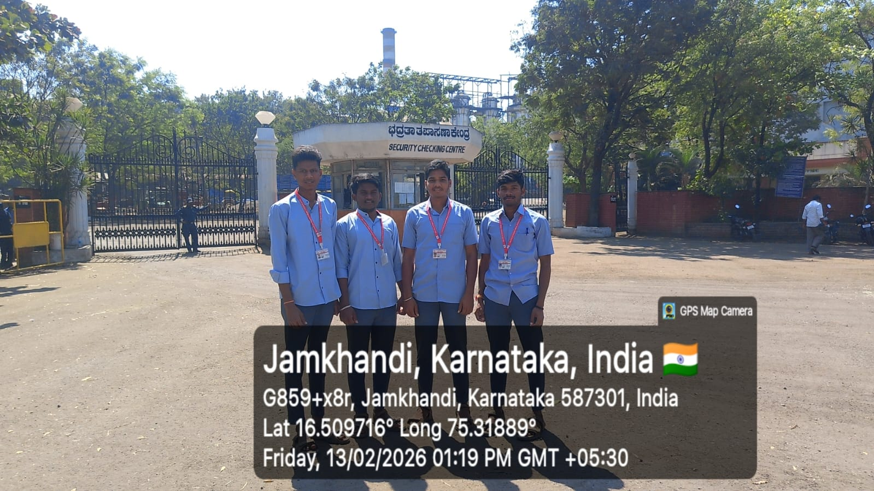

BIBILOGRAPHY
Websites:
- www.wikipedia.com
- https://www.prabhusugars.com
- Company annual reports and HR policy documents, SPSCL, Siddapur.
- Babasabpatilfreepptmba.com

