Task001 — User Search API Testing
TASK001
Assigned
Project: User Management System
Module: User Search
Priority: High | Test Type: Functional API Testing
Tool: Postman | Method: GET
1. Business requirement — BR001
Our application allows users to retrieve information from the User Management System.
The client should be able to retrieve the details of a specific user by providing a valid User ID.
Acceptance criteria
ID | Business requirement
AC01 | A valid User ID must return HTTP 200 OK
AC02 | Response must be in JSON format
AC03 | Response must contain id, name, username, email, and address
AC04 | Returned User ID must match the requested User ID
AC05 | Email must have a valid basic format
AC06 | Nonexistent User ID should return HTTP 404
AC07 | Response time must be below 2000 ms for this exercise
2. API details provided by development team
Field | Value
Base URL | https://jsonplaceholder.typicode.com
Endpoint | /users
HTTP Method | GET
Test User IDs | 1, 3, 5
Invalid User ID | 999
This is a simulated company requirement using JSONPlaceholder, a public practice API. No credentials are required.
3. Your responsibilities
As my QA Engineer, complete these activities:
Create a collection named TASK001_User_Search
Create a GET request to retrieve User ID 3
Execute it and examine the response
Write at least 5 manual test cases with expected results
Create a negative test using User ID 999
Record actual status codes and response times
Progress
0/6 completed
4. Your first deliverable
Before writing JavaScript automation scripts, submit five manual test cases.
Use this structure:
Field | Example
Test Case ID | TC_01
Scenario | Verify GET response for valid User ID
Test Data | User ID = 3
Expected Result | HTTP 200 OK
Actual Result | Fill after execution
Status | Pass/Fail after execution
I am intentionally not providing the full test cases. I want to see how you analyze requirements independently.
5. Submit your first test cases
TASK001 — QA Engineer Submission
file:///C:/Users/Miles/OneDrive%20-%20FUTURENSE%20TECHNOLOGIES%20PRIVATE%20LIMITED/Desktop/Chaitra%20Krishnaprasad/Chaitra/My%20Studies/API%20Doc/Practical%20Postman%20Examples/TASK001_Dashboard.html

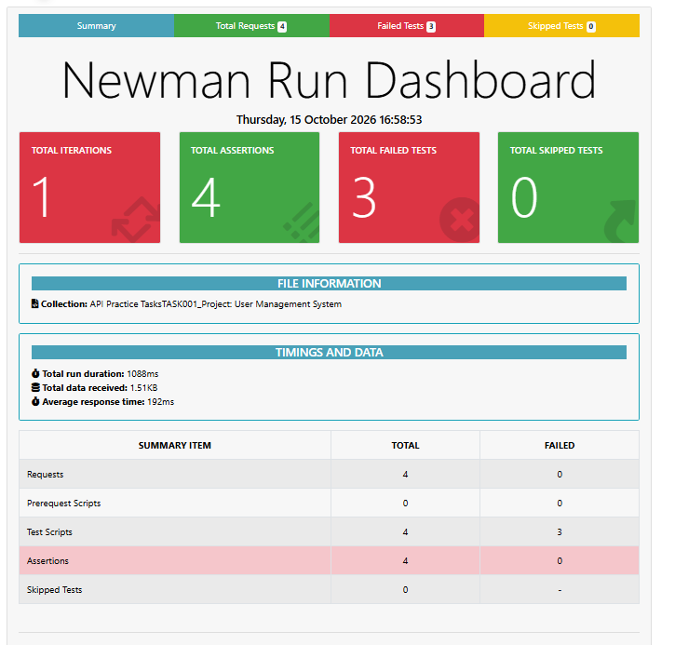

C:\Users\Miles>cd onedrive - Futurense Technologies private limited

C:\Users\Miles\OneDrive - FUTURENSE TECHNOLOGIES PRIVATE LIMITED>cd desktop

C:\Users\Miles\OneDrive - FUTURENSE TECHNOLOGIES PRIVATE LIMITED\Desktop>cd Chaitra Krishnaprasad

C:\Users\Miles\OneDrive - FUTURENSE TECHNOLOGIES PRIVATE LIMITED\Desktop\Chaitra Krishnaprasad>cd Chaitra

C:\Users\Miles\OneDrive - FUTURENSE TECHNOLOGIES PRIVATE LIMITED\Desktop\Chaitra Krishnaprasad\Chaitra>cd my studies

C:\Users\Miles\OneDrive - FUTURENSE TECHNOLOGIES PRIVATE LIMITED\Desktop\Chaitra Krishnaprasad\Chaitra\My Studies>cd api doc
C:\Users\Miles\OneDrive - FUTURENSE TECHNOLOGIES PRIVATE LIMITED\Desktop\Chaitra Krishnaprasad\Chaitra\My Studies\API Doc>cd practical postman examples

C:\Users\Miles\OneDrive - FUTURENSE TECHNOLOGIES PRIVATE LIMITED\Desktop\Chaitra Krishnaprasad\Chaitra\My Studies\API Doc\Practical Postman Examples>dir *.postman_collection.json
Volume in drive C has no label.
Volume Serial Number is 007C-3960

Directory of C:\Users\Miles\OneDrive - FUTURENSE TECHNOLOGIES PRIVATE LIMITED\Desktop\Chaitra Krishnaprasad\Chaitra\My Studies\API Doc\Practical Postman Examples

15-10-2026 16:39 8,858 API Practice TasksTASK001_Project- User Management System.postman_collection.json
1 File(s) 8,858 bytes
0 Dir(s) 640,577,110,016 bytes free

C:\Users\Miles\OneDrive - FUTURENSE TECHNOLOGIES PRIVATE LIMITED\Desktop\Chaitra Krishnaprasad\Chaitra\My Studies\API Doc\Practical Postman Examples>npm install -g newman-reporter-htmlextra

C:\Users\Miles\OneDrive - FUTURENSE TECHNOLOGIES PRIVATE LIMITED\Desktop\Chaitra Krishnaprasad\Chaitra\My Studies\API Doc\Practical Postman Examples>newman run "API Practice TasksTASK001_Project- User Management System.postman_collection.json" -r cli,htmlextra --reporter-htmlextra-export "TASK001_Dashboard.html"

newman run "API Practice TasksTASK001_Project- User Management System.postman_collection.json" -r cli,htmlextra --reporter-htmlextra-export "TASK001_Dashboard.html"

SYNTAX: newman run “file name which we extracted and saved in local folder” -r cli, htlextra --reporter-htmlextra-export “File name needs to be saved”

Command part | Explanation
newman | Calls the Newman tool installed on your computer.
run | Tells Newman to execute a Postman collection.
" Project- User Management System.postman_collection.json " | The exported Postman collection file containing your API requests and test scripts.
-r | Short form of --reporters. It specifies how execution results should be displayed.
cli | Displays test execution results in Command Prompt.
htmlextra | Generates the detailed HTML dashboard like your second screenshot.
--reporter-htmlextra-export | Specifies the output file for the HTML Extra report.
"TASK001_Dashboard.html" | The name we chose for the generated HTML report.

CLI Report
API Practice TasksTASK001_Project: User Management System

→ Get_UserSearch_TC_01
GET https://jsonplaceholder.typicode.com/users/3 [200 OK, 1.49kB, 399ms]
1⠄ SyntaxError in test-script

→ Get_UserSearch_TC_03
GET https://jsonplaceholder.typicode.com/users/3 [200 OK, 1.49kB, 111ms]
2⠄ SyntaxError in test-script

→ Get_UserSearch_TC_05
GET https://jsonplaceholder.typicode.com/users/5 [200 OK, 1.47kB, 139ms]
3⠄ SyntaxError in test-script

→ Get_UserSearch_TC_Invalid Userid
GET https://jsonplaceholder.typicode.com/users/999 [404 Not Found, 950B, 120ms]
√ TC_07 - Invalid User ID returns 404
√ TC_08 - Response is JSON
√ TC_09 - Response is empty JSON object
√ TC_10 - Response time below 2000ms

┌─────────────────────────┬─────────────────────┬────────────────────┐
│ │ executed │ failed │
├─────────────────────────┼─────────────────────┼────────────────────┤
│ iterations │ 1 │ 0 │
├─────────────────────────┼─────────────────────┼────────────────────┤
│ requests │ 4 │ 0 │
├─────────────────────────┼─────────────────────┼────────────────────┤
│ test-scripts │ 4 │ 3 │
├─────────────────────────┼─────────────────────┼────────────────────┤
│ prerequest-scripts │ 0 │ 0 │
├─────────────────────────┼─────────────────────┼────────────────────┤
│ assertions │ 4 │ 0 │
├─────────────────────────┴─────────────────────┴────────────────────┤
│ total run duration: 1088ms │
├────────────────────────────────────────────────────────────────────┤
│ total data received: 1.55kB (approx) │
├────────────────────────────────────────────────────────────────────┤
│ average response time: 192ms [min: 111ms, max: 399ms, s.d.: 119ms] │
└────────────────────────────────────────────────────────────────────┘

# failure detail

1. SyntaxError Identifier 'data' has already been declared
at test-script
inside "Get_UserSearch_TC_01"

2. SyntaxError Identifier 'data' has already been declared
at test-script
inside "Get_UserSearch_TC_03"

3. SyntaxError Identifier 'data' has already been declared
at test-script
inside "Get_UserSearch_TC_05"

