V. SREE CHAITRAN

List of Programs
S. No. | Title
1. | Auto regressive integrated moving average (ARIMA)
2. | Seasonal auto regressive integrated moving average (SARIMA)
3. | Linear Regression
4. | Polynomial Regression
5. | Artificial Neural Network (ANN)
6. | Long Short term memory (LSTM)
7. | Recurrent neural network (RNN)
8. | Convolutional neural network (CNN)
9. | Support Vector Machine (SVM)
10. | Random Forest

- Auto regressive integrated moving average (ARIMA)

Code:
import xarray as xr
import numpy as np
import pandas as pd
import matplotlib.pyplot as plt

from statsmodels.tsa.arima.model import ARIMA
from statsmodels.tsa.stattools import adfuller
from sklearn.preprocessing import MinMaxScaler
from sklearn.metrics import mean_squared_error
sst_file_path = r"D:\\NITD\\2nd Sem\\Computational Simulation Lab\\ERA5_SST_sst_K_monmean_7924_1.nc"
ds = xr.open_dataset(sst_file_path)
sst = ds["sst"]
# Spatial mean (global or regional mean SST)
sst_series = sst.mean(dim=["lat", "lon"], skipna=True).values
time = pd.to_datetime(ds["time"].values)
# Convert Kelvin to Celsius
sst_celsius = sst_series - 273.15
scaler = MinMaxScaler(feature_range=(0, 1))
sst_norm = scaler.fit_transform(sst_celsius.reshape(-1, 1)).flatten()

df = pd.DataFrame({
"time": time,
"sst": sst_norm
}).dropna()

df.set_index("time", inplace=True)
adf_result = adfuller(df["sst"])
print(f"ADF Statistic : {adf_result[0]:.4f}")
print(f"p-value : {adf_result[1]:.4f}")
# Decide differencing order d
if adf_result[1] > 0.05:
d = 2
print("Series is non-stationary → using d = 2")
else:
d = 0
print("Series is stationary → using d = 0")

train_size = int(len(df) * 0.8)
train = df["sst"].iloc[:train_size]
test = df["sst"].iloc[train_size:]

p = 12
q = 12

model = ARIMA(train, order=(p, d, q))
model_fit = model.fit()

print(model_fit.summary())

forecast = model_fit.forecast(steps=len(test))

rmse = np.sqrt(mean_squared_error(test, forecast))
print(f"RMSE (normalized SST): {rmse:.4f}")

train_inv = scaler.inverse_transform(train.values.reshape(-1, 1)).flatten()
test_inv = scaler.inverse_transform(test.values.reshape(-1, 1)).flatten()
forecast_inv = scaler.inverse_transform(forecast.values.reshape(-1, 1)).flatten()

plt.figure(figsize=(11, 6))

plt.plot(df.index[:train_size], train_inv,
label="Training SST", linewidth=2)

plt.plot(df.index[train_size:], test_inv,
label="Observed SST", linewidth=2)

plt.plot(df.index[train_size:], forecast_inv,
label="ARIMA Forecast", linestyle="--", linewidth=2)

plt.axvline(df.index[train_size],
color="black", linestyle="--", label="Train–Test Split")

plt.xlabel("Time")
plt.ylabel("SST (°C)")
plt.title("ARIMA Model on ERA5 Monthly SST")
plt.legend()
plt.grid(True)

plt.tight_layout()
plt.show()

Output:
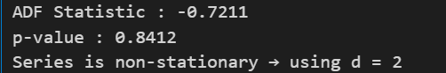
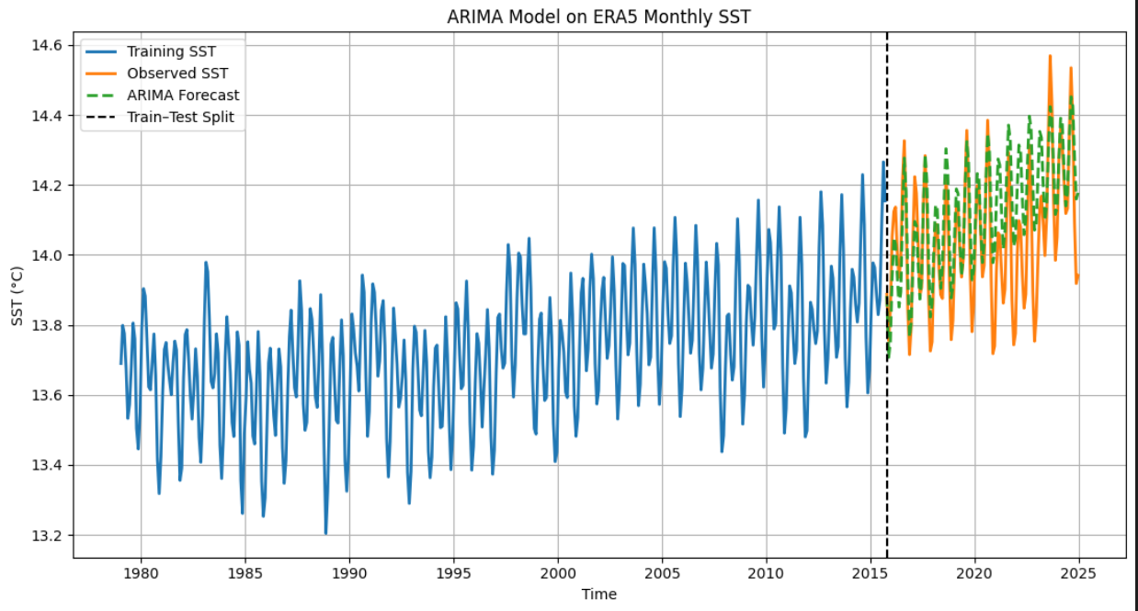

- Seasonal auto regressive integrated moving average (SARIMA)

Code:
import xarray as xr
import numpy as np
import pandas as pd
import matplotlib.pyplot as plt

from statsmodels.tsa.statespace.sarimax import SARIMAX
from statsmodels.tsa.stattools import adfuller
from sklearn.metrics import mean_squared_error

# =============================
# Load NetCDF File
# =============================

sst_file_path = r"D:\\NITD\\2nd Sem\\Computational Simulation Lab\\ERA5_SST_sst_K_monmean_7924_1.nc"
ds = xr.open_dataset(sst_file_path)

sst = ds["sst"]

# =============================
# Spatial Mean SST
# =============================

sst_series = sst.mean(dim=["lat", "lon"], skipna=True).values
time = pd.to_datetime(ds["time"].values)

# Convert Kelvin → Celsius
sst_celsius = sst_series - 273.15

df = pd.DataFrame({
"time": time,
"sst": sst_celsius
}).dropna()

df.set_index("time", inplace=True)

# =============================
# ADF Test
# =============================

adf_result = adfuller(df["sst"])

print(f"ADF Statistic : {adf_result[0]:.4f}")
print(f"p-value : {adf_result[1]:.4f}")

if adf_result[1] > 0.05:
d = 1
print("Series is non-stationary → using d = 1")
else:
d = 0
print("Series is stationary → using d = 0")

# =============================
# Train-Test Split
# =============================

train_size = int(len(df) * 0.8)
train = df["sst"].iloc[:train_size]
test = df["sst"].iloc[train_size:]

# =============================
# SARIMA Model
# Monthly Data → seasonality = 12
# =============================

model = SARIMAX(train,
order=(1, d, 1),
seasonal_order=(1, 1, 1, 12),
enforce_stationarity=False,
enforce_invertibility=False)

model_fit = model.fit()

print(model_fit.summary())

# =============================
# Forecast
# =============================

forecast = model_fit.forecast(steps=len(test))

rmse = np.sqrt(mean_squared_error(test, forecast))
print(f"RMSE (°C): {rmse:.4f}")

# =============================
# Plot Results
# =============================

plt.figure(figsize=(11, 6))

plt.plot(df.index[:train_size], train,
label="Training SST", linewidth=2)

plt.plot(df.index[train_size:], test,
label="Observed SST", linewidth=2)

plt.plot(df.index[train_size:], forecast,
label="SARIMA Forecast", linestyle="--", linewidth=2)

plt.axvline(df.index[train_size],
color="black", linestyle="--", label="Train–Test Split")

plt.xlabel("Time")
plt.ylabel("SST (°C)")
plt.title("SARIMA Model on ERA5 Monthly SST")
plt.legend()
plt.grid(True)
plt.tight_layout()
plt.show()

Output:

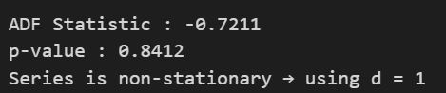

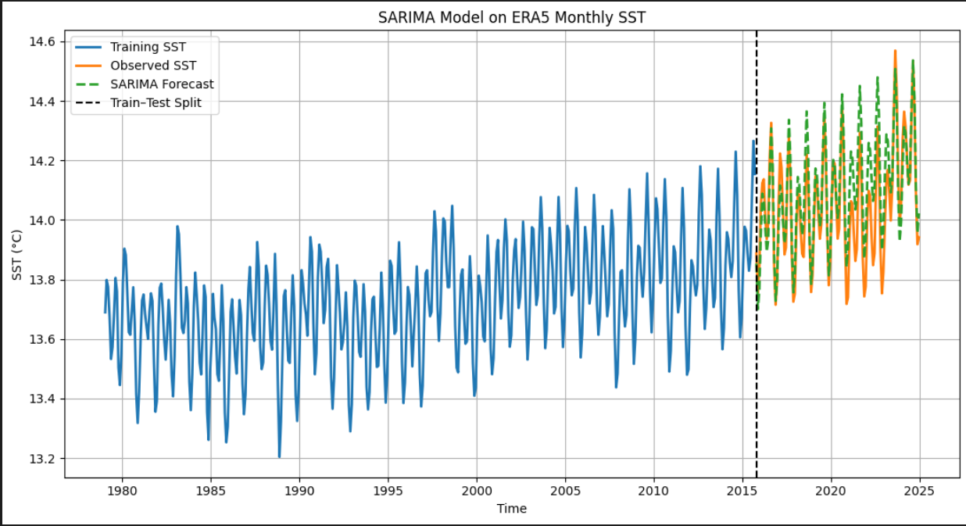

- Linear Regression

Code:
import pandas as pd
import numpy as np
import matplotlib.pyplot as plt
import xarray as xr
from sklearn.linear_model import LinearRegression

# -----------------------------
# Load ENSO (Nino 3.4) data
# -----------------------------
enso_file = "nino-3.4_7924_noaa.txt"
enso = pd.read_csv(enso_file, delim_whitespace=True, header=None)

# ENSO index
enso_index = enso.iloc[:,1].values

# -----------------------------
# Load SST NetCDF file
# -----------------------------
sst_file = "ERA5_SST_sst_K_monmean_7924_1.nc"
ds = xr.open_dataset(sst_file)

# Extract SST variable
sst = ds['sst']

# Calculate global mean SST
sst_mean = sst.mean(dim=["lat","lon"])

# Convert to pandas
sst_values = sst_mean.values

# -----------------------------
# Match ENSO and SST length
# -----------------------------
min_len = min(len(enso_index), len(sst_values))

X = enso_index[:min_len].reshape(-1,1) # ENSO (Independent variable)
y = sst_values[:min_len] # SST (Dependent variable)

# -----------------------------
# Linear Regression Model
# -----------------------------
model = LinearRegression()
model.fit(X, y)

# Predictions
y_pred = model.predict(X)

# -----------------------------
# Results
# -----------------------------
print("Slope (ENSO influence on SST):", model.coef_[0])
print("Intercept:", model.intercept_)
print("R² score:", model.score(X,y))

# -----------------------------
# Plot
# -----------------------------
plt.scatter(X, y, label="Observed SST")
plt.plot(X, y_pred, color="red", label="Regression Line")

plt.xlabel("Nino 3.4 Index (ENSO)")
plt.ylabel("Sea Surface Temperature (SST)")
plt.title("Linear Regression: ENSO vs SST")

plt.legend()
plt.show()

Output:
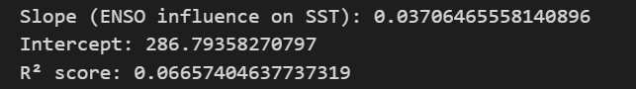
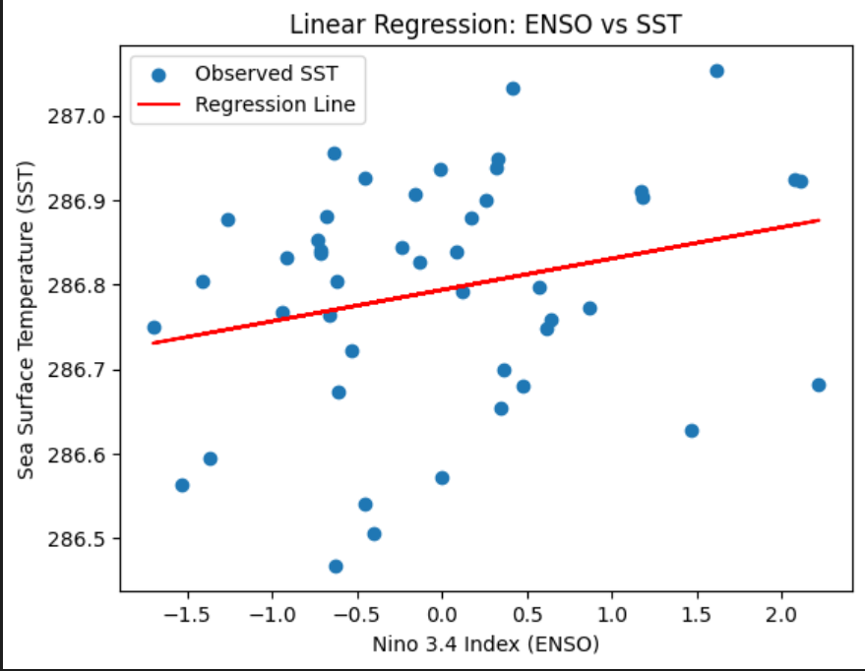

Code for Spatial Prediction:
import pandas as pd
import numpy as np
import xarray as xr
import matplotlib.pyplot as plt
from sklearn.linear_model import LinearRegression

# Load ENSO data

enso_file = "nino-3.4_7924_noaa.txt"
enso = pd.read_csv(enso_file, delim_whitespace=True, header=None)

enso_index = enso.iloc[:,1].values

# Convert yearly ENSO → monthly
enso_monthly = np.repeat(enso_index, 12)

# Load SST dataset
sst_file = "ERA5_SST_sst_K_monmean_7924_1.nc"

ds = xr.open_dataset(sst_file)
sst = ds["sst"]

time = ds["time"]
lat = ds["lat"]
lon = ds["lon"]

# Match ENSO length
enso_monthly = enso_monthly[:len(time)]

ds["enso"] = (("time"), enso_monthly)

# Define seasons

seasons = {
"DJF":[12,1,2],
"MAM":[3,4,5],
"JJA":[6,7,8],
"SON":[9,10,11]
}

fig, axes = plt.subplots(2,2, figsize=(14,8))

axes = axes.flatten()

# Seasonal regression

for idx,(season, months) in enumerate(seasons.items()):

season_ds = ds.sel(time=ds["time"].dt.month.isin(months))

enso = season_ds["enso"].values
sst = season_ds["sst"].values

slope_map = np.zeros((len(lat), len(lon)))

for i in range(len(lat)):
for j in range(len(lon)):

y = sst[:, i, j]

if np.isnan(y).any():
slope_map[i,j] = np.nan
continue

X = enso.reshape(-1,1)

model = LinearRegression()
model.fit(X,y)

slope_map[i,j] = model.coef_[0]

ax = axes[idx]

c = ax.contourf(lon, lat, slope_map, 20)

ax.set_title(season)
ax.set_xlabel("Longitude")
ax.set_ylabel("Latitude")

# Colorbar
fig.colorbar(c, ax=axes.ravel().tolist(), label="Regression Slope")

plt.suptitle("Global Seasonal Influence of ENSO on SST")

plt.tight_layout()

plt.show()

Output:
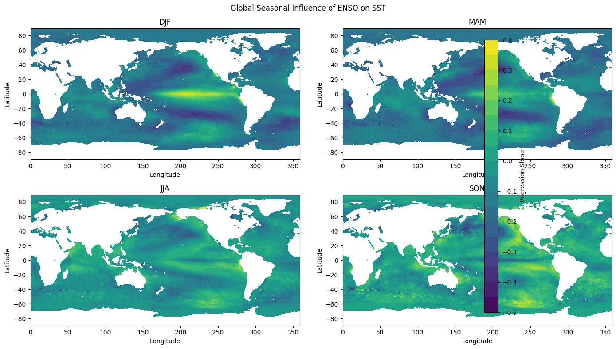

Linear Regression with 95% Confidence Interval

Code:
import numpy as np
import pandas as pd
import matplotlib.pyplot as plt
from sklearn.linear_model import LinearRegression
from scipy.stats import t

# Load data
file_path = "nino-3.4_7924_noaa.txt"
data = pd.read_csv(file_path, delim_whitespace=True, header=None)

X = data.iloc[:,0].values.reshape(-1,1)
y = data.iloc[:,1].values

# Fit model
model = LinearRegression()
model.fit(X, y)

y_pred = model.predict(X)

n = len(y)
p = 1 # number of predictors

residuals = y - y_pred
s_err = np.sqrt(np.sum(residuals**2) / (n - p - 1))
t_val = t.ppf(0.975, df=n-p-1) # 95% CI

x_mean = np.mean(X)
Sxx = np.sum((X - x_mean)**2)

ci = t_val * s_err * np.sqrt(1/n + ((X - x_mean)**2 / Sxx))

upper = y_pred + ci.flatten()
lower = y_pred - ci.flatten()

inside_ci = (y >= lower) & (y <= upper)
outside_ci = ~inside_ci

plt.figure(figsize=(8,6))

# Regression line
plt.plot(X, y_pred, color='black', label='Regression Line')

# Confidence interval band
plt.fill_between(X.flatten(), lower, upper, color='lightblue', alpha=0.5,
label='95% Confidence Interval')

# Points inside CI
plt.scatter(X[inside_ci], y[inside_ci], color='green', label='Inside 95% CI')

# Points outside CI
plt.scatter(X[outside_ci], y[outside_ci], color='red', label='Outside 95% CI')

plt.xlabel("Year")
plt.ylabel("ENSO Index")
plt.title("Linear Regression with 95% Confidence Interval (Student t-test)")
plt.legend()
plt.show()

Output:

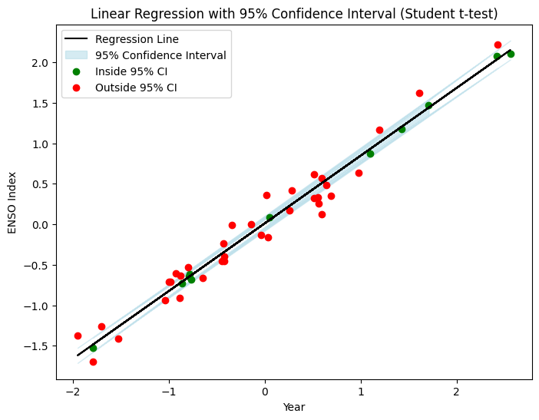

ENSO Influence on SST with 95% Confidence (Hatched Regions)

Code:
#95 percent
import pandas as pd
import numpy as np
import xarray as xr
import matplotlib.pyplot as plt
from scipy.stats import t

# -----------------------------
# Load ENSO
# -----------------------------
enso_file = "nino-3.4_7924_noaa.txt"
enso = pd.read_csv(enso_file, delim_whitespace=True, header=None)

enso_index = enso.iloc[:,1].values
enso_monthly = np.repeat(enso_index,12)

# -----------------------------
# Load SST dataset
# -----------------------------
sst_file = "ERA5_SST_sst_K_monmean_7924_1.nc"

ds = xr.open_dataset(sst_file)

lat = ds["lat"].values
lon = ds["lon"].values
time = ds["time"]

enso_monthly = enso_monthly[:len(time)]
ds["enso"] = (("time"), enso_monthly)

# -----------------------------
# Seasons
# -----------------------------
seasons = {
"DJF":[12,1,2],
"MAM":[3,4,5],
"JJA":[6,7,8],
"SON":[9,10,11]
}

fig, axes = plt.subplots(2,2, figsize=(14,8))
axes = axes.flatten()

for idx,(season,months) in enumerate(seasons.items()):

season_ds = ds.sel(time=ds["time"].dt.month.isin(months))

X = season_ds["enso"].values
Y = season_ds["sst"].values

n = len(X)

# anomalies
X_anom = X - X.mean()
Y_anom = Y - Y.mean(axis=0)

# regression slope
slope = np.sum(X_anom[:,None,None]*Y_anom,axis=0) / np.sum(X_anom**2)

# predicted values
Y_pred = slope[None,:,:] * X_anom[:,None,None]

residual = Y_anom - Y_pred

sigma2 = np.sum(residual**2,axis=0)/(n-2)

Sxx = np.sum(X_anom**2)

SE = np.sqrt(sigma2/Sxx)

# t statistic
t_stat = slope/SE

t_crit = t.ppf(0.975,n-2)

significance = np.abs(t_stat) > t_crit

ax = axes[idx]

# main regression map
c = ax.contourf(lon, lat, slope, 20, cmap="spring")

# hatch for significant region
ax.contourf(
lon,
lat,
significance,
levels=[0.5,1],
hatches=['///'],
colors='none'
)

ax.set_title(season)
ax.set_xlabel("Longitude")
ax.set_ylabel("Latitude")

fig.colorbar(c, ax=axes.ravel().tolist(), label="Regression Slope")

plt.suptitle("ENSO Influence on SST with 95% Confidence (Hatched Regions)")

plt.tight_layout()
plt.show()

Output:
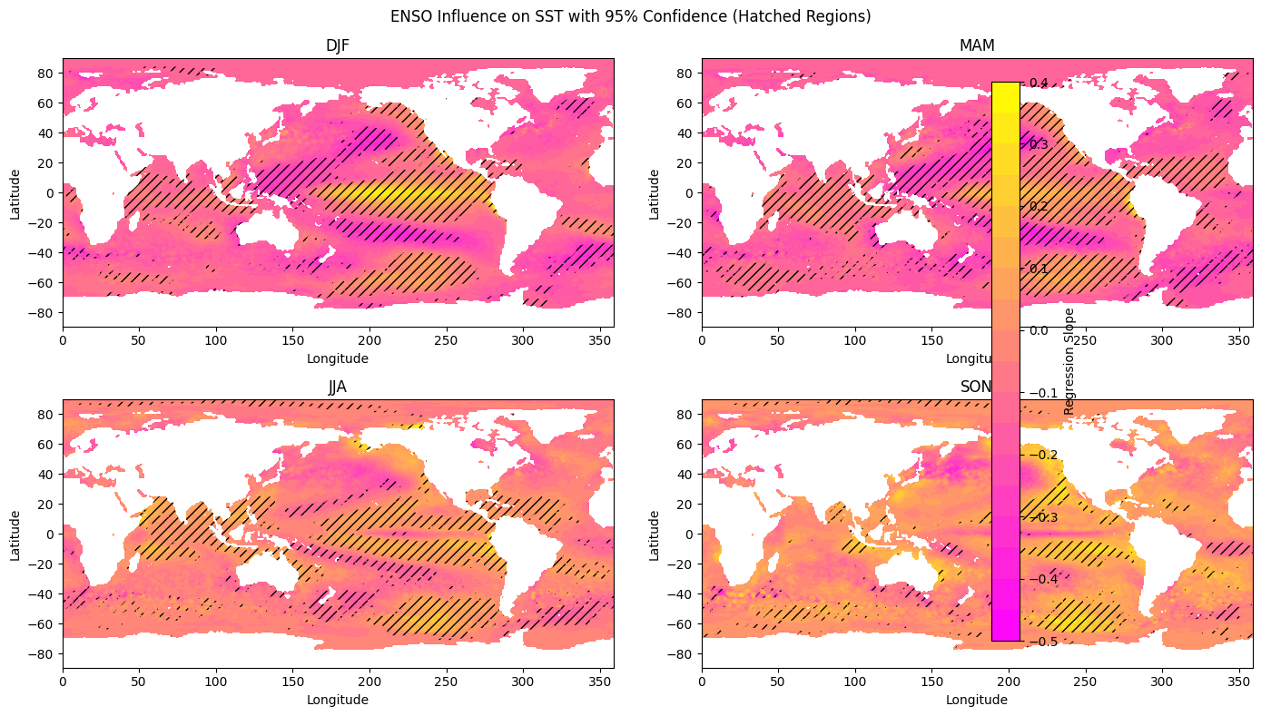
- Polynomial Regression

Code:
import pandas as pd
import numpy as np
import matplotlib.pyplot as plt

from sklearn.preprocessing import PolynomialFeatures
from sklearn.linear_model import LinearRegression
from sklearn.model_selection import train_test_split
from sklearn.metrics import mean_squared_error, r2_score, accuracy_score

# -------------------------------
# Load Data
# -------------------------------
file = "nino-3.4_7924_noaa.txt"
data = pd.read_csv(file, sep='\s+', header=None)

values = data.values.flatten()
values = values[values > -90]

df = pd.DataFrame(values, columns=["ENSO"])

# -------------------------------
# Feature Engineering
# -------------------------------
df["lag1"] = df["ENSO"].shift(1)
df["lag2"] = df["ENSO"].shift(2)

df = df.dropna()

# -------------------------------
# Polynomial Features
# -------------------------------
X = df[["lag1", "lag2"]]
y = df["ENSO"]

poly = PolynomialFeatures(degree=2) # try degree=3 later
X_poly = poly.fit_transform(X)

# -------------------------------
# Train-Test Split
# -------------------------------
X_train, X_test, y_train, y_test = train_test_split(
X_poly, y, test_size=0.2, random_state=42
)

# -------------------------------
# Model Training
# -------------------------------
model = LinearRegression()
model.fit(X_train, y_train)

# -------------------------------
# Predictions
# -------------------------------
y_pred = model.predict(X_test)

print("R2 Score:", r2_score(y_test, y_pred))
print("MSE:", mean_squared_error(y_test, y_pred))

# -------------------------------
# Convert to Classes
# -------------------------------
def classify(x):
if x < -0.5:
return 0
elif x > 0.5:
return 2
else:
return 1

y_test_class = y_test.apply(classify)
y_pred_class = pd.Series(y_pred).apply(classify)

print("\nClassification Accuracy:",
accuracy_score(y_test_class, y_pred_class) * 100)

# -------------------------------
# Visualization
# -------------------------------
lag1_range = np.linspace(df["lag1"].min(), df["lag1"].max(), 200)
lag2_mean = df["lag2"].mean()

X_plot = pd.DataFrame({
"lag1": lag1_range,
"lag2": lag2_mean
})

X_plot_poly = poly.transform(X_plot)
y_plot = model.predict(X_plot_poly)

plt.figure()

# Regression curve
plt.plot(lag1_range, y_plot, label="Polynomial Regression Curve")

# Scatter actual ENSO values
plt.scatter(df["lag1"], df["ENSO"], alpha=0.3, label="Actual ENSO")

# Threshold lines
plt.axhline(0.5, linestyle='--', label="El Niño Threshold")
plt.axhline(-0.5, linestyle='--', label="La Niña Threshold")

plt.xlabel("Lags")
plt.ylabel("ENSO Value")
plt.title("Polynomial Regression on ENSO Data")
plt.legend()
plt.grid()

plt.show()

Output:
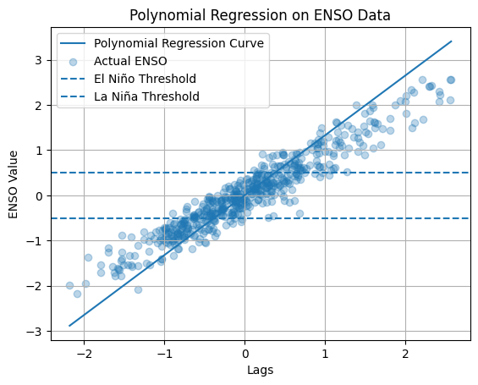

Polynomial Regression for Spatial Prediction

Code:
#Polynomal regression
import pandas as pd
import numpy as np
import xarray as xr
import matplotlib.pyplot as plt
from sklearn.linear_model import LinearRegression
from sklearn.preprocessing import PolynomialFeatures

# Load ENSO data
enso_file = "nino-3.4_7924_noaa.txt"
enso = pd.read_csv(enso_file, delim_whitespace=True, header=None)

enso_index = enso.iloc[:,1].values

# Convert yearly ENSO → monthly
enso_monthly = np.repeat(enso_index, 12)

# Load SST dataset
sst_file = "ERA5_SST_sst_K_monmean_7924_1.nc"
ds = xr.open_dataset(sst_file)

sst = ds["sst"]
time = ds["time"]
lat = ds["lat"]
lon = ds["lon"]

# Match ENSO length
enso_monthly = enso_monthly[:len(time)]
ds["enso"] = (("time"), enso_monthly)

# Define seasons
seasons = {
"DJF":[12,1,2],
"MAM":[3,4,5],
"JJA":[6,7,8],
"SON":[9,10,11]
}

# Polynomial transformer
poly = PolynomialFeatures(degree=2, include_bias=False)

# Create subplot figure
fig, axes = plt.subplots(2,2, figsize=(14,8))
axes = axes.flatten()

# Seasonal regression
for idx,(season, months) in enumerate(seasons.items()):

season_ds = ds.sel(time=ds["time"].dt.month.isin(months))

enso_vals = season_ds["enso"].values
sst_vals = season_ds["sst"].values

slope_linear = np.zeros((len(lat), len(lon)))
slope_quad = np.zeros((len(lat), len(lon))) # NEW

for i in range(len(lat)):
for j in range(len(lon)):

y = sst_vals[:, i, j]

if np.isnan(y).any():
slope_linear[i,j] = np.nan
slope_quad[i,j] = np.nan
continue

X = enso_vals.reshape(-1,1)

# Polynomial Features(Regression)
X_poly = poly.fit_transform(X)
# Columns → [ENSO, ENSO^2]

model = LinearRegression()
model.fit(X_poly, y)

#Slope of beta values
beta = model.coef_

slope_linear[i,j] = beta[0] # ENSO
slope_quad[i,j] = beta[1] # ENSO^2

ax = axes[idx]

# You can choose what to plot:
c_linear = ax.contourf(lon, lat, slope_linear, 20)
# OR:
# c = ax.contourf(lon, lat, slope_quad, 20)

ax.set_title(season)
ax.set_xlabel("Longitude")
ax.set_ylabel("Latitude")

plt.suptitle("Polynomial Regression (ENSO & ENSO²) Influence on SST")

fig.colorbar(c_linear, ax=axes.ravel().tolist(), label="Regression Coefficient")

plt.show()

Output:
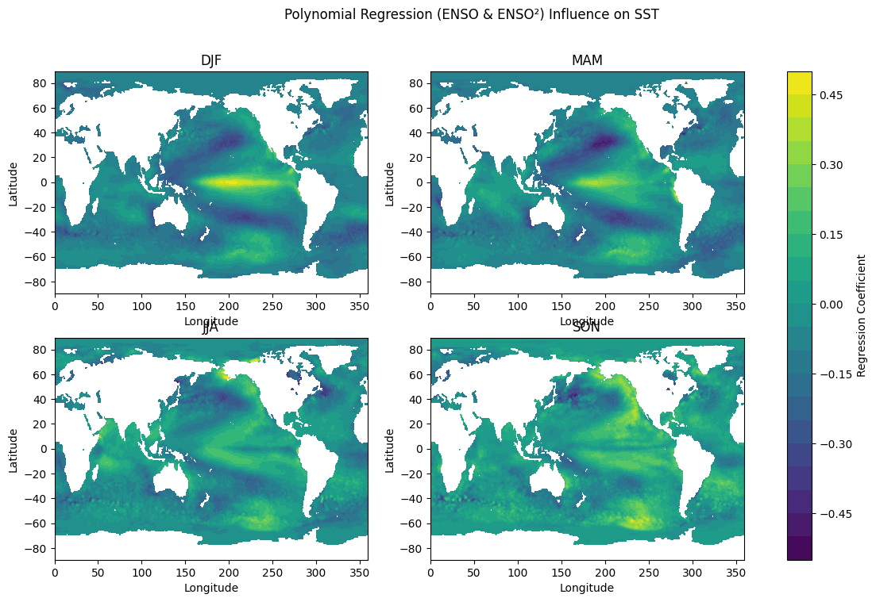

- Artificial Neural Network (ANN)

Code:
import pandas as pd
import numpy as np
import matplotlib.pyplot as plt
from sklearn.preprocessing import MinMaxScaler
from sklearn.metrics import mean_squared_error, mean_absolute_error
from tensorflow.keras.models import Sequential
from tensorflow.keras.layers import Dense

# 1. LOAD DATA
file_path = "nino-3.4_7924_noaa.txt"
df = pd.read_csv(file_path, sep="\s+", header=None)

months = ['Jan','Feb','Mar','Apr','May','Jun',
'Jul','Aug','Sep','Oct','Nov','Dec']

df.columns = months

# 2. CONVERT TO TIME SERIES
series = df.values.flatten() # 46x12 -> 552

# 3. NORMALIZATION
scaler = MinMaxScaler()
series_scaled = scaler.fit_transform(series.reshape(-1,1))

# 4. CREATE SEQUENCES
def create_sequences(data, seq_len=12):
X, y = [], []
for i in range(len(data) - seq_len):
X.append(data[i:i+seq_len])
y.append(data[i+seq_len])
return np.array(X), np.array(y)

SEQ_LEN = 12
X, y = create_sequences(series_scaled, SEQ_LEN)

# Flatten input for ANN (IMPORTANT)
X = X.reshape(X.shape[0], X.shape[1])

print("X shape:", X.shape)
print("y shape:", y.shape)

# 5. TRAIN-TEST SPLIT (TIME BASED)
split = int(0.8 * len(X))
X_train, X_test = X[:split], X[split:]
y_train, y_test = y[:split], y[split:]

# 6. BUILD ANN MODEL
model = Sequential()
model.add(Dense(64, activation='relu', input_dim=SEQ_LEN))
model.add(Dense(32, activation='relu'))
model.add(Dense(1)) # Regression output

model.compile(
optimizer='adam',
loss='mse'
)

model.summary()

# 7. TRAIN MODEL
history = model.fit(
X_train, y_train,
epochs=50,
batch_size=8,
validation_data=(X_test, y_test),
verbose=1
)

# 8. PREDICTION
y_pred = model.predict(X_test)

# Inverse scaling
y_test_inv = scaler.inverse_transform(y_test)
y_pred_inv = scaler.inverse_transform(y_pred)

# 9. EVALUATION METRICS
mse = mean_squared_error(y_test_inv, y_pred_inv)
rmse = np.sqrt(mse)
mae = mean_absolute_error(y_test_inv, y_pred_inv)

print("\nEvaluation Metrics:")
print("MSE :", mse)
print("RMSE:", rmse)
print("MAE :", mae)

# 10. PLOT PREDICTION CURVE
plt.figure(figsize=(12,5))
plt.plot(y_test_inv, label='Actual')
plt.plot(y_pred_inv, label='Predicted')
plt.title("ANN Time Series Prediction (NINO 3.4)")
plt.xlabel("Time Steps (Months)")
plt.ylabel("NINO Index")
plt.legend()
plt.grid()
plt.show()

Output:
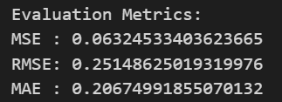
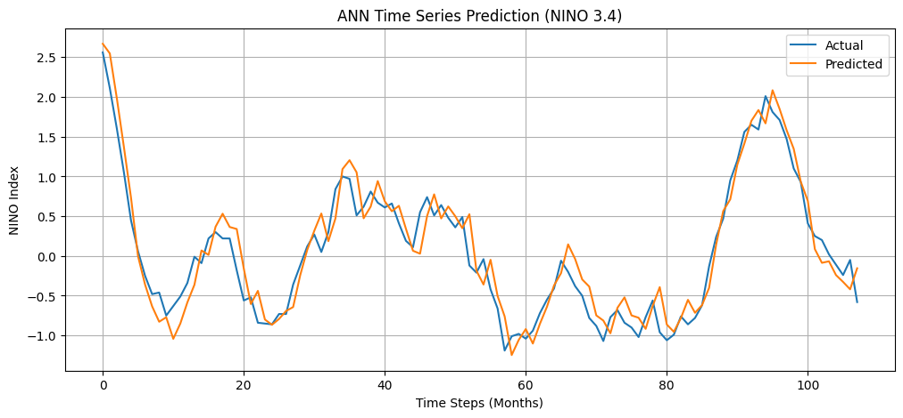

- Long short term memory (LSTM)

Code:
import pandas as pd
import numpy as np
import matplotlib.pyplot as plt
from sklearn.preprocessing import MinMaxScaler
from sklearn.model_selection import train_test_split
from tensorflow.keras.models import Sequential
from tensorflow.keras.layers import LSTM, Dense

# 1. LOAD DATA
file_path = "nino-3.4_7924_noaa.txt"
df = pd.read_csv(file_path, sep="\s+", header=None)

months = ['Jan','Feb','Mar','Apr','May','Jun',
'Jul','Aug','Sep','Oct','Nov','Dec']

df.columns = months
print("Original shape:", df.shape)

# 2. CONVERT TO TIME SERIES
# Flatten 46x12 -> 552 monthly values
series = df.values.flatten()

# Convert to DataFrame
ts = pd.DataFrame(series, columns=['NINO'])

# 3. NORMALIZATION
scaler = MinMaxScaler()
ts_scaled = scaler.fit_transform(ts)

# 4. CREATE SEQUENCES
def create_sequences(data, seq_length=12):
X, y = [], []
for i in range(len(data) - seq_length):
X.append(data[i:i+seq_length])
y.append(data[i+seq_length])
return np.array(X), np.array(y)

SEQ_LEN = 12
X, y = create_sequences(ts_scaled, SEQ_LEN)

print("X shape:", X.shape)
print("y shape:", y.shape)

# 5. TRAIN-TEST SPLIT
split = int(0.8 * len(X))
X_train, X_test = X[:split], X[split:]
y_train, y_test = y[:split], y[split:]

# 6. BUILD LSTM MODEL
model = Sequential()
model.add(LSTM(50, activation='tanh', input_shape=(SEQ_LEN, 1)))
model.add(Dense(1))

model.compile(optimizer='adam', loss='mse')
model.summary()

# 7. TRAIN MODEL
history = model.fit(
X_train, y_train,
epochs=50,
batch_size=8,
validation_data=(X_test, y_test),
verbose=1
)

# 8. PREDICTION
y_pred = model.predict(X_test)

# Inverse scaling
y_test_inv = scaler.inverse_transform(y_test)
y_pred_inv = scaler.inverse_transform(y_pred)

# 9. PLOT PREDICTION CURVE
plt.figure(figsize=(12,5))
plt.plot(y_test_inv, label='Actual')
plt.plot(y_pred_inv, label='Predicted')
plt.title("LSTM Prediction of NINO 3.4 Index")
plt.xlabel("Time Steps (Months)")
plt.ylabel("NINO Index")
plt.legend()
plt.grid()

plt.show()

Output:
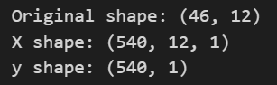
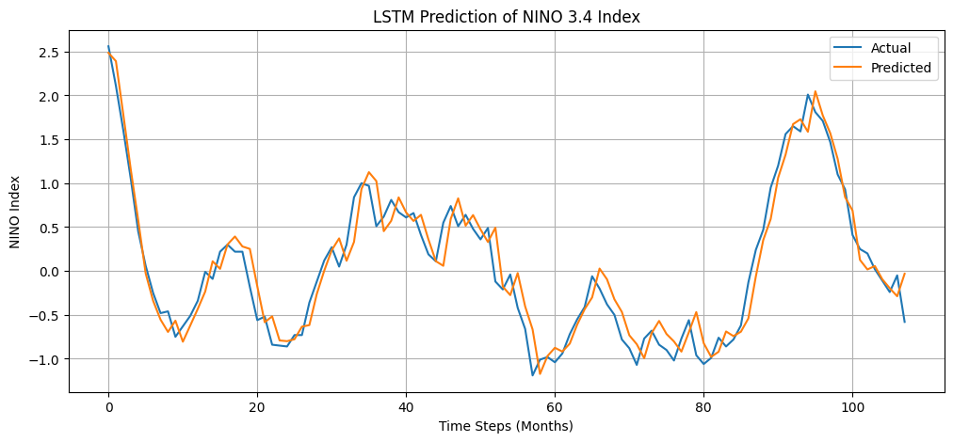

- Recurrent neural network (RNN)

Code:
import pandas as pd
import numpy as np
import matplotlib.pyplot as plt
from sklearn.preprocessing import MinMaxScaler
from tensorflow.keras.models import Sequential
from tensorflow.keras.layers import SimpleRNN, Dense

# 1. LOAD DATA
file_path = "nino-3.4_7924_noaa.txt"
df = pd.read_csv(file_path, sep="\s+", header=None)

months = ['Jan','Feb','Mar','Apr','May','Jun',
'Jul','Aug','Sep','Oct','Nov','Dec']

df.columns = months
print("Original shape:", df.shape)

# 2. CONVERT TO TIME SERIES
series = df.values.flatten()
ts = pd.DataFrame(series, columns=['NINO'])

# 3. NORMALIZATION
scaler = MinMaxScaler()
ts_scaled = scaler.fit_transform(ts)

# 4. CREATE SEQUENCES
def create_sequences(data, seq_length=12):
X, y = [], []
for i in range(len(data) - seq_length):
X.append(data[i:i+seq_length])
y.append(data[i+seq_length])
return np.array(X), np.array(y)

SEQ_LEN = 12
X, y = create_sequences(ts_scaled, SEQ_LEN)

print("X shape:", X.shape)
print("y shape:", y.shape)

# 5. TRAIN-TEST SPLIT (Time-based)
split = int(0.8 * len(X))
X_train, X_test = X[:split], X[split:]
y_train, y_test = y[:split], y[split:]

# 6. BUILD SIMPLE RNN MODEL
model = Sequential()
model.add(SimpleRNN(
50,
activation='tanh',
input_shape=(SEQ_LEN, 1)
))
model.add(Dense(1))

model.compile(
optimizer='adam',
loss='mse'
)

model.summary()

# 7. TRAIN MODEL
history = model.fit(
X_train, y_train,
epochs=50,
batch_size=8,
validation_data=(X_test, y_test),
verbose=1
)

# 8. PREDICTION
y_pred = model.predict(X_test)

# Inverse scaling
y_test_inv = scaler.inverse_transform(y_test)
y_pred_inv = scaler.inverse_transform(y_pred)

# 9. PLOT PREDICTION CURVE
plt.figure(figsize=(12,5))
plt.plot(y_test_inv, label='Actual')
plt.plot(y_pred_inv, label='Predicted')
plt.title("RNN Prediction of NINO 3.4 Index")
plt.xlabel("Time Steps (Months)")
plt.ylabel("NINO Index")
plt.legend()
plt.grid()
plt.show()

from sklearn.metrics import mean_squared_error, mean_absolute_error, r2_score
import numpy as np

# EVALUATION METRICS
mse = mean_squared_error(y_test_inv, y_pred_inv)
rmse = np.sqrt(mse)
mae = mean_absolute_error(y_test_inv, y_pred_inv)
r2 = r2_score(y_test_inv, y_pred_inv)

print("\nEvaluation Metrics:")
print("MSE :", mse)
print("RMSE:", rmse)
print("MAE :", mae)
print("R2 :", r2)

Output:
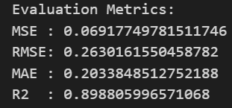
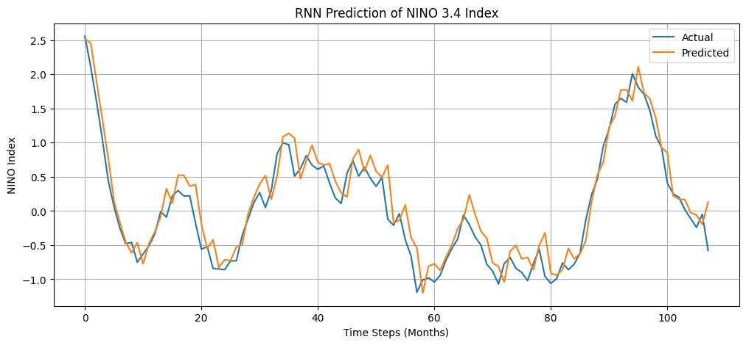

- Convolutional neural network (CNN)

Code:
import pandas as pd
import numpy as np
import matplotlib.pyplot as plt
from sklearn.preprocessing import MinMaxScaler
from tensorflow.keras.models import Sequential
from tensorflow.keras.layers import Conv1D, Dense, Flatten

# 1. LOAD DATA
file_path = "nino-3.4_7924_noaa.txt"
df = pd.read_csv(file_path, sep="\s+", header=None)

months = ['Jan','Feb','Mar','Apr','May','Jun',
'Jul','Aug','Sep','Oct','Nov','Dec']

df.columns = months
print("Original shape:", df.shape)

# 2. CONVERT TO TIME SERIES
series = df.values.flatten()
ts = pd.DataFrame(series, columns=['NINO'])

# 3. NORMALIZATION
scaler = MinMaxScaler()
ts_scaled = scaler.fit_transform(ts)

# 4. CREATE SEQUENCES
def create_sequences(data, seq_length=12):
X, y = [], []
for i in range(len(data) - seq_length):
X.append(data[i:i+seq_length])
y.append(data[i+seq_length])
return np.array(X), np.array(y)

SEQ_LEN = 12
X, y = create_sequences(ts_scaled, SEQ_LEN)

print("X shape:", X.shape)
print("y shape:", y.shape)

# 5. TRAIN-TEST SPLIT (Time-based)
split = int(0.8 * len(X))
X_train, X_test = X[:split], X[split:]
y_train, y_test = y[:split], y[split:]

# 6. BUILD CNN MODEL (Conv1D)
model = Sequential()
model.add(Conv1D(
filters=64,
kernel_size=3,
activation='relu',
input_shape=(SEQ_LEN, 1)
))
model.add(Flatten())
model.add(Dense(50, activation='relu'))
model.add(Dense(1))

model.compile(
optimizer='adam',
loss='mse'
)

model.summary()

# 7. TRAIN MODEL
history = model.fit(
X_train, y_train,
epochs=50,
batch_size=8,
validation_data=(X_test, y_test),
verbose=1
)

# 8. PREDICTION
y_pred = model.predict(X_test)

# Inverse scaling
y_test_inv = scaler.inverse_transform(y_test)
y_pred_inv = scaler.inverse_transform(y_pred)

# 9. PLOT PREDICTION CURVE
plt.figure(figsize=(12,5))
plt.plot(y_test_inv, label='Actual')
plt.plot(y_pred_inv, label='Predicted')
plt.title("CNN (Conv1D) Prediction of NINO 3.4 Index")
plt.xlabel("Time Steps (Months)")
plt.ylabel("NINO Index")
plt.legend()
plt.grid()
plt.show()

from sklearn.metrics import mean_squared_error, mean_absolute_error, r2_score
import numpy as np

# EVALUATION METRICS
mse = mean_squared_error(y_test_inv, y_pred_inv)
rmse = np.sqrt(mse)
mae = mean_absolute_error(y_test_inv, y_pred_inv)
r2 = r2_score(y_test_inv, y_pred_inv)

print("\nEvaluation Metrics:")
print("MSE :", mse)
print("RMSE:", rmse)
print("MAE :", mae)
print("R2 :", r2)

Output:
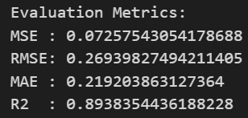
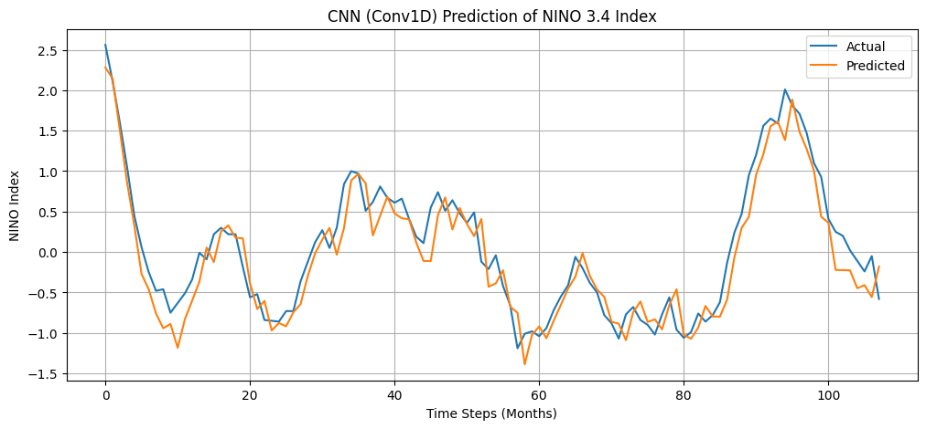

- Support Vector Machine (SVM)

Code:
import pandas as pd
import numpy as np
import matplotlib.pyplot as plt
from sklearn.preprocessing import MinMaxScaler
from sklearn.svm import SVR
from sklearn.metrics import mean_squared_error, mean_absolute_error

# 1. LOAD DATA
file_path = "nino-3.4_7924_noaa.txt"
df = pd.read_csv(file_path, sep="\s+", header=None)

months = ['Jan','Feb','Mar','Apr','May','Jun',
'Jul','Aug','Sep','Oct','Nov','Dec']

df.columns = months

# 2. CONVERT TO TIME SERIES
series = df.values.flatten() # 552 values

# 3. NORMALIZATION
scaler = MinMaxScaler()
series_scaled = scaler.fit_transform(series.reshape(-1,1))

# 4. CREATE SEQUENCES
def create_sequences(data, seq_len=12):
X, y = [], []
for i in range(len(data) - seq_len):
X.append(data[i:i+seq_len])
y.append(data[i+seq_len])
return np.array(X), np.array(y)

SEQ_LEN = 12
X, y = create_sequences(series_scaled, SEQ_LEN)

# Flatten input for SVR
X = X.reshape(X.shape[0], X.shape[1])

print("X shape:", X.shape)
print("y shape:", y.shape)

# 5. TRAIN-TEST SPLIT (TIME BASED)
split = int(0.8 * len(X))
X_train, X_test = X[:split], X[split:]
y_train, y_test = y[:split], y[split:]

# Flatten y for SVR
y_train = y_train.ravel()
y_test = y_test.ravel()

# 6. BUILD SVR MODEL
model = SVR(
kernel='rbf', # best for nonlinear data
C=100,
gamma=0.1,
epsilon=0.01
)

model.fit(X_train, y_train)

# 7. PREDICTION
y_pred = model.predict(X_test)

# Reshape for inverse scaling
y_test = y_test.reshape(-1,1)
y_pred = y_pred.reshape(-1,1)

y_test_inv = scaler.inverse_transform(y_test)
y_pred_inv = scaler.inverse_transform(y_pred)

# 8. EVALUATION METRICS
mse = mean_squared_error(y_test_inv, y_pred_inv)
rmse = np.sqrt(mse)
mae = mean_absolute_error(y_test_inv, y_pred_inv)

print("\nEvaluation Metrics:")
print("MSE :", mse)
print("RMSE:", rmse)
print("MAE :", mae)

# 9. PLOT PREDICTION CURVE
plt.figure(figsize=(12,5))
plt.plot(y_test_inv, label='Actual')
plt.plot(y_pred_inv, label='Predicted')
plt.title("SVR Time Series Prediction (NINO 3.4)")
plt.xlabel("Time Steps (Months)")
plt.ylabel("NINO Index")
plt.legend()
plt.grid()
plt.show()

Output:
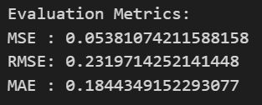
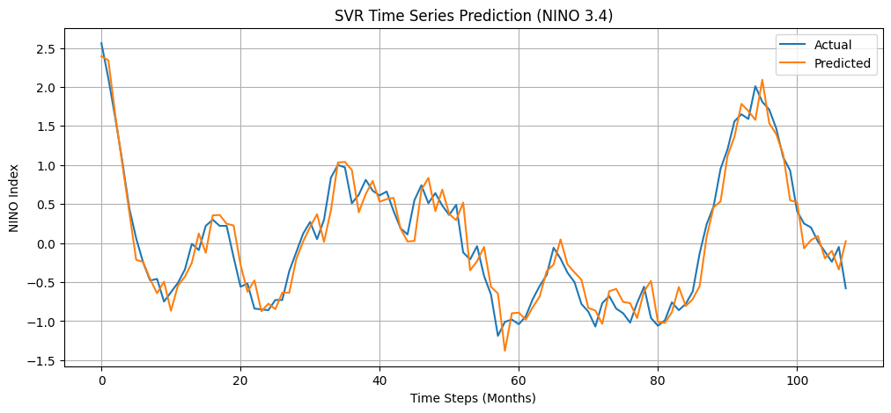

- Random Forest

Code:
import numpy as np
import pandas as pd
import matplotlib.pyplot as plt
from sklearn.ensemble import RandomForestRegressor
from sklearn.model_selection import train_test_split
from sklearn.metrics import mean_squared_error, r2_score

# Load ENSO (Niño 3.4 index)
enso_file = "nino-3.4_7924_noaa.txt"
enso = pd.read_csv(enso_file, delim_whitespace=True, header=None)

# Flatten to 1D array
enso_index = enso.values.flatten()

def create_lag_features(data, lag=6):
X, y = [], []
for i in range(len(data) - lag):
X.append(data[i:i+lag])
y.append(data[i+lag])
return np.array(X), np.array(y)

lag = 6
X, y = create_lag_features(enso_index, lag)

X_train, X_test, y_train, y_test = train_test_split(
X, y, test_size=0.2, shuffle=False
)

rf_model = RandomForestRegressor(
n_estimators=100,
max_depth=10,
random_state=42
)

rf_model.fit(X_train, y_train)

y_pred = rf_model.predict(X_test)

rmse = np.sqrt(mean_squared_error(y_test, y_pred))
r2 = r2_score(y_test, y_pred)

print("RMSE:", rmse)
print("R2 Score:", r2)

plt.figure(figsize=(10,5))
plt.plot(y_test, label="Actual")
plt.plot(y_pred, label="Predicted")
plt.legend()
plt.title("Random Forest Prediction on ENSO Data")
plt.show()

Output:
