**MICROSERVICES WITH SPRING BOOT 3 AND SPRING CLOUD**

**CREATING MICROSERVICES FOR ACCOUNT AND LOAN:**

**Account Microservice:**

1.Create folder with employee id in D: drive

2.Create folder named 'microservices' in the new folder created in previous step.

3.Open https://start.spring.io/ in browser

4.Enter form field values as specified below:

**Group:** com.cognizant

**Artifact:** account

5.Select the following modules

Developer Tools > Spring Boot DevTools

Web > Spring Web

6.Click generate and download the zip file

7.Extract 'account' folder from the zip and place this folder in the 'microservices' folder.

8.Open command prompt in account folder and build using mvn clean package command.

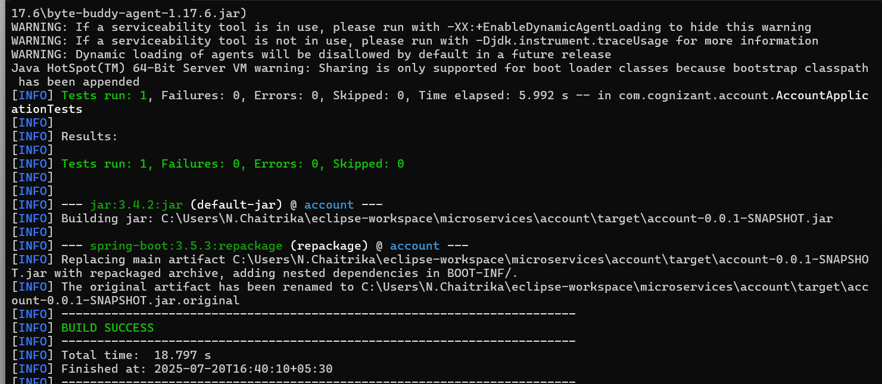

9.Import this project in Eclipse.

**pom.xml**

<dependencies>

<dependency>

<groupId>org.springframework.boot</groupId>

<artifactId>spring-boot-starter-web</artifactId>

</dependency>

<dependency>

<groupId>org.springframework.boot</groupId>

<artifactId>spring-boot-devtools</artifactId>

<scope>runtime</scope>

<optional>true</optional>

</dependency>

<dependency>

<groupId>org.springframework.boot</groupId>

<artifactId>spring-boot-starter-test</artifactId>

<scope>test</scope>

</dependency>

</dependencies>

**AccountController.java**

**package** com.cognizant.account.controller;

**import** org.springframework.web.bind.annotation.*;

**import** java.util.Map;

@RestController

@RequestMapping("/accounts")

**public** **class** AccountController {

@GetMapping("/{number}")

**public** Map<String, Object> getAccountDetails(@PathVariable String number) {

**return** Map.*of*(

"number", number,

"type", "savings",

"balance", 234343

);

}

}

**AccountApplication.java**

**package** com.cognizant.account;

**import** org.springframework.boot.SpringApplication;

**import** org.springframework.boot.autoconfigure.SpringBootApplication;

@SpringBootApplication

**public** **class** AccountApplication {

**public** **static** **void** main(String[] args) {

SpringApplication.*run*(AccountApplication.**class**, args);

}

}

**OUTPUT:**

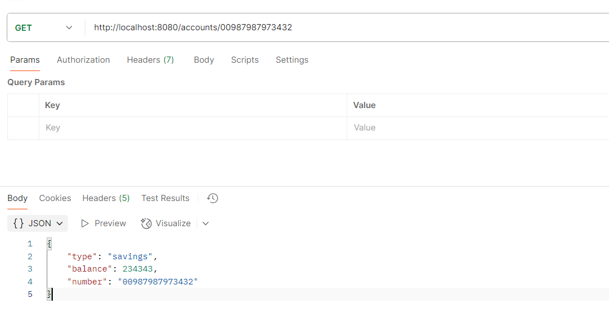

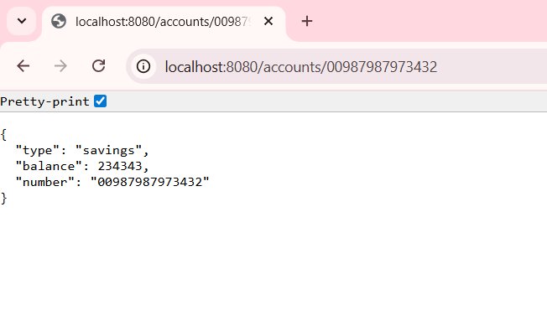

**Loan Microservice:**

1.Open https://start.spring.io/ in browser

2.Enter form field values as specified below:

**Group:** com.cognizant

**Artifact:** loan

3.Select the following modules

Developer Tools > Spring Boot DevTools

Web > Spring Web

4.Click generate and download the zip file

5.Extract 'loan' folder from the zip and place this folder in the 'microservices' folder.

6.Open command prompt in loan folder and build using mvn clean package command.

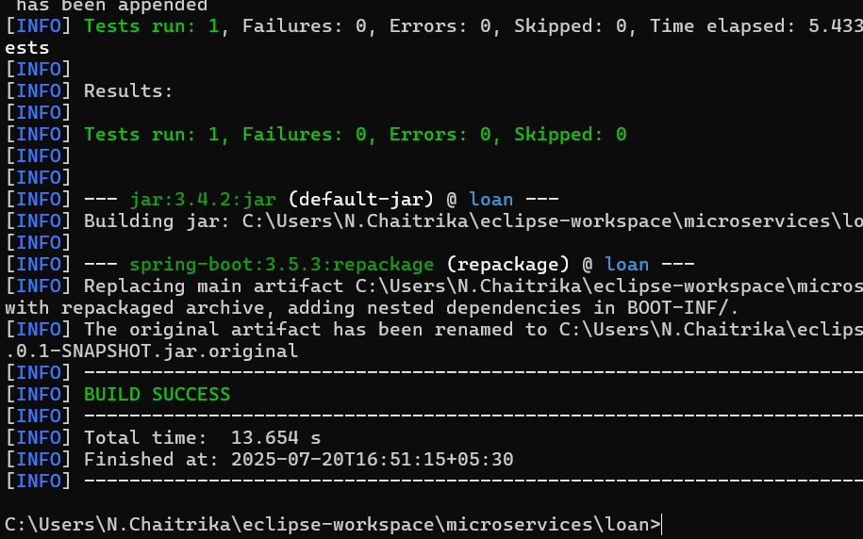

7.Import this project in Eclipse.

**LoanController.java**

**package** com.cognizant.loan.controller;

**import** org.springframework.web.bind.annotation.*;

**import** java.util.Map;

@RestController

@RequestMapping("/loans")

**public** **class** LoanController {

@GetMapping("/{number}")

**public** Map<String, Object> getLoanDetails(@PathVariable String number) {

**return** Map.*of*(

"number", number,

"type", "car",

"loan", 400000,

"emi", 3258,

"tenure", 18

);

}

}

**LoanApplication.java**

**package** com.cognizant.loan;

**import** org.springframework.boot.SpringApplication;

**import** org.springframework.boot.autoconfigure.SpringBootApplication;

@SpringBootApplication

**public** **class** LoanApplication {

**public** **static** **void** main(String[] args) {

SpringApplication.*run*(LoanApplication.**class**, args);

}

}

**application.properties:**

spring.application.name=loan

server.port=8081

**OUTPUT:**

