**1. REACTJS-HOL**

**Creating a “myfirstreact” Application:**

1. To create a new React app, Install Nodejs and Npm from the following link:

<https://nodejs.org/en/download/>

2. Install Create-react-app by running the following command in the command

prompt.

3. Create a React Application with the name of “myfirstreact”.

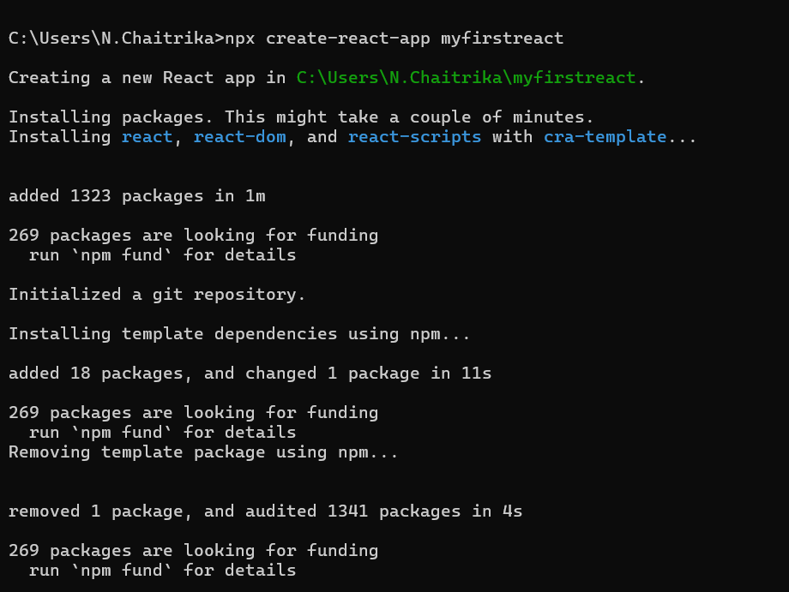

4. Once the App is created, navigate into the folder of myfirstreact.

5. Open the folder of myfirstreact in Visual Studio Code.

**App.js**

import logo from './logo.svg';

import './App.css';

function App() {

  return(

    <h1 style={{textAlign:'center'}}> Welcome the first session of React</h1>

  )

}

export default App;

6. Run the following command to execute the React application.

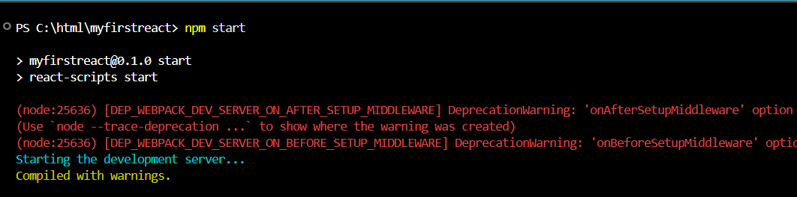

**OUTPUT:**

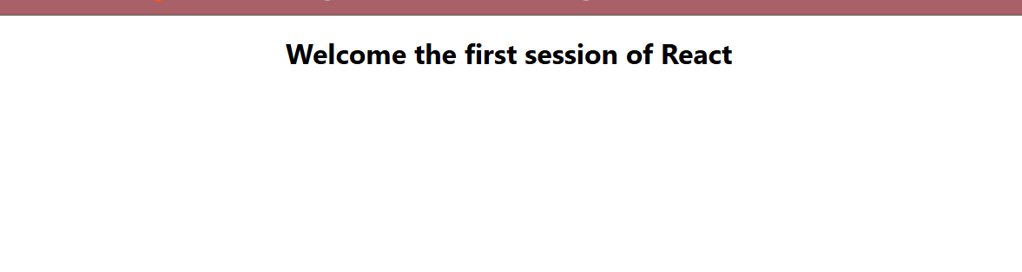

**2. REACTJS-HOL**

**Creating “Student Management Portal”:**

1.Create a React Application with the name of “studentapp”.

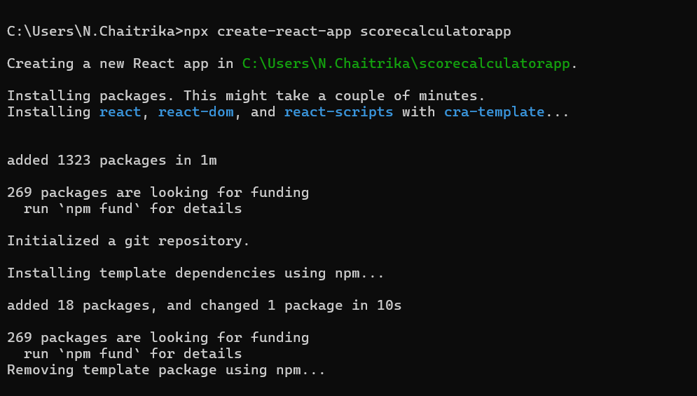

2. Once the App is created, navigate into the folder of studentapp.

3. Open the folder of studentapp in Visual Studio Code.

4. Create a new folder named “Components” under src folder and create three components named “Home”, “About”, “Contact”.

**Home.js:**

import React from 'react'

function Home() {

return (

<div>

<h3>Welcome to the Home Page of Student Management Portal</h3>

</div>

)

}

export default Home

**About.js:**

import React from 'react'

function About() {

return (

<div>

<h3>Welcome to the About Page of Student Management Portal</h3>

</div>

)

}

export default About

**Contact.js**

import React from 'react'

function Contact() {

  return (

    <div>

        <h3>Welcome to the Contact Page of Student Management Portal</h3>

    </div>

  )

}

export default Contact;

**App.js:**

import './App.css';

import Home from './Components/Home';

import About from './Components/About';

import Contact from './Components/Contact';

function App() {

  return (

    <div className='container'>

      <Home/>

      <About/>

      <Contact/>

    </div>

  );

}

export default App;

5. Run the following command to execute the React application.

**OUTPUT:**

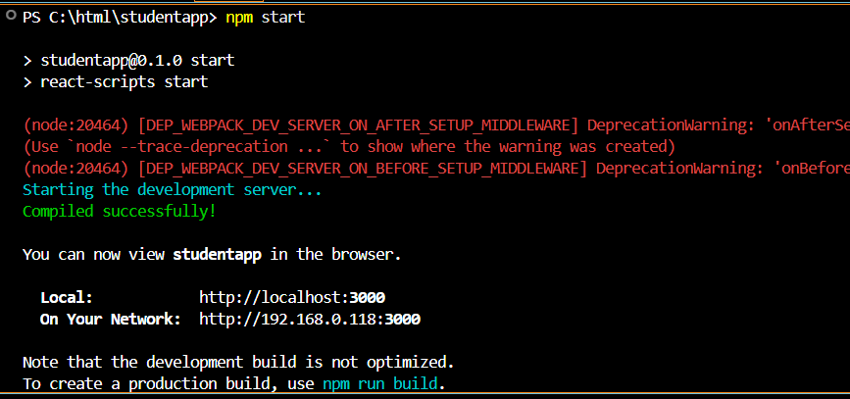

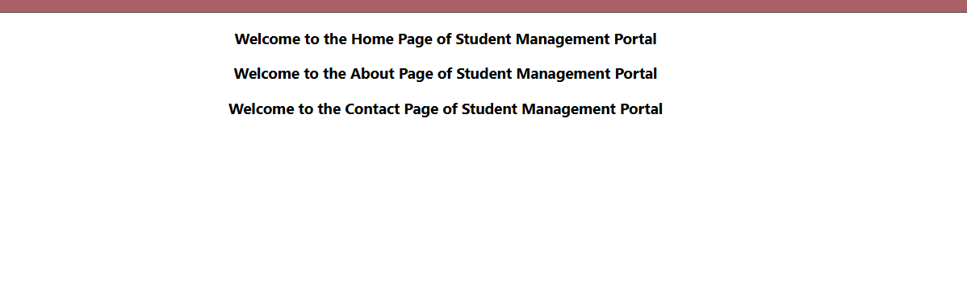

**3. REACTJS-HOL**

**Creating “Score Calculator App”:**

1.Create a React Application with the name of “scorecalculatorapp”.

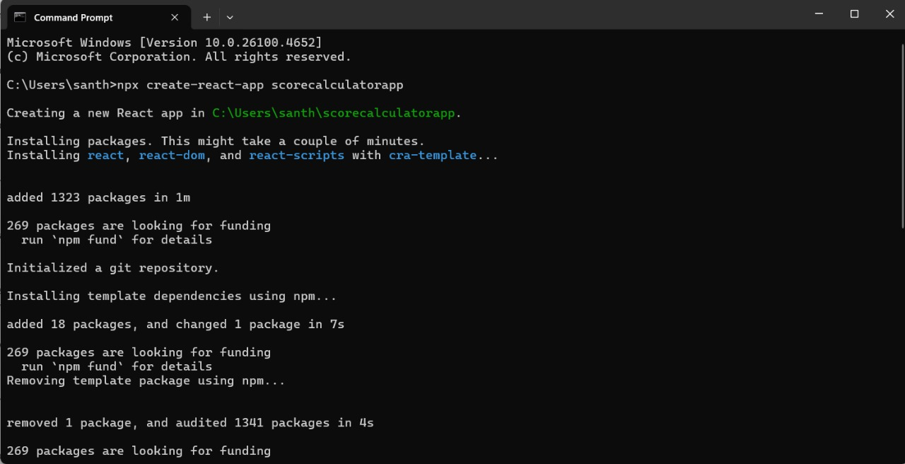

2. Create a new folder under Src folder with the name “Components”. Add a new file named “CalculateScore.js”

**CalculateScore.js:**

import '../Stylesheets/mystyle.css'

const percentToDecimal = (decimal)=>{

    return (decimal.toFixed(2)+'%')

}

const calcScore=(total,goal)=>{

    return percentToDecimal(total/goal)

}

export const CalculateScore=({Name,School,total,goal})=>(

    <div className="formatstyle">

        <h1><font color="Brown">Student Details:</font></h1>

        <div className="Name">

            <b><span>Name: </span></b>

            <span>{Name}</span>

        </div>

        <div className="School">

            <b><span>Total:</span></b>

            <span>{total}</span>

            <span>Marks</span>

        </div>

        <div className="Score">

            <b>Score:</b>

            <span>

                {calcScore(total,goal)}

            </span>

        </div>

    </div>

);

**mystyle.css:**

.Name{

    font-weight: 300;

    color:blue;

}

.School{

    color:crimson;

}

.Total{

    color:darkmagenta;

}

.formatstyle{

    text-align:center;

    font-size: large;

}

.Score{

    color:forestgreen;

}

**App.js:**

import { CalculateScore } from "./Components/CalculateScore";

function App(){

  return(

    <div>

      <CalculateScore Name={"Steeve"}

      School={"DNV Public School"}

      total={284}

      goal={3}

      />

    </div>

  )

}

export default App;

3. Run the following command to execute the React application.

**OUTPUT:**

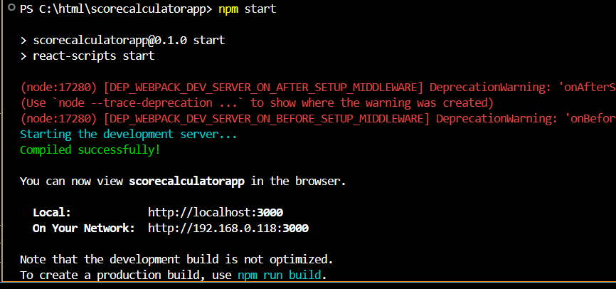

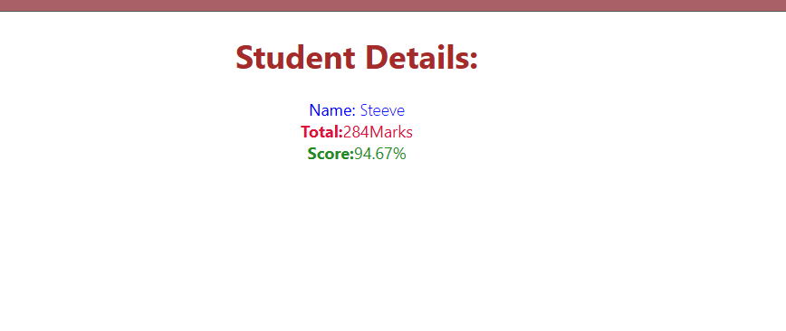

**4. REACTJS-HOL**

**Creating “blogapp”**

1.Create a React Application with the name of “blogapp”.

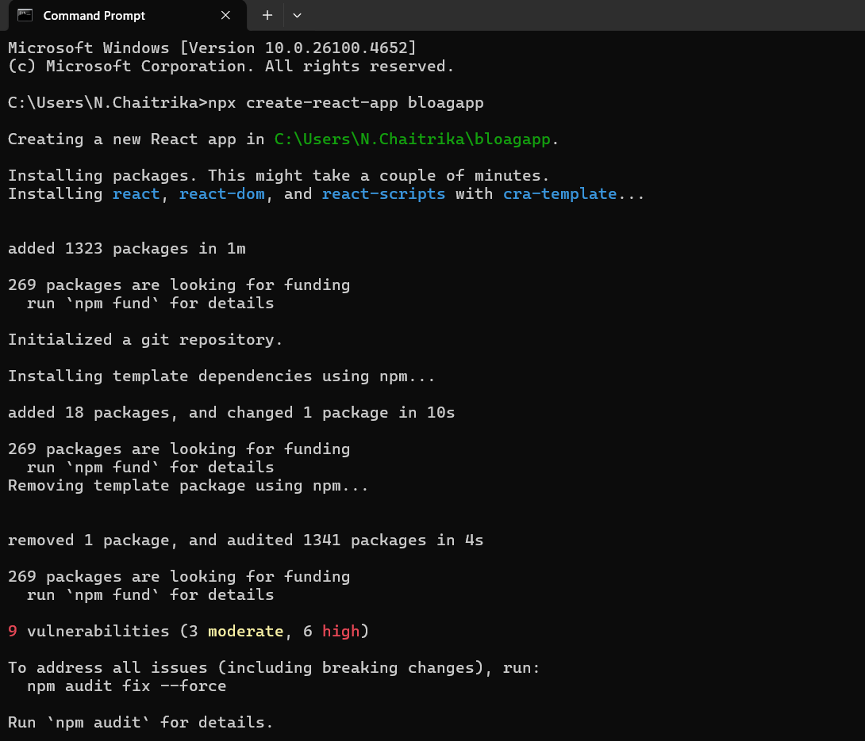

2. Open the application using VS Code

**Post.js:**

class Post {

  constructor(userId, id, title, body) {

    this.userId = userId;

    this.id = id;

    this.title = title;

    this.body = body;

  }

}

export default Post;

**Posts.js:**

import React, { Component } from "react";

import Post from "./Post";

class Posts extends Component {

  constructor(props) {

    super(props);

    this.state = {

      posts: [],

    };

  }

  loadPosts() {

    fetch("https://jsonplaceholder.typicode.com/posts")

      .then((res) => res.json())

      .then((data) => {

        const postList = data.map(

          (item) => new Post(item.userId, item.id, item.title, item.body)

        );

        this.setState({ posts: postList });

      })

      .catch((error) => {

        alert("Error loading posts: " + error.message);

      });

  }

  componentDidMount() {

    this.loadPosts();

  }

  componentDidCatch(error, info) {

    alert("Something went wrong: " + error.message);

  }

  render() {

    return (

      <div>

        <h1 style={{ textAlign: 'center' }}>Blog Posts</h1>

        {this.state.posts.map((post) => (

          <div key={post.id}>

            <h2>{post.title}</h2>

            <p>{post.body}</p>

            <hr />

          </div>

        ))}

      </div>

    );

  }

}

export default Posts;

**App.js:**

import React from "react";

import Posts from "./Posts";

function App() {

  return (

    <div className="App">

      <Posts />

    </div>

  );

}

export default App;

3. Run the following command to execute the React application.

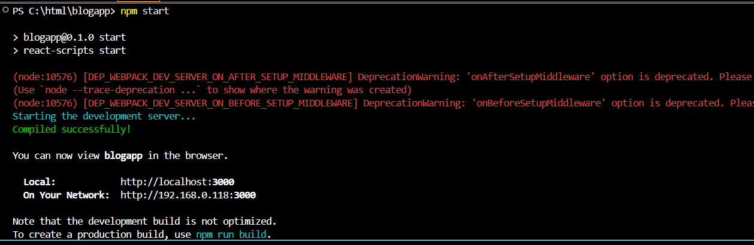

**OUTPUT:**

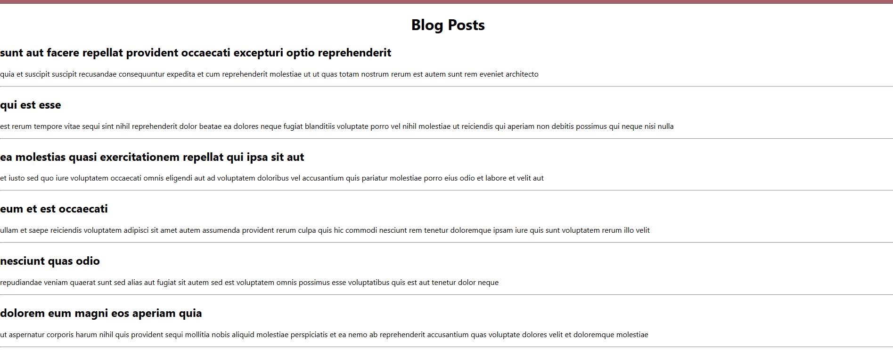

**5. REACTJS-HOL**

**Creating “Cohorttracker application”**

1.Download the zip file “cohorttracker.zip”.

2. Unzip the react application in a folder.

3. Restore the node packages using the following commands: npm install

4.Create a new CSS Module in a file called “CohortDetails.module.css”

**CohortDetails.module.css:**

.box {

width: 300px;

display: inline-block;

margin: 10px;

padding: 10px 20px;

border: 1px solid black;

border-radius: 10px;

}

dt {

font-weight: 500;

}

**CohortDetails.js:**

import styles from './CohortDetails.module.css';

function CohortDetails(props) {

const { cohort } = props;

return (

<div className={styles.box}>

<h3 style={{ color: cohort.currentStatus === 'Ongoing' ? 'green' : 'blue' }}>

{cohort.cohortCode} - <span>{cohort.technology}</span>

</h3>

<dl>

<dt>Started On</dt>

<dd>{props.cohort.startDate}</dd>

<dt>Current Status</dt>

<dd>{props.cohort.currentStatus}</dd>

<dt>Coach</dt>

<dd>{props.cohort.coachName}</dd>

<dt>Trainer</dt>

<dd>{props.cohort.trainerName}</dd>

</dl>

</div>

);

}

export default CohortDetails;

5. Run the following command to execute the React application.

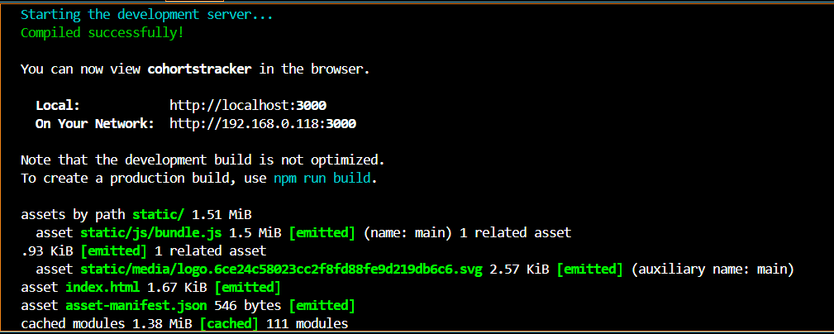

**OUTPUT:**

