**9. REACTJS-HOL**

**Creating a “cricketapp” Application:**

1. Create a React Application with the name of “cricketapp”.

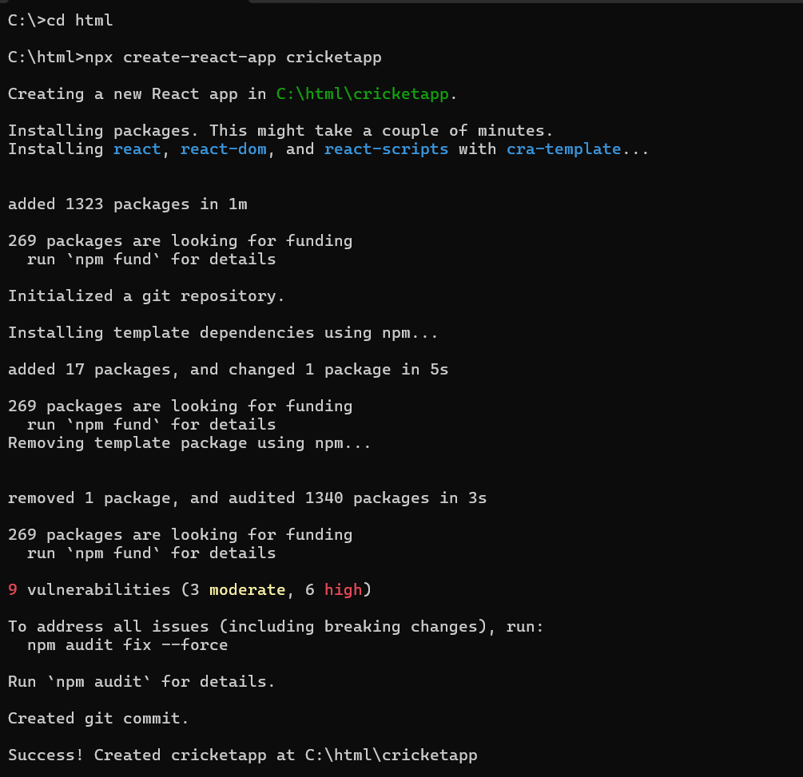

2. Once the App is created, navigate into the folder of cricketapp.

3. Open the folder of cricketapp in Visual Studio Code.

4. Create a folder named ‘components’ in src folder and create the components named EvenPlayers.js, OddPlayers.js, IndianTeamDetails.js, ListOfIndianPlayers.js, ScoreBelow70.js

**EvenPlayers.js**

// src/components/EvenPlayers.js

export function EvenPlayers([, second, , fourth, , sixth]) {

  return (

    <div>

      <li>Second : {second}</li>

      <li>Fourth : {fourth}</li>

      <li>Sixth : {sixth}</li>

    </div>

  );

}

**IndianTeamDetails.js:**

export const IndianTeam = ['Sachin1', 'Dhoni2', 'Virat3', 'Rohit4', 'Yuvaraj5', 'Raina6'];

const T20Players = ['First Player', 'Second Player', 'Third Player'];

const RanjiTrophyPlayers = ['Fourth Player', 'Fifth Player', 'Sixth Player'];

export const IndianPlayers = [...T20Players, ...RanjiTrophyPlayers];

**ListOfIndianPlayers.js**

import React from 'react';

const ListOfIndianPlayers = ({ IndianPlayers }) => {

  return (

    <ul>

      {IndianPlayers.map((item, index) => (

        <li key={index}>Mr. {item}</li>

      ))}

    </ul>

  );

};

export default ListOfIndianPlayers;

**ListOfPlayers.js**

import React from 'react';

const ListofPlayers = ({ players }) => {

  return (

    <ul>

      {players.map((item, index) => (

        <li key={index}>

          Mr. {item.name} <span>{item.score}</span>

        </li>

      ))}

    </ul>

  );

};

export default ListofPlayers;

**OddPlayers.js**

// src/components/OddPlayers.js

export function OddPlayers([first, , third, , fifth]) {

  return (

    <div>

      <li>First : {first}</li>

      <li>Third : {third}</li>

      <li>Fifth : {fifth}</li>

    </div>

  );

}

**ScoreBelow70.js**

// src/components/ScoreBelow70.js

import React from 'react';

const ScoreBelow70 = ({ players }) => {

  const players70 = [];

  players.map((item) => {

    if (item.score <= 70) {

      players70.push(item);

    }

    return null;

  });

  return (

    <ul>

      {players70.map((item, index) => (

        <li key={index}>

          Mr. {item.name} <span>{item.score}</span>

        </li>

      ))}

    </ul>

  );

};

export default ScoreBelow70;

5. Run the following command to execute the React application.

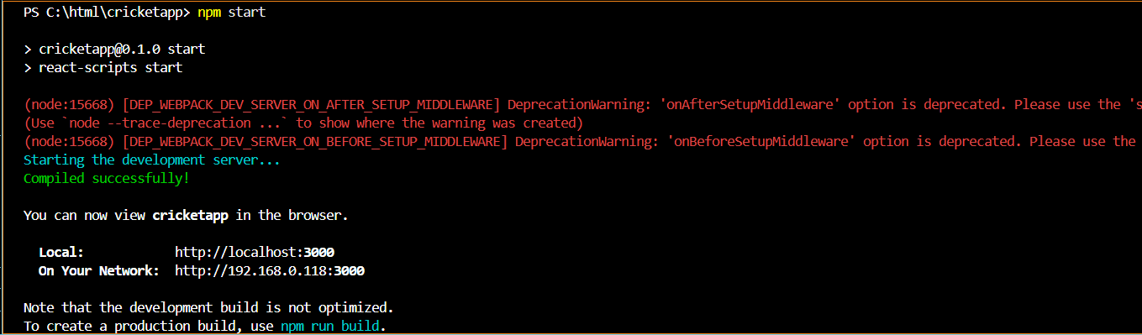

**OUTPUT:**

When flag = true

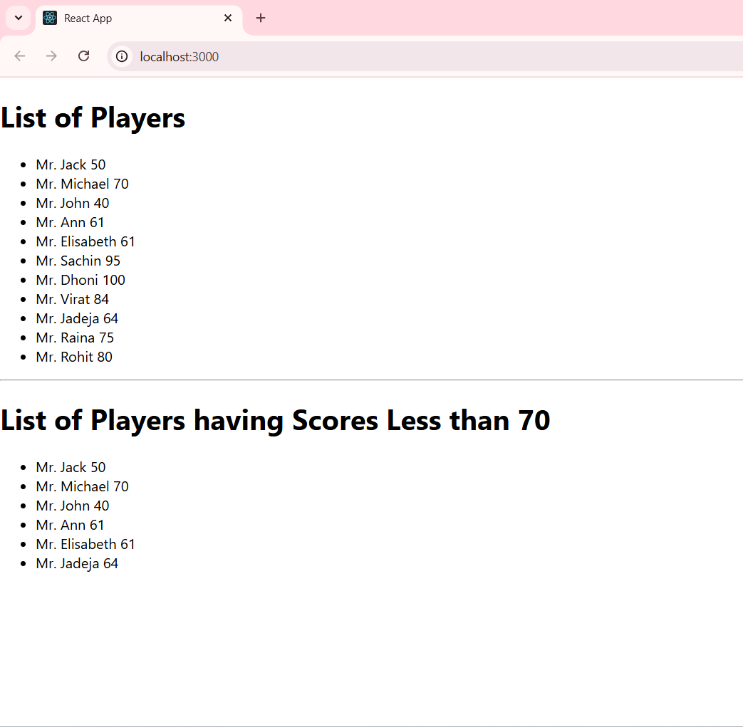

When flag = false

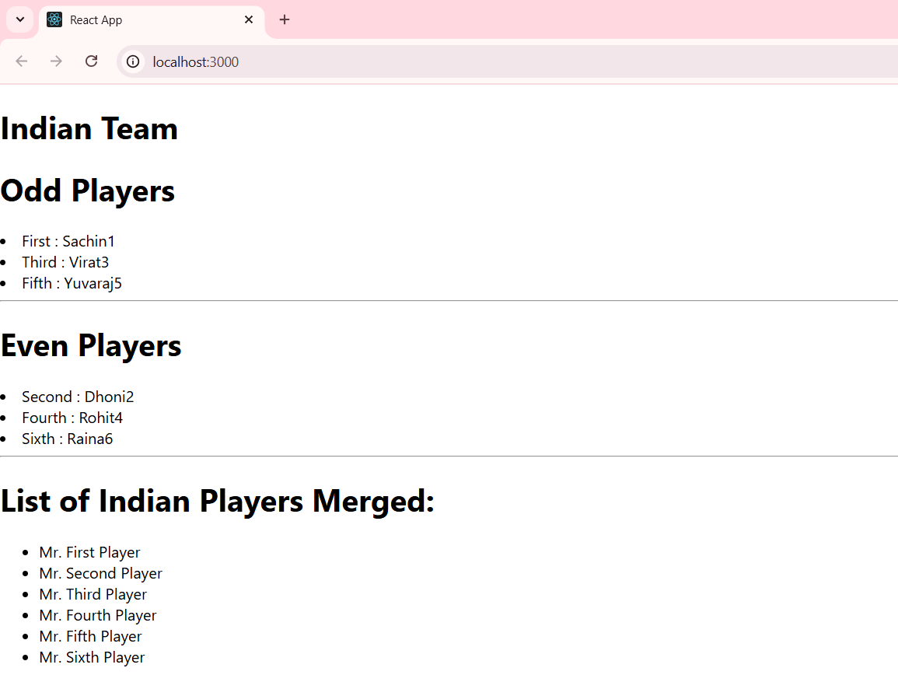

**10. REACTJS-HOL**

**Creating “officespacerentalapp”:**

1.Create a React Application with the name of “officespacerentalapp”.

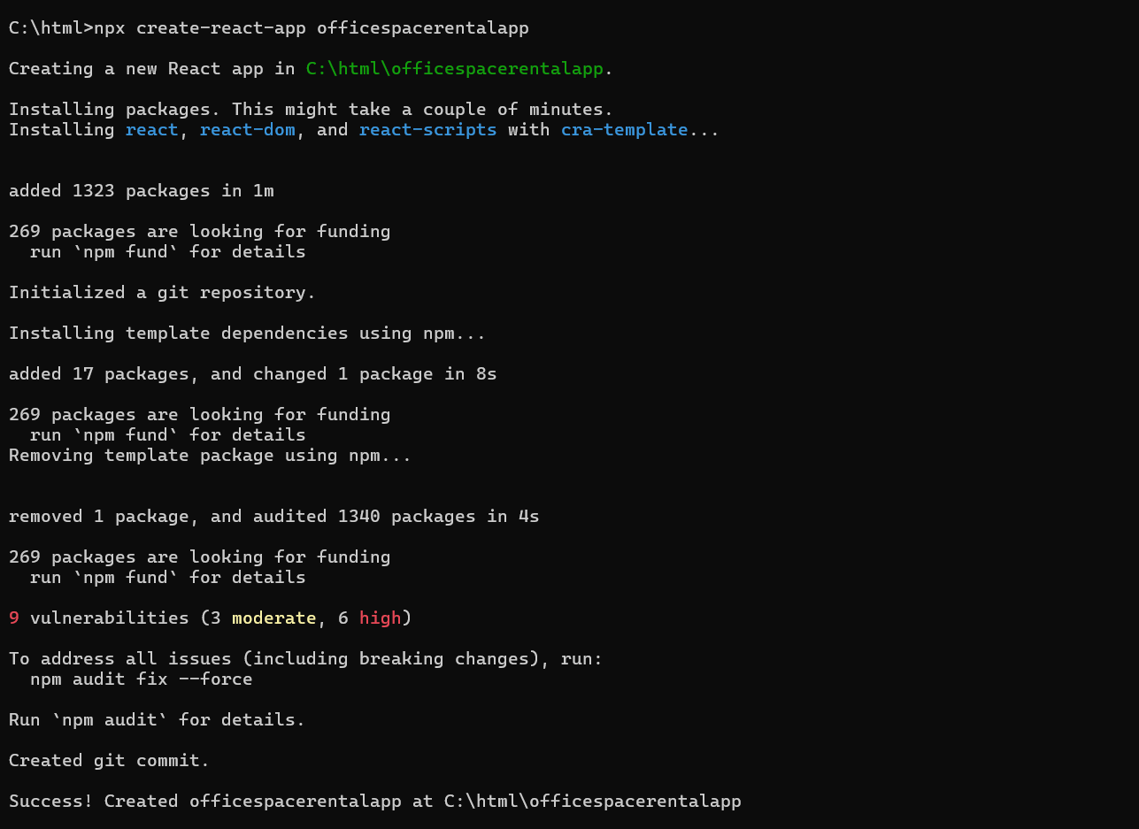

2. Once the App is created, navigate into the folder of officespacerentalapp.

3. Open the folder of officespacerentalapp in Visual Studio Code.

**App.js**

import React from 'react';

import './App.css';

function App() {

  const heading = "Office Space, at Affordable Range";

  const officeSpaces = [

  {

    name: "VertexSpace",

    rent: 45000,

    address: "Pune"

  },

  {

    name: "MetroNest",

    rent: 62000,

    address: "Bengaluru"

  },

  {

    name: "NextHive",

    rent: 70000,

    address: "Gurgaon"

  },

  {

    name: "BrightWorks",

    rent: 59000,

    address: "Jaipur"

  },

  {

    name: "UrbanCore",

    rent: 75000,

    address: "Mumbai"

  }

];

  return (

    <div className="App" style={{ padding: '20px' }}>

      <h1>{heading}</h1>

      <img

        src="https://soulspaces.london/wp-content/uploads/industrial.png"

        alt="Office space"

        width="500"

        height="300"

        style={{ margin: '5px 0' }}

      />

      {officeSpaces.map((office, index) => (

        <div key={index} style={{ marginBottom: '5px' }}>

          <h3><strong>Name:</strong> {office.name}</h3>

          <p>

            <strong>Rent:</strong>{" "}

            <span style={{ color: office.rent < 60000 ? "red" : "green", fontWeight: 'bold' }}>

              Rs. {office.rent}

            </span>

          </p>

          <p><strong>Address:</strong> {office.address}</p>

        </div>

      ))}

    </div>

  );

}

export default App;

5. Run the following command to execute the React application.

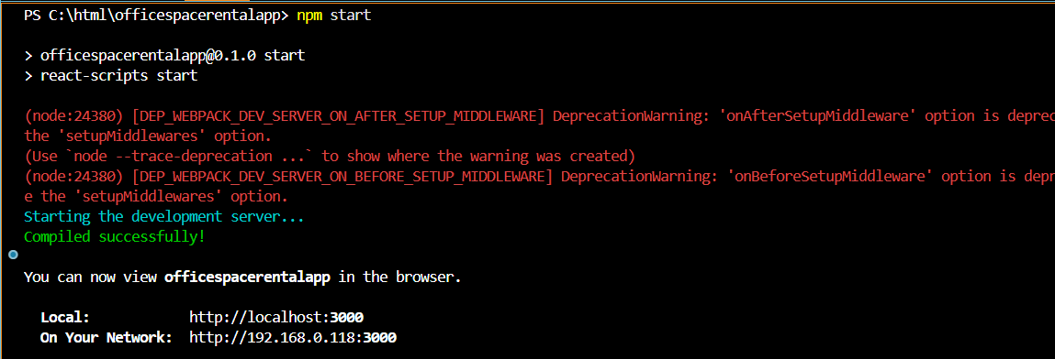

**OUTPUT:**

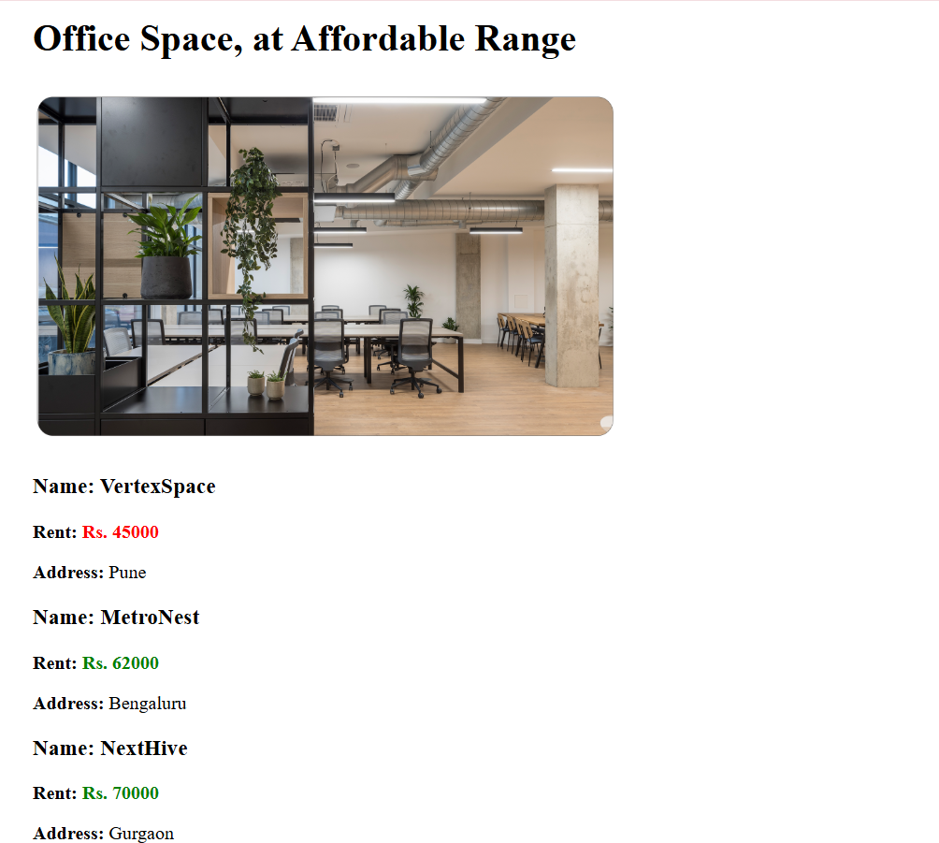

**11. REACTJS-HOL**

**Creating “eventexamplesapp”:**

1.Create a React Application with the name of “eventexamplesapp”.

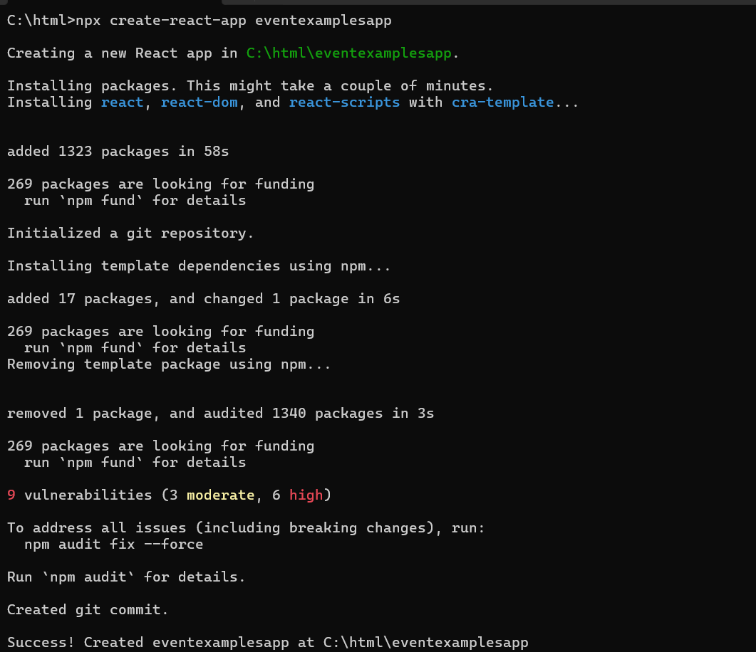

2. Once the App is created, navigate into the folder of eventexamplesapp.

3. Open the folder of eventexamplesapp in Visual Studio Code.

**App.js**

import React, { useState } from 'react';

import CurrencyConvertor from './Currencyconvertor';

function App() {

  const [count, setCount] = useState(0);

  const handleIncrement = () => {

    increment();

    sayHello();

  };

  const increment = () => {

    setCount(count + 1);

  };

  const decrement = () => {

    setCount(count - 1);

  };

  const sayHello = () => {

    alert("Hello Learners!");

  };

  const sayWelcome = (message) => {

    alert(message);

  };

  const handleOnPress = (event) => {

    alert("I was clicked");

  };

  return (

    <div style={{ padding: '20px', fontFamily: 'Arial' }}>

      <h1>React Event Examples App</h1>

      <h2>Counter: {count}</h2>

      <button onClick={handleIncrement}>Increment</button>{' '}

      <button onClick={decrement}>Decrement</button>

      <hr />

      <button onClick={() => sayWelcome("Welcome!")}>Say Welcome</button>

      <hr />

      <button onClick={handleOnPress}>OnPress</button>

      <hr />

      <CurrencyConvertor />

    </div>

  );

}

export default App;

**CurrencyConvertor.js**

import React, { useState } from 'react';

import './CurrencyConvertor.css';

function CurrencyConvertor() {

  const [amount, setAmount] = useState('');

  const [conversionType, setConversionType] = useState('inrToEuro');

  const handleSubmit = (e) => {

    e.preventDefault();

    const amountNum = parseFloat(amount);

    if (isNaN(amountNum)) {

      alert("Please enter a valid number for amount.");

      return;

    }

    const euroRate = 0.011;

    let result = 0;

    let message = '';

    if (conversionType === 'inrToEuro') {

      result = amountNum * euroRate;

      message = `₹${amountNum} INR = €${result.toFixed(2)} EURO`;

    } else if (conversionType === 'euroToInr') {

      result = amountNum / euroRate;

      message = `€${amountNum} EURO = ₹${result.toFixed(2)} INR`;

    }

    alert(message);

  };

  return (

    <div className="convertor-container">

      <h2 className="title">Currency Convertor!!!</h2>

      <form onSubmit={handleSubmit}>

        <div className="form-row">

          <label>Amount:</label>

          <input

            type="text"

            value={amount}

            onChange={(e) => setAmount(e.target.value)}

            required

          />

        </div>

        <div className="form-row">

          <label>Convert:</label>

          <select

            value={conversionType}

            onChange={(e) => setConversionType(e.target.value)}

            required

          >

            <option value="inrToEuro">INR to EURO</option>

            <option value="euroToInr">EURO to INR</option>

          </select>

        </div>

        <button type="submit">Submit</button>

      </form>

    </div>

  );

}

export default CurrencyConvertor;

**CurrencyConvertor.css:**

.convertor-container {

  margin-top: 30px;

  font-family: Arial, sans-serif;

}

.title {

  color: green;

  font-weight: bold;

  font-size: 24px;

}

.form-row {

  margin: 10px 0;

  display: flex;

  align-items: center;

}

.form-row label {

  width: 80px;

  font-weight: bold;

}

.form-row input,

.form-row textarea {

  width: 200px;

  padding: 5px;

  margin-left: 10px;

}

button {

  margin-top: 10px;

  padding: 5px 15px;

  font-weight: bold;

}

4. Run the following command to execute the React application.

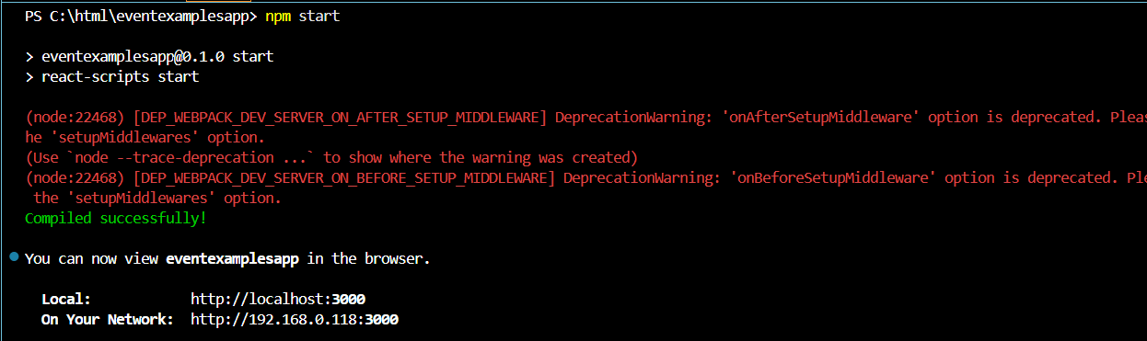

**OUTPUT:**

1.Incrementing and decrementing value

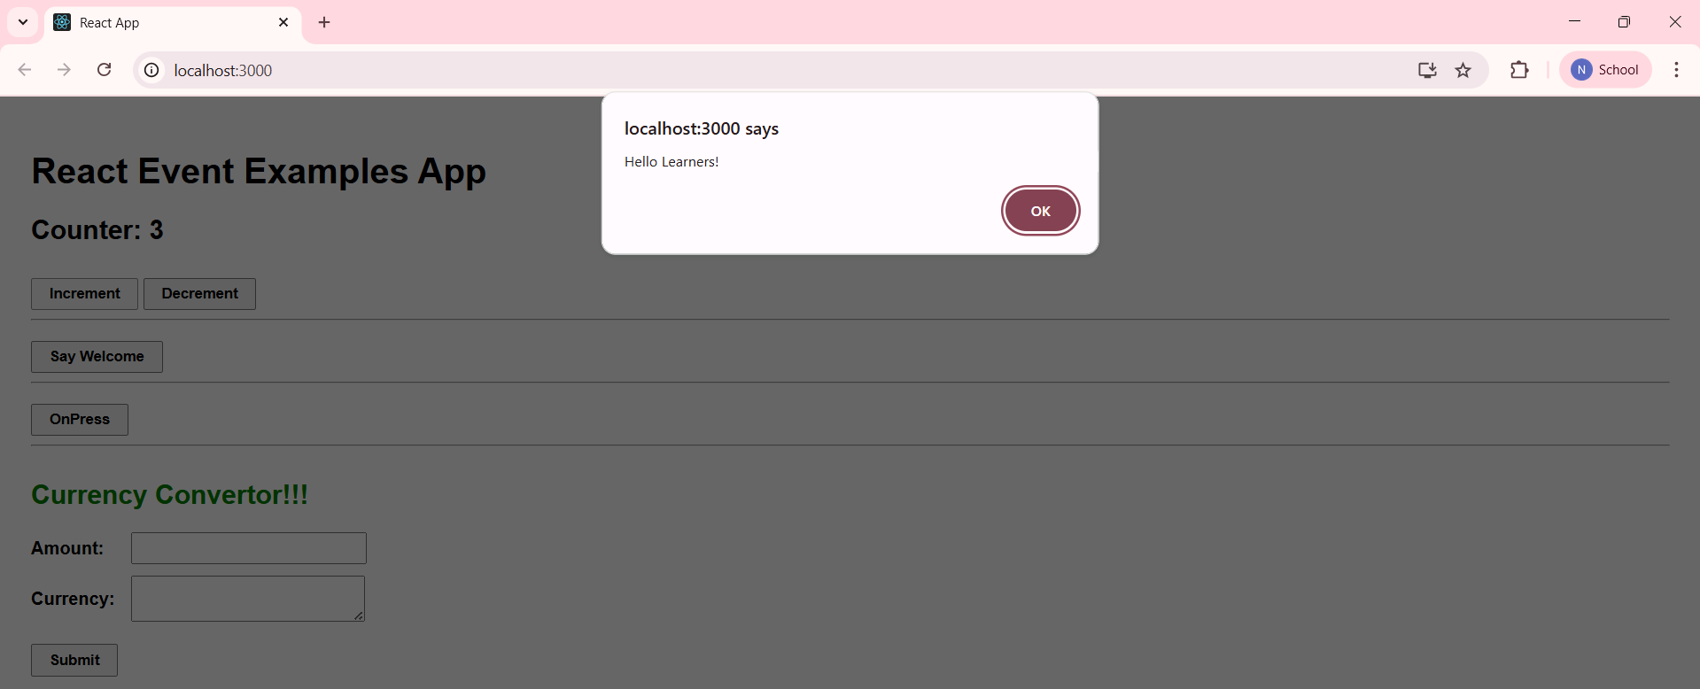

2. Clicking on “Say Welcome” button.

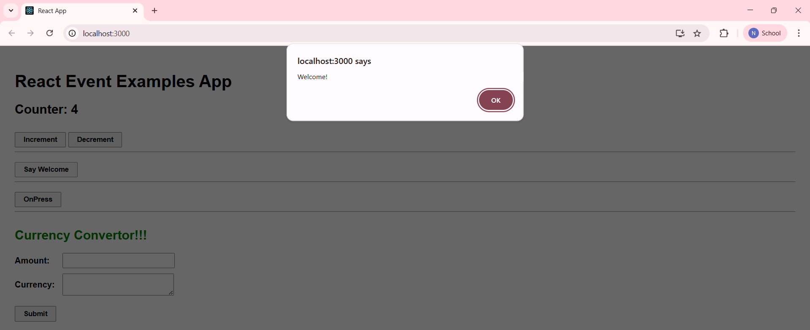

3. Clicking on “OnPress” button.

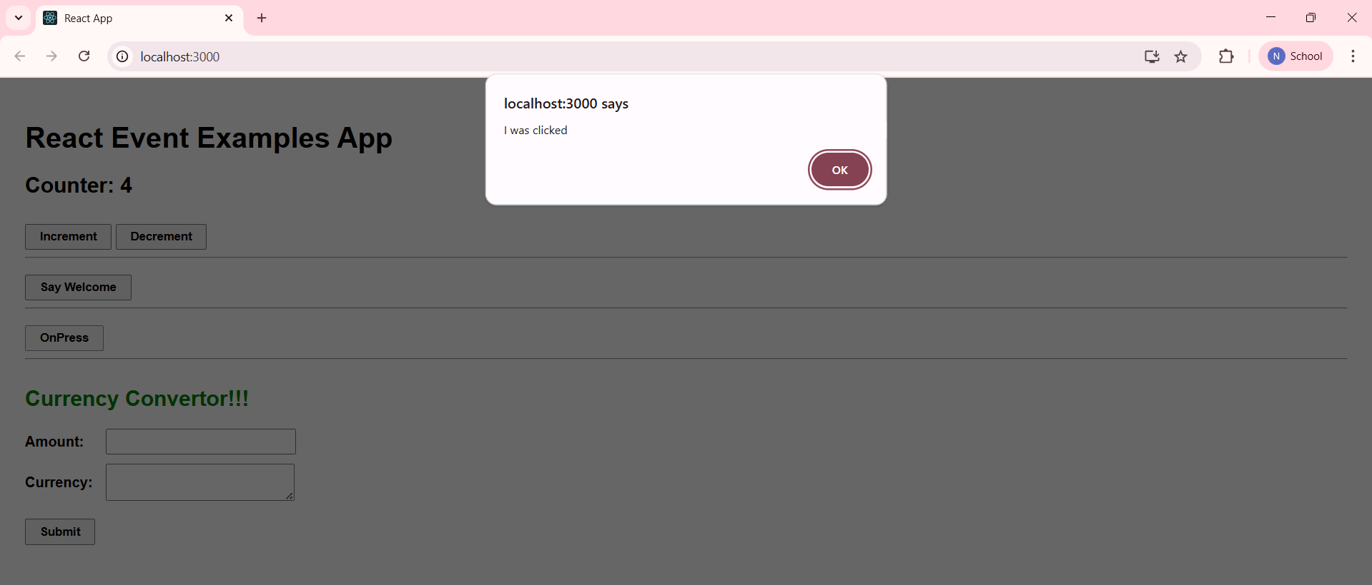

4. Converting from inr to euros in “CurrencyCoverter”

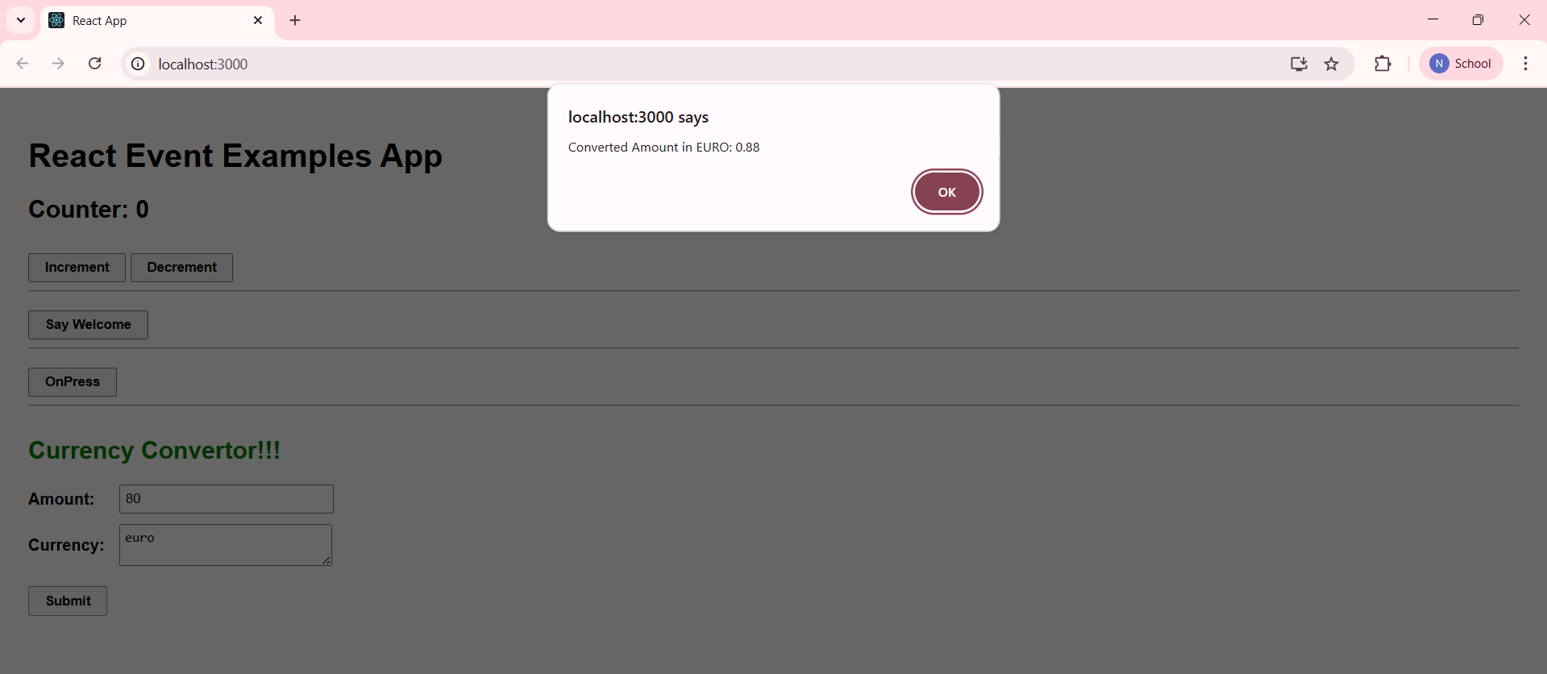

5. Converting from euros to inr in “CurrencyCoverter”

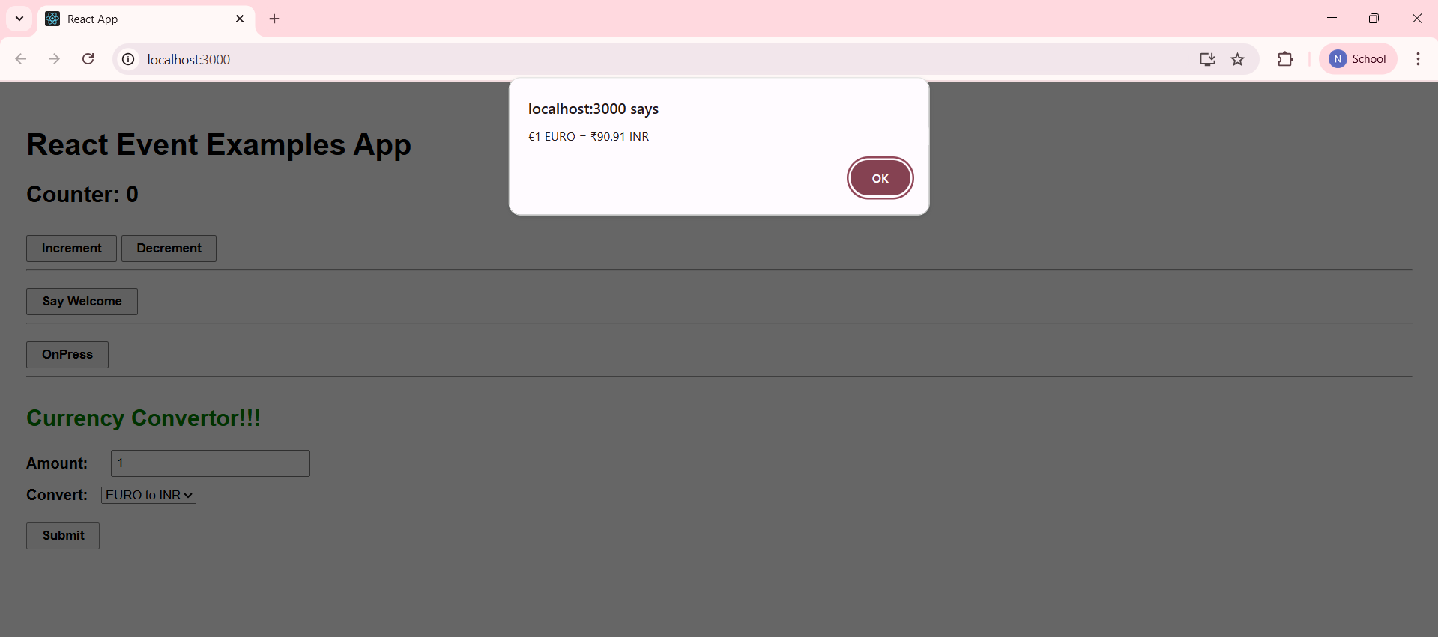

**12. REACTJS-HOL**

**Creating “ticketbookingapp”**

1.Create a React Application with the name of “ticketbookingapp”.

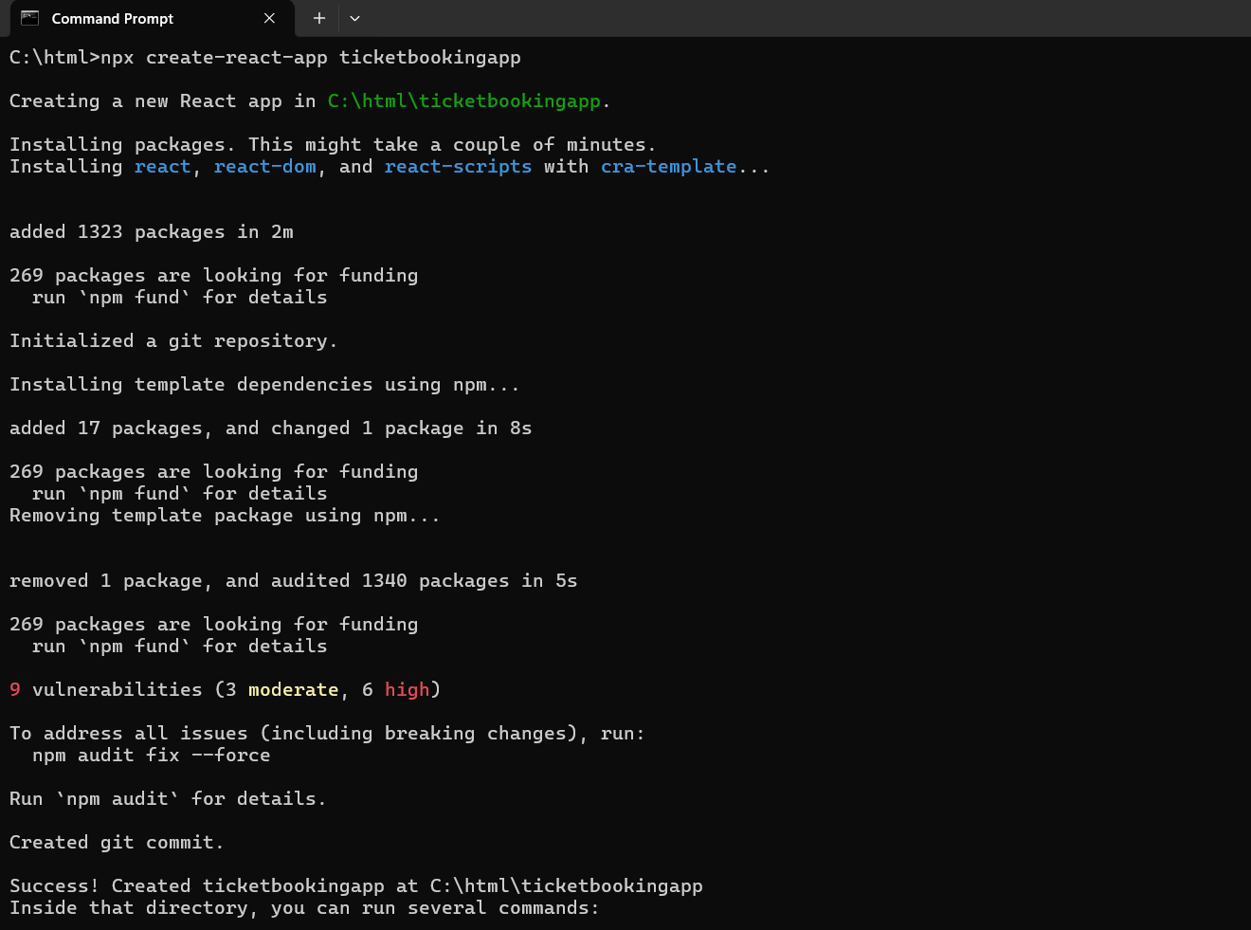

2. Once the App is created, navigate into the folder of ticketbookingapp.

3. Open the folder of ticketbookingapp in Visual Studio Code.

**App.js**

import React, { useState } from 'react';

import Guest from './Guest';

import User from './User';

function App() {

  const [isLoggedIn, setIsLoggedIn] = useState(false);

  const handleLogin = () => setIsLoggedIn(true);

  const handleLogout = () => setIsLoggedIn(false);

  return (

    <div className="App">

      {isLoggedIn ? (

        <User handleLogout={handleLogout} />

      ) : (

        <Guest handleLogin={handleLogin} />

      )}

    </div>

  );

}

export default App;

**Guest.js**

import React from 'react';

import FlightDetails from './FlightDetails';

function Guest({ handleLogin }) {

  return (

    <div>

      <h1>Welcome Guest</h1>

      <h6>{FlightDetails}</h6>

      <p>Please log in to book your flight tickets.</p>

      <button onClick={handleLogin}>Login</button>

    </div>

  );

}

export default Guest;

**User.js**

import React, { useState } from 'react';

function User({ handleLogout }) {

  const [name, setName] = useState('');

  const [flightId, setFlightId] = useState('');

  const handleBook = () => {

    if (!name || !flightId) {

      alert("Please fill in all fields");

      return;

    }

    alert(`Ticket Booked!\nName: ${name}\nFlight ID: ${flightId}`);

    setName('');

    setFlightId('');

  };

  return (

    <div>

      <h1>Welcome back</h1>

      <h3>Book Your Ticket</h3>

      <div>

        <label>Name: </label>

        <input value={name} onChange={e => setName(e.target.value)} />

      </div>

      <div>

        <label>Flight ID: </label>

        <input value={flightId} onChange={e => setFlightId(e.target.value)} />

      </div>

      <br />

      <button onClick={handleBook}>Book Now</button>

      <br /><br />

      <button onClick={handleLogout}>Logout</button>

    </div>

  );

}

export default User;

4. Run the following command to execute the React application.

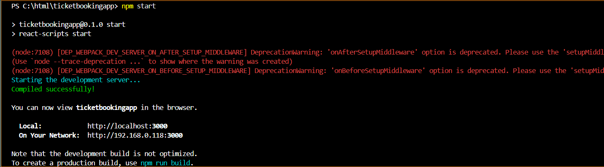

**OUTPUT:**

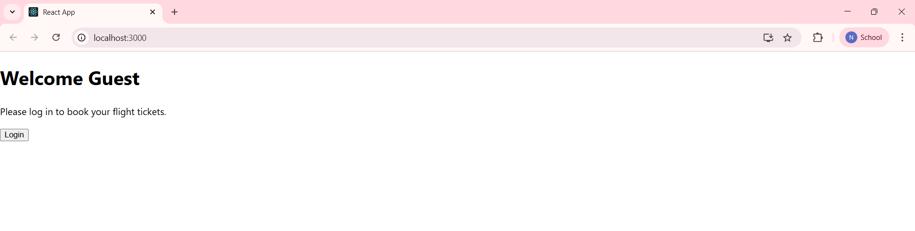

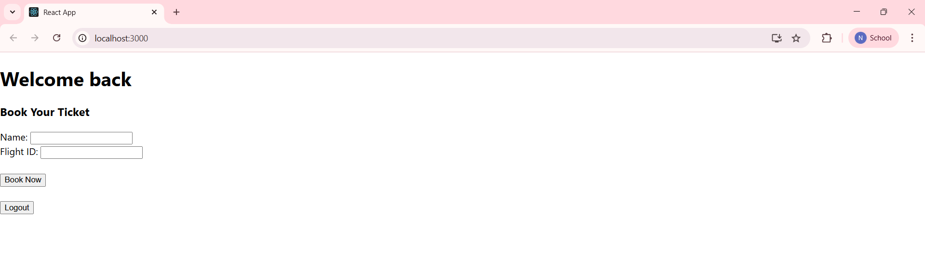

**13. REACTJS-HOL**

**Creating “bloggerapp”**

1. Create a React Application with the name of “bloggerapp”.

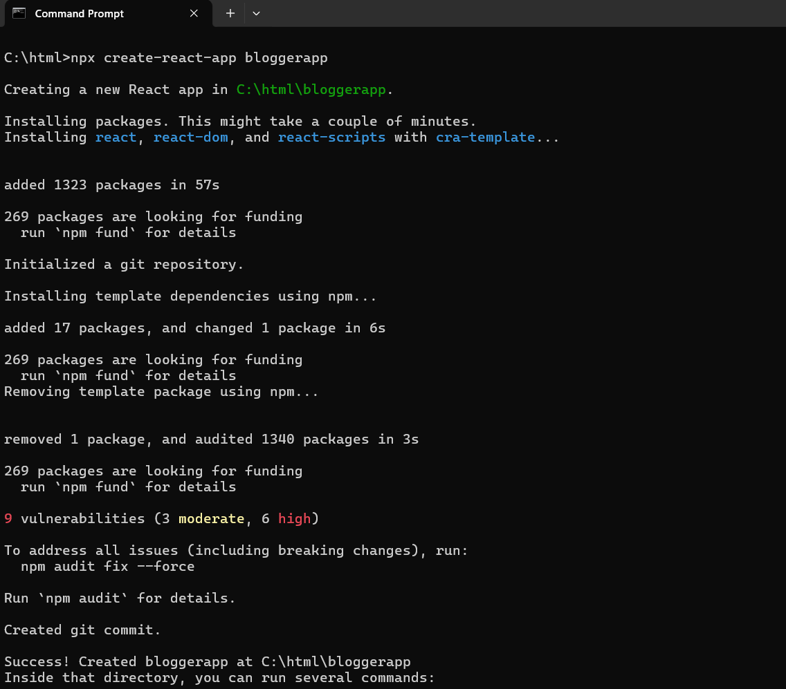

2. Once the App is created, navigate into the folder of bloggerapp.

3. Open the folder of bloggerapp in Visual Studio Code.

4. Create a folder named ‘components’ in src folder and create the components named BlogDetails.js, BookDetails.js, CourseDetails.js.

**BlogDetails.js**

import React from "react";

function BlogDetails() {

  const blogs = [

    { title: "React Learning", author: "Stephen Biz", content: "Welcome to learning React!" },

    { title: "Installation", author: "Schwazenbier", content: "You can install React from npm." },

  ];

  return (

    <div className="card">

      <h2>Blog Details</h2>

      {blogs.length ? (

        blogs.map((blog, index) => (

          <div key={index}>

            <p><strong>{blog.title}</strong></p>

            <p>{blog.author}</p>

            <p>{blog.content}</p>

          </div>

        ))

      ) : (

        <p>No Blogs Found</p>

      )}

    </div>

  );

}

export default BlogDetails;

**BookDetails.js**

import React from "react";

function BookDetails() {

  const books = [

    { title: "Master React", price: 670 },

    { title: "Deep Dive into Angular 11", price: 800 },

    { title: "Mongo Essentials", price: 450 },

  ];

  return (

    <div className="card">

      <h2>Book Details</h2>

      {books.length > 0 ? (

        books.map((book, index) => (

          <div key={index}>

            <p><strong>{book.title}</strong></p>

            <p>{book.price}</p>

          </div>

        ))

      ) : (

        <p>No Books Found</p>

      )}

    </div>

  );

}

export default BookDetails;

**CourseDetails.js**

import React from "react";

function CourseDetails() {

  const courses = [

    { name: "Angular", date: "4/5/2021" },

    { name: "React", date: "6/13/2021" },

  ];

  return (

    <div className="card">

      <h2>Course Details</h2>

      {courses.length ? (

        courses.map((course, index) => (

          <div key={index}>

            <p><strong>{course.name}</strong></p>

            <p>{course.date}</p>

          </div>

        ))

      ) : (

        <p>No Courses Found</p>

      )}

    </div>

  );

}

export default CourseDetails;

**App.js**

import React from "react";

import CourseDetails from "./components/CourseDetails";

import BookDetails from "./components/BookDetails";

import BlogDetails from "./components/BlogDetails";

import "./App.css";

function App() {

  return (

    <div className="container">

      <CourseDetails />

      <BookDetails />

      <BlogDetails />

    </div>

  );

}

export default App;

5. Run the following command to execute the React application.

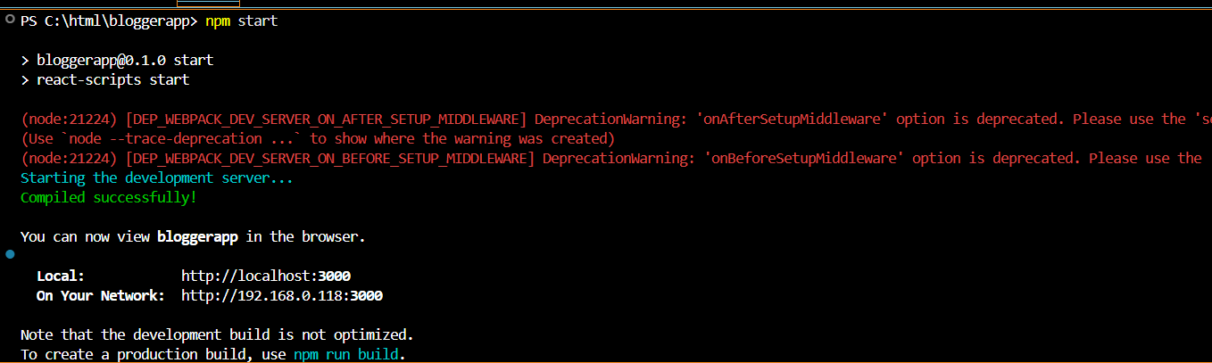

**OUTPUT:**

