Part A – NumPy

Question: 1
Create a NumPy array containing the integers from 1 to 20. Perform the following operations:
1. Display the array.
2. Find the shape of the array.
3. Find the maximum and minimum values.
4. Calculate the mean and standard deviation.
5. Reshape the array into a 4 × 5 matrix.
6. Display the second row of the matrix.
7. Display the third column of the matrix.

Code:
import numpy as np
arr = np.arange(1,21)
print(arr)
print("\nShape of the array is: ")
print(arr.shape)
print("\nMaximum value: ",arr.max())
print("\nMinimum value: ",arr.min())
sum = 0
for i in range(len(arr)):
sum = sum+arr[i]
mean = sum/len(arr)
print("\nMean: ",mean)
print("\nStandard drviation: ",np.std(arr))
re_shape = arr.reshape(4,5)
print("\nReshaped array: ",re_shape)
print("\nSecond row: ")
print(re_shape[1])
print("\nThird column: ")
print(re_shape[:,2])
Output:

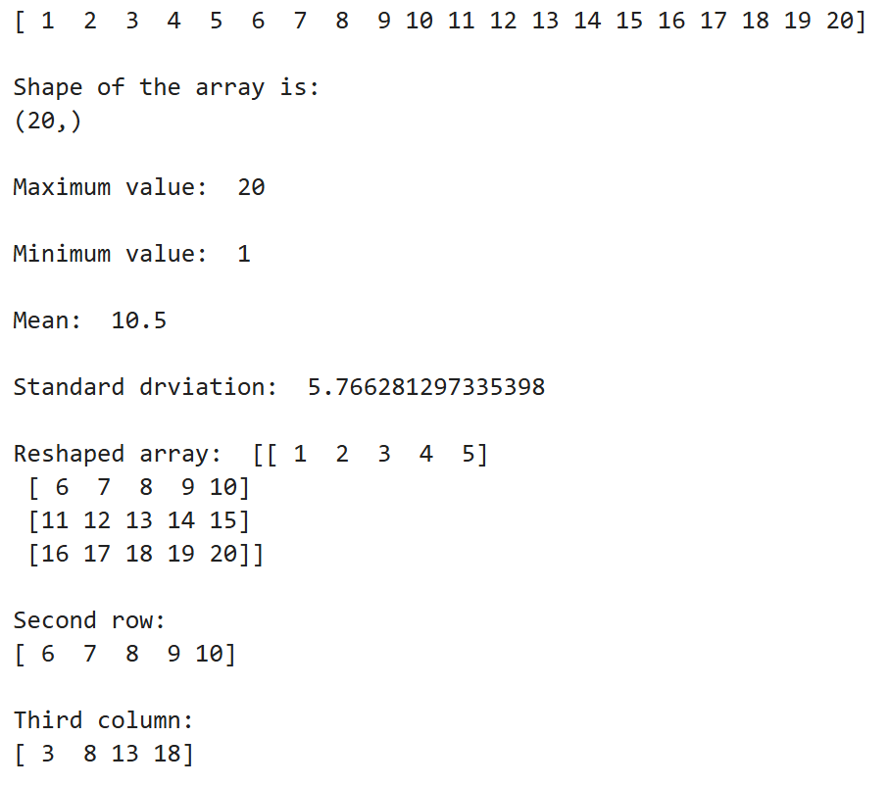

Question: 2
Create two NumPy arrays: A = [10, 20, 30, 40, 50] B = [5, 10, 15, 20, 25] Perform:
1. Addition of A and B.
2. Subtraction of B from A.
3. Element-wise multiplication.
4. Element-wise division.
5. Find the sum of all elements in A.
Code:
import numpy as np
A = np.arange(10,60,10)
B = np.arange(5,30,5)
print("\nAddition of A, B is: ")
print(A+B)
print("\nSubtraction of B from A is: ")
print(A-B)
print("\nElement-wise multiplication: ",A*B)
print("\nElement-wise devision: ",A/B)
sum = 0
for i in range(len(A)):
sum += A[i]
print("\nSum of all elements: ",sum)
Output:
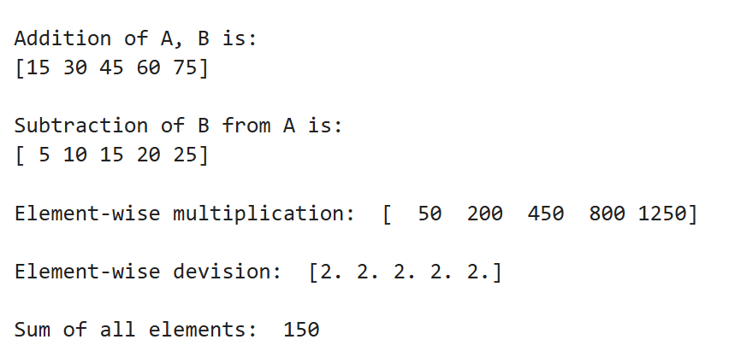

Part B – Pandas

Question: 3
Create a DataFrame using the following student data: Roll No Name Marks 101 102 103 104 105 Ravi 85 Priya 92 Kiran 78 Anu 88 Sita 95 Perform the following operations:
1. Display the DataFrame.
2. Display the first three records.
3. Find the average marks.
4. Find the student with the highest marks.
5. Find the student with the lowest marks.
6. Add a new column called "Grade" using:
o A for Marks ≥ 90
o B for Marks between 80 and 89
o C for Marks < 80
Code:
import pandas as pd
data = {
'Roll No' : [101, 102, 103, 104, 105],
'Name' : ['Ravi', 'Priya', 'Kiran', 'Anu', 'Sita'],
'Marks' : [85, 92, 78, 88, 95]
}
df = pd.DataFrame(data)
print("DataFrame: ")
print(df)
print("\nFirst three records are: ")
print(df.head(3))
print("\nAverage Marks are: ")
avg = df["Marks"].mean()
print(avg)
max = df.loc[df["Marks"].idxmax()]
print("\nStudent with highest marks: \n",max)
min = df.loc[df["Marks"].idxmin()]
print("\nStudent with lowest marks: \n",min)
def grade(marks):
if marks >= 90:
return "O"
elif marks >= 75:
return "A"
else:
return "B"
df["Grade"] = df["Marks"].apply(grade)
print("\nDataFrame with Grade column: \n",df)
Output:
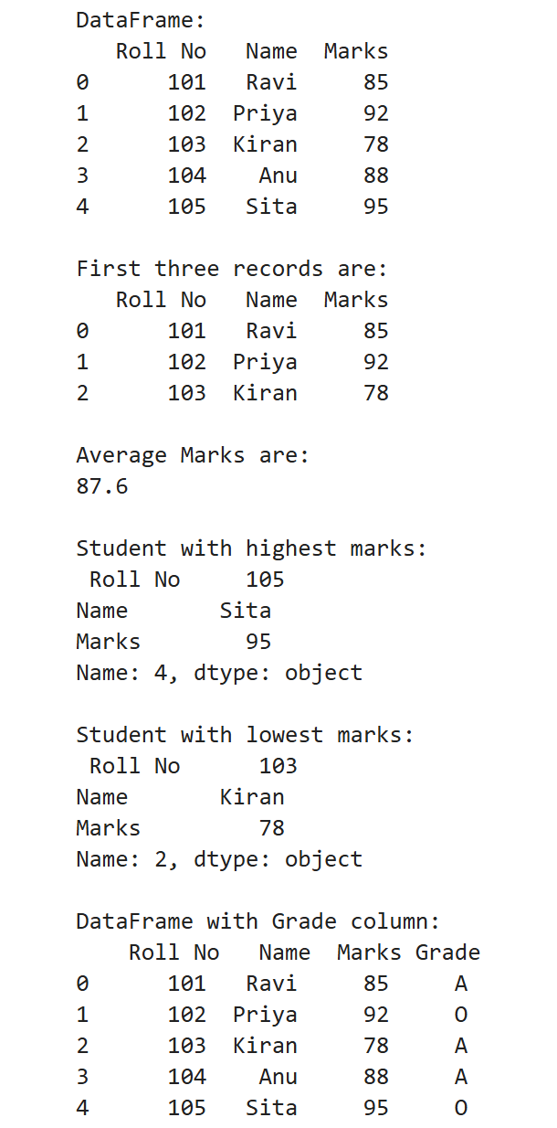

Question: 4
Create a DataFrame containing the following information: Product Price Quantity Laptop 50000 10 Mouse 500 50 Keyboard 1200 30 Monitor 10000 15 Perform:
1. Calculate the total value of each product using: Total Value = Price × Quantity
2. Add the Total Value column.
3. Find the product with the highest total value.
4. Calculate the overall inventory value.
Code:
import pandas as pd
data = {
'Product' : ['Laptop', 'Mouse', 'Keyboard', 'Monitor'],
'Price' : [50000, 500, 1200, 10000],
'Quantity' : [10, 50, 30, 15]
}
df = pd.DataFrame(data)
print("Dataframe: \n",df)
total_value = []
for i in range(len(df)):
c = df["Price"][i]*df["Quantity"][i]
total_value.append(c)
print("\nTotal value is: \n",total_value)
df["Total value"] = df["Price"]*df["Quantity"]
print("\nDataFrame with total value column: \n",df)
max = df.loc[df["Total value"].idxmax()]
print("\nProduct with highest total value: \n",max)
inventory_value = df["Total value"].sum()
print("\nOverall inventory value: ",inventory_value)
Output:
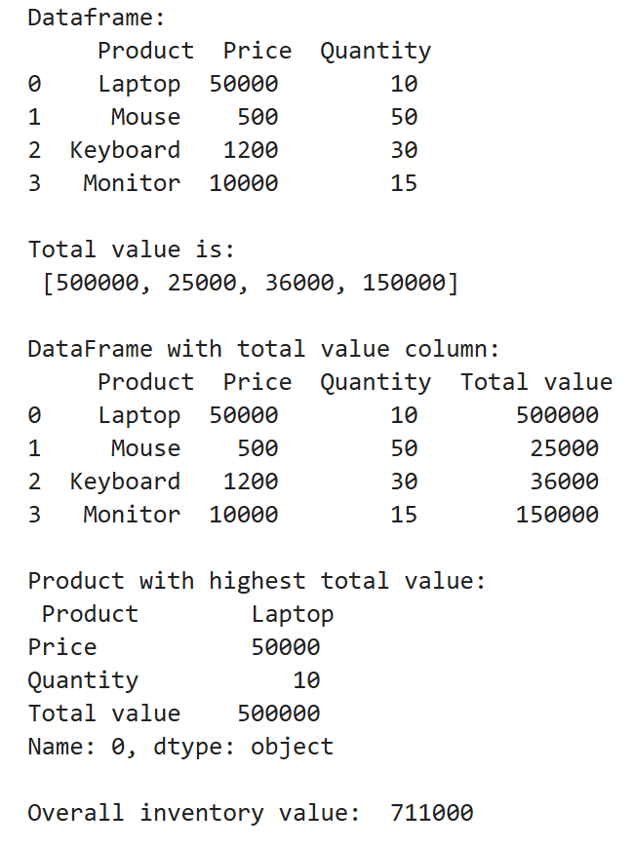
Part C – Dataset Exploration

Question: 5
Download the Iris dataset from Scikit-learn and perform the following:
1. Load the dataset into a Pandas DataFrame.
2. Display the first five records.
3. Find the number of rows and columns.
4. Display column names.
5. Check for missing values.
6. Generate summary statistics using describe().
7. Find the number of samples belonging to each class.
Code:
import pandas as pd
from sklearn.datasets import load_iris
iris = load_iris()
df = pd.DataFrame(iris.data, columns=iris.feature_names)
df['target'] = iris.target
print("First Five Records:")
print(df.head())
print("\nShape of Dataset:")
print(df.shape)
print("\nColumn Names:")
print(df.columns)
print("\nMissing Values:")
print(df.isnull().sum())
print("\nSummary Statistics:")
print(df.describe())
print("\nSamples in Each Class:")
print(df['target'].value_counts())
print("\nClass Names:")
for i, name in enumerate(iris.target_names):
print(f"{i}: {name}")
Output:

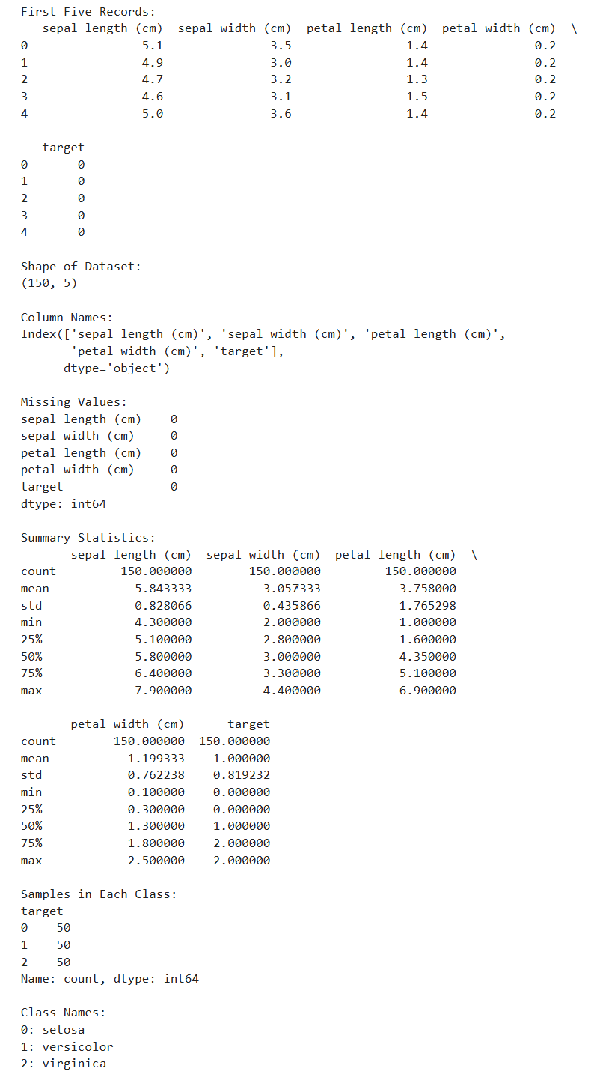

Week-2:
Aim: To perform exploratory data analysis (EDA) on a student performance dataset using Pandas and Matplotlib. Dataset Create a CSV file named student_data.csv with the following data:
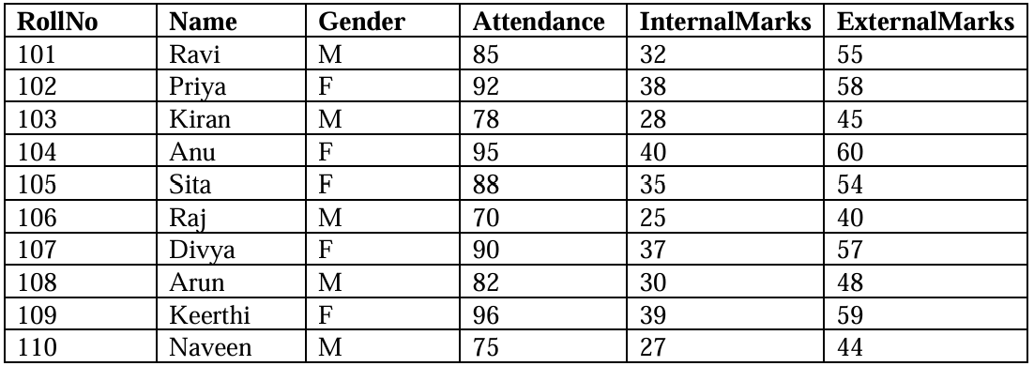
Tasks
Task A: Dataset Loading and Inspection
• Import the necessary Python libraries.
• Load the dataset into a Pandas DataFrame.
• Display the first five records.
• Display the last five records.
• Find the total number of rows and columns.
• Display the names of all columns.
• Display the data type of each column.
• Generate dataset information using info().
Code:
import pandas as pd
import matplotlib.pyplot as plt
df = pd.read_csv('student_data.csv')
print(df)
print("\nFirst five records: \n",df.head(5))
print("\nLast five records: \n",df.tail(5))
print("\nTotal number of rows and columns: ",df.shape)
print("\nNames of all columns: \n",df.columns)
print("\nData type of each column: \n",df.dtypes)
print("\nDataset Information: \n")
df.info()

Output:
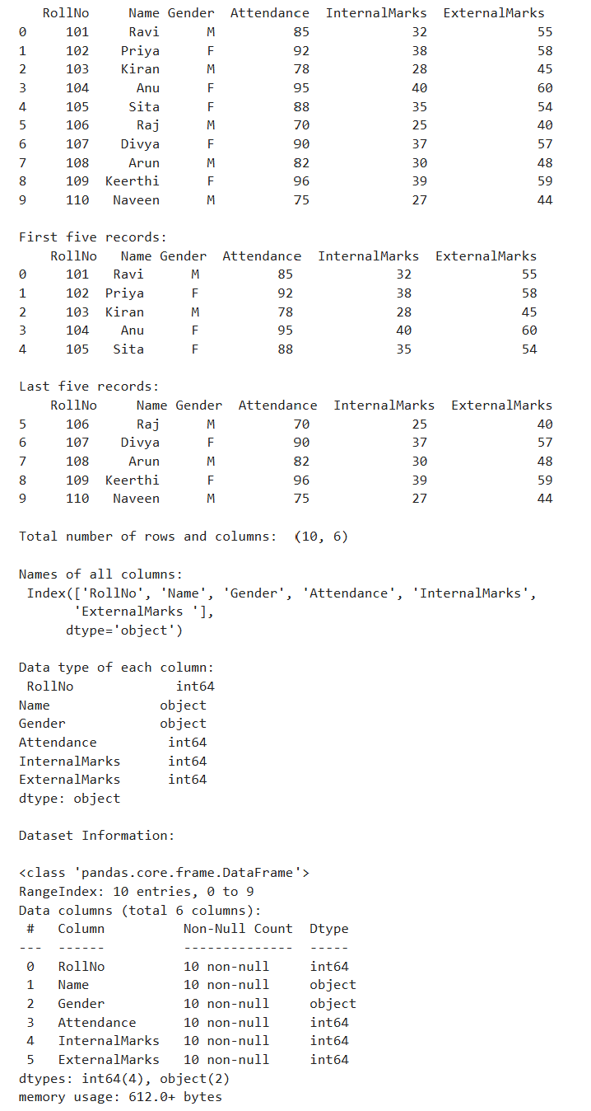

Task B: Statistical Analysis
• Calculate the mean attendance of all students.
• Calculate the average Internal Marks.
• Calculate the average External Marks.
• Find the maximum Internal Marks.
• Find the minimum Internal Marks.
• Find the maximum External Marks.
• Find the minimum External Marks.
• Calculate the standard deviation of Internal Marks.
• Generate summary statistics using describe().

Code:
import pandas as pd
import numpy as np
df = pd.read_csv('student_data.csv')
print("Mean Attendance: ", df['Attendance'].mean())
print("Avg Internal Marks: ", df['InternalMarks'].mean())
print("Max Internal Marks: ", df['InternalMarks'].max())
print("Min Internal Marks: ", df['InternalMarks'].min())
print("Max External Marks: ", df['ExternalMarks'].max())
print("Min External Marks: ", df['ExternalMarks'].min())
print("Avg External Marks: ", df['ExternalMarks'].mean())
print("SD of Internal Marks: ", np.sqrt(df['InternalMarks'].std()))

print("\nSummary Statistics: ", df.describe())
Output:
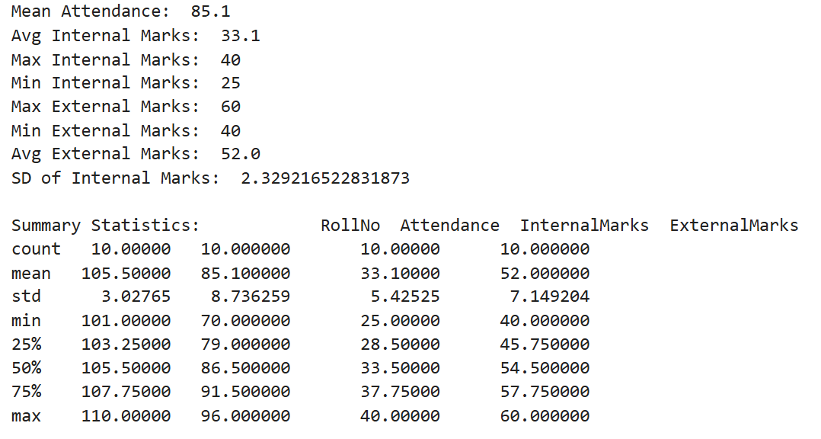
Task C: Data Manipulation
• Create a new column named TotalMarks.
• TotalMarks=InternalMarks+ExternalMarks
• Create a new column named Percentage. 1. Percentage=TotalMarks/100×100
• Display the updated DataFrame.
Code:
import pandas as pd
df = pd.read_csv('student_data.csv')
df['Total Marks'] = df['InternalMarks'] + df['ExternalMarks']
print(df.to_string())
df['Percentage'] = (df['Total Marks'] / 100) * 100
print(df.to_string())
df.to_csv('new_student_data.csv', index=False)
Output:
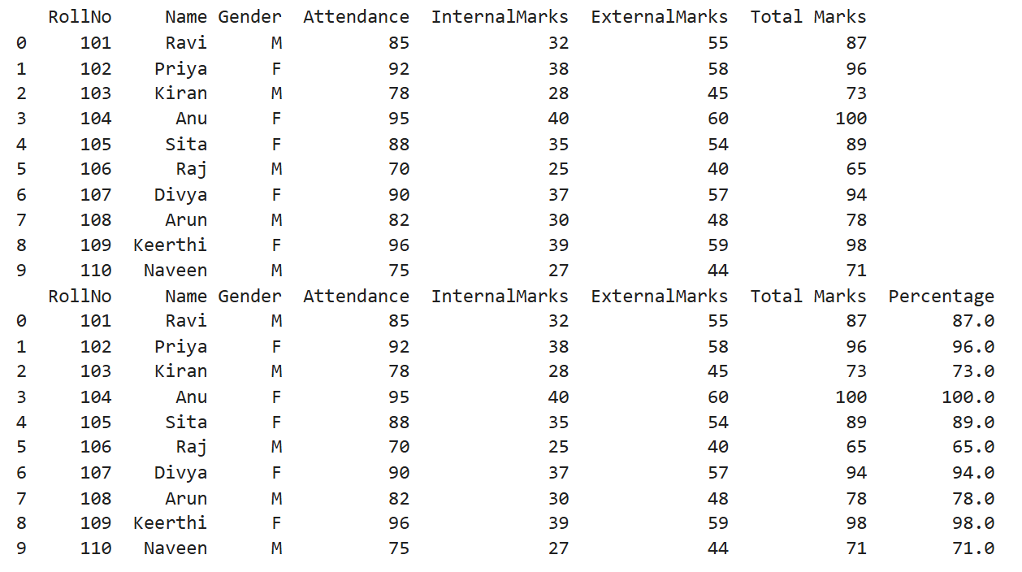
Task D: Filtering and Searching
• Display the details of students whose attendance is greater than 90%.
• Display the details of students whose TotalMarks exceed 90.
• Display the details of female students.
• Display the details of male students.
• Display students whose ExternalMarks are less than 50.
Code:
import pandas as pd
df = pd.read_csv('new_student_data.csv')
print("Students having attendence greater than 90 details: \n", df[df['Attendance'] > 90].to_string())
#print(df[df['Attendance'] > 90]['Name'])
print("Students having Total Marks greater than 90 details: \n", df[df['Total Marks'] > 90].to_string())
# df.loc[condition, 'Name']
#df[condition]['Name']
print("Female Students details: \n", df[df['Gender'] == ' F']['Name'].tolist())
print("Male Students details: \n", df[df['Gender'] == ' M']['Name'].tolist())
print("Students having External Marks less than 50 details: \n", df[df['ExternalMarks'] < 50].to_string())
Output:
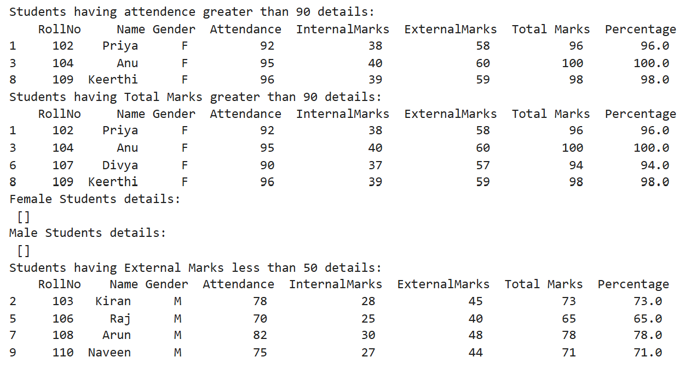
Task E: Ranking and Comparison
• Identify the student with the highest TotalMarks.
• Identify the student with the lowest TotalMarks.
• Display the top three performers based on TotalMarks.
• Display the bottom three performers based on TotalMarks.
• Determine how many students scored above the class average.
Code:
import pandas as pd
df = pd.read_csv('new_student_data.csv')
print("Student having the max marks: ", df.loc[df['Total Marks'].idxmax()]['Name'])
print("Student having the min marks: ", df.loc[df['Total Marks'].idxmin()]['Name'])
print("Top 3 students based on Total Marks: \n", df.nlargest(3, 'Total Marks').to_string())
print("Bottom 3 students based on Total Marks: \n", df.nsmallest(3, 'Total Marks').to_string())
print("Number of people above average marks: ", len(df[df['Total Marks'] > df['Total Marks'].mean()]))
Output:
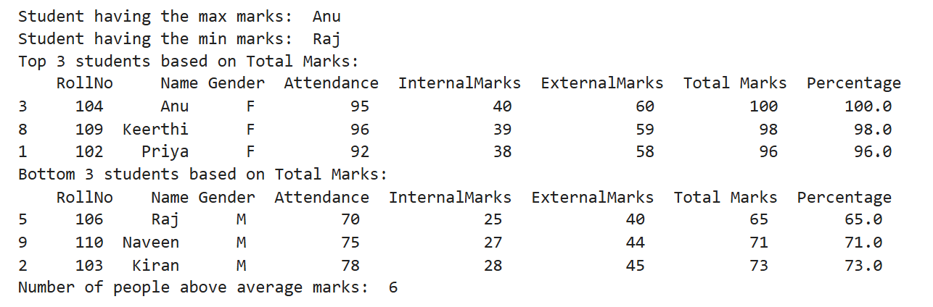

Task F: Group-wise Analysis
• Calculate the average TotalMarks of male students.
• Calculate the average TotalMarks of female students.
• Compare the average attendance of male and female students.
Code:
import pandas as pd
df = pd.read_csv('new_student_data.csv')
print("Average total marks for Males: ", df[df['Gender'] == ' M']['Total Marks'].mean())
print("Average total marks for Females: ", df[df['Gender'] == ' F']['Total Marks'].mean())
print("Average Attendance: ", df['Attendance'].mean())
Output:
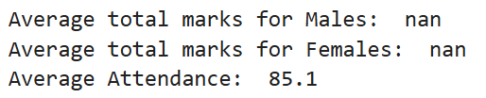
Task G: Data Visualization
• Plot a bar chart showing TotalMarks of all students.
• Plot a histogram of Attendance.
• Plot a pie chart showing the distribution of male and female students.
• Plot a scatter plot between Attendance and TotalMarks.
• Interpret the relationship between Attendance and TotalMarks.
Code:
import pandas as pd
import matplotlib.pyplot as plt
df = pd.read_csv('new_student_data.csv')
plt.figure(figsize=(8,5))
plt.bar(df['Name'], df['Total Marks'])
plt.show()
plt.hist(df['Attendance'])
plt.xlabel("Attendance")
plt.ylabel("Number of Students")
plt.show()
#x = [len(df[df['Gender'] == ' M']), len(df[df['Gender'] == ' F'])]
x = df["Gender"].value_counts()
plt.pie(x, labels=x.index)
plt.show()
plt.scatter(df['Attendance'], df['Total Marks'])
plt.xlabel('Attendance')
plt.ylabel('Total Marks')
plt.show()
Output:
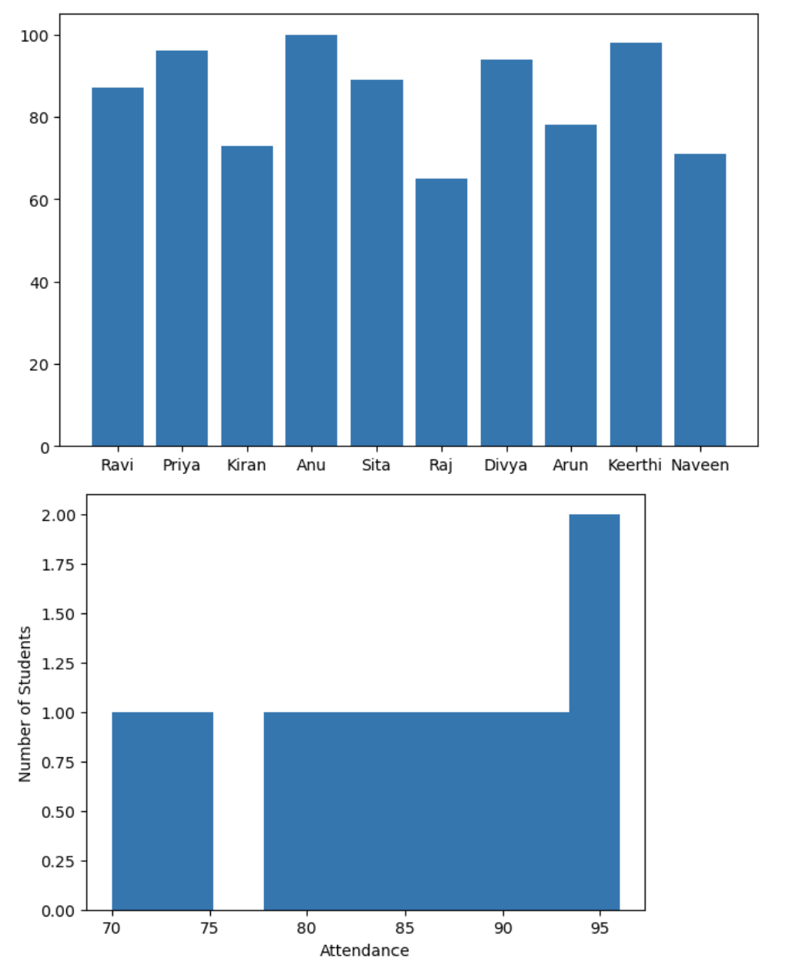
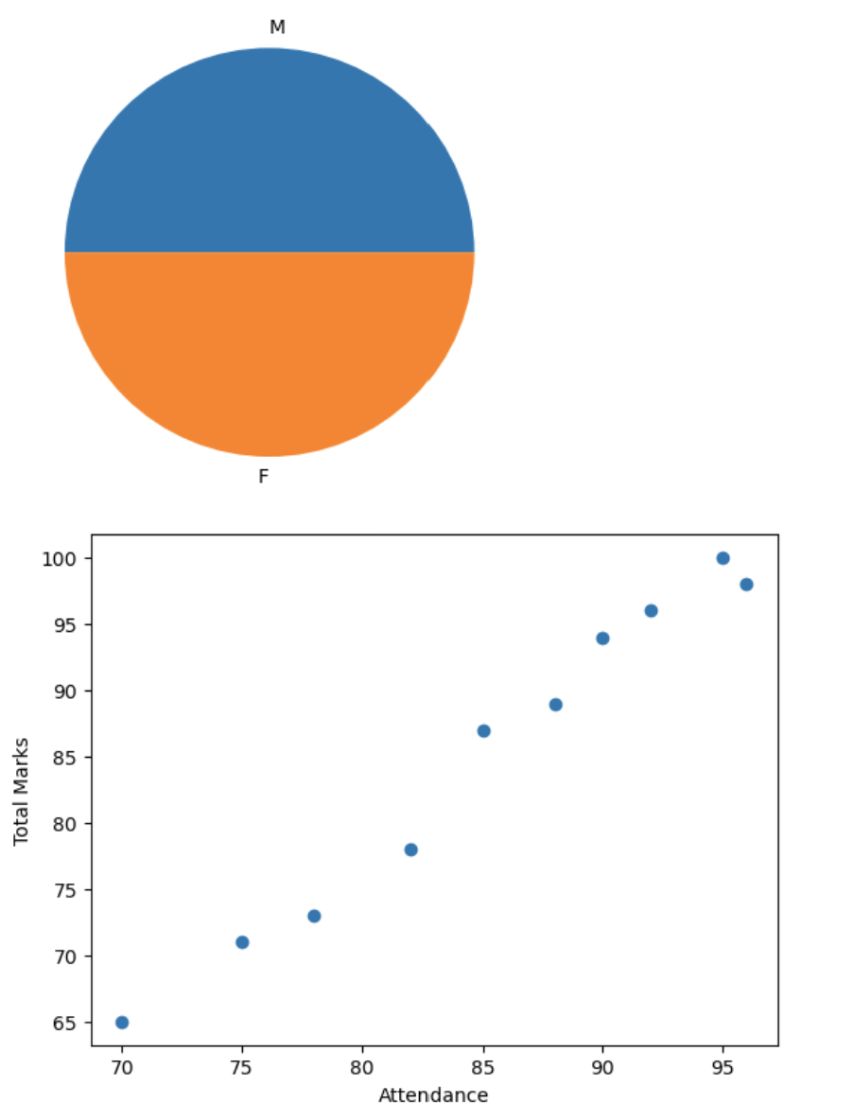
Task H: Observations
• Write any three observations based on the analysis performed.
• State whether higher attendance appears to be associated with better academic performance.
Answers:
1)
1. The average attendance of the students is 85.1%, indicating that most students have good attendance.
2. The highest Internal Marks are 40 and the highest External Marks are 60, while the lowest Internal Marks are 25 and the lowest External Marks are 40.
3. Students who scored higher in Internal Marks generally also obtained higher Total Marks, showing consistent academic performance.

2)
Relationship between Attendance and Academic Performance
Yes. The analysis suggests that higher attendance appears to be associated with better academic performance. Students with attendance above 90% (such as Anu and Keerthi) have higher Total Marks compared to students with lower attendance (such as Raj and Naveen). Although this dataset is small, it indicates a positive relationship between attendance and academic performance.

