#### NORMALIZATION:

Let us consider the following database schema. As you can see in Fig 1, there are four tables (Existing Database) -Projects, Employees, Project Employees, and Job Orders. Recently, the Customers table has also been added to the database to store the customers' information. As you can see in the diagram below, the Customers table has not been designed in a proper way to support the normal forms, let's go ahead and fix it.

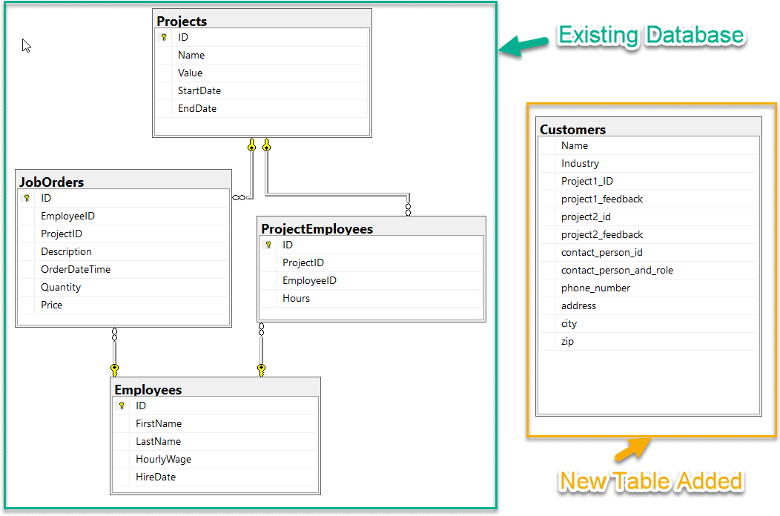

CREATE TABLE Projects(

[ID]INT PRIMARY KEY IDENTITY, [Name] VARCHAR(100),

[Value]DECIMAL(5,2),

StartDate DATE, EndDate DATE

) GO

CREATE TABLE Employees(

[ID]INT PRIMARY KEY IDENTITY,

[FirstName]VARCHAR(50), [LastName] VARCHAR(50),

[HourlyWage]DECIMAL(5,2), [HireDate] DATE

) GO

CREATE TABLE ProjectEmployees( [ID]INT PRIMARY KEY IDENTITY,

[ProjectID] INT, [EmployeeID] INT, [Hours]DECIMAL(5,2),

CONSTRAINT FK_ProjectEmployees_Projects FOREIGN KEY([ProjectID]) REFERENCES[Projects] ([ID]),

CONSTRAINT FK_ProjectEmployees_Employees FOREIGN KEY([EmployeeID]) REFERENCES[Employees] ([ID])

) GO

CREATE TABLE JobOrders(

[ID]INT PRIMARY KEY IDENTITY,

[EmployeeID] INT, [ProjectID] INT, [Description] TEXT, [OrderDateTime]DATETIME, [Quantity] INT,

[Price]DECIMAL(5,2),

CONSTRAINT FK_JobOrders_Projects FOREIGN KEY([ProjectID])REFERENCES [Projects] ([ID]),

CONSTRAINT FK_JobOrders_Employees FOREIGN KEY([EmployeeID])REFERENCES [Employees] ([ID])

) GO

CREATETABLE Customers( [Name]VARCHAR(100),

[Industry] VARCHAR(100), [Project1_ID] INT, [Project1_Feedback]TEXT, [Project2_ID] INT,

[Project2_Feedback] TEXT, [ContactPersonID] INT, [ContactPersonAndRole]VARCHAR(255), [PhoneNumber]VARCHAR(12),[Address] VARCHAR(255),

[City]VARCHAR(255), [Zip] VARCHAR(5)

)

GO

OUTPUT: