**RESTUARENT WEBSITE**

Submitted in partial fulfilment of the requirements for the award of Degree of

**Bachelor of Technology**

**Computer Science & Engineering**

**Lovely Professional University**

**PHAGWARA, PUNJAB**



**Submitted To: Dr. Karthick Panneerselvam**

**Submitted By:** Chaitanya Pavuluri

**Registration No:** 12103286

**Subject Code:** INT-219

**TABLE OF CONTENT**

# ● Introduction

* **Purpose**
* **Scope**
* **Definitions & Abbreviation**
* **Overview**

# ● General Description

* **Product Perspective**
* **Product Functions**
* **User Characteristics**
* **General Constraints**
* **Assumptions & Dependencies**

# ● Specification

* **User Interface Requirements**
* **Functional Requirements**
* **Non-Functional Requirements**

# ● Additional Details

* **Design Considerations**
* **Legal & Compliance**
* **Data Security**
* **User Account Features**

**● Change Management**

● **Conclusion**

**1. Introduction**

In an era marked by digital transformation, establishing a robust online presence has become paramount for businesses across various industries. The culinary landscape is no exception, as restaurants seek innovative ways to engage with their patrons and enhance their dining experience. This project endeavours to address this need by introducing the "Food Restaurant Website" – a dynamic and feature-rich online platform tailored to the specific requirements of a modern gastronomic establishment.

## 1.1 Purpose

The primary objective of the Food Restaurant Website is to create a seamless bridge between the restaurant and its customers in the digital realm. By harnessing the power of cutting-edge web technologies, this platform aims to redefine the way patrons interact with the restaurant's offerings. From perusing an enticing menu to reserving a table for an upcoming special occasion or conveniently placing an order for takeout or delivery, this website endeavours to streamline every facet of the dining experience.

## Scope

This project encompasses a comprehensive range of activities, including meticulous requirement analysis, intuitive UI/UX design, robust back-end development, rigorous testing, and seamless deployment. The website will be optimized for various devices, ensuring a consistent and engaging experience across desktops, tablets, and mobile phones. Additionally, it will integrate with existing restaurant systems for efficient order management and reservation handling.

## 1.3 Definitions, Acronyms, and Abbreviations

* **Menu Item**: A specific dish, beverage, or culinary offering available at the restaurant.
* **CMS**: Content Management System, a platform for creating, editing, and managing digital content.
* **API**: Application Programming Interface, a set of protocols allowing different software applications to communicate with each other.
* **UX/UI**: User Experience/User Interface, the design and functionality aspects of the website that directly impact user interaction and satisfaction.
* **SEO**: Search Engine Optimization, the process of optimizing a website to rank higher in search engine results, increasing its visibility to potential customers.

**1.4 Overview:**

The Food Restaurant Website is poised to become the digital face of our restaurant, embodying our commitment to culinary excellence and customer satisfaction. Beyond being a mere virtual menu, it will be an interactive and intuitive platform that anticipates and fulfils the needs of our discerning clientele. From the moment a visitor lands on our homepage to the final click of the "Place Order" button, every interaction will be characterized by elegance, efficiency, and exceptional service.

**2. General Description:**

Our restaurant operates on a robust and scalable platform that ensures seamless operations. We utilize state-of-the-art kitchen equipment and technology to deliver high-quality food and service.

## 2.1 Product Perspective: -

Our product is not just the food, but the entire dining experience. We leverage technology to enhance this experience - from digital menus with real-time updates, to a sophisticated order management system that ensures timely and accurate order fulfilment.

## 2.2 Product Functions: -

Our restaurant’s functions are powered by a suite of software applications. These include a Point of Sale (POS) system for billing, an Inventory Management system for tracking ingredients, and a Customer Relationship Management (CRM) system for managing customer feedback and loyalty programs.

## 2.3 User Characteristics: -

Our users are both our customers who interact with our digital platforms and our staff who use our systems for daily operations. Our platforms are designed to be user-friendly and accessible, catering to a wide range of tech proficiency levels.

## 2.4 General Constraints: -

We operate within the constraints of data privacy laws and food safety regulations. Our systems are designed to be secure and compliant with these regulations. We also face constraints in terms of network reliability and speed, especially for our online ordering and delivery services.

## 2.5 Assumptions and Dependencies

Our operations depend heavily on the reliability of our tech infrastructure and the availability of electricity and internet connectivity. We assume that our users have access to internet-enabled devices to use our digital services.

**3. Specific Requirements**

## 3.1 User Interface Requirements

Our restaurant’s digital platforms, including the website and mobile app, are designed to be intuitive and user-friendly. They feature a clean layout, easy navigation, and high-quality images of our dishes. The platforms are also responsive, ensuring a seamless experience across different devices and screen sizes.

## 3.2 Functional Requirements

* [**Menu**: Having the menu available online lets the reader know what you are offering](https://www.w3schools.com/howto/howto_website_restaurant.asp).
* [**About the restaurant**: Give the reader a summary of the restaurant and its history](https://www.w3schools.com/howto/howto_website_restaurant.asp)..
* [**Contact us**: Let the reader know your location and how they can get in touch](https://www.w3schools.com/howto/howto_website_restaurant.asp).
* **Feedback System**: Our system should allow customers to provide feedback on their dining experience.

## 3.5 Non-Functional Requirements

* **Performance**: Our systems should be fast and responsive, even during peak hours.
* **Reliability**: Our systems should be reliable with minimal downtime.
* **Security**: Our systems should adhere to the highest standards of data security and privacy.
* **Scalability**: Our systems should be scalable to handle growth in customer base and menu expansion.

**4. Additional Details**

## 4.1 Design Considerations

Our digital platforms are designed with the user in mind. The interface is clean and intuitive, ensuring that users can easily navigate through the menu, place orders, make reservations, and provide feedback. We also ensure that our platforms are accessible to users with disabilities by adhering to web accessibility standards.

## 4.2 Legal and Compliance

The website should comply with all applicable laws and regulations, including those related to online commerce, privacy, and data protection.

## 4.3 Data Security

* User data, including personal and payment information, should be encrypted and stored securely.
* Payment processing must adhere to industry standards and employ secure encryption protocols.

## 4.4 User Account Features

* Future expansion might include user registration and login features.
* User accounts could store order history and address information for a more personalized shopping experience.

1. **Change Management** 
   * Changes to the SRS should be proposed, reviewed, and approved by the project stakeholders.
   * A version control system will be used to track changes and revisions to the document.

**References:**

MDN docs: Web technology for developers | MDN (mozilla.org)

Bootstrap: https://getbootstrap.com/docs/4.1/getting-started/introduction

1. **Conclusion**

The Software Requirements Specification (SRS) document provides a comprehensive and detailed overview of the E-Service project. Encompassing eight A4 pages, it delves into the project's functionality, design considerations, legal compliance, and potential avenues for future enhancements. This document serves as a foundational blueprint, outlining the core features and functionalities of the E-Shop platform.

In terms of functionality, the SRS meticulously outlines how the platform will operate, including features such as user registration, product browsing, secure payment processing, and order management. It also addresses the design considerations, ensuring an intuitive and user-friendly interface. The document emphasizes compliance with legal standards, covering aspects like data privacy, accessibility, and any relevant industry-specific regulations.

While the document spans eight pages, it's important to note that its length and level of detail can be further tailored to align precisely with the unique requirements of your project. Whether it involves additional functionalities, specific design preferences, or compliance with specific legal frameworks, the SRS is adaptable to suit your project's distinct needs. This flexibility ensures that the E-Service project can be developed and fine-tuned in a manner that best serves your business objectives and user base.

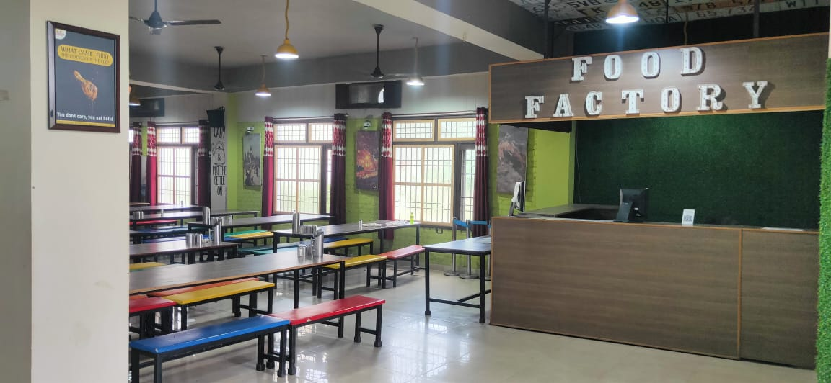

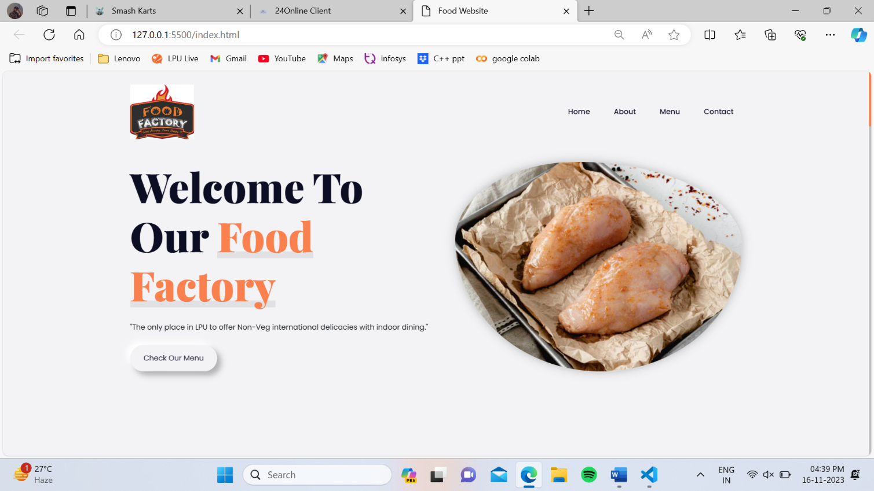

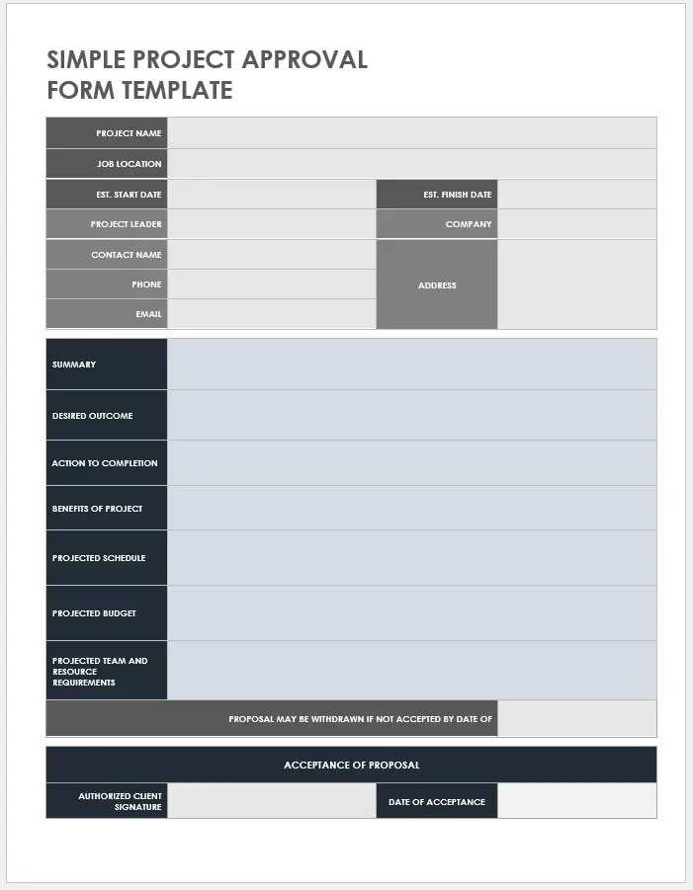

User-friendly South Indian tiffin's software web application booking

system and management for customers.

The Food Factory Web Application is an online platform that allows customers to explore and purchase a variety of non-veg items.

HTML, Bootstrap, CSS for styling, JavaScript.

The benefits of this web application include ordering efficiency,

enhanced customer experience and streamlined staff management.

The project is scheduled in September, and it has done in October by Chaitanya.

Chaitanya Pavuluri

null

02-11-2023

15-11-2023

Chaitanya

LPU

Lovely Professional

University, Grand

Trunk Road,

Phagwara

20-10-2023

11-09-2023

Lovely Professional University, Phagwara

Pchaitu62@gmail.com

9392463947

Chaitanya Pavuluri

Food Factory