Point Of Sale(POS)

A PROJECT REPORT

Submitted by

Yadav Ayush(216400316015)

Unhavne Marut(216400316016)

Shah Chaitya(216400316018)

In partial fulfilment for the award of the

# DIPLOMA ENGINEERING

in

Information Technology Department



R. C. Technical Institute, Ahmedabad

# Gujarat Technological University, Ahmedabad

May,2024

R. C. TECHNICAL INSTITUTE

# Opposite Gujarat High Court, S. G. Highway, Sola, Ahmedabad-380060

DEPARTMENT OF INFORMATION TECHNOLOGY

2022

# CERTIFICATE

This is to certify that Shah Chaitya(216400316018) has satisfactorily completed the project work entitled Contactless Ordering System assigned as UDP/IDP in partial fulfilment of Software Development(4361604) during 5th semester of academic year 2023-2024.

Internal guide Head of Department

Mr.Shashikant Sarvaiya Mr. Jaydip R. Mahida

Lecturer in IT Department IT Department

# Acknowledgement

We take this opportunity to express our profound gratitude and deep regards to our internal guide ***Mr. Shashikant Sarvaiya*** for his perfect guidance, monitoring and constant encouragement throughout the course of this project. The blessing, help and guidance given by his time to time shall carry us a long way in the journey of life on which we are about to embark.

We also take this opportunity to express a deep sense of gratitude to Mr. Jaydip R. Mahida H.O.D of Information Technology department for his cordial support, valuable information and guidance, which helped us in completing this task through various stages.

We are obliged to staff members of IT department, for the valuable information provided by them. We are grateful for their cooperation during the period of our project.

Lastly, we thank almighty, our parents, brother, sisters and friends for their constant encouragement without which this project work would not be possible.

# Abstract

A Point of Sale (POS) system is a cornerstone of modern business operations, particularly in retail and hospitality sectors. In a Flutter application, a comprehensive POS system encompasses an array of crucial functionalities.Firstly, it streamlines Transaction Management by allowing smooth item additions, applying discounts, managing quantities, and computing accurate totals. Secondly, it empowers businesses with robust Inventory Management, ensuring real-time tracking of stock levels, timely updates, and proactive alerts for low stock situations, thus optimizing inventory control.

The system's Payment Processing capabilities are versatile, supporting various payment methods such as cash, cards, and digital wallets. Integration with UPI QR code generation and scanning facilitates seamless digital transactions, enhancing customer convenience.Generating detailed Receipts is another vital aspect, providing customers with comprehensive payment records including itemized lists, prices, taxes, discounts, and UPI QR codes for digital payments. This transparency improves trust and customer satisfaction.

For efficient kitchen operations, the POS system includes Kitchen Order Ticket (KOT) Management, ensuring timely order processing and fulfillment. Moreover, it offers Reporting and Analytics tools for valuable insights into sales trends, revenue analysis, and employee performance, aiding strategic decision-making.Security is paramount, with User Authentication and role-based permissions ensuring data integrity and confidentiality. The system's scalability and customization options further enhance its adaptability to evolving business needs.

**Working of Contactless Ordering System:**

1. Users select items or services from a catalog or menu displayed on the POS interface.
2. The selected items are added to a virtual cart with details such as quantity, price, and any applicable discounts or promotions.
3. As items are added to the transaction, the system updates the inventory database in real-time to reflect the stock changes.
4. Once the transaction is finalized, the POS system processes payments using various methods like cash, credit/debit cards, mobile wallets, or digital payment platforms.
5. After successful payment, the system generates a detailed receipt for the customer, including itemized lists, prices, taxes, discounts, and payment method details.

Overall, a Flutter-based POS system optimizes business processes, enhances customer experiences, and facilitates informed decision-making, contributing significantly to business growth and success.By integrating these functionalities seamlessly, a POS system streamlines operations, improves accuracy, enhances customer experiences, and provides valuable data for business growth and decision-making.

List of Figures

Sr. No. Name of figures Page No.

|  |  |  |
| --- | --- | --- |
| 1 | E-R Diagram | 21 |
| 2 | Control Flow Graph for Chef | 23 |
| 3 | Control Flow Graph for Cashier | 24 |

List of Tables

Sr. No. Name of table Page No.

|  |  |  |
| --- | --- | --- |
| 1 | User Information | 22 |
| 2 | Generated Receipts | 22 |
| 3 | Products Data | 22 |

-

# Table of Contents

Acknowledgement i

Abstract ii

List of Figures iii

List of Tables iv

Table of contents v

|  |  |  |
| --- | --- | --- |
| **Chapter** | **Topic** | **Page No.** |
| 1 | Introduction | 6 |
| 2 | System Requireents Study | 11 |
| 3 | System Analysis | 13 |
| 4 | Implementattion Planning and  Details | 26 |
| 5 | Output | 30 |

**CHAPTER:1**

* 1. **PROJECT SUMMARY**

A Point of Sale (POS) system is a cornerstone of modern business operations, particularly in retail and hospitality sectors. In a Flutter application, a comprehensive POS system encompasses an array of crucial functionalities.A POS system streamlines the sales process, improves efficiency, enhances customer experience, and provides valuable data for business decision-making and growth.

Firstly, it streamlines Transaction Management by allowing smooth item additions, applying discounts, managing quantities, and computing accurate totals. Secondly, it empowers businesses with robust Inventory Management, ensuring real-time tracking of stock levels, timely updates, and proactive alerts for low stock situations, thus optimizing inventory control.

The system's Payment Processing capabilities are versatile, supporting various payment methods such as cash, cards, and digital wallets. Integration with UPI QR code generation and scanning facilitates seamless digital transactions, enhancing customer convenience.

Generating detailed Receipts is another vital aspect, providing customers with comprehensive payment records including itemized lists, prices, taxes, discounts, and UPI QR codes for digital payments. This transparency improves trust and customer satisfaction.

For efficient kitchen operations, the POS system includes Kitchen Order Ticket (KOT) Management, ensuring timely order processing and fulfillment. Moreover, it offers Reporting and Analytics tools for valuable insights into sales trends, revenue analysis, and employee performance, aiding strategic decision-making.Security is paramount, with User Authentication and role-based permissions ensuring data integrity and confidentiality.

The system's scalability and customization options further enhance its adaptability to evolving business needs.A Point of Sale (POS) system works by seamlessly integrating various components to facilitate efficient transactions, manage inventory, process payments, and enhance overall business operations.

Overall, a Flutter-based POS system optimizes business processes, enhances customer experiences, and facilitates informed decision-making, contributing significantly to business growth and success.

* 1. **PURPOSE OF POS**

**The primary purpose of a Point of Sale (POS) system is to facilitate smooth and efficient transactions between businesses and customers.**

The main reason is that it benefits the cashier/owner to generate new receipts and kot quickly and store and edit there products

The Key Purposes of POS are:

1. **Transaction Processing**: POS systems handle the process of item selection, pricing, and payment, ensuring accurate and secure transactions.
2. **Inventory Management**: POS systems track inventory levels in real-time, update stock quantities after each transaction, and provide insights into stock movement and reordering needs.
3. **Sales Reporting and Analytics**: POS systems generate reports and analytics on sales trends, best-selling items, revenue, and customer behavior, helping businesses make informed decisions and strategies.
4. **Customer Relationship Management (CRM)**: Some POS systems integrate CRM functionalities, allowing businesses to manage customer information, preferences, and loyalty programs for personalized interactions.
5. **Payment Processing**: POS systems support various payment methods, including cash, credit/debit cards, mobile wallets, and digital payments, providing convenience and flexibility to customers.
6. **Enhanced Efficiency**: By automating tasks like calculations, inventory updates, and reporting, POS systems improve operational efficiency and reduce human errors.
7. **Compliance and Security**: POS systems adhere to regulatory standards such as PCI DSS for payment security, ensuring that customer data is protected during transactions.
8. **Integration with Other Systems**: POS systems can integrate with accounting software, inventory management systems, eCommerce platforms, and more, streamlining overall business operations.

* 1. **OBJECTIVES OF POS**

The objectives of a Point of Sale (POS) system revolve around improving business efficiency, enhancing customer experience, and driving growth. Here are the key objectives of a POS system:

1. **Streamline Transactions:** Simplify the checkout process, reduce transaction times, and minimize errors in pricing and inventory management.
2. **Inventory Management:** Maintain accurate and real-time inventory records, optimize stock levels, and prevent stockouts or overstocking.
3. **Enhance Customer Service:** Provide a seamless and convenient shopping experience, offer multiple payment options, and facilitate quick and efficient customer service.
4. **Increase Sales:** Identify sales trends, analyze customer buying behavior, and implement targeted marketing strategies to boost sales and revenue.
5. **Improve Data Accuracy:** Ensure accurate recording of sales data, inventory levels, and customer information to support informed decision-making.
6. **Cost Control:** Monitor costs related to inventory, labor, and operations, identify inefficiencies, and implement cost-saving measures.
7. **Security and Compliance:** Ensure secure payment processing, protect customer data, and comply with industry regulations and standards such as PCI DSS.
8. **Reporting and Analytics:** Generate detailed reports and analytics on sales performance, inventory turnover, customer retention, and profitability to gain insights and make data-driven decisions.
9. **Integrate Business Processes:** Seamlessly integrate with other business systems such as accounting, CRM, and marketing tools to streamline workflows and improve overall efficiency.
10. **Support Business Growth:** Provide scalability to accommodate business expansion, adapt to changing needs, and support new initiatives for business growth and success.

By achieving these objectives, a POS system contributes to operational excellence, customer satisfaction, and sustainable business growth.

* 1. **SCOPE OF POS**

The scope of a Point of Sale (POS) system encompasses various aspects related to retail and hospitality operations, technology integration, and customer engagement. Here's a breakdown of the scope of a POS system:

1. **Retail Operations:** POS systems are widely used in retail environments to manage transactions, inventory, and customer interactions. They handle tasks such as item scanning, pricing, discounts, promotions, and payment processing.
2. **Hospitality Management:** In the hospitality industry, POS systems are essential for managing orders, table reservations, billing, and kitchen operations. They facilitate smooth communication between front-of-house and back-of-house staff.
3. **Inventory Control:** POS systems track inventory levels, monitor stock movement, generate purchase orders, and provide insights into stock turnover rates. They help businesses optimize inventory management and reduce costs related to overstocking or stockouts.
4. **Payment Processing:** POS systems support multiple payment methods, including cash, credit/debit cards, mobile wallets, and digital payments. They ensure secure and efficient payment processing for customers and businesses.
5. **Customer Relationship Management (CRM):** Many POS systems include CRM functionalities to manage customer information, preferences, purchase history, loyalty programs, and personalized marketing campaigns.
6. **Reporting and Analytics:** POS systems generate detailed reports and analytics on sales performance, inventory turnover, customer behavior, employee productivity, and profitability. These insights enable data-driven decision-making and strategic planning.
7. **Integration with Other Systems:** POS systems integrate with accounting software, inventory management systems, eCommerce platforms, loyalty programs, and third-party services for seamless data flow and operational efficiency.
8. **Mobile and Cloud-based Solutions:** The scope of POS systems has expanded with the adoption of mobile POS (mPOS) and cloud-based POS solutions. These offer flexibility, scalability, and accessibility for businesses of all sizes.
9. **Security and Compliance:** POS systems prioritize security by encrypting payment data, ensuring PCI DSS compliance, and implementing user authentication controls. They protect customer information and prevent fraud or data breaches.
10. **Scalability and Customization:** POS systems are scalable to accommodate business growth and customizable to meet specific industry requirements, workflows, and branding needs.

Overall, the scope of a POS system is comprehensive, covering a wide range of functionalities and technologies to support modern business operations and enhance customer experiences.

* 1. **TECHNOLOGIES TO USE**

Dart Programming(For Flutter Framework)

Flutter Framework

Firebase Database(For Database)

**CHAPTER : 2**

**2.1 USER CHARACTERISTICS**

The user characteristics of a Point of Sale (POS) system can vary depending on the type of business, industry, and specific roles within the organization. However, there are several common user characteristics associated with POS systems:

1. **Retail and Hospitality Staff:** Front-line retail and hospitality staff are primary users of POS systems. They include cashiers, sales associates, waitstaff, bartenders, and receptionists who use the POS interface to process transactions, manage orders, accept payments, and issue receipts.
2. **Managers and Supervisors:** Managers and supervisors play a crucial role in overseeing POS operations, monitoring sales performance, analyzing data, managing inventory, setting up promotions, and generating reports. They require access to POS system settings, administrative controls, and advanced analytics features.
3. **Inventory Managers:** Users responsible for inventory management rely on POS systems to track stock levels, update product information, generate purchase orders, manage suppliers, and conduct inventory audits. They use POS reports and analytics to optimize inventory turnover and minimize stockouts.
4. **Accounting and Finance Personnel:** Accounting and finance teams utilize POS data for financial reporting, reconciliation of transactions, tracking revenue, monitoring expenses, and managing cash flow. They may integrate POS data with accounting software for seamless financial management.
5. **Customer Service Representatives:** In businesses with integrated CRM functionality, customer service representatives use POS systems to access customer profiles, track purchase history, manage loyalty programs, process returns or exchanges, and provide personalized recommendations.
6. **IT Administrators and Support Staff:** IT administrators and support staff are responsible for POS system setup, maintenance, troubleshooting, software updates, data backup, security configurations, and ensuring system reliability. They collaborate with vendors and internal teams to address technical issues and implement system enhancements.
7. **Business Owners and Executives:** Business owners and executives utilize POS data for strategic decision-making, business planning, performance evaluation, identifying growth opportunities, and assessing overall business health. They rely on POS reports and analytics to drive business growth and profitability.

**How To Set-up a POS System for a Restaurant?**

Step-1: Login with Email and Password

Step-2:Connect the Bluetooth Printer

Step-3: Go to Generate Bill Section

Step-4: Add the Required Products to the cart and select mode of payment

Step-5: Print KOT for Kitchen/Chef & Bill for Customers

**2.2 SOFTWARE AND HARDWARE REQUIREMENTS**

**2.2.1 Software Requirements:**

As Flutter Application is a multi-platform application means it can be used as Mobile-Applocation,Website,Web-Application

**BROWSER :** To use Point of Sale(POS) as website, you must have a browser that supports your website to run perfectly so you can able to place your orders easily.

**POS SYSTEM :** You’ll not required to setup a huge and expensive pos system to print receipts and KOT,you just need a smart phone and a bluretooth thermal printer to print receipts.

**DATABASE :** The most important part of this system is to provide a database which stores all the records of receipts details and the orders they placed to the restaurant.We can use FIREBASE for better connectivity with our Application.

**2.2.2 Hardware Requirements:**

**SMART PHONE :** Smart phones are initial part for connect with the Application.You need a smart phone that can able to connect with your Printer for generating bills for customers. You must have a Bluetooth version 2.5 in your phone for connecting with printer

**CONNECTIONS :** You must need internet connectivity to connect or run your system.To search your Application to install for generating Receipts you must have the internet so you can able to search of your choices. Wi-Fi or mobile data needed. Bluetooth v2.9 is needed.

**PRINTER:** You just need a Bluetooth Thermal Printer that will connect to your allpication and than we can print Receipts and KOT’s.

**2.3 Constraints:**

1. Must require a smartphone with Bluetooth v2.9 and Android 8.0 to generat eBills.
2. Only users who have a thermal printer and Bluetooth on their mobile phone can use this technology.
3. With a POSSystem, you can pay through UPI using the Qr code Printed on Bills.
4. Users may have trouble priniting if the battery in their mobile phone or Bluetooth Printer is low.
5. Some people who is less educated can also print the Receipts using the Product Code
6. The User require internet only to add data to database when they were online the database will be updated.

**CHAPTER : 3**

**3.1 STUDY OF POINT OF SALE(POS)**

A Point of Sale (POS) system is a cornerstone of modern business operations, particularly in retail and hospitality sectors. In a Flutter application, a comprehensive POS system encompasses an array of crucial functionalities.A POS system streamlines the sales process, improves efficiency, enhances customer experience, and provides valuable data for business decision-making and growth.

Firstly, it streamlines Transaction Management by allowing smooth item additions, applying discounts, managing quantities, and computing accurate totals. Secondly, it empowers businesses with robust Inventory Management, ensuring real-time tracking of stock levels, timely updates, and proactive alerts for low stock situations, thus optimizing inventory control.

The system's Payment Processing capabilities are versatile, supporting various payment methods such as cash, cards, and digital wallets. Integration with UPI QR code generation and scanning facilitates seamless digital transactions, enhancing customer convenience.

Generating detailed Receipts is another vital aspect, providing customers with comprehensive payment records including itemized lists, prices, taxes, discounts, and UPI QR codes for digital payments. This transparency improves trust and customer satisfaction.

For efficient kitchen operations, the POS system includes Kitchen Order Ticket (KOT) Management, ensuring timely order processing and fulfillment. Moreover, it offers Reporting and Analytics tools for valuable insights into sales trends, revenue analysis, and employee performance, aiding strategic decision-making.Security is paramount, with User Authentication and role-based permissions ensuring data integrity and confidentiality.

The system's scalability and customization options further enhance its adaptability to evolving business needs.A Point of Sale (POS) system works by seamlessly integrating various components to facilitate efficient transactions, manage inventory, process payments, and enhance overall business operations.

Overall, a Flutter-based POS system optimizes business processes, enhances customer experiences, and facilitates informed decision-making, contributing significantly to business growth and success.

**3.2 WORKING OF POS**

A Point of Sale (POS) system works by seamlessly integrating various components to facilitate efficient transactions, manage inventory, process payments, and enhance overall business operations. Here's an overview of how a POS system typically works:

1. **Item Selection and Transaction Entry:**The POS system allows users to select items or services from a catalog or menu.Users can add items to a cart, specify quantities, apply discounts or promotions, and review the transaction details.
2. **Inventory Management:**As items are added to the transaction, the POS system automatically updates the inventory database in real-time.It tracks stock levels, alerts for low inventory, and provides insights into popular items for restocking decisions.
3. **Payment Processing:**Once the transaction is finalized, the POS system processes payments using various methods like cash, credit/debit cards, mobile wallets, or UPI.For digital payments, the system may generate a QR code for customers to scan or facilitate card transactions through integrated payment terminals.
4. **Receipt Generation:**After payment confirmation, the POS system generates a detailed receipt for the customer.The receipt includes itemized lists, prices, taxes, discounts, payment method details, and may also include a UPI QR code for digital payment records.
5. **Reporting and Analytics:**The POS system collects transaction data, which is used to generate reports and analytics.Reports may include sales trends, revenue analysis, inventory turnover, employee performance, and customer insights, helping businesses make data-driven decisions.
6. **Security and Compliance:**POS systems prioritize security by encrypting sensitive payment information, ensuring PCI compliance, and implementing user authentication and authorization controls.This helps protect customer data and prevents unauthorized access or fraudulent activities.
7. **Customization and Integration:**POS systems are often customizable to suit specific business needs, such as adding new products, modifying prices, or integrating with other systems like accounting software, CRM systems, or loyalty programs.

**Benefits Of Point Of Sale(POS)**

Point of Sale (POS) systems offer numerous benefits to businesses across various industries. Here are some key advantages:

1. **Efficient Transactions:** POS systems streamline the checkout process, reducing waiting times and improving customer satisfaction. They automate tasks such as item scanning, pricing, discounts, and payment processing, leading to faster and more accurate transactions.
2. **Inventory Management:** POS systems help businesses manage inventory more effectively by tracking stock levels in real-time, generating automatic reorders, and providing insights into sales trends. This leads to reduced stockouts, minimized overstocking, and optimized inventory turnover.
3. **Sales Reporting and Analytics:** POS systems generate detailed reports and analytics on sales performance, customer buying behavior, popular products, and revenue trends. This data enables businesses to make informed decisions, identify growth opportunities, and implement targeted marketing strategies.
4. **Improved Accuracy and Reduced Errors:** POS systems automate calculations, pricing, and inventory updates, reducing the risk of manual errors associated with traditional paper-based systems. This leads to improved accuracy in transactions, inventory records, and financial reporting.
5. **Enhanced Customer Experience:** POS systems offer various features to enhance the customer experience, such as personalized recommendations, loyalty program integration, quick checkouts, and multiple payment options (e.g., cash, credit/debit cards, mobile wallets). This improves customer satisfaction and encourages repeat business.
6. **Cost Savings:** POS systems help businesses save costs by optimizing inventory management, reducing shrinkage due to stockouts or overstocking, minimizing errors in pricing and billing, and improving overall operational efficiency. They also enable better cost control through detailed expense tracking and reporting.
7. **Security and Fraud Prevention:** POS systems implement security measures such as encryption, tokenization, and PCI DSS compliance to protect customer payment information and prevent fraud or data breaches. This builds trust with customers and ensures data security.
8. **Integration and Scalability:** POS systems integrate with other business systems such as accounting software, inventory management tools, eCommerce platforms, and CRM systems. This seamless integration improves data flow, enhances collaboration between departments, and supports business scalability.
9. **Remote Access and Mobility:** Cloud-based POS systems offer the advantage of remote access and mobility, allowing businesses to manage operations from anywhere, access real-time data, and serve customers efficiently, even in off-site locations or during remote work situations.

**How Point Of Sale(POS) works?**

A Point of Sale (POS) system works by integrating hardware and software components to facilitate retail transactions. Here's a simplified breakdown of how a POS system typically operates:

1. **Inputting Items:** The cashier or user selects items for purchase by scanning barcodes, manually entering product codes, or using touchscreens to select items from a digital catalog.
2. **Calculating Costs:** The POS system calculates the total cost of the items based on their prices, quantities, and any applicable discounts or promotions.
3. **Payment Processing:** The customer chooses a payment method (cash, credit/debit card, mobile payment, etc.).For card payments, the POS system interfaces with a card reader to process the transaction securely.For digital payments, the system may generate a QR code for scanning or provide payment instructions for mobile wallets.
4. **Transaction Confirmation:** Once the payment is processed successfully, the POS system generates a receipt for the customer, including details of the purchased items, total cost, taxes, discounts, and payment method.
5. **Inventory Management:** Simultaneously, the POS system updates the inventory database to reflect the sold items, deducting them from the available stock.This real-time inventory tracking helps businesses manage stock levels, reorder products, and avoid stockouts or overstocking.
6. **Reporting and Analytics:** The POS system stores transaction data, which can be used to generate reports and analytics.Reports may include sales trends, top-selling items, revenue analysis, inventory turnover, and customer purchase history.Analytics provide insights for decision-making, such as identifying popular products, optimizing pricing strategies, and planning inventory purchases.
7. **Integration with Other Systems:** POS systems often integrate with accounting software, inventory management systems, customer relationship management (CRM) tools, and other business applications.This integration ensures seamless data flow between different departments, improves operational efficiency, and supports business processes.
8. **Security Features:** POS systems include security measures such as encryption, tokenization, and compliance with Payment Card Industry Data Security Standard (PCI DSS) to protect customer payment information and prevent fraud.

**3.3 PROBLEMS AND WEAKNESS OF POINT OF SALE(POS)**

While Point of Sale (POS) systems offer numerous benefits, they also have potential problems and weaknesses that businesses should be aware of:

1. **Cost of Implementation**: Acquiring and implementing a POS system can be costly, especially for small businesses. Costs include hardware (e.g., terminals, scanners, printers), software licenses, setup fees, training expenses, and ongoing maintenance costs.
2. **Technical Issues and Downtime:** POS systems are reliant on technology, and technical glitches, software bugs, hardware malfunctions, or network issues can lead to system downtime. This can disrupt business operations and impact customer service.
3. **Complexity and Learning Curve:** POS systems can be complex, especially for users who are not tech-savvy. Training staff on how to use the system effectively and troubleshoot common issues can be time-consuming and require ongoing support.
4. **Integration Challenges:** Integrating a POS system with existing business systems (e.g., accounting software, inventory management tools) can be challenging. Compatibility issues, data migration complexities, and customization requirements may arise during integration.
5. **Data Security Risks:** POS systems handle sensitive customer payment information, making them a target for cyberattacks and data breaches. Weak security measures, non-compliance with industry standards (e.g., PCI DSS), and lack of regular security updates can pose significant risks.
6. **Limited Mobility:** Traditional POS systems are stationary and may not support mobile or remote operations. This can restrict business flexibility, especially for businesses that operate in multiple locations or require on-the-go sales capabilities.
7. **Maintenance and Support:** POS systems require regular maintenance, software updates, and technical support to ensure optimal performance. Dependence on third-party vendors for support and the availability of trained technicians can be challenging.
8. **Scalability Issues:** Some POS systems may lack scalability, making it difficult to expand or customize functionalities as business needs evolve. Upgrading hardware, adding new features, and accommodating growth can be cumbersome with certain systems.
9. **User Errors and Fraud:** Human errors, such as incorrect data entry, pricing mistakes, or mishandling transactions, can occur with POS systems. Additionally, inadequate fraud prevention measures can leave businesses vulnerable to internal or external fraud.
10. **Dependency on Internet Connectivity:** Cloud-based POS systems rely on internet connectivity, and interruptions in internet service can disrupt POS operations. Offline capabilities and backup measures are essential to mitigate this risk.

**3.3 REQUIREMENTS OF NEW SYSTEM**

**User Requirements:**

1. **SMART PHONE :** User must have a smart phone to place an order of their choices through online contactless system. Smart Phone required for connect users with the system by an internet connection, so user must able to connect system with proper internet connection. Smart Phone with camera is required to selecting your menus from scanning QR code scanner.
2. **INTERNET CONNECTION :** This is very important in our contactless ordering system because we must have an internet connect by which our system works and users can connect with system. Internet is required for both users and for system to work efficiently.
3. **ONLINE PAYMENT :** Users need to pay their payment online so they required online payment application through which they can scan systems QR and pay bills online. This is safe and secure for users to pay their bills contactless.

**System Requirements:**

1. **DEVICES :** To print Receipts and KOT using the pos application you just need a smart phone with internet connection,bluetooth v2.9 and a bluetooth thermal printer.

**3.4 FEASIBILITY STUDY OF POS**

A feasibility study for a Point of Sale (POS) system involves assessing the practicality, viability, and potential success of implementing such a system within a business context. Here are the key aspects typically included in a feasibility study for a POS system:

1. **Technical Feasibility:**
2. **Hardware and Software Requirements:** Evaluate the technical requirements for POS hardware (e.g., terminals, scanners, printers) and software (e.g., POS application, database, integrations). Ensure compatibility with existing infrastructure and assess the need for upgrades or new installations.
3. **System Performance:** Assess the system's ability to handle transaction volumes, process payments efficiently, generate reports in real-time, and support integrations with other business systems.
4. **Scalability:** Determine if the POS system can scale up to accommodate business growth, add new features, and support increased transaction loads without compromising performance.
5. **Operational Feasibility:**
6. **Business Processes Alignment:** Evaluate how well the POS system aligns with existing business processes, workflows, and operational requirements. Identify areas where the system can streamline operations, improve efficiency, and enhance customer service.
7. **Training and User Adoption:** Assess the feasibility of training staff on using the POS system effectively. Consider factors such as user-friendliness, learning curve, training resources availability, and ongoing support to ensure successful user adoption.
8. **Economic Feasibility:**
9. **Cost-Benefit Analysis:** Conduct a cost-benefit analysis to determine the financial feasibility of implementing the POS system. Evaluate one-time costs (e.g., hardware, software, setup fees) and recurring costs (e.g., maintenance, support, licensing). Compare these costs against the expected benefits such as increased sales, cost savings, improved efficiency, and competitive advantage.
10. **Return on Investment (ROI):** Calculate the expected ROI from implementing the POS system over a defined period. Consider factors such as increased revenue, reduced operational costs, improved inventory management, and customer retention.
11. **Legal and Regulatory Feasibility:**
12. **Compliance Requirements:** Ensure that the POS system complies with legal and regulatory requirements related to data privacy, security standards (e.g., PCI DSS for payment processing), tax regulations, and industry-specific mandates (e.g., healthcare or food service regulations).
13. **Vendor Contracts and Agreements:** Review vendor contracts, service level agreements (SLAs), and warranties to assess legal implications, rights, responsibilities, and potential risks associated with the POS system implementation.
14. **Market and Competitive Feasibility:**
15. **Market Analysis:** Evaluate market trends, customer preferences, competitive landscape, and industry benchmarks related to POS systems. Identify opportunities for differentiation, innovation, and value-added features that can make the POS system competitive in the market.
16. **Customer Acceptance:** Assess customer acceptance and demand for the POS system. Consider feedback from stakeholders, potential users, and customers to gauge their expectations, requirements, and willingness to adopt the system.
17. **Environmental and Social Feasibility:**
18. **Sustainability Impact:** Consider the environmental impact of the POS system, such as energy consumption, waste generation, and carbon footprint. Evaluate options for eco-friendly hardware, software optimizations, and sustainable practices.
19. **Social Responsibility:** Assess the social implications of the POS system, including its impact on employees, customers, communities, and ethical considerations related to data privacy, security, and fair business practices.

**3.5** **REQUIREMENTS VALIDATION IS CONCERNED WITH SHOWING THAT THE REQUIREMENTS ACTUALLY DEFINE THE SYSTEM WHICH THE CUSTOMER WANTS.**

Requirements validation in the context of a Point of Sale (POS) system involves ensuring that the specified requirements accurately capture the needs and expectations of the customer or stakeholders. Here's how requirements validation is concerned with showing that the requirements define the POS system that the customer wants:

1. **Understanding Customer Needs:** The first step in requirements validation is to thoroughly understand the customer's needs, goals, and expectations regarding the POS system. This involves gathering requirements through interviews, surveys, workshops, and documentation review.
2. **Requirement Analysis:** Once the requirements are gathered, they undergo analysis to ensure clarity, completeness, consistency, and feasibility. Ambiguous or contradictory requirements are clarified, and missing requirements are identified.
3. **Stakeholder Review:** The validated requirements are shared with stakeholders, including the customer, end-users, business analysts, and project team members. Stakeholders review the requirements to verify that they accurately reflect their needs and priorities.
4. **Prototyping and Mockups:** Prototyping and creating mockups of the POS system based on the requirements allow stakeholders to visualize the system's functionality, user interface, and workflow. Feedback from stakeholders during this phase helps validate and refine the requirements further.
5. **Use Cases and Scenarios:** Use cases and scenarios are developed based on the requirements to illustrate how the POS system will be used in different situations. Stakeholders review these use cases to validate that the system's behavior aligns with their expectations.
6. **User Acceptance Testing (UAT):** User acceptance testing is conducted with representative users or stakeholders to validate that the POS system meets their needs and is usable in real-world scenarios. Feedback from UAT helps identify any discrepancies or gaps in the requirements.
7. **Requirement Traceability:** Requirement traceability ensures that each requirement is traceable back to its source (e.g., customer request, business process, regulatory requirement). This traceability helps validate that all customer needs are addressed and nothing is missed.
8. **Validation Criteria:** Validation criteria are established to objectively assess whether the requirements meet the customer's expectations. These criteria may include usability, functionality, performance, security, compliance, and alignment with business objectives.
9. **Iterative Feedback:** Requirements validation is an iterative process that involves continuous feedback and collaboration with stakeholders. Any changes or updates to the requirements based on feedback are documented, reviewed, and validated again.

**3.6 DATA MODELING**

**3.6.1 E-R DIAGRAM**

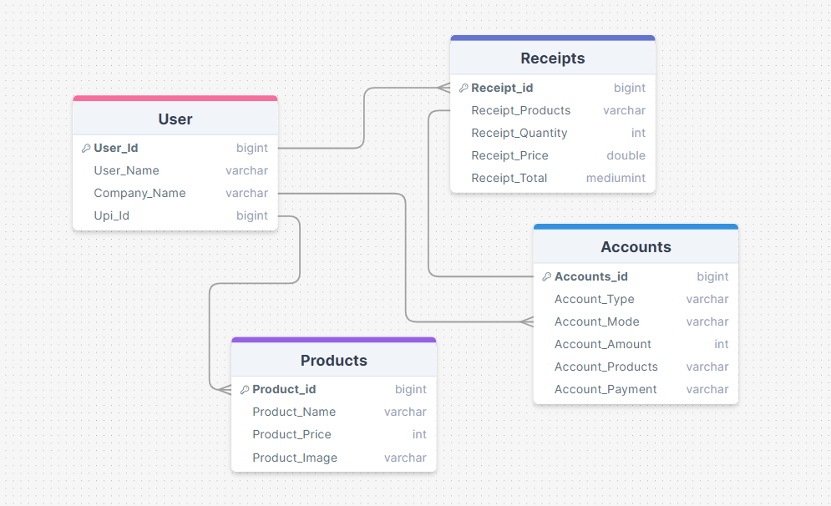

**3.6.2 DATA DICTIONARY**

**For User**

|  |  |  |  |  |  |  |
| --- | --- | --- | --- | --- | --- | --- |
| **Field Name** | **Data Type** | **Data Format** | **Field Size** | **Description** | **Example** | **Validation** |
| Email ID | String | Name@gmail.com | 20 | Email Id Of User | Chaitya | cs@gmail.com |
| Password | String | Chaitya123 | 20 | Password Of User | 123456 | Small,  Uppercase,  Lowercase,  Special Letter |
| Username | String | Chaitya Shah | 20 | Username Of User | Chaitya Shah |  |
| Business Name | String | K.J Financial Consultancy | 20 | Business name Of User | K.j Financial Consulatncy |  |
| Upi-Id | String | 942@oksbi | 20 | UpiId Of User | 942@oksbii |  |
| Logo | Image | Image.png | - | Logo Of Businness | - |  |

**For Receipts**

|  |  |  |
| --- | --- | --- |
| **Id** | **Data Type** | **Data Format** |
| Receipt Id | int | 123 |
| Items | String |  |
| Quantity | int |  |
| Price | double | 125.30 |
| Total Amount | double | 1000.30 |

**3.6.3 Control Flow Diagram**

**3.6.3.1 For Kitchen/Chef:**

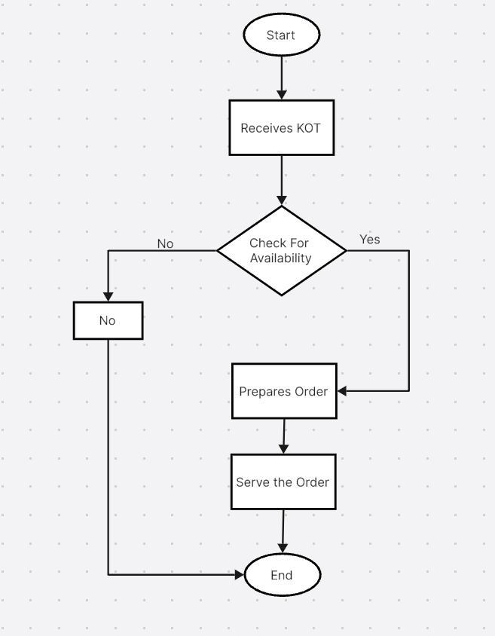

**3.6.3.2 For Cashier:**

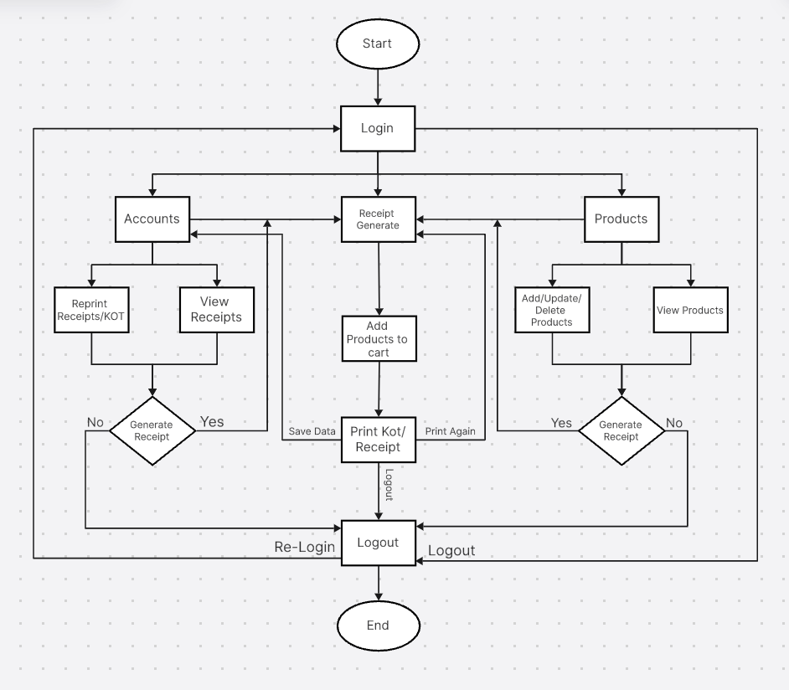

**3.7 MAIN MODULES OF NEW SYSTEM**

The main modules of a Point of Sale (POS) system typically include:

1. User Management
2. Product Management
3. Inventory Management
4. Sales Processing
5. Customer management
6. Reporting and Analysis
7. Integrating with Payment Gateway
8. Securty and Compliance
9. **User Management:** This module manages user accounts, permissions, roles, and access levels within the POS system. It allows administrators to create, modify, and deactivate user accounts, set permissions based on roles (cashier, manager, supervisor), and track user activities.
10. **Product Management:** Product management handles the management of products or items available for sale. It includes functionalities such as adding new products, updating product information (description, price, stock levels), categorizing products, setting up discounts or promotions, and managing product variants (e.g., sizes, colors).
11. **Inventory Management:** The inventory management module tracks stock levels, updates inventory in real-time based on sales and purchases, generates alerts for low stock or stockouts, manages product returns or exchanges, and facilitates inventory audits. It helps businesses optimize stock levels, reduce holding costs, and avoid overstocking or stock shortages.
12. **Sales Processing:** This module handles the core sales processing functionalities, including creating sales orders, processing transactions (cash, credit/debit card, mobile payments), generating invoices or receipts, applying discounts or coupons, calculating taxes, and providing multiple payment options to customers.
13. **Customer Management:** Customer management module stores and manages customer information, including contact details, purchase history, preferences, loyalty program participation, and feedback. It supports functionalities such as creating customer profiles, segmenting customers based on behavior or demographics, sending targeted promotions, and tracking customer interactions.
14. **Reporting and Analytics:** Reporting and analytics module generates various reports and analytics to provide insights into sales performance, inventory turnover, customer behavior, profitability, and trends. It includes standard reports (e.g., sales summary, inventory status) and customizable reports based on user requirements. Analytics tools may include dashboards, charts, graphs, and data visualization features.
15. **Integration with Payment Gateways:** This module integrates with payment gateways and processors to securely process payments from customers. It supports various payment methods such as credit/debit cards, mobile wallets, UPI, QR codes, and contactless payments. It ensures compliance with payment security standards (e.g., PCI DSS) and provides secure transaction processing.
16. **Security and Compliance:** The security and compliance module includes features to ensure data security, regulatory compliance, and fraud prevention. It implements security measures such as encryption, tokenization, user authentication, audit trails, and access controls. It also facilitates compliance with industry standards and regulations related to data privacy, payment processing, and financial reporting.

**CHAPTER - 4**

**4.1 implementation Environment (Single vs Multi-user, GUI vs Non-GUI)**

The implementation environment of a Point of Sale (POS) system can vary based on factors such as the number of users, graphical user interface (GUI) requirements, and the overall system architecture. Here's a breakdown of the implementation environment for a single-user POS system:

1. **Single-User Environment:** A single-user POS system is designed to be used by one user at a time. It typically operates on a standalone device such as a desktop computer, laptop, tablet, or mobile device. This type of environment is suitable for small businesses or individual users who do not require simultaneous access by multiple users.
2. **GUI (Graphical User Interface):** A GUI-based single-user POS system features a user-friendly interface with graphical elements such as buttons, menus, icons, and interactive screens. It allows users to navigate through different functionalities, input data, process transactions, view reports, and manage settings using intuitive graphical controls.
3. **Key Features of Single-User GUI-based POS:** Product Management: Add, edit, and delete products, manage pricing, categories, and variants.
4. Inventory Management: Track stock levels, receive alerts for low stock, manage product returns.
5. Sales Processing: Create sales orders, process transactions, generate invoices/receipts, apply discounts.
6. Customer Management: Store customer information, track purchase history, manage loyalty programs.
7. Reporting and Analytics: Generate sales reports, inventory reports, customer analytics, and performance metrics.
8. Payment Integration: Integrate with payment gateways for secure payment processing (credit/debit cards, mobile wallets).
9. **Advantages of Single-User GUI-based POS:**
10. Simplicity: Easy to set up and use, suitable for small businesses with limited user requirements.
11. Cost-effective: Lower hardware and software costs compared to multi-user systems.
12. User-Friendly: Intuitive GUI enhances user experience and reduces training time.
13. Efficient: Streamlines sales processes, inventory management, and reporting tasks

**4.2 Program/ Module Specification**

1. **User Management:** This module manages user accounts, permissions, roles, and access levels within the POS system. It allows administrators to create, modify, and deactivate user accounts, set permissions based on roles (cashier, manager, supervisor), and track user activities.
2. **Product Management:** Product management handles the management of products or items available for sale. It includes functionalities such as adding new products, updating product information (description, price, stock levels), categorizing products, setting up discounts or promotions, and managing product variants (e.g., sizes, colors).
3. **Inventory Management:** The inventory management module tracks stock levels, updates inventory in real-time based on sales and purchases, generates alerts for low stock or stockouts, manages product returns or exchanges, and facilitates inventory audits. It helps businesses optimize stock levels, reduce holding costs, and avoid overstocking or stock shortages.
4. **Sales Processing:** This module handles the core sales processing functionalities, including creating sales orders, processing transactions (cash, credit/debit card, mobile payments), generating invoices or receipts, applying discounts or coupons, calculating taxes, and providing multiple payment options to customers.
5. **Customer Management:** Customer management module stores and manages customer information, including contact details, purchase history, preferences, loyalty program participation, and feedback. It supports functionalities such as creating customer profiles, segmenting customers based on behavior or demographics, sending targeted promotions, and tracking customer interactions.
6. **Reporting and Analytics:** Reporting and analytics module generates various reports and analytics to provide insights into sales performance, inventory turnover, customer behavior, profitability, and trends. It includes standard reports (e.g., sales summary, inventory status) and customizable reports based on user requirements. Analytics tools may include dashboards, charts, graphs, and data visualization features.
7. **Integration with Payment Gateways:** This module integrates with payment gateways and processors to securely process payments from customers. It supports various payment methods such as credit/debit cards, mobile wallets, UPI, QR codes, and contactless payments. It ensures compliance with payment security standards (e.g., PCI DSS) and provides secure transaction processing.
8. **Security and Compliance:** The security and compliance module includes features to ensure data security, regulatory compliance, and fraud prevention. It implements security measures such as encryption, tokenization, user authentication, audit trails, and access controls. It also facilitates compliance with industry standards and regulations related to data privacy, payment processing, and financial reporting.

**4.3 CODING STANDARDS**

In Flutter, adhering to coding standards is essential for writing maintainable, readable, and efficient code. Here are some key coding standards and best practices to follow:

1. **Naming Conventions:** Use meaningful and descriptive names for variables, functions, classes, and files.Follow camelCase for variable and function names (e.g., myVariable, calculateTotal).Use PascalCase for class names (e.g., MyClass, ShoppingCart).
2. **Indentation and Formatting:**Use consistent indentation (typically 2 or 4 spaces) for code blocks and nested structures.Follow a consistent code formatting style throughout the project.Use clear and concise comments to document code logic, especially for complex or non-obvious sections.
3. **Imports and Dependencies:**Organize import statements alphabetically and separate them into core Dart imports, package imports, and local project imports.Avoid importing unnecessary packages or libraries to keep the project lightweight.Use explicit import statements to avoid namespace clashes and improve code readability.
4. **Class Structure:**Follow a modular and component-based architecture, dividing the code into reusable widgets, functions, and classes.Use stateless and stateful widgets appropriately based on the widget's need for state management.Encapsulate related functionality within classes and use inheritance and composition principles effectively.
5. **Error Handling:**Use try-catch blocks for handling exceptions and errors, especially when dealing with asynchronous operations.Implement error handling strategies such as displaying user-friendly error messages, logging errors for debugging, and gracefully handling unexpected failures.
6. **Code Organization:**Organize code files into logical directories and subdirectories based on functionality (e.g., screens, widgets, models, utilities).Separate UI logic (presentation layer) from business logic (data layer) to maintain a clear separation of concerns.Follow the Model-View-Controller (MVC) or Model-View-ViewModel (MVVM) design patterns for scalable and maintainable code organization.
7. **Documentation:**Write clear and concise documentation for classes, functions, and methods using comments.Document the purpose, parameters, return values, and usage examples of functions and methods.Use DartDoc comments (///) for generating API documentation and supporting IDE features like code completion and documentation tooltips.
8. **Testing:** Write unit tests and integration tests for critical components, functions, and UI elements using Flutter's testing framework (flutter_test package).Follow test-driven development (TDD) principles to ensure code reliability, identify bugs early, and facilitate code refactoring and maintenance.

**4.4 PACKAGES OF FLUTTER USED**

pie_chart: ^5.4.0

  date_time: ^0.10.0

  cloud_firestore: ^4.14.0

  firebase_auth: ^4.16.0

  firebase_storage: ^11.6.0

  firebase_core: ^2.24.2

  flutter_gif: ^0.0.4

  file_picker: ^4.5.1

  google_sign_in: ^6.1.6

  image_picker: ^0.8.4+3

  fluttertoast: ^8.2.4

  esc_pos_utils_plus: ^2.0.3

  print_bluetooth_thermal: ^1.0.2

**CHAPTER - 5**

1. **Login Page**

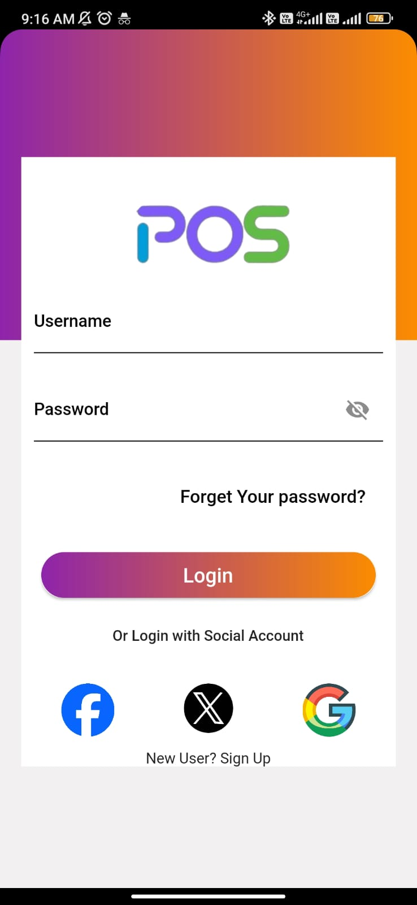

1. **Signup Page**

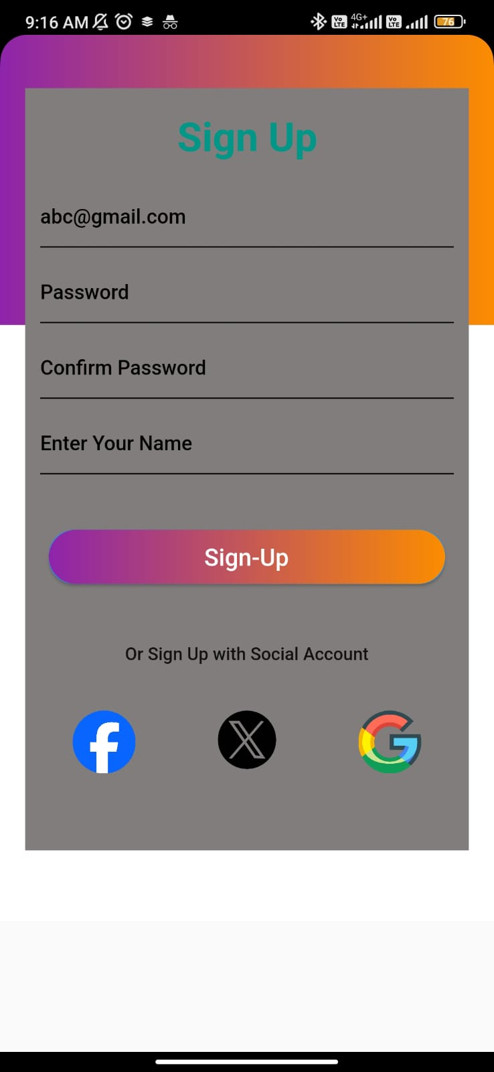

1. **Forget-Password Page**



1. **Dashboard**

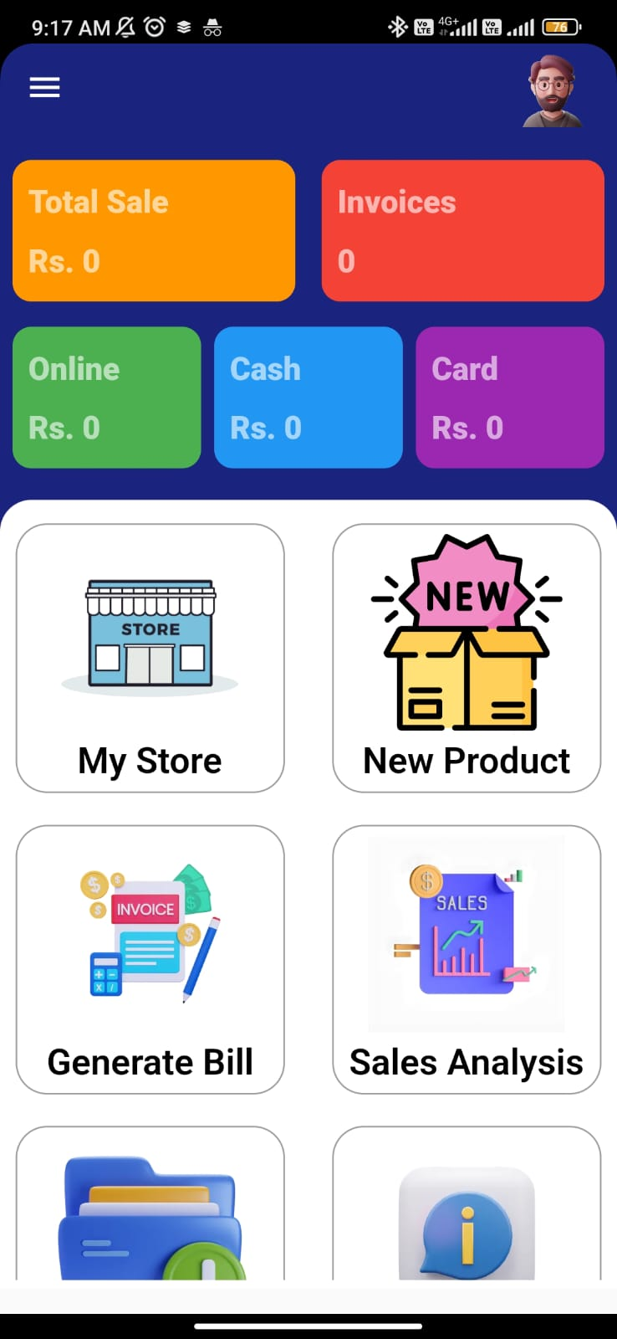

1. **Generate Bill Page**

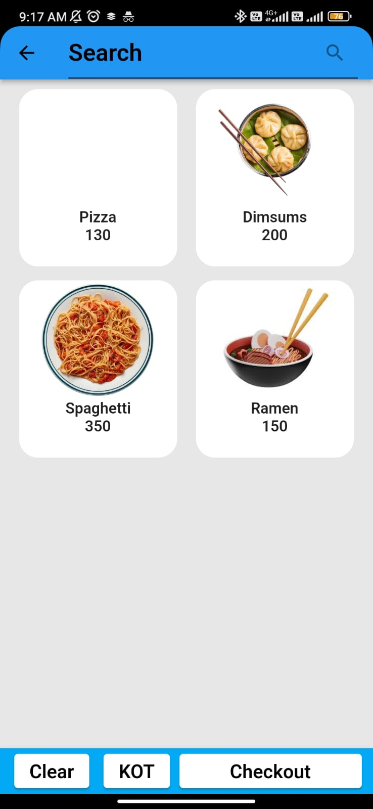

1. **Cart Page**

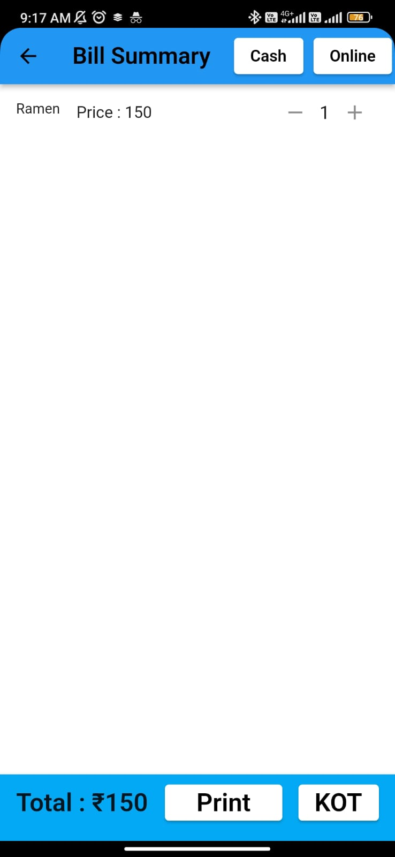

1. 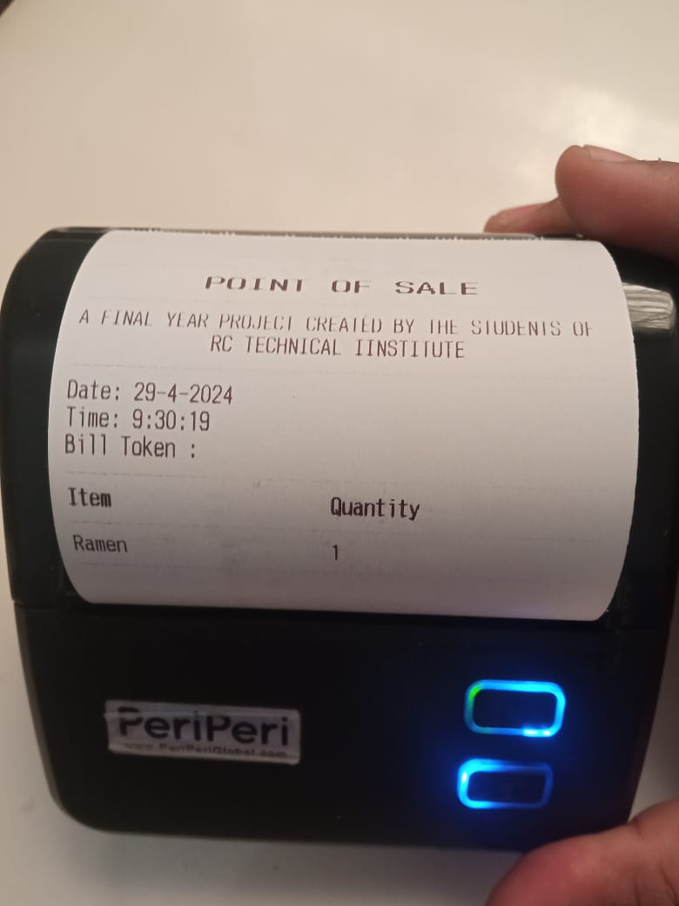**KOT PRINT**
2. 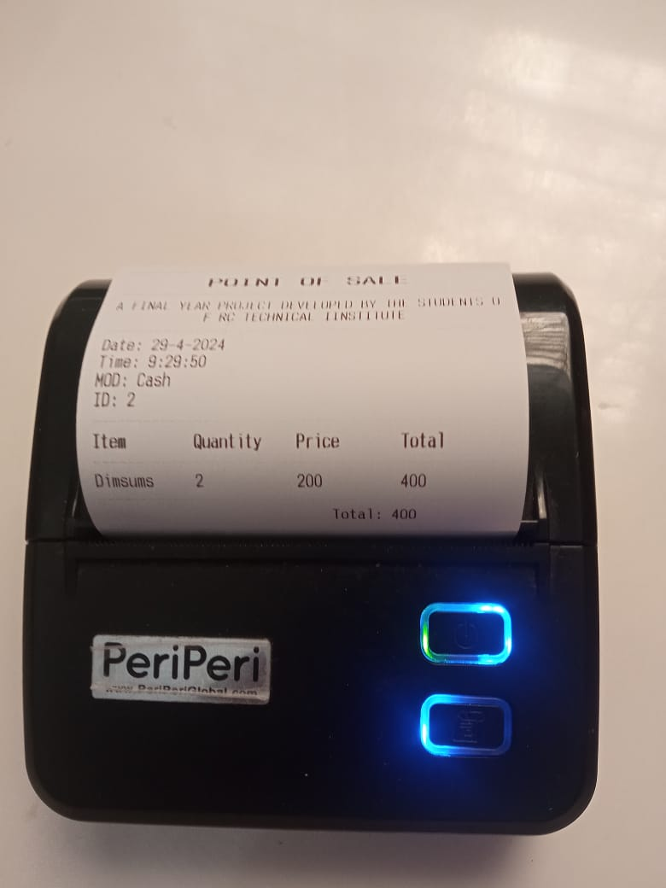**Bill Print**
3. **Dashboard Update**

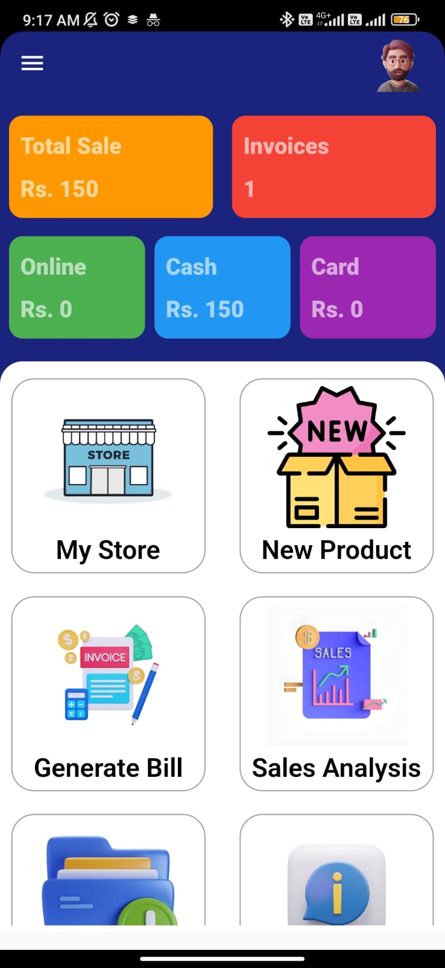

**CONCLUSION**

In conclusion, a Point of Sale (POS) system plays a crucial role in modern businesses by streamlining sales processes, optimizing inventory management, enhancing customer interactions, and providing valuable insights for decision-making. Here are the key points to summarize the significance of POS systems:

1. Efficiency and Accuracy: POS systems automate tasks such as item scanning, pricing, discounts, and payment processing, leading to faster and more accurate transactions.
2. Inventory Optimization: POS systems help businesses track stock levels, manage inventory, and avoid stockouts or overstocking, leading to improved inventory turnover and reduced holding costs.
3. Customer Experience: POS systems enhance the customer experience by providing quick checkouts, multiple payment options, personalized recommendations, loyalty programs, and efficient customer service.
4. Data-Driven Insights: POS systems generate reports and analytics on sales performance, customer behavior, inventory status, and financial metrics, enabling data-driven decision-making and business optimization.
5. Security and Compliance: POS systems implement security measures to protect customer payment information, comply with industry standards (e.g., PCI DSS), and prevent fraud or data breaches.
6. Integration and Scalability: POS systems integrate with other business systems (e.g., accounting, inventory, CRM) and support scalability to accommodate business growth and evolving requirements.
7. Cost Savings and ROI: POS systems offer cost savings through efficient operations, reduced errors, optimized inventory, and improved customer retention, leading to a positive return on investment (ROI).
8. User-Friendly and Productive: POS systems with intuitive interfaces, user-friendly features, and productivity tools (e.g., reporting, analytics, automation) enhance user experience and boost operational efficiency.

Overall, POS systems are indispensable tools for businesses across various industries, helping them streamline operations, improve customer satisfaction, drive revenue growth, and stay competitive in today's dynamic market environment.