IMPACT OF OPEC REGULATIONS ON OIL PRICES
Jáchym Dytrt 554492, Marek Dytrt 530924

Introduction
The project implements repeated game-theoretic model to analyze the evolution of crude oil prices under different strategic scenarios adopted by OPEC member states. Implementation of the model was done in Python.

Theoretical base - Cournot oligopoly
Cournot oligopoly model is widely used in economics to describe a market where firms produce a homogeneous product; crude oil is a classic example of this. In this model, firms compete by independently choosing their production quantities. Further details on the Cournot framework can be found in [1]. The market price is determined by total output through an inverse demand function:
$$P \text{= }α \text{-} bQ$$
$Q$…sum of production of all firms
$α$…theoretical maximum price when quantity is zeros
$b$…supply sensitivity; e. g. how strongly added production pushes prices down

In our model, the inverse demand function is calibrated to a realistic real-world equilibrium ($P_{base}$ and $Q_{base}$ ) to avoid the need for estimating the unobservable theoretical intercept $α$. Final price calculation is the following:
$$P \text{= }P_{base }\text{-} b\left(Q\text{-}Q_{base}\right)$$
$P_{base}$ and $Q_{base}$ were set to correspond to historical oil market data and the parameter $b$ was fixed at 8. Notably, these parameters remain constant throughout the model's iterations. The only changing parameter is the total quantity $Q$, which is determined as a sum of oil production of OPEC members. Furthermore, a small random noise term was added to capture short-term fluctuations outside the strategic model
¨
Attributes for each country
Our model simulates a 50-round game involving four players, each representing an archetype of an OPEC member state. The characteristics and production quotas assigned to each player are summarized in table below. These parameters were selected to produce plausible market behavior, not to mirror exact real-world conditions — different parameter choices would likely shift the quantitative results, though the qualitative conclusions should hold.
 | Quota  [mb/d] | Mine Price  [USD/bbl] | Budget Price  [USD/bbl] | Cut-off Price  [USD/bbl] | Max Production  [mb/d]
Saudi Arabia | 9 | 5 | 82 | 68 | 12
Venezuela | 1.8 | 35 | 120 | 100 | 2.2
UAE | 4 | 12 | 65 | 62 | 4.5
Nigeria | 1.5 | 30 | 60 | 50 | 2
Table: Attributes of all players
Note: mb/d…Million barrels per day; USD/bbl…US Dollars per Barrel

Quota refers to a production allocation assigned to the state by OPEC, while Max Production is the maximum production capacity of state's oil infrastructure. Budget price defines the price level necessary for the state to maintain national expenditures. Cut-off price represents the market price at which the state shifts from a passive strategy to an active market intervention.

The effectiveness of OPEC Quotas
We examined the effectiveness of OPEC-enforced quotas to determine whether they enable member states to increase their aggregate revenue. To do so, we evaluated two distinct strategic scenarios. First strategy assumes that each state decides to produce exactly the amount of barrels per day as they are assigned by OPEC quota (compliance_strat). Each state then produces a lower volume than its maximum production capacity would otherwise allow. Resulting revenues after 50 rounds of game are in table below.
Table: Revenues of each state and total revenue if all states comply to OPEC (million USD)

quotas

Saudi Arabia | Venezuela | UAE | Nigeria | Total
32 670 | 6 534 | 14 519 | 5 444 | 59 169

The second strategy simulates a market scenario without an operative OPEC, where states produce at their maximum capacity to maximize revenue in each round. (ignore_opec) The corresponding revenues for this scenario are presented in table below.
Table: Revenues of each state and total revenue if all states produce at their maximum capacity (million USD)
Saudi Arabia | Venezuela | UAE | Nigeria | Total
22 439 | 4 114 | 8 415 | 3 740 | 38 708

Our model results confirm the economic rationale for OPEC's existence: by coordinating production through quotas, member states can restrict supply to sustain higher market prices, thereby achieving higher aggregate revenues than would be possible under unconstrained competition.
Price enforcing mechanisms
A rather unexpected finding of the model was the difference in revenue when comparing two strategies by which Saudi Arabia tries to keep the price above certain threshold. To ensure that prices would drop below Saudi Arabia's threshold and trigger its enforcement mechanism, we designed the following scenario. The three countries besides Saudi Arabia had these strategies:
Venezuela
- simple comply strategy, always follows its quota
UAE
- Complies when prices are low
- Gradually increases production above its quota when prices are strong.
- Attempts to earn extra revenue while avoiding a major response from other producers.
Nigeria
- Complies with its quota when oil prices are sufficiently high.
- Rapidly increases production when prices fall below its budget requirements.
- Prioritizes maintaining revenue over strict adherence to production limits.

For Saudi Arabia we explored two opposite strategies – saudi_enforcer and saudi_saviour
a) Saudi Arabia Floods the Market (saudi_enforcer)
In this strategy Saudi Arabia follows its quota until the price drops to a certain threshold. Once this happens, Saudi Arabia deliberately breaks its own quota to “punish” which translates to the price drops in the price graph.
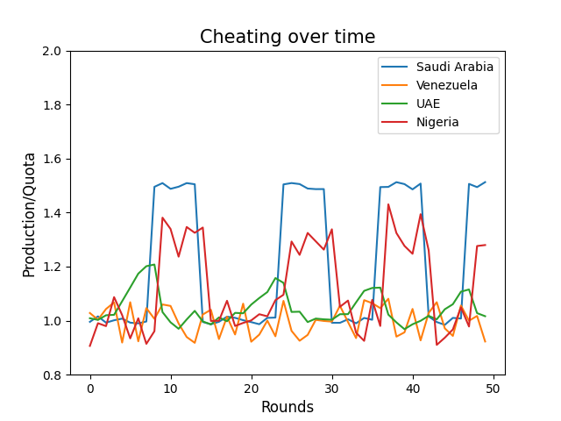
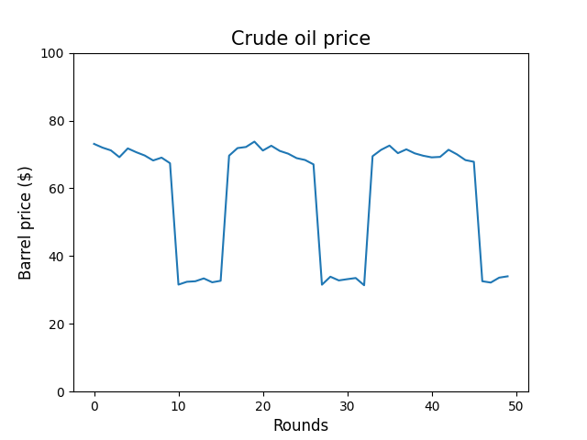

Saudi Arabia | Venezuela | UAE | Nigeria | Total
28 207 | 5 146 | 12 183 | 4 585 | 50 121
Table: Revenues of each state and total revenue in the saudi_enforcer scenario (million USD)
b) Saudi Arabia Saves the Market Price (saudi_saviour)
The opposite approach Saudi Arabia can take once the price drops to a certain level is “saving” the market price by deliberately under-producing. Because the supply drops, the price rises. The spikes in the graphs are caused by the price hovering around the threshold for Saudi to start under producing.
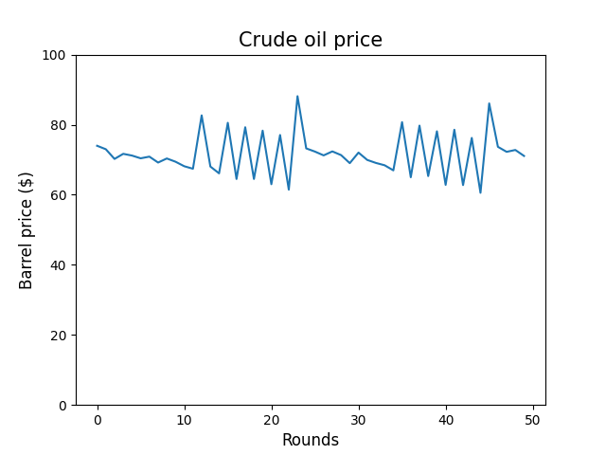
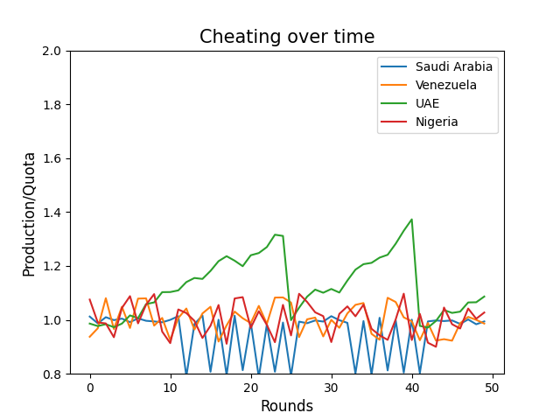
Table: Revenues of each state and total revenue in the saudi_enforcer scenario (million USD)
Saudi Arabia | Venezuela | UAE | Nigeria | Total
29 878 | 6 404 | 16 768 | 5 337 | 58 389

Comparison
Saudi Arabia has a disproportionate share of the market, which means its decisions have a disproportionately large effect on the final oil price. As expected, the revenues of the other countries were higher in the saudi_saviour scenario because the higher market price benefited all producers.
What is more interesting is that Saudi Arabia itself also achieved higher revenue in the saudi_saviour scenario. Although Saudi Arabia sold fewer barrels by deliberately restricting production, the resulting increase in price more than compensated for the reduction in volume sold. In this particular simulation, maintaining a high market price proved more profitable than attempting to punish quota violators through a temporary price war.
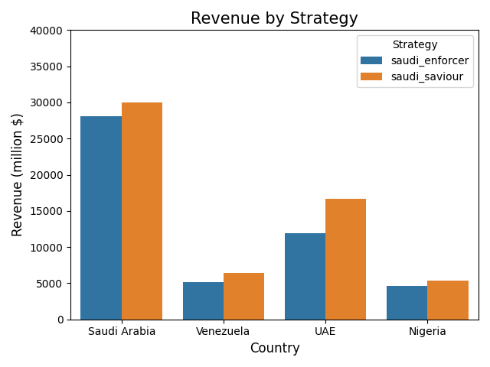
Of course, this result should be interpreted with caution because the model contains several limitations. Most importantly, countries do not adapt their strategies in response to Saudi Arabia's actions. In reality, producers would likely react to a deliberate market flood by changing their own production decisions, potentially making the enforcement strategy more effective than shown here. The model also assumes fixed demand behaviour, fixed production capacities, and does not account for political considerations or uncertainty in future prices. Therefore, the results should be viewed as an illustration of the mechanisms involved rather than a prediction of real-world OPEC behaviour.

Overall results
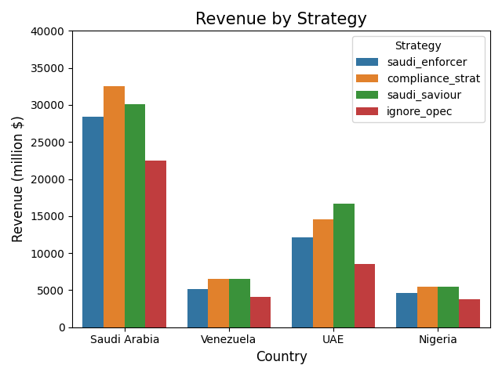
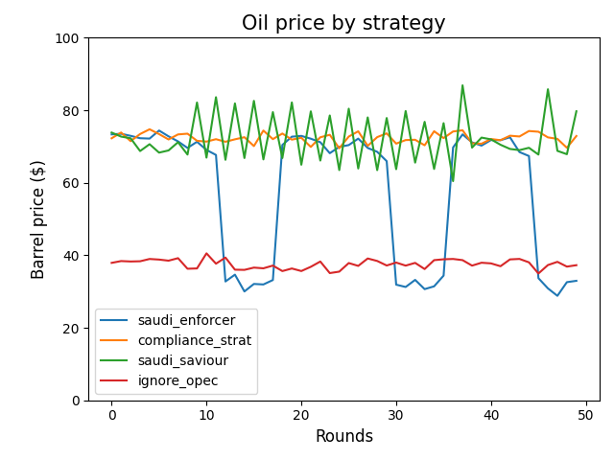
Overall, the model suggests that OPEC quotas can substantially increase collective revenue by maintaining higher oil prices. Furthermore, under the assumptions of the model, Saudi Arabia achieves higher revenue by stabilizing prices through production cuts rather than by engaging in price wars. However, these conclusions depend heavily on the simplifying assumptions of fixed strategies and demand conditions.
References
- Marker, D. (2019). Notes on Cournot oligopoly. University of Illinois Chicago, Department of Mathematics, Statistics, and Computer Science.
https://homepages.math.uic.edu/~marker/stat473-s19/Cournot.pdf

