PHASE-5 PROJECT DOCUMENTATION AND SUBMISSION

Introduction to Smart Parking:

Smart parking is a modern and innovative approach to managing and optimizing parking spaces in urban areas and other congested environments. It leverages technology, data, and automation to improve the efficiency, convenience, and sustainability of parking facilities. The primary goal of smart parking systems is to alleviate the challenges associated with finding and using parking spaces in crowded cities, ultimately enhancing the overall urban experience.

Key components of a smart parking system typically include:

1. **Sensors:** Smart parking solutions often employ a variety of sensors, such as ultrasonic or infrared sensors, cameras, and even mobile apps, to monitor parking space availability in real-time.
2. **Data Collection:** These sensors collect data about the occupancy of parking spaces, whether they are vacant or occupied. This data is transmitted to a central control system.
3. **Data Processing:** The collected data is processed and analyzed to provide real-time information on available parking spaces, which can be made accessible to drivers through mobile apps or on-site displays.
4. **Navigation and Guidance:** With the help of mobile apps, digital signs, and navigation systems, drivers can receive real-time information about the nearest available parking spaces and directions on how to reach them efficiently.
5. **Payment Systems:** Smart parking systems often include cashless payment options, allowing users to pay for parking digitally, either through mobile apps or automated kiosks.
6. **Remote Management:** Parking facility managers can monitor and control the parking infrastructure remotely, making it easier to handle maintenance, security, and compliance.

Benefits of Smart Parking:

Smart parking offers several advantages to both city authorities and drivers:

1. **Reduced Congestion:** By helping drivers find available parking spaces quickly, smart parking systems reduce the time spent searching for parking. This, in turn, minimizes traffic congestion and carbon emissions.
2. **Improved User Experience:** Drivers benefit from the convenience of finding parking easily and making cashless payments, enhancing their overall experience.
3. **Resource Optimization:** City authorities can better manage and allocate parking resources based on real-time data, making parking infrastructure more efficient.
4. **Revenue Generation:** Smart parking systems can generate additional revenue through improved space utilization, pricing flexibility, and digital payment options.
5. **Environmental Impact:** Reduced time spent searching for parking means less fuel consumption, contributing to environmental sustainability.
6. **Safety and Security:** Smart parking facilities are often equipped with security features, such as surveillance cameras and well-lit areas, enhancing safety.
7. **Data Insights:** The data collected by smart parking systems can be analyzed to gain insights into parking patterns, which can inform urban planning and policy decisions.

In an increasingly urbanized world with growing traffic congestion, smart parking is a promising solution to alleviate parking-related challenges, enhance urban mobility, and contribute to a more sustainable and efficient urban environment. It represents a key component of the broader concept of smart cities, where technology and data are harnessed to improve the quality of life for urban residents.

Top of Form

PROJECT OBJECTIVES OF IOT SENSOR SETUP:

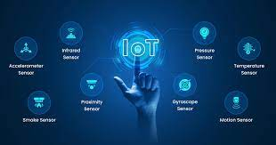

When planning an IoT sensor setup project, it's essential to define clear and specific objectives to guide the project's scope, execution, and success. The specific objectives can vary depending on the application and industry, but here are common project objectives for an IoT sensor setup:

1. Data Collection and Monitoring: Collect data from various sensors to monitor and track specific parameters or environmental conditions, such as temperature, humidity, air quality, motion, light levels, sound, or any other relevant data points.
2. Real-time Data: Enable real-time data acquisition and transmission, ensuring that sensor data is promptly accessible for analysis and decision-making.
3. Remote Accessibility: Establish remote access to the sensor data through the internet or other networks, allowing users to monitor and analyze data from anywhere, anytime.
4. Alerts and Notifications: Implement real-time alerting mechanisms to notify users or system administrators when specific conditions are met or when data falls outside predefined thresholds, helping to address critical situations promptly.
5. Data Analysis and Insights: Utilize the collected data to gain valuable insights, make informed decisions, and potentially predict future trends or issues. The objective is to turn raw data into actionable information.
6. Efficiency Improvement: Improve operational efficiency, resource management, and cost-effectiveness by using data-driven insights to optimize processes or make informed decisions.
7. Cost Reduction: Identify opportunities to reduce operational costs, energy consumption, or resource wastage through data-driven optimization.
8. Security and Privacy: Ensure data security and privacy by implementing encryption, access control, and other security measures to protect sensitive information from unauthorized access or cyber threats.
9. Scalability: Design the sensor setup to be scalable, allowing for easy addition of more sensors, devices, or expansion to cover larger areas or more complex environments.
10. Integration: Integrate the IoT sensor data with existing systems, software, or technologies to enable a seamless flow of information and support decision-making processes.
11. Compliance: Ensure that the project complies with relevant industry standards, regulations, and data protection laws to avoid legal or regulatory issues.
12. Energy Efficiency: Optimize power consumption in sensor nodes and devices to prolong battery life or reduce energy costs.
13. Reliability and Redundancy: Build in redundancy and failover mechanisms to ensure data collection and monitoring continue even in the event of sensor failures or network issues.
14. User Experience: Prioritize user experience by providing intuitive and user-friendly interfaces for accessing and visualizing sensor data.
15. Maintenance and Support: Plan for ongoing maintenance, updates, and user support to keep the system operational and meet evolving needs.
16. Long-term Sustainability: Consider the long-term sustainability and future-proofing of the IoT sensor setup, accommodating for technological advancements and changing requirements.
17. Environmental Impact: Implement eco-friendly practices and consider the environmental impact of the project, such as minimizing waste or resource consumption.
18. Performance Optimization: Continuously optimize the system's performance and reliability, ensuring that it meets or exceeds expectations.
19. Feedback Loop: Establish mechanisms for collecting feedback from users and stakeholders to make iterative improvements and enhancements.
20. ROI and Business Objectives: Define specific return on investment (ROI) or business objectives to measure the project's success and justify its implementation.

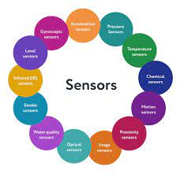

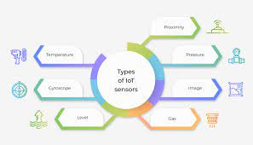

The specific objectives of an IoT sensor setup project will depend on the application, goals, and industry, so it's essential to tailor them to the unique requirements of the project. These objectives should be SMART (Specific, Measurable, Achievable, Relevant, and Time-bound) to ensure they can be effectively tracked and accomplished.

Top of Form

PROJECT OBJECTIVES OF MOBILE APP DEVELOPMENT: Bottom of Form



When undertaking a mobile app development project, it's crucial to establish clear and specific objectives to guide the development process and ensure the app's success. Here are common project objectives for mobile app development:

1. **Solve a Problem**: Identify a specific problem or address a pain point that the app will solve. The primary objective is to provide a solution that enhances user experience or adds value to users' lives.
2. **User Experience (UX)**: Ensure that the app delivers an exceptional user experience by creating an intuitive and user-friendly interface. The primary goal is to make the app easy to navigate and enjoyable to use.
3. **Platform Compatibility**: Develop the app to be compatible with the targeted mobile platforms, such as iOS, Android, or both. The objective is to reach a broad user base and maximize market reach.
4. **Performance**: Optimize the app for speed, responsiveness, and reliability. The objective is to provide a seamless and fast user experience.
5. **Unique Features**: Define unique and compelling features that set the app apart from competitors. The primary goal is to differentiate the app in a crowded market.
6. **Monetization**: Determine the app's revenue model, whether it's through in-app purchases, subscriptions, ads, or a paid download. The objective is to generate revenue or achieve other financial goals.
7. **Market Reach**: Set objectives for market penetration and user acquisition, including target user demographics and geographical regions.
8. **User Engagement**: Define engagement metrics and objectives, such as daily active users (DAU), monthly active users (MAU), and retention rates. The primary goal is to keep users engaged and returning to the app.
9. **Data Security and Privacy**: Ensure that user data is protected and that the app complies with data protection regulations. The objective is to establish trust with users.
10. **Testing and Quality Assurance**: Implement rigorous testing to identify and rectify bugs and issues. The primary goal is to release a stable and error-free app.
11. **Maintenance and Updates**: Plan for ongoing maintenance, updates, and improvements to keep the app relevant and competitive.
12. **Marketing and Promotion**: Develop a strategy for app promotion and user acquisition, including specific objectives for downloads, user ratings, and reviews.
13. **Analytics and Performance Monitoring**: Implement analytics tools to track user behaviour and app performance. The objective is to gather data for continuous improvement.
14. **User Feedback**: Create mechanisms for collecting user feedback and implementing user-driven improvements.
15. **Timelines and Deadlines**: Establish project timelines and delivery deadlines to ensure that the app is developed and launched according to the schedule.
16. **Budget and Cost Management**: Define the budget for app development and manage costs effectively to avoid overspending.
17. **Legal and Compliance**: Ensure that the app complies with relevant legal and regulatory requirements, including copyrights, trademarks, and industry-specific standards.
18. **Customer Support**: Plan for customer support and address user inquiries or issues promptly.

It's important to note that these objectives may vary based on the app's purpose, target audience, and business model. Additionally, project objectives should be specific, measurable, achievable, relevant, and time-bound (SMART) to ensure they can be effectively tracked and accomplished.

Top of Form

RASPBERRY PI INTEGRATION AND CODE IMPLEMENTATION:

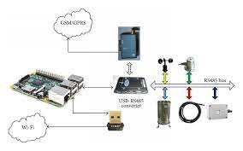

When working on a project that involves integrating Raspberry Pi and implementing code for various applications, it's crucial to have clear project objectives and an organized approach. Here are the key steps and considerations for Raspberry Pi integration and code implementation:

1. **Project Objectives**:
   * Clearly define the objectives of your project. What do you aim to achieve with the integration of Raspberry Pi and code implementation? Is it for home automation, IoT, robotics, data analysis, or another application?
2. **Hardware Selection**:
   * Choose the appropriate Raspberry Pi model and any additional hardware components (sensors, actuators, cameras, etc.) required for your project.
3. **Operating System**:
   * Install and configure a suitable operating system for the Raspberry Pi, such as Raspbian (now Raspberry Pi OS) or a specialized OS for your application.
4. **Programming Language**:
   * Select a programming language for your code implementation. Python is a popular choice due to its compatibility with Raspberry Pi and its extensive library support.
5. **GPIO (General Purpose Input/Output)**:
   * Learn about the GPIO pins on the Raspberry Pi and how to use them to interface with sensors, LEDs, and other external devices.
6. **Sensor Integration**:
   * Connect and interface with sensors and peripherals relevant to your project, following datasheets and guides. Examples include DHT sensors, motion sensors, and ultrasonic sensors.
7. **Code Development**:
   * Write the code to interact with the sensors and control actuators. This may involve collecting data from sensors, processing data, making decisions, and controlling connected devices.
8. **User Interface**:
   * If your project requires a user interface, design and implement it. This can be a web interface, mobile app, or a command-line interface.
9. **Data Storage and Processing**:
   * Decide how and where you will store and process data collected by the Raspberry Pi. You may use local storage, cloud services, or databases.
10. **Connectivity**:
    * Configure network connectivity for your Raspberry Pi. You may need Wi-Fi or Ethernet for internet access and remote management.
11. **Security**:
    * Implement security measures to protect your Raspberry Pi and data. This includes setting up firewalls, encryption, and access controls.
12. **Automation and Control**:
    * If your project involves automation, create code to control external devices based on predefined conditions or user inputs.
13. **Testing and Debugging**:
    * Thoroughly test your code and hardware to ensure they work as expected. Debug any issues that arise during testing.
14. **Documentation**:
    * Create documentation for your code, hardware setup, and system architecture. This documentation will be useful for future reference, troubleshooting, and knowledge transfer.
15. **User Training and Support**:
    * If the project is for a broader user base, provide user training and support materials to help users understand and use your system.
16. **Maintenance and Updates**:
    * Plan for ongoing maintenance, including updates, bug fixes, and improvements to keep your system operational and up-to-date.
17. **Compliance and Regulations**:
    * Ensure your project complies with relevant regulations, standards, and licensing requirements.
18. **Deployment**:
    * Deploy your Raspberry Pi-based system in its intended environment, whether it's at home, in an industrial setting, or elsewhere.
19. **Monitoring and Scaling**:
    * Implement monitoring to keep an eye on the system's performance, and plan for scalability if your project grows in complexity or user base.
20. **Backup and Disaster Recovery**:
    * Implement backup and disaster recovery strategies to protect against data loss and system failures.

Raspberry Pi integration and code implementation projects can vary widely in scope and complexity, so adapt the above steps to the specific needs and goals of your project. Effective project planning, documentation, and testing are key to a successful implementation.

Top of Form

SCREENSHOTS OF IOT SENSORS AND MOBILE APP:

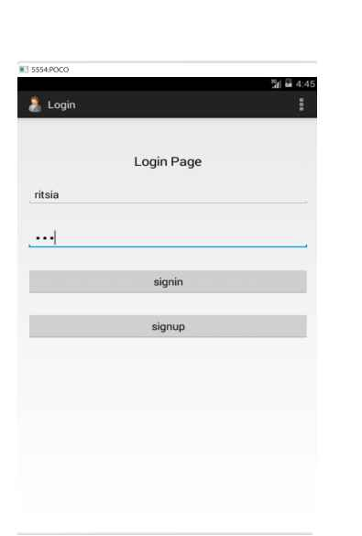

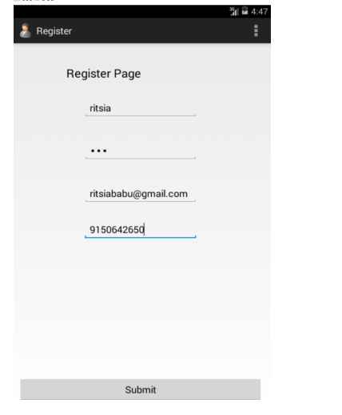





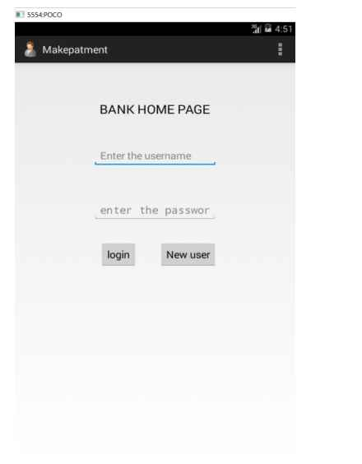

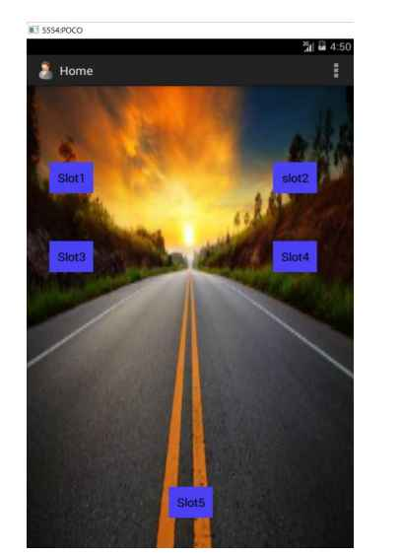

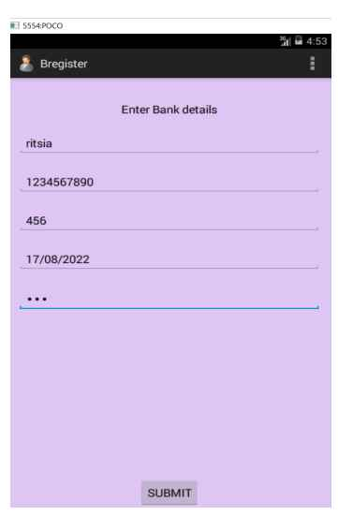

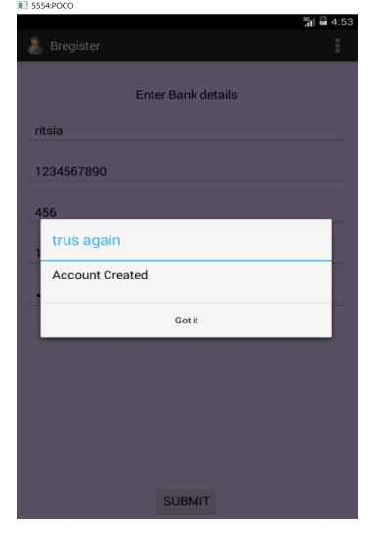

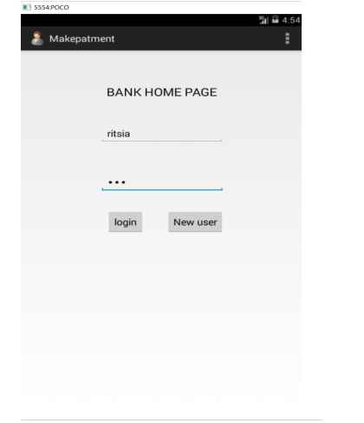



THE REAL TIME PARKING AVAILABILITY SYSTEM CAN BENEFIT DRIVERS AND ALLEVIATE PARKING ISSUES:

A real-time parking availability system offers significant benefits to both drivers and the urban environment by addressing and alleviating common parking issues. This innovative solution uses technology and data to improve the parking experience, making it more convenient, efficient, and sustainable. Here's how such a system can benefit drivers and help mitigate parking challenges:

**Benefits for Drivers:**

1. **Time Savings:** Real-time parking availability systems provide drivers with up-to-the-minute information about available parking spaces in their vicinity. This reduces the time and frustration spent circling the area searching for a parking spot, making the overall parking process faster and more efficient.
2. **Reduced Stress:** The stress of finding a parking spot in a crowded city or congested area can be significant. Real-time availability information eases this stress by guiding drivers directly to open parking spaces, reducing frustration and road rage.
3. **Cost Savings:** Some parking availability systems offer information about the cost of parking in various locations, helping drivers make informed choices and potentially save money by selecting more affordable parking options.
4. **Environmental Impact:** By reducing the time spent searching for parking, real-time availability systems contribute to lower fuel consumption and carbon emissions, thereby supporting environmental sustainability.
5. **Enhanced Convenience:** Drivers can use mobile apps or in-car navigation systems to locate available parking spaces easily. This convenience improves the overall urban commuting experience.
6. **Improved Accessibility:** Drivers with special needs or disabilities benefit from these systems by being directed to accessible parking spaces that meet their requirements.

**Benefits for the Urban Environment:**

1. **Reduced Traffic Congestion:** One of the most significant benefits is the reduction in traffic congestion. Less time spent circling for parking means fewer cars on the road, which, in turn, decreases traffic jams and emissions.
2. **Optimized Space Utilization:** Real-time parking systems help cities optimize their parking space usage, making it possible to accommodate more vehicles with existing infrastructure.
3. **Enhanced Urban Planning:** By collecting and analyzing parking data, cities gain valuable insights into parking patterns and can use this information for better urban planning, infrastructure improvements, and policy decisions.
4. **Revenue Generation:** Cities can generate additional revenue through data-driven pricing strategies, dynamic parking rates, and improved enforcement.
5. **Reduced Illegal Parking:** Real-time parking availability systems can help reduce illegal parking, such as double-parking or parking in no-parking zones, which can obstruct traffic flow.
6. **Support for Smart Cities:** Real-time parking systems are integral to the concept of smart cities, where data and technology are harnessed to enhance urban living, mobility, and resource management.

In conclusion, a real-time parking availability system benefits both drivers and the urban environment by making the parking process more convenient and efficient for users, reducing congestion, and improving the overall quality of urban life. It represents an important component of smart urban planning and transportation management.

Top of Form

Bottom of Form