Society Generale- Employee Portal

Revision List

|  |  |  |  |
| --- | --- | --- | --- |
| **Ver. Rev** | **Date** | **Authors** | **Description** |
| 0.1 | 29-July-2019 | Chakradhar B | Employee Portal Design |
|  |  |  |  |

Table of Contents

**1.** INTRODUCTION 1

**2.** Technologies Used: 1

**3.** Use Cases: 2

**4.** Application Setup: 2

**2.** Code Repository: 2

**3.** Frontend: 2

**2.** Backend: 3

**5.** Test: 3

**1.** Junit Test cases Run: 3

**2.** UI Run: 4

# INTRODUCTION

This document describes the Understanding of Employee Portal application.

# Technologies Used:

Front End: Angular 7, Bootstrap, Typescript, Jasmine, Karma

Back End: Java 1.8, Spring Boot, Rest API, Swagger, Junit, Mockito and Maven 3

DB: H2 DB

# Use Cases:

* **Use Case 1: Employee Registration**
* As a user, I should be able to Register an employee with following details:
  + First Name
  + Last Name
  + Gender
  + Date of Birth
  + Department
* **Use Case 2: Employee List**
* As a user, I should be able to see all the employee details in a tabular form (or any other way) in ascending order by first name

# Application Setup:

# Code Repository:

* + - Find complete code in below GitHub Repository Link

<https://github.com/Chakradhar-Battili/EmployeePortal>

# Frontend:

* + - Install Node.js
    - Install latest Angular using this below command

npm install -g @angular/cli

* + - Build the project using this below command

ng build

* + - Run below command to Install Node packages i.e. all dependent libraries which are mentioned in the package.json will get stored in node_modules folder.

npm install

* + - Start Angular application Using the below command

npm start

* + - Once It is ran we would see below snapshot

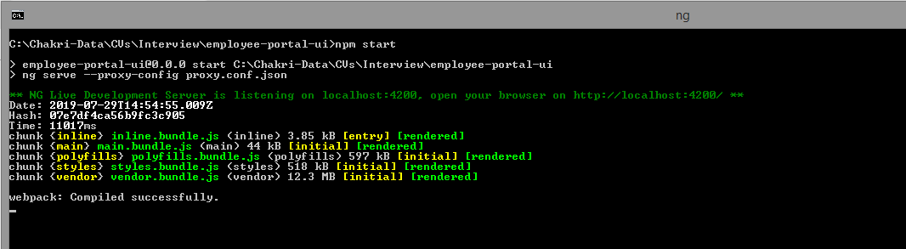

# Backend:

* + - Download Java 1.8
    - Build the Project using below command

mvn clean install

* + - Run Spring Boot Server using below command

mvn spring-boot:run

* + - Once It is ran we would see below snapshot

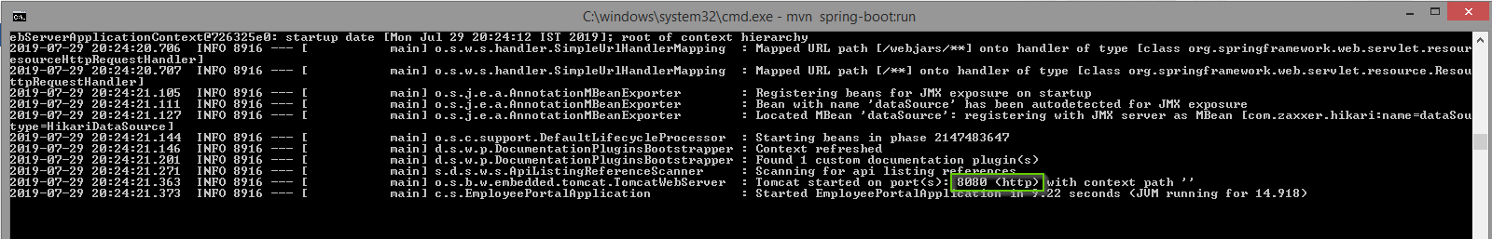

# Test:

# Junit Test cases Run:

* Run the Back-end Junit test cases from eclipse or run below command

mvn clean test

* Once It is run we would see below snapshot

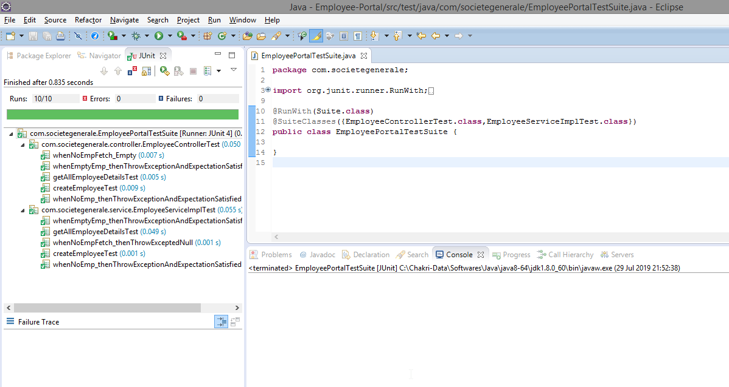

* Run UI test cases of Karma using the below command

ng test

# UI Run:

* Open Below URL in Browser(<http://localhost:4200/>)
* Click on Add User Link, Fill All input fields & click on Register Button

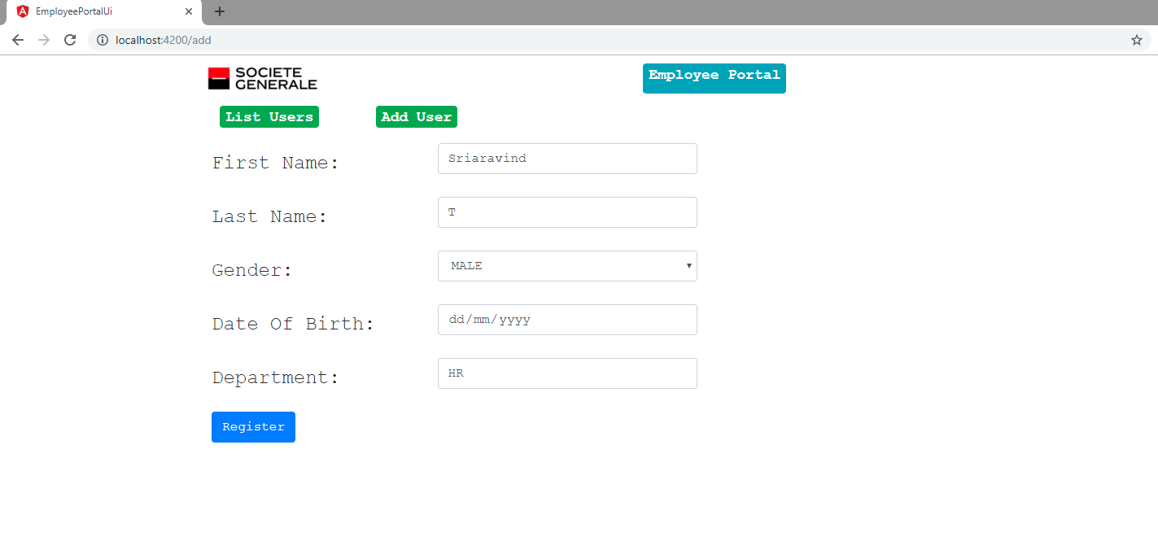

* Click on List Users Link & We would see below page.

