R-ECLAT TOOL

In this project we are implementing two algorithms called ECLAT and RECLAT. ECLAT algorithms can be used to find frequent items from a list of dataset transactions and RECLAT can be used to find INFREQUENT items from a list of transactions.

Below code used to implement RECLAT

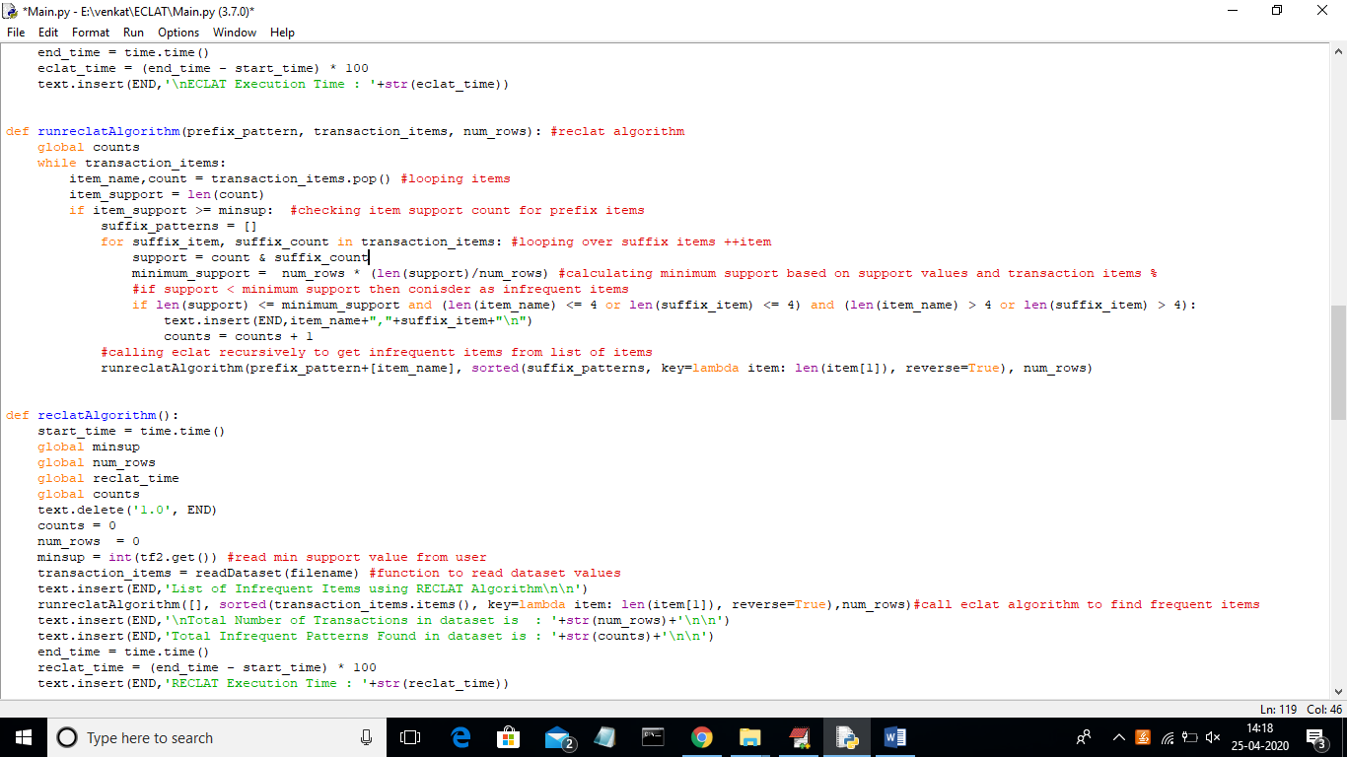

Below code is used to implement ECLAT Algorithm

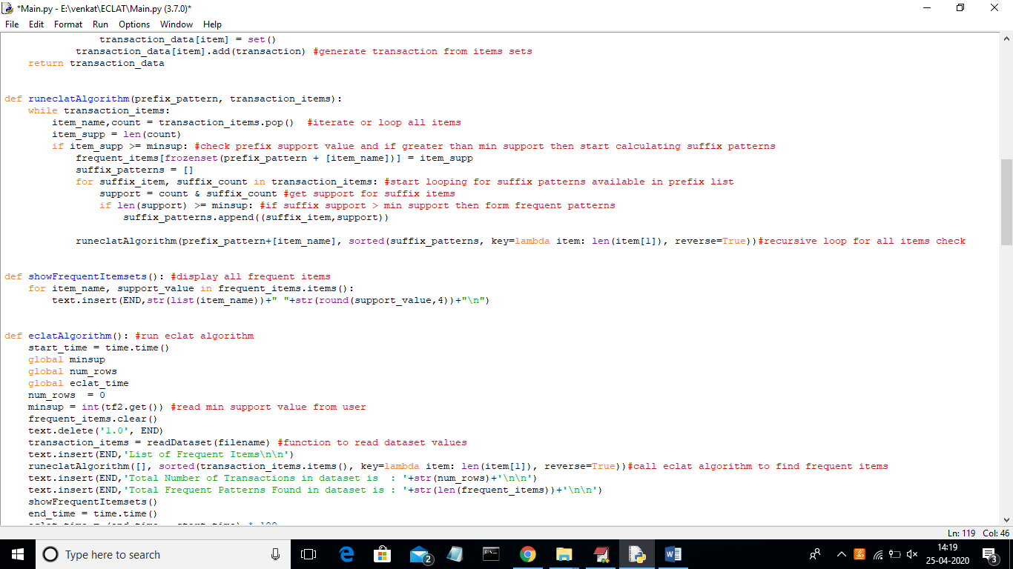

Screen shots

To run project double click on ‘run.bat’ file to get below screen

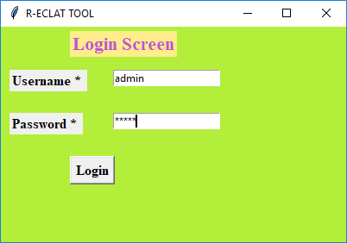

In above screen enter username as ‘admin’ and password as ‘admin’ and click on ‘Login’ button to get below screen

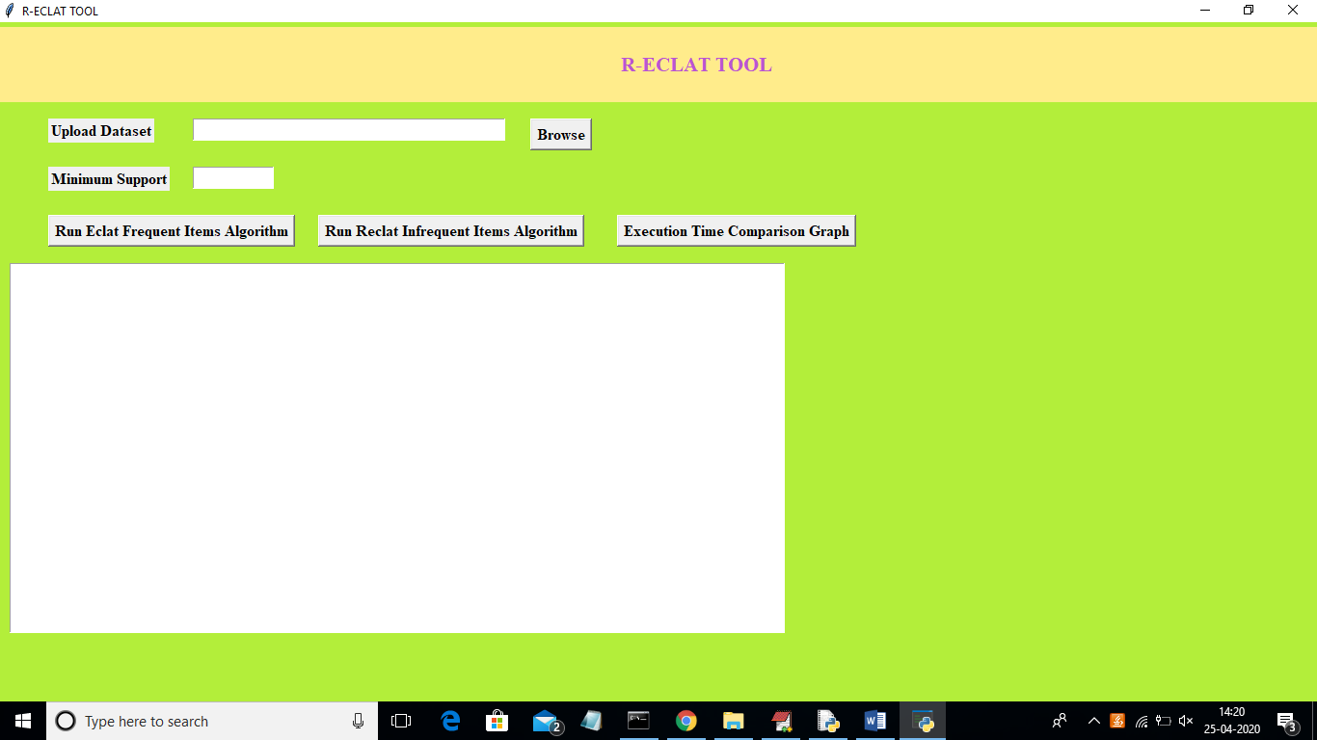

In above screen click on ‘Browse’ button to upload dataset

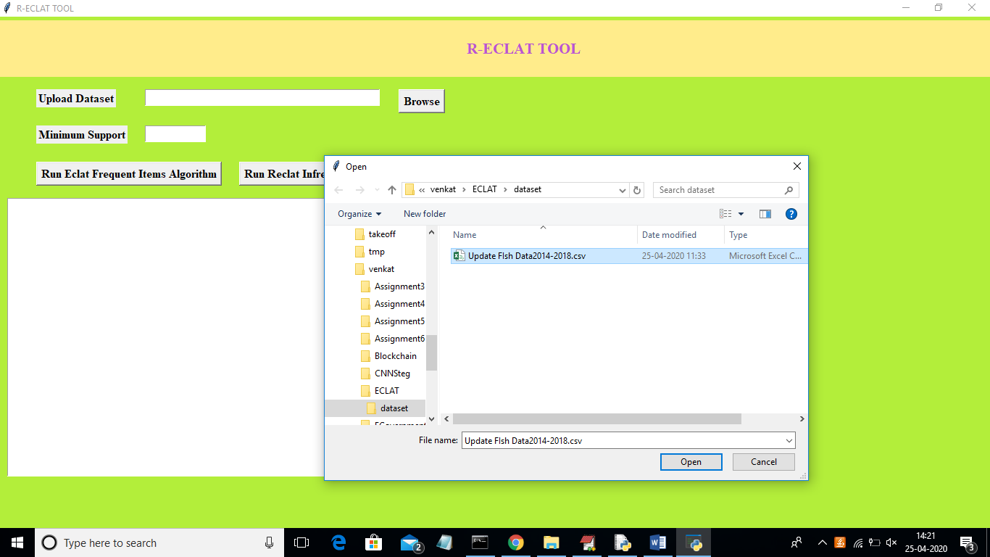

In above screen I am uploading ‘Fish’ dataset file and after uploading dataset will get below screen

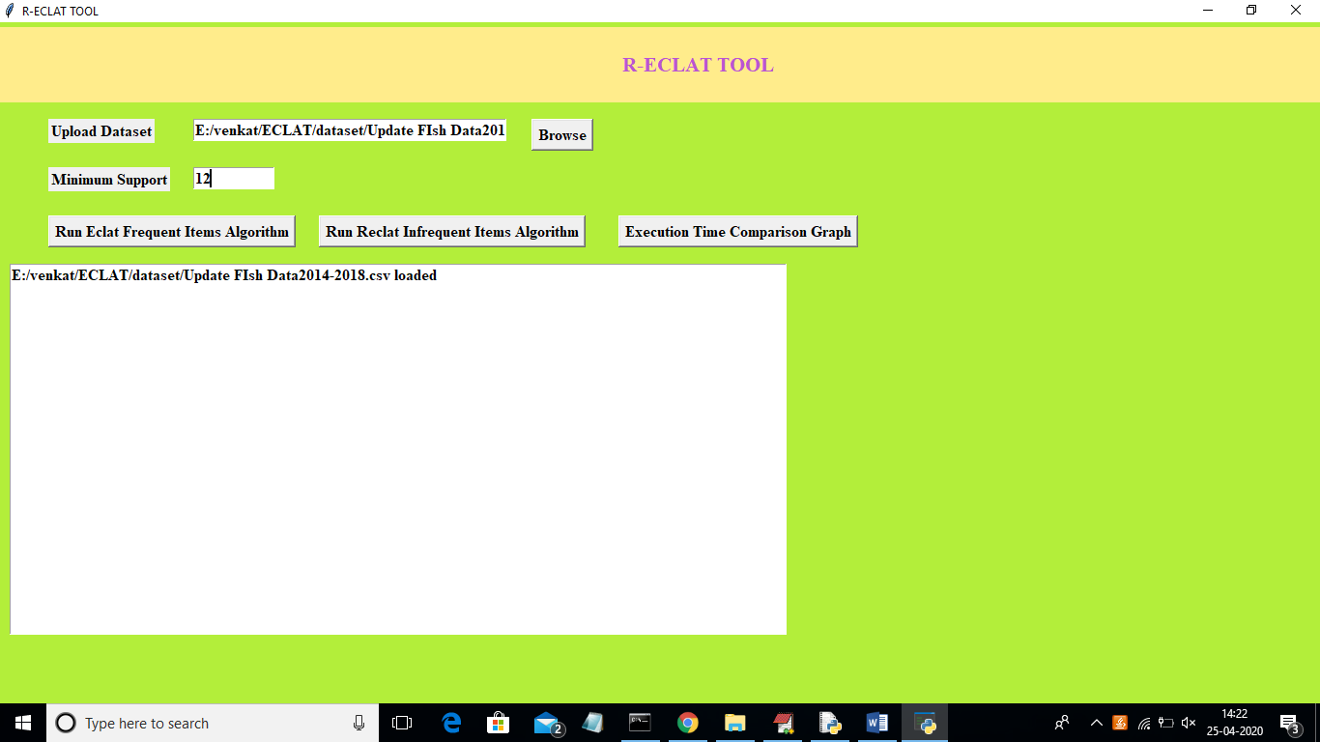

In above screen I gave Minimum support value as ‘12’ and whatever transaction whose support count > minimum support will form patterns and consider as frequent patterns. Now click on ‘Run Eclat Frequent Items Algorithm’ button to run ECLAT algorithm on uploaded dataset

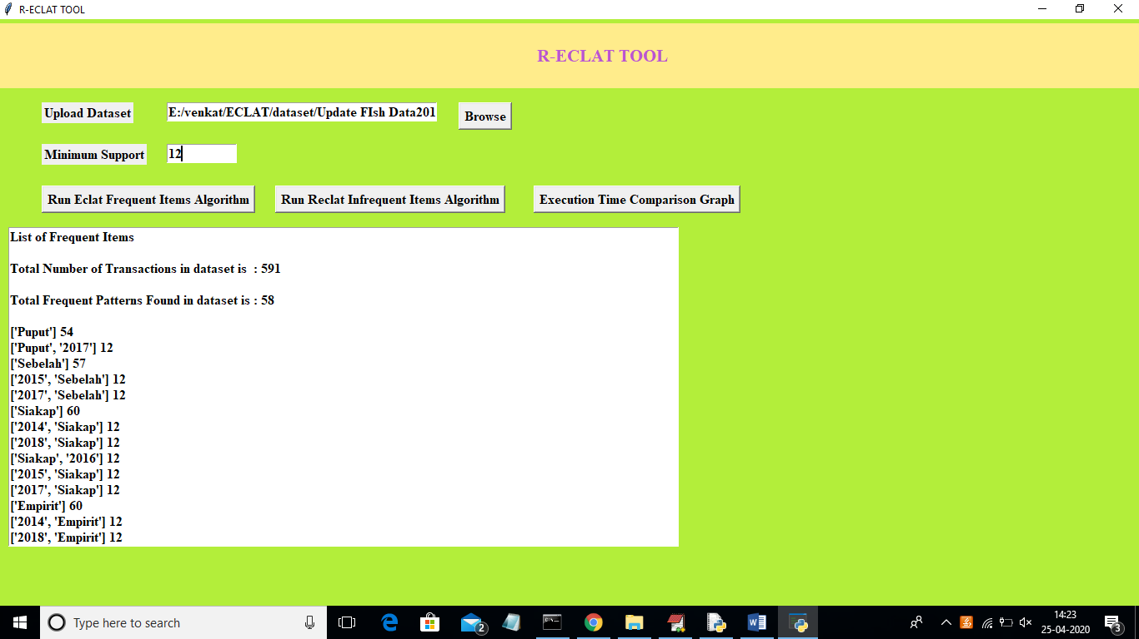

In above screen with ECLAT we got 58 frequent patterns from total 591 dataset records. In above frequent patterns fish species ‘Puput’ appear 54 times in all transaction and in patterns with combination [‘Puput’,’2017’] which means Puput appear 12 times with year 2017 or we can consider Puput deliver 12 times in year 2017. Scroll down text area to view all frequent patterns. Similarly we can see all species frequent patterns in different years. Now click on ‘Run Reclat Infrequent Items Algorithm’ button to find all infrequent items

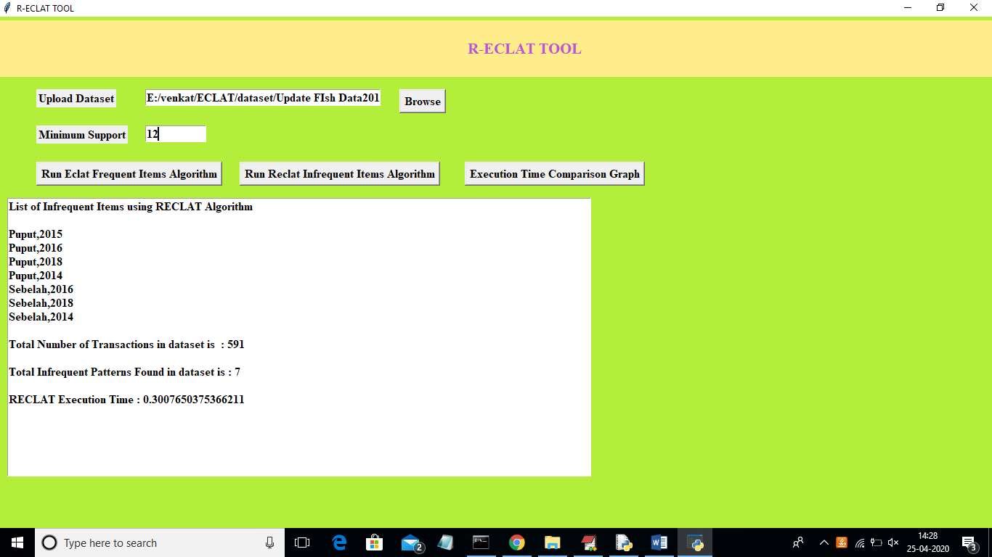

In above screen total 7 infrequent items found which means ‘Puput’ deliver less number of times in year 2015. In simple terms Puput in year 2015 is not in frequent species list. Now click on ‘Execution Time Comparison Graph’ button to get algorithm execution time comparison graph

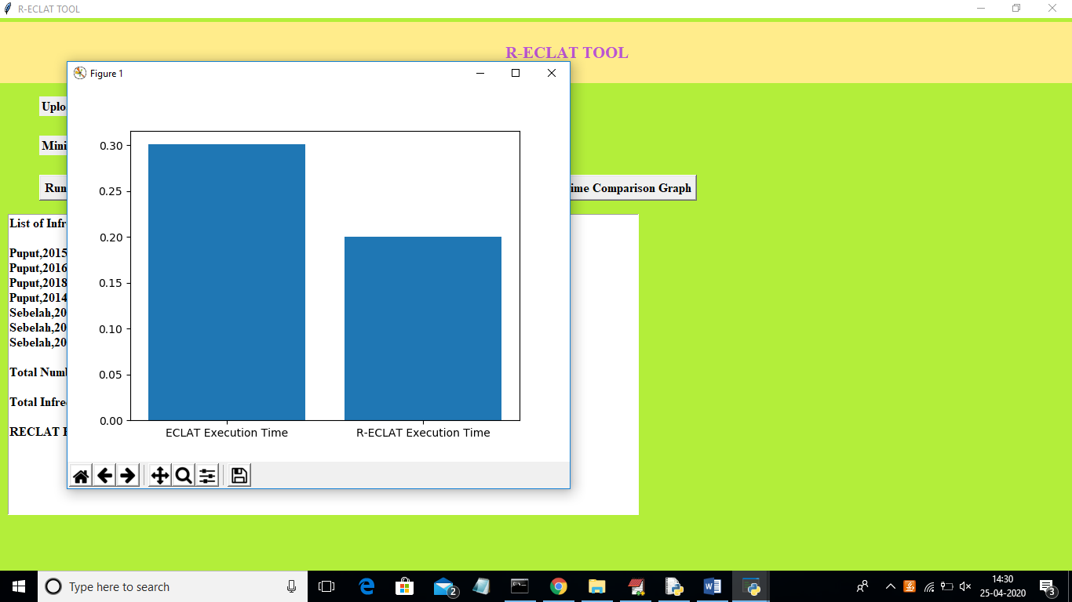

In above graph x-axis represents algorithm name and y-axis represents execution time. From above graph RECLAT took less execution time compare to ECLAT