Perplexity analysis
Figure 1 shows the relationship between model perplexity and the number of topics in LDA. The perplexity decreases sharply when the number of topics increases from 2 to 4, reaching a local minimum at 4 topics.
Although perplexity slightly improves again for larger numbers of topics, the improvement is marginal and accompanied by increased model complexity.
Therefore, 4 topics were selected as the optimal number, providing a balance between model performance and interpretability.
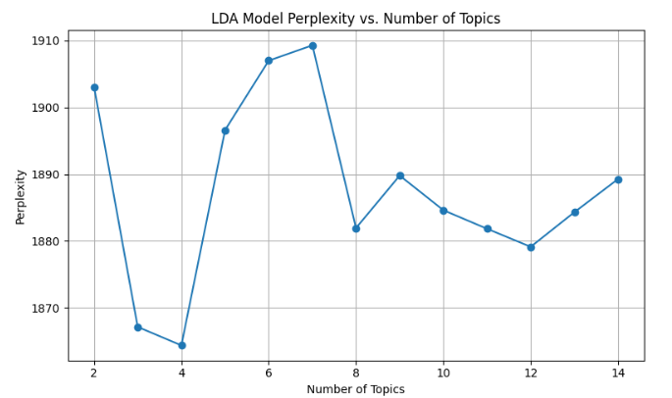
Figure 1 Perplexity of top singers
Figure 2 shows the relationship between the number of topics and model perplexity. The perplexity reaches its minimum at 10 topics, indicating that the model achieves the best predictive performance at this point. Although lower topic numbers (e.g., 6 topics) show local minimum, a substantial decrease in perplexity is observed only at 10 topics.
Beyond this point, increasing the number of topics does not lead to further improvement and results in perplexity values. Therefore, 10 topics were selected as the optimal number for the LDA model.
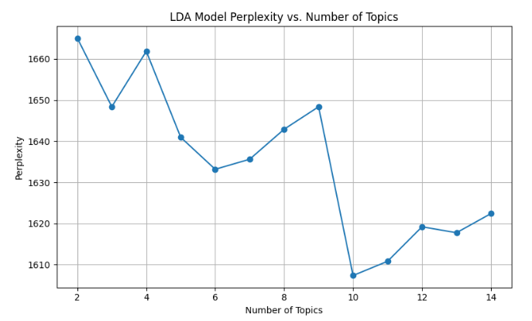
Figure 2 Perplexity of low singers
Result of LDA
Table 1 shows the LDA results of top artist. Figure 3 shows the distribution of topics. Following are our interpretation of these results.
Topic 1: Romantic emotions and relationship communication
This topic is primarily centered on romantic emotions and interpersonal communication within relationships. Keywords such as love, baby, feel, wanna, and need indicate expressions of affection and emotional desire, while verbs like tell, let, and come suggest communicative or relational actions between partners. Overall, this topic reflects songs that focus on emotional intimacy, longing, and relational negotiation.
Topic 2: Lifestyle, ambition, and nightlife experiences
This topic highlights themes related to lifestyle and personal ambition, particularly in the context of nightlife and material concerns. Words such as money, life, night, and high point to experiences associated with success, excitement, or escapism, while want, need, and real suggest personal aspirations and self-reflection. Songs within this topic often emphasize living in the moment and pursuing a desired way of life.
Topic 3: Personal reflection and social identity
This topic appears to focus on personal reflection and identity construction, often in a social or relational context. Keywords such as think, need, way, and new suggest introspection and change, while girl and money imply interpersonal or social dimensions. The combination of reflective verbs and social references indicates songs that explore self-definition, growth, and navigating life choices.
Topic 4: Longing and emotional attachment in romantic relationships
This topic emphasizes emotional attachment and longing within romantic relationships. Words such as long, need, want, and feel directly express desire and emotional dependency, while girl, baby, and love reinforce the romantic context. The presence of new and time suggests themes of evolving relationships and emotional development over time.
Table 1 LDA results of top artist
Topic_ID | LDA_Topic_Keywords
Topic1 | like, baby, let, time, make, feel, love, tell, wanna, want, need, right, way, come
Topic2 | like, come, high, want, make, night, life, money, need, real, really, let, tell, big
Topic3 | like, make, time, come, tell, think, let, need, wanna, girl, way, money, black, new
Topic4 | love, come, like, girl, baby, long, need, look, want, feel, new, make, time, way
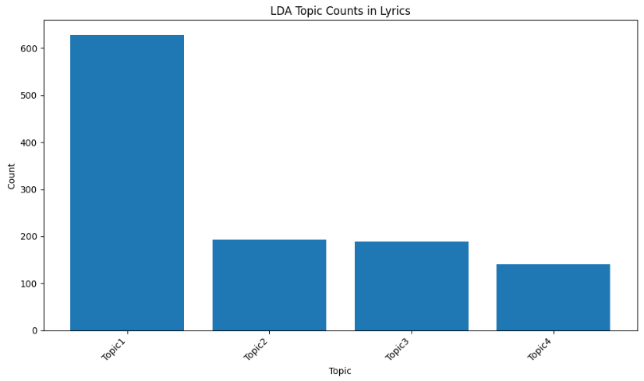
Figure 3 Distribution of topics of top artist
Table 2shows the LDA results of low artists. Figure 3 shows the distribution of topics. Following are our interpretation of these results.
Topic 1: Everyday emotional expression and introspection
This topic reflects everyday emotional expression and personal introspection. Words such as feel, think, want, and leave indicate internal reflection and decision-making, while love and need suggest emotional attachment. The dominant language is casual and conversational, capturing routine emotional experiences rather than dramatic events.
Topic 2: Romantic intimacy and domestic longing
This topic centers on romantic intimacy and longing for emotional closeness. The presence of baby, girl, and love strongly anchors the theme in romantic relationships, while words like home, night, and long imply emotional attachment and a desire for togetherness over time.
Topic 3: Desire, comfort, and emotional vulnerability
This topic emphasizes emotional vulnerability and desire for comfort. Keywords such as wanna, fall, sleep, and home suggest intimacy and emotional reliance, while wonder and good reflect uncertainty mixed with hope. Songs in this topic often depict soft emotional states and relational closeness.
Topic 4: Explicit language, rap identity, and aggression
This topic displays a strong use of explicit language and hip-hop–style expressions. Words such as fuckin, rap, and ass indicate aggressive or confrontational tones, while unusual or non-standard tokens (fokken, hosh, jou) may reflect slang, multilingual usage, or noise common in underground or low-resource lyrics. This topic likely represents raw self-expression and street-oriented identity.
Topic 5: Self-assertion and identity expression
This topic focuses on self-assertion and identity expression. Words such as soul, boy, ninja, and hit suggest individuality and strength, while think, need, and safe point to internal conflict or reflection. Non-English tokens (maak) further indicate linguistic variation and stylistic diversity.
Topic 6: Life struggles and emotional realism
This topic reflects themes of life struggles and emotional realism. Words such as life, real, care, and die convey seriousness and existential reflection, while high may imply escapism or emotional coping. Songs in this category appear to engage with hardship and lived experience.
Topic 7: Freedom, rebellion, and youthful energy
This topic highlights rebellion and a desire for freedom. Keywords like wild, free, break, and away suggest escape from constraints, while boy and wanna express youthful impulsiveness. The language captures energy-driven and rebellious musical themes.
Topic 8: Performance, rhythm, and appearance
This topic is associated with musical performance and physical expression. Words such as beat, step, and hit relate to rhythm and movement, while look, face, and perfect suggest appearance and presentation. This theme likely represents songs emphasizing performance aesthetics and style.
Topic 9: Social change and existential tension
This topic reflects broader social or existential tension. Words like world, change, death, and stop indicate confrontation with life realities, while run and river suggest movement or escape. The mixture of abstract and concrete terms may reflect uncertainty and instability.
Topic 10: Brotherhood, rhythm, and street culture
This topic highlights themes of brotherhood and rhythmic expression. Words such as rhyme, bang, and hard connect to hip-hop performance, while brother and guru suggest mentorship or community. This topic reflects collective identity and musical solidarity.
Table 2 LDA results of low artist
Topic_ID | LDA_Topic_Keywords
Topic1 | love, feel, like, want, tell, think, time, make, day, need, let, right, leave, thing
Topic2 | baby, come, let, love, time, little, long, lie, tell, like, way, home, night, girl
Topic3 | love, wanna, make, like, good, fall, want, sleep, way, wonder, home, time, baby, tell
Topic4 | like, make, fuckin, rap, ass, jou, die, right, hosh, fokken, maybe, carson, game, fake
Topic5 | like, need, make, boy, wanna, ninja, soul, hit, come, look, safe, think, maak, time
Topic6 | life, care, like, make, real, come, let, way, day, use, high, love, time, die
Topic7 | like, let, away, hear, wild, wanna, white, make, free, ass, break, boy, baruch, want
Topic8 | like, way, look, beat, make, step, hit, feel, perfect, face, rat, good, girl, boy
Topic9 | come, like, river, crackin, nkqo, boy, rich, world, stop, run, death, line, change, thing
Topic10 | like, run, home, bang, hard, come, wanna, pocot, rhyme, cause, love, make, guru, brother
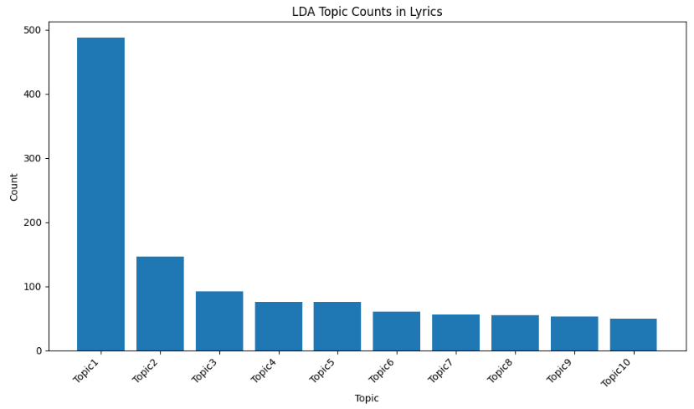
The results show that popular artists tend to focus more on universal themes such as romance, relationships, and self-identity, which are easier for a wide audience to relate to. In contrast, less popular artists often explore more niche and fragmented topics, including teenage experiences, social change, street culture, brotherhood, rap, and explicit language. Although these themes may strongly resonate with certain listeners who share similar life experiences, they may not appeal to audiences from different age groups or backgrounds. As a result, differences in thematic focus contribute to the gap in popularity between the two groups. Even within similar themes such as romantic relationships, clearer storytelling or more polished musical expression may further influence an artist’s popularity.

