Application has two layers

1. Service Layer

**FSE_Project_Manager_Core**

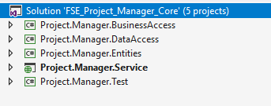

Above layer classified into 5 types mentioned above.

1. Front End Layer

**Project.Manager.Web**

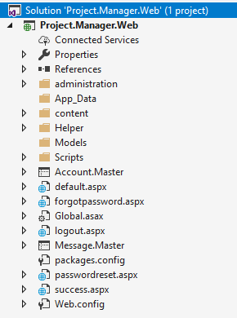

Entity Framework Code First Approach is used for data access.

JavaScript Data table is used to display the Records in List, which provide the features like Sort, Search, Pagination and Much More

To run the application, please refer the documents 1 and 2nd