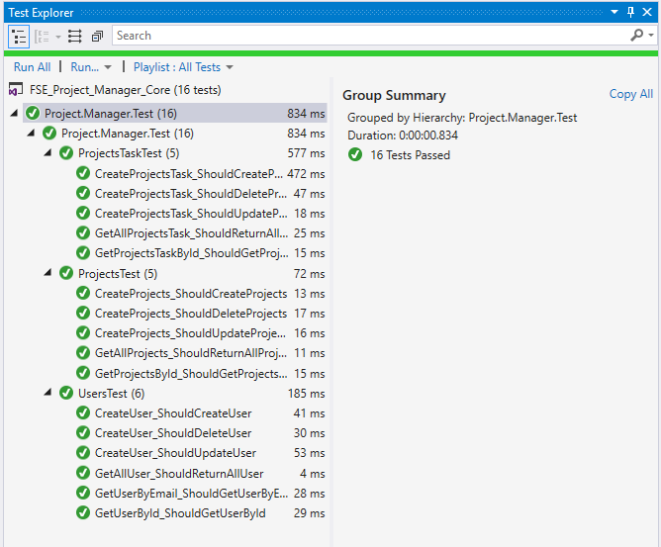

Redirect to folder **“NUnit_Testing_Using_Console_Runner”** and open command prompt here, then run below command

**nunit3-console.exe Project.Manager.Test.dll**

